24 Dynamic Path Segment:
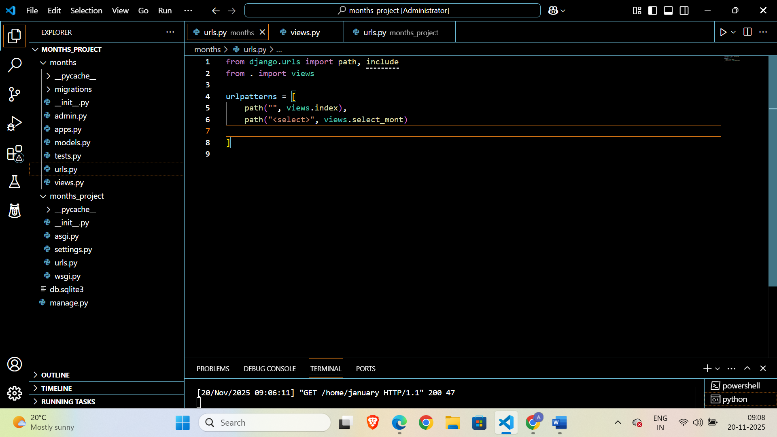

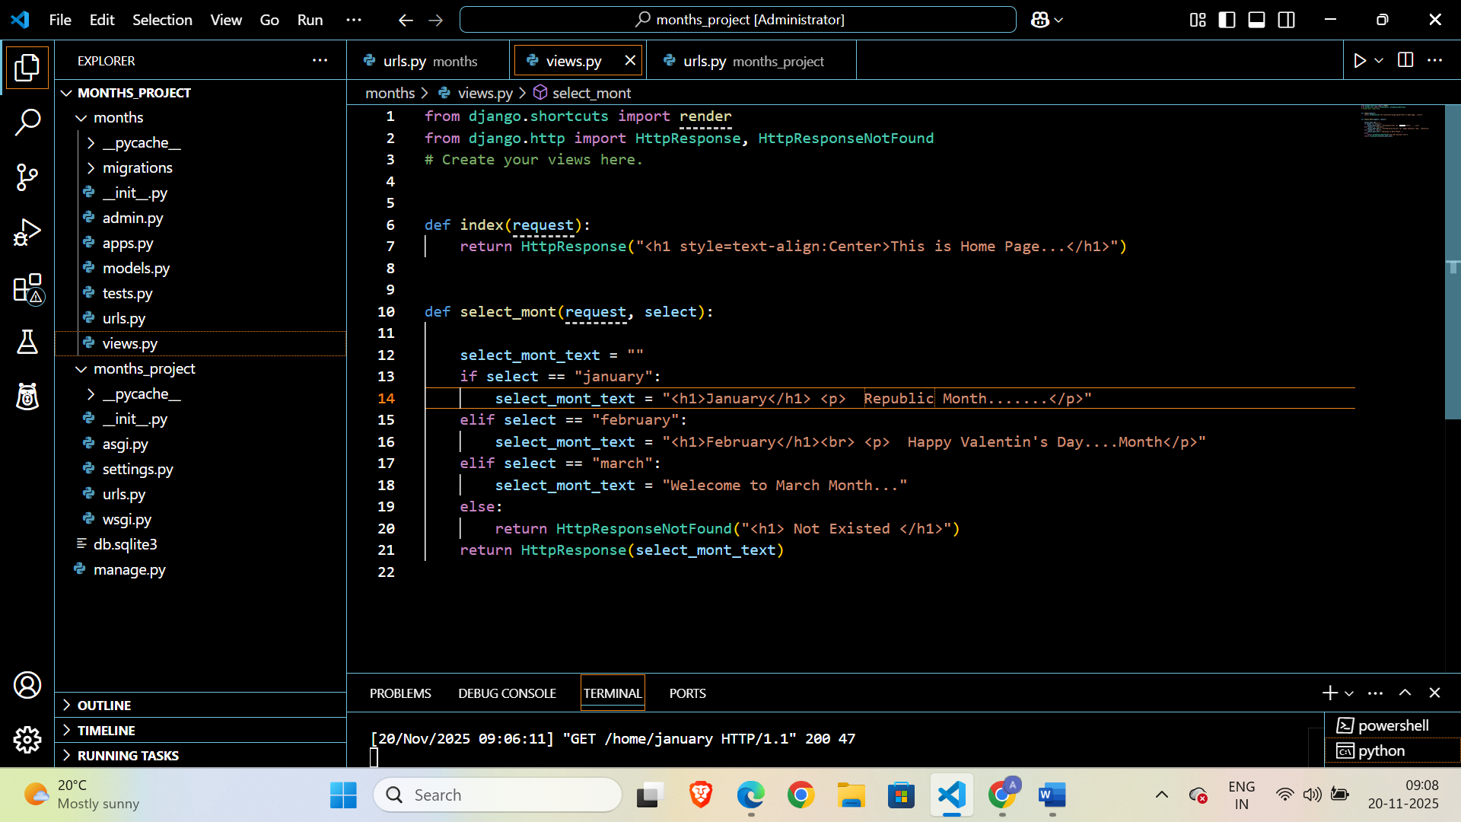

25 Path Converter:
A path converter tells Django:
- What type of value to expect in the URL
- How to capture it
- And pass it to the view function
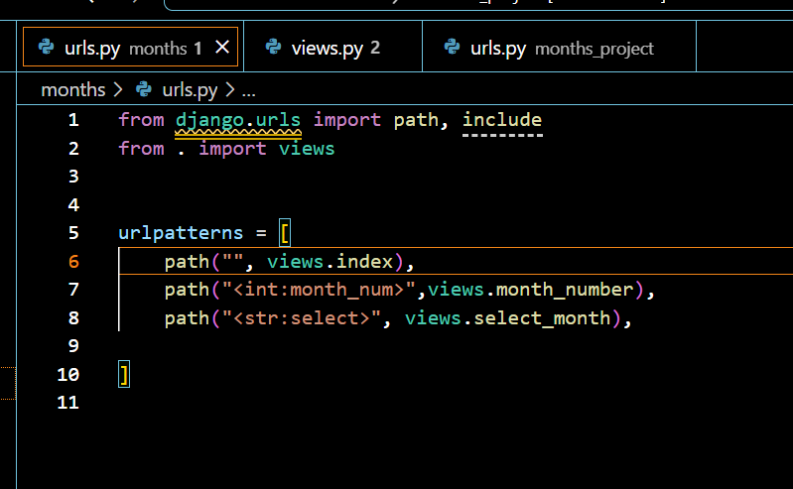

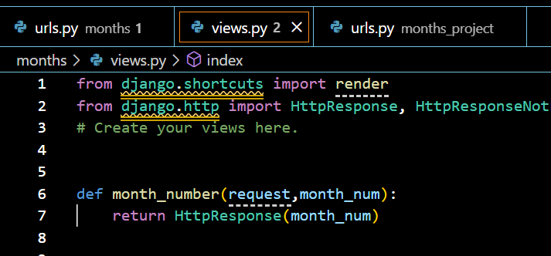
26 Adding more Dynamic view logic:

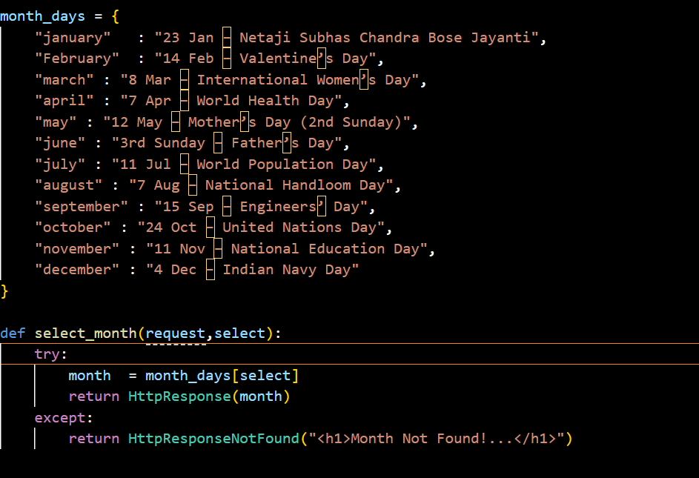
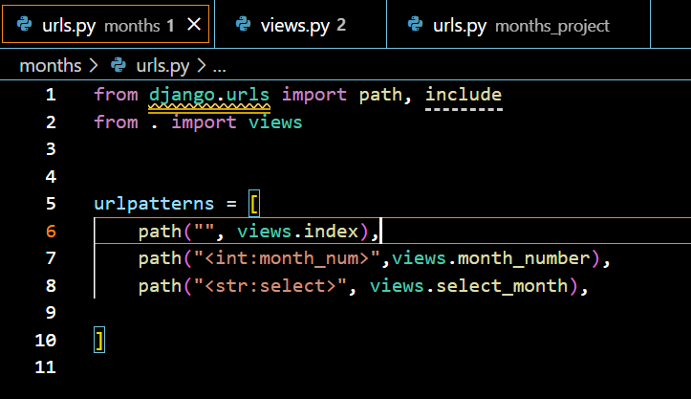
27 Redirect:
In Django, redirects are used to send the user from one URL to another. They are very common in login flows, form submissions, and when moving pages.

✅ What is a Redirect in Django?
A redirect tells the browser:
"Go to a different URL."
Django gives you a built-in helper: redirect()
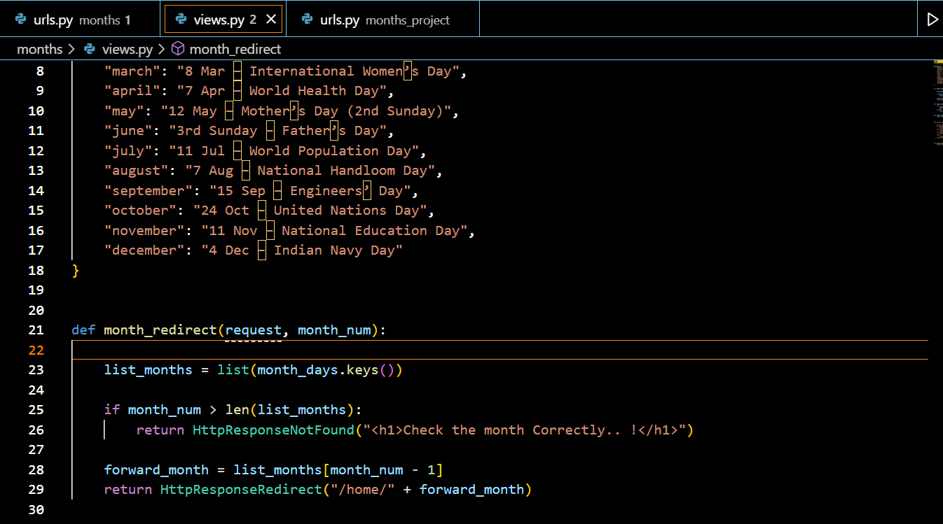
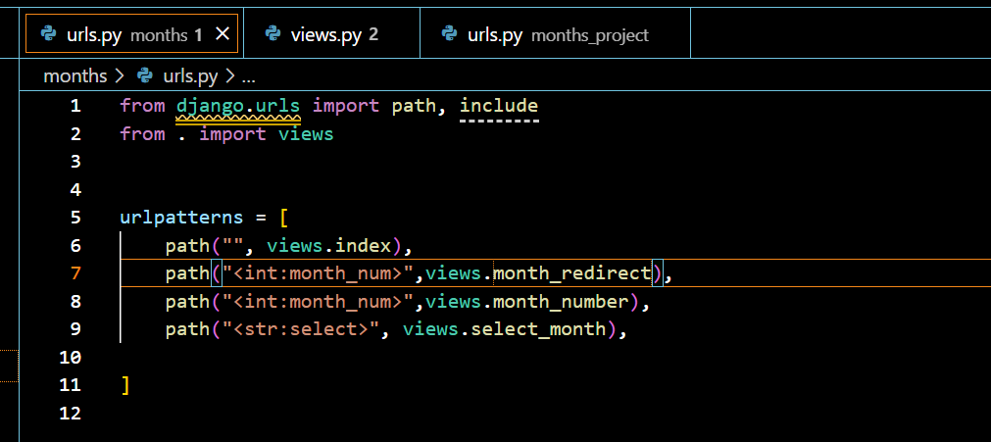
28 reverse() Function & Named URL:
A named URL means giving a name to a path in urls.py so you can use that name later (in templates, views, redirects, etc.).
reverse() is used to get the actual URL path using the URL name.
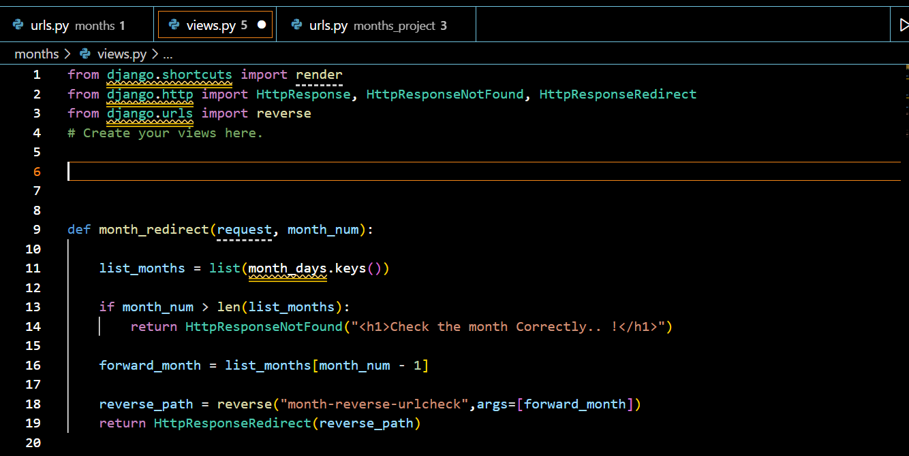

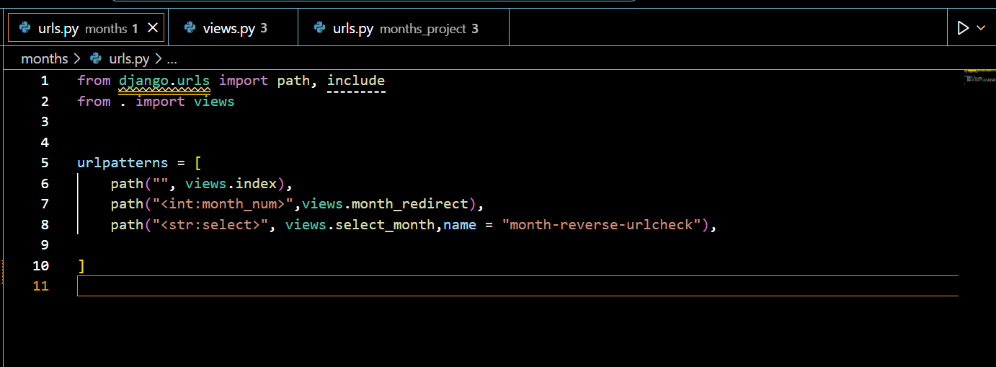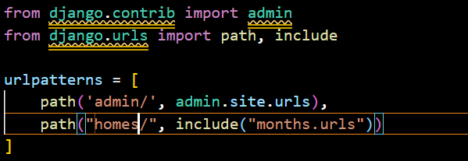
29 Return HTML:
Views:
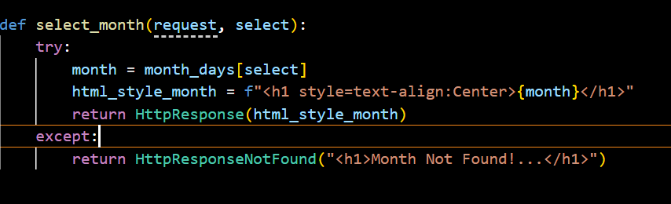
Urls:
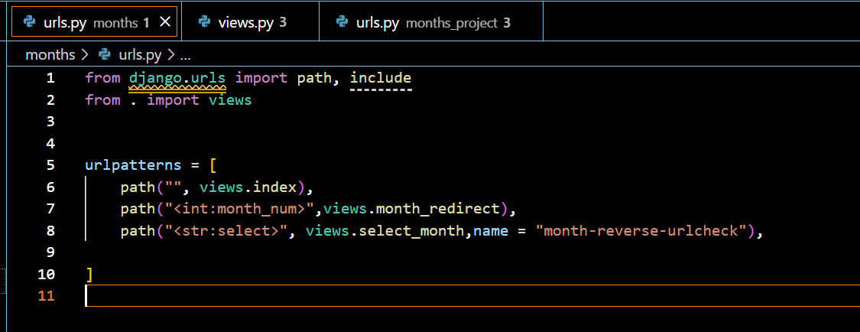

30. Practicing URLs, Views & Dynamic View Logic:
Views:
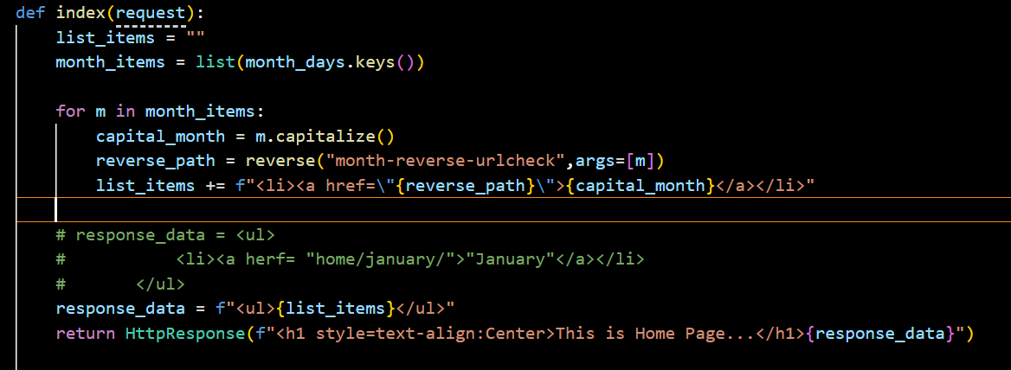

Urls:
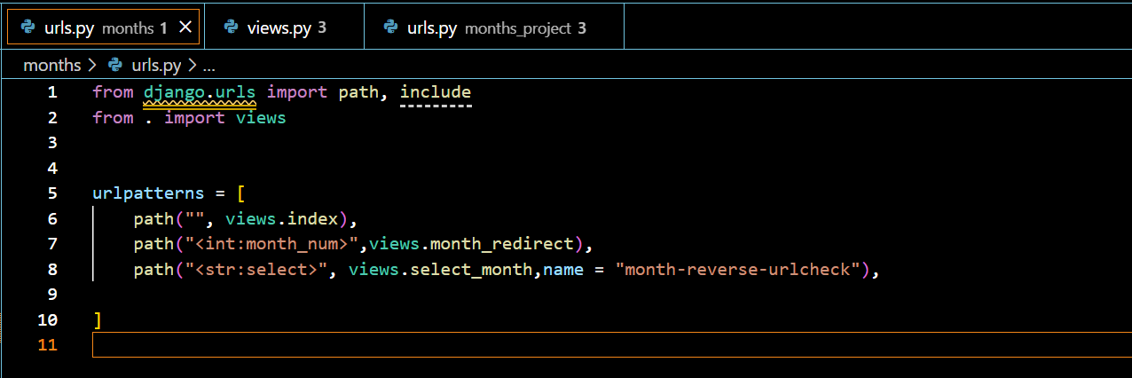

URL’S & Views

Urls:
from django.urls import path, include
from . import views

urlpatterns = [
path("", views.index),
path("<int:month_num>",views.month_redirect),
path("<str:select>", views.select_month,name = "month-reverse-urlcheck"),

]

Views:
from django.shortcuts import render
from django.http import HttpResponse, HttpResponseNotFound, HttpResponseRedirect
from django.urls import reverse
# Create your views here.

month_days = {
"january": "23 Jan – Netaji Subhas Chandra Bose Jayanti",
"February": "14 Feb – Valentine’s Day",
"march": "8 Mar – International Women’s Day",
"april": "7 Apr – World Health Day",
"may": "12 May – Mother’s Day (2nd Sunday)",
"june": "3rd Sunday – Father’s Day",
"july": "11 Jul – World Population Day",
"august": "7 Aug – National Handloom Day",
"september": "15 Sep – Engineers’ Day",
"october": "24 Oct – United Nations Day",
"november": "11 Nov – National Education Day",
"december": "4 Dec – Indian Navy Day"
}

def index(request):
list_items = ""
month_items = list(month_days.keys())

for m in month_items:
capital_month = m.capitalize()
reverse_path = reverse("month-reverse-urlcheck",args=[m])
list_items += f"<li><a href=\"{reverse_path}\">{capital_month}</a></li>"

# response_data = <ul>
# <li><a herf= "home/january/">"January"</a></li>
# </ul>
response_data = f"<ul>{list_items}</ul>"
return HttpResponse(f"<h1 style=text-align:Center>This is Home Page...</h1>{response_data}")

def month_redirect(request, month_num):

list_months = list(month_days.keys())

if month_num > len(list_months):
return HttpResponseNotFound("<h1>Check the month Correctly.. !</h1>")

forward_month = list_months[month_num - 1]

reverse_path = reverse("month-reverse-urlcheck",args=[forward_month])
return HttpResponseRedirect(reverse_path)

def select_month(request, select):
try:
month = month_days[select]
html_style_month = f"<h1 style=text-align:Center>{month}</h1>"
return HttpResponse(html_style_month)
except:
return HttpResponseNotFound("<h1>Month Not Found!...</h1>")
'''
def select_month(request, select):
select_mont_text = ""
if select == "january":
select_mont_text = "<h1>January</h1> <p> Republic Month.......</p>"
elif select == "february":
select_mont_text = "<h1>February</h1><br> <p> Happy Valentin's Day....Month</p>"
elif select == "march":
select_mont_text = "Welecome to March Month..."
else:
return HttpResponseNotFound("<h1> Not Existed </h1>")
return HttpResponse(select_mont_text)
'''
'''
def month_number(request, month_num):
return HttpResponse(month_num)
'''

Urls(project):
from django.contrib import admin
from django.urls import path, include

urlpatterns = [
path('admin/', admin.site.urls),
path("home/", include("months.urls"))
]

https://github.com/academind/django-practical-guide-course-code/tree/master/code/03%20Urls%20and%20Views

SECTION – 4
Template’s & static files
34 Adding & Registering templates:
Setting(project): Registering app in setting file
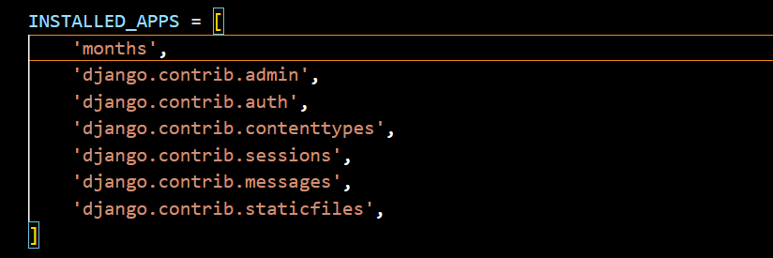
Html :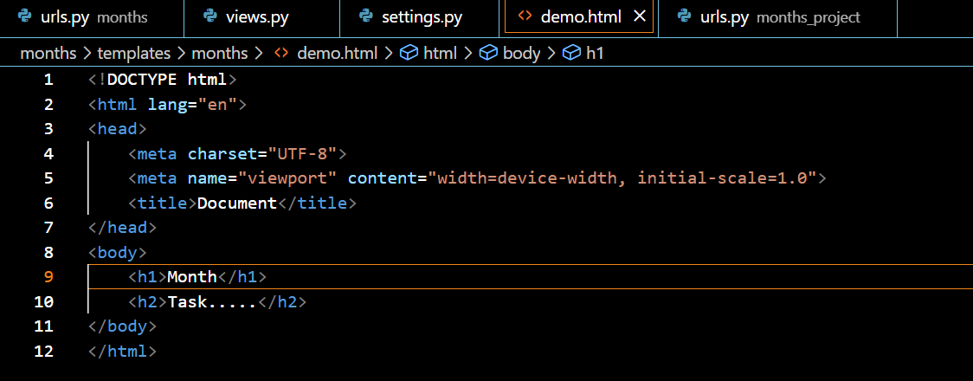Views(app):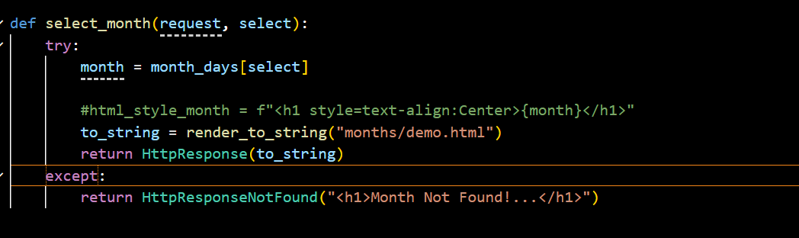

35 Rendering Template’s:
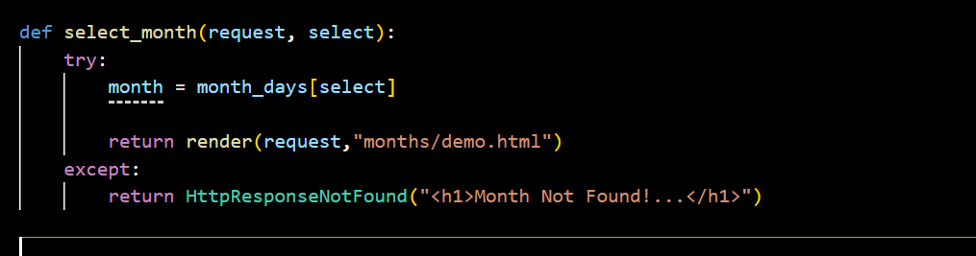

36. Template Language & Variable Interpolation: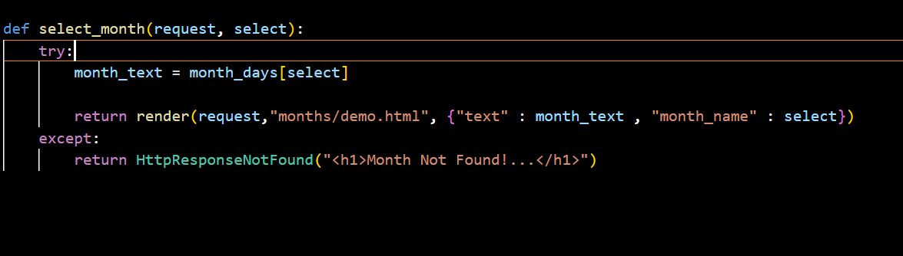
Html: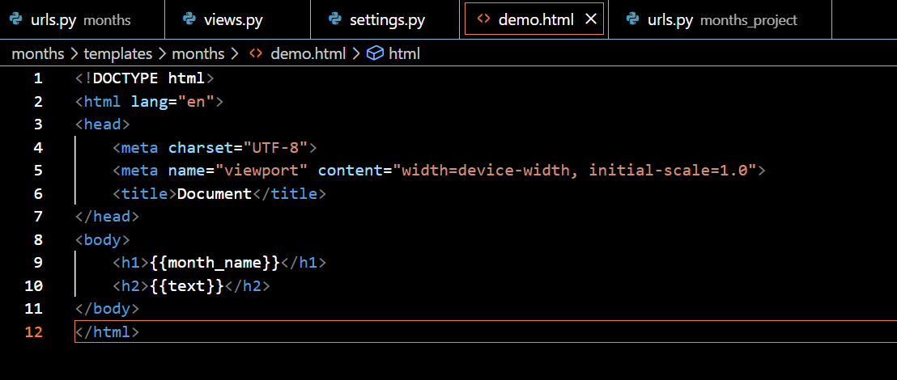

38. Filters:
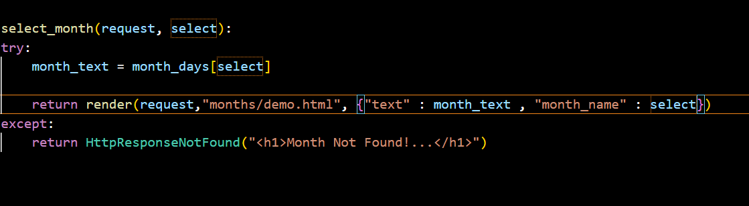
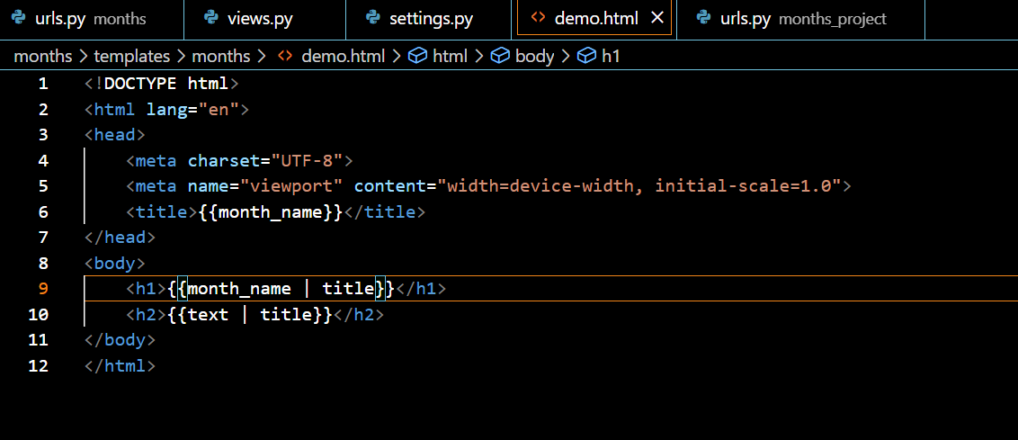

40. Tags & the "for" Tag:
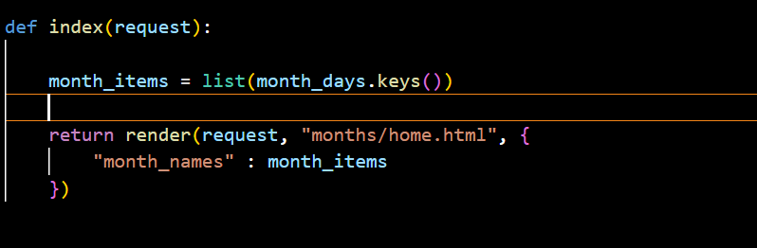

Demo.html:
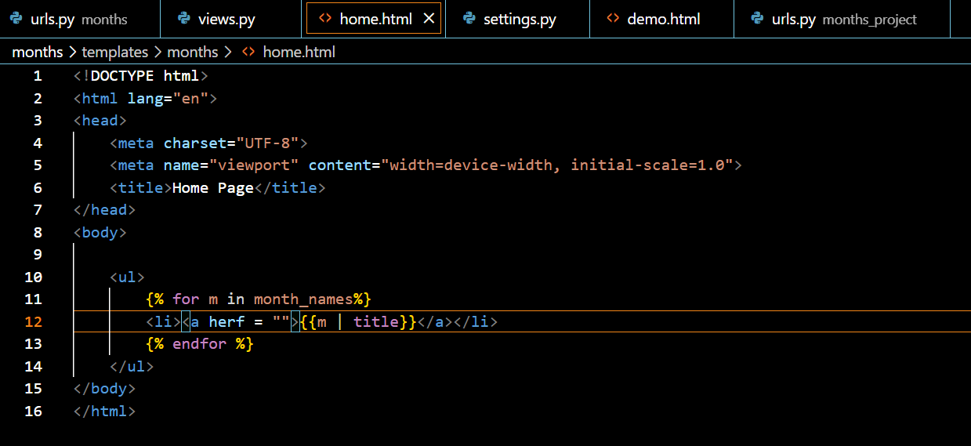

41. The URL Tag for Dynamic URLs:
Views: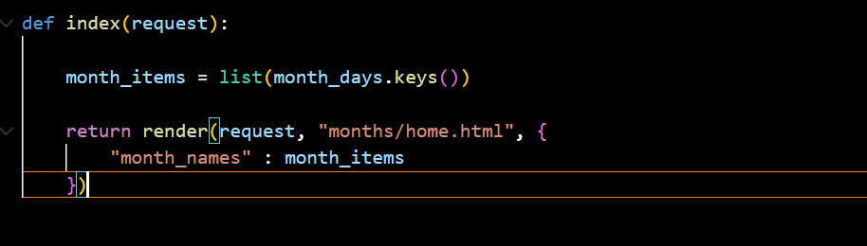
Home.html (Hard Code):
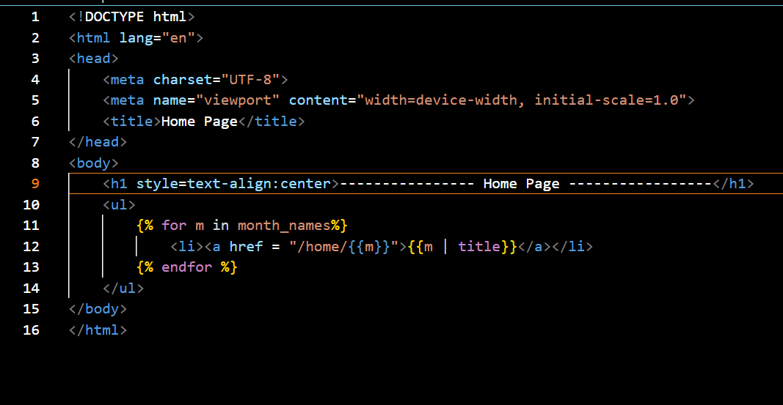
Home.html (Dynamic):
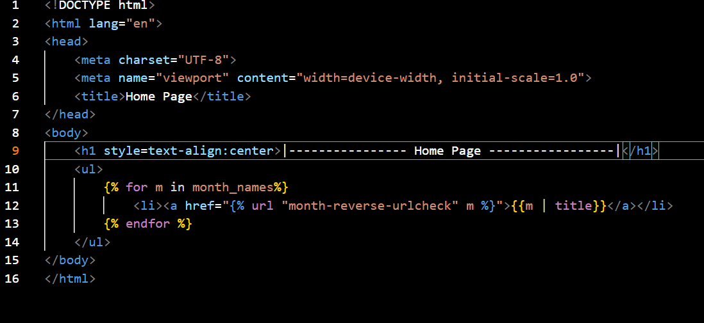
42. The "if" Tag for Conditional Content:
Demo.html:
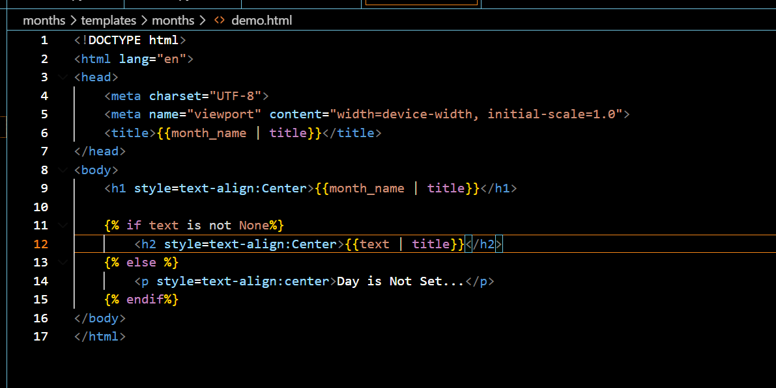
Views:
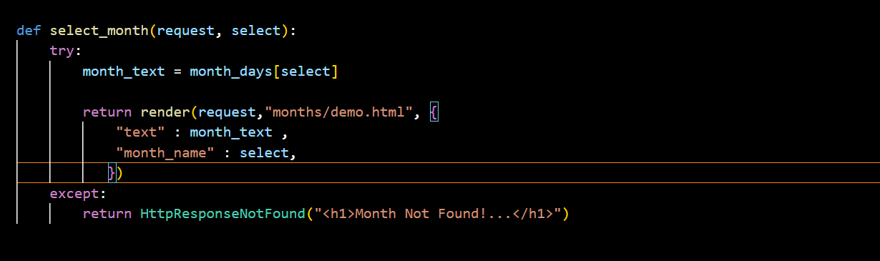
43. Template Inheritance:
Base.html: in separate folder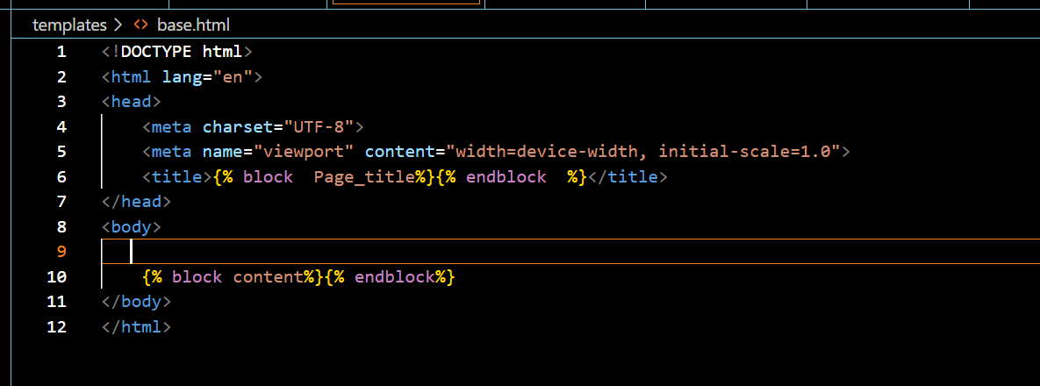
Adding this base.html path in setting file:
Setting(project):
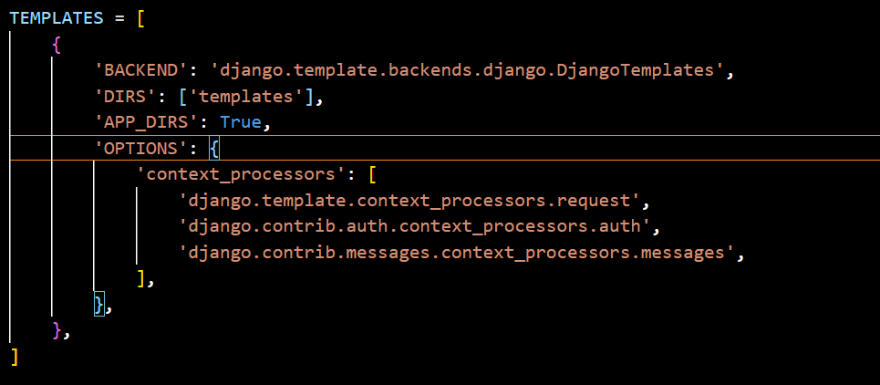
Home.html:
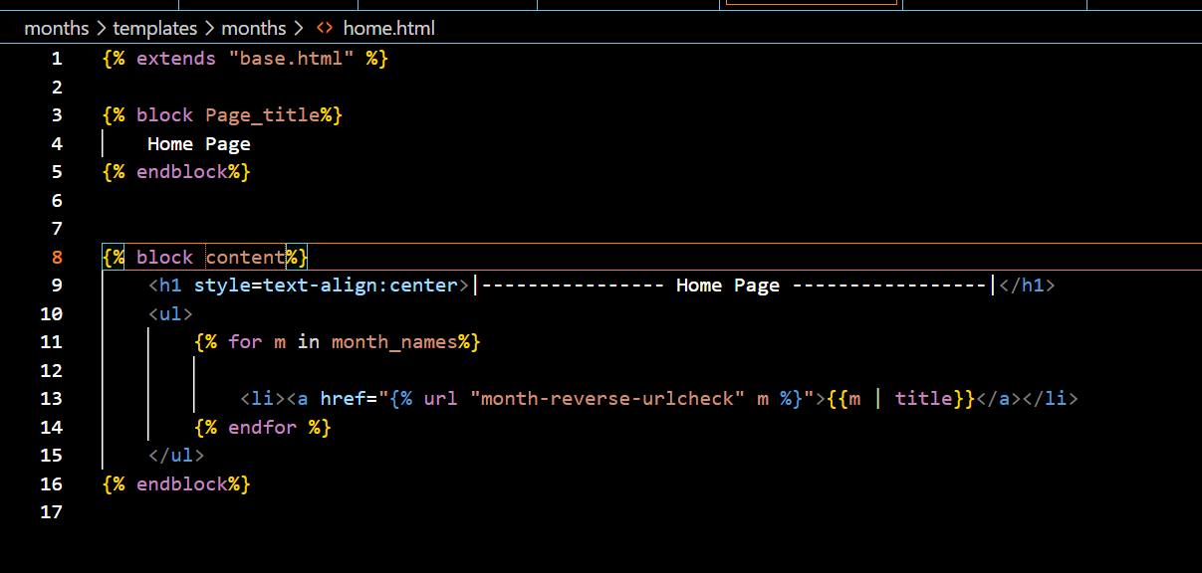
Demo.html:
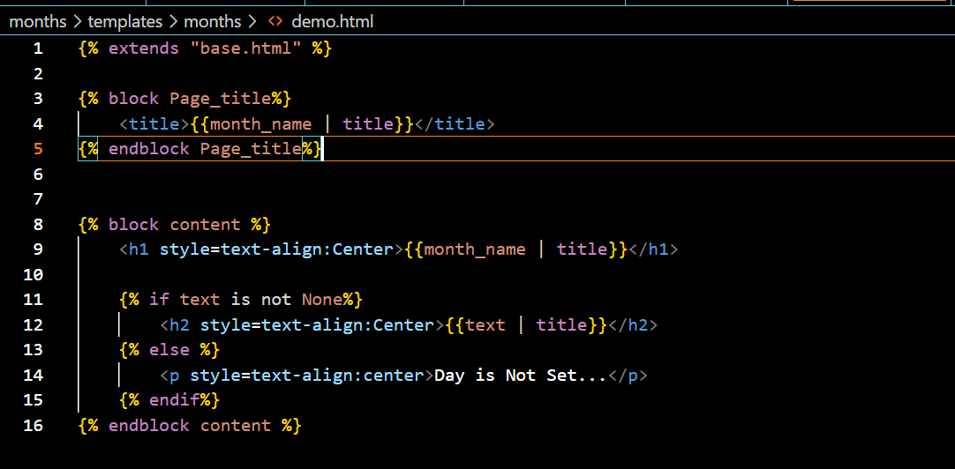
45. Including Partial Template Snippets:
Header.html: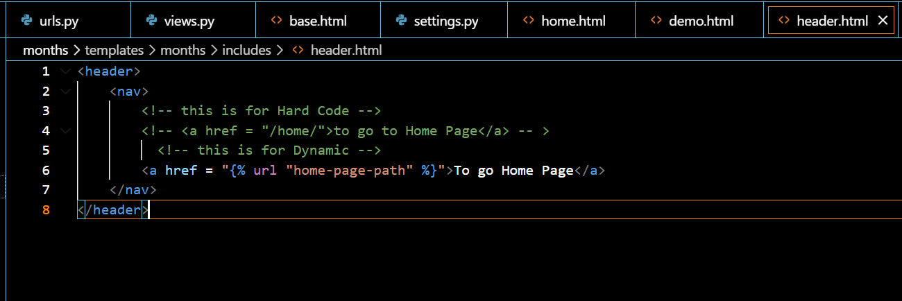
Demo.html:
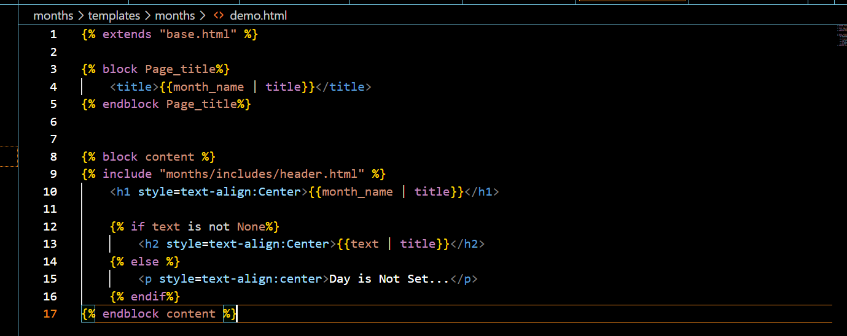
Home.html:
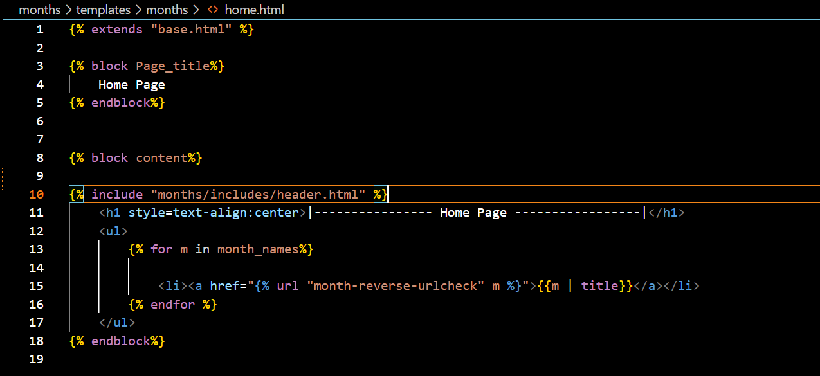
Urls:
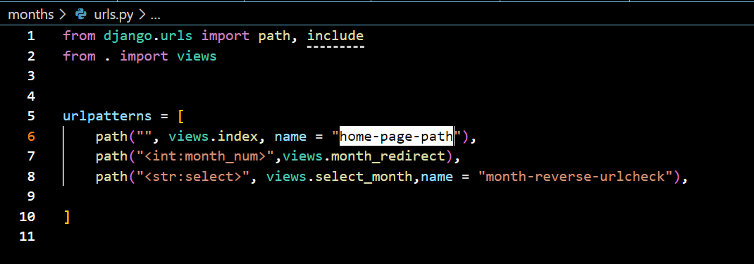

47. 404 Templates:
Views:
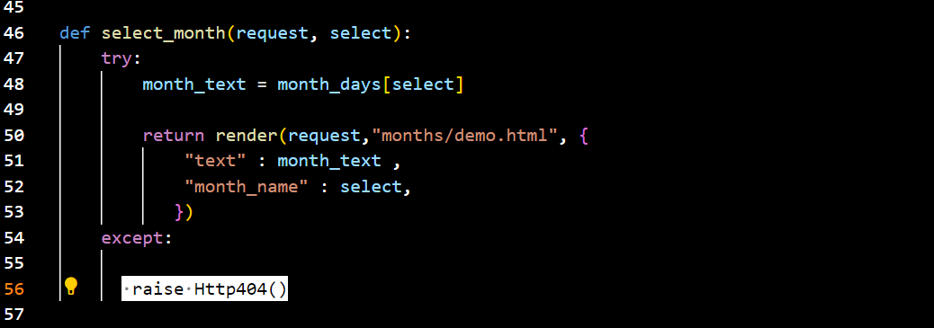
404.html(This name must be the same):