OPEARING SYSTEM UNIT 04

Practice Problems on Memory Management.

- Find the size of the memory if its address consists of 22 bits. Assume the memory is 2-byte addressable.
- Calculate the number of address bits, if the memory has a size of 16 GB. Assume the memory is 4-byte addressable.
- Consider a machine with 32 bit logical addresses, 4 KB page size and page table entries of 4 bytes each. Find the size of the page table in bytes. Assume the memory is byte addressable.
- Consider a system with page table entries of 8 bytes each. If the size of the page table is 256 bytes, what is the number of entries in the page table?
- Find the total number of frames. If a system, size of the main memory is 230 bytes, the page size is 4 KB and the size of each page table entry is 32-bit.
- Consider a single level paging scheme. The virtual address space is 4 MB and page size is 4 KB. What is the maximum page table entry size possible such that the entire page table fits well in one page?
- Consider a single level paging scheme. The virtual address space is 4 GB and page size is 128 KB. What is the maximum page table entry size possible such that the entire page table fits well in one page?
- Consider a single level paging scheme. The virtual address space is 128 TB and page size is 32 MB. What is the maximum page table entry size possible such that the entire page table fits well in one page?
- Consider a single level paging scheme. The virtual address space is 256 MB and page table entry size is 4 bytes. What is the minimum page size possible such that the entire page table fits well in one page?
- Consider a single level paging scheme. The virtual address space is 512 KB and page table entry size is 2 bytes. What is the minimum page size possible such that the entire page table fits well in one page?
- Consider a single level paging scheme. The virtual address space is 16 GB and page table entry size is 4 bytes. What is the minimum page size possible such that the entire page table fits well in one page?
- Consider a system using multilevel paging scheme. The page size is 1 MB. The memory is byte addressable and virtual address is 64 bits long. The page table entry size is 4 bytes.
- Let the page fault service time be 10 ms in a computer with average memory access time being 20 ns. If one page fault is generated for every 10⁶ memory accesses, what is the effective access time for the memory?
- Consider a system with a two-level paging scheme in which a regular memory access takes 150 nanoseconds and servicing a page fault takes 8 milliseconds. An average instruction takes 100 nanoseconds of CPU time and two memory accesses. The TLB hit ratio is 90% and the page fault rate is one in every 10,000 instructions. What is the effective average instruction execution time.

- Consider the following segment table-
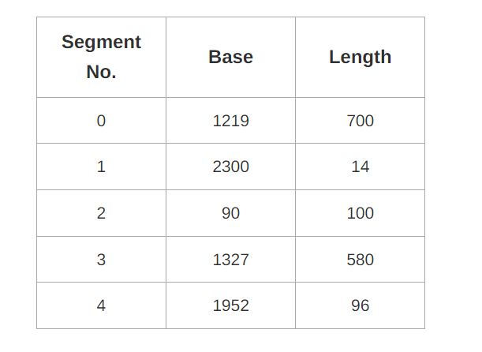
Which of the following logical address will produce trap addressing error?
- 0, 430
- 1, 11
- 2, 100
- 3, 425
- 4, 95

Calculate the physical address if no trap is produced.

- A system uses 3 page frames for storing process pages in main memory. It uses the First in First out (FIFO) page replacement policy. Assume that all the page frames are initially empty. What is the total number of page faults that will occur while processing the page reference string given below- 4 , 7, 6, 1, 7, 6, 1, 2, 7, 2
Also calculate the hit ratio and miss ratio.

- A system uses 3 page frames for storing process pages in main memory. It uses the Least Recently Used (LRU) page replacement policy. Assume that all the page frames are initially empty. What is the total number of page faults that will occur while processing the page reference string given below- 4 , 7, 6, 1, 7, 6, 1, 2, 7, 2
Also calculate the hit ratio and miss ratio.

- A system uses 3 page frames for storing process pages in main memory. It uses the Optimal page replacement policy. Assume that all the page frames are initially empty. What is the total number of page faults that will occur while processing the page reference string given below- 4 , 7, 6, 1, 7, 6, 1, 2, 7, 2
Also calculate the hit ratio and miss ratio.

