מגישים:

אברהם רובין : 302483607

אלכס זקשנסקי : 310110028

1. יישום פילטרים ( Dilation, Erosion)

תוכנית :

%%----------------------------------------

subplot(2,3,4);

[m,n]=size(pic1);

pic_7X7_Erosion=zeros(m,n);

for i=4:m-4

for j=4:n-4

flag=0;

for x=-3:3

for y=-3:3

if pic1(i+x,j+y) == 1

flag=flag+1;

end

end

end

if flag==49

pic_7X7_Erosion(i,j)=1;

end

end

end

imshow(pic_7X7_Erosion)

title('Erosion 7X7 picture');

%%----------------------------------------

subplot(2,3,5);

[m,n]=size(pic1);

pic_7X3_Erosion=zeros(m,n);

for i=4:m-4

for j=4:n-4

flag=0;

for x=-3:3

for y=-1:1

if pic1(i+x,j+y) == 1

flag=flag+1;

end

end

end

if flag==21

pic_7X3_Erosion(i,j)=1;

end

end

end

imshow(pic_7X3_Erosion)

title('Erosion 7X7 picture');

%% Lab 6 - Morphological

clear;clc;

pic1=imread('01.png');

pic1=im2bw(pic1);

figure(1)

subplot(2,3,1);

imshow(pic1)

title('Original picture');

grey = 150.0;

h1=7;

h2=7;

x1=int8((-1*(h1))/2)+1;

x2=int8(((h1))/2)-1;

y1=int8((-1*(h2))/2)+1;

y2=int8(((h2))/2)-1;

%%----------------------------------------

subplot(2,3,2);

[m,n]=size(pic1);

pic_3X3_Dilation=zeros(m,n);

for i=4:m-4

for j=4:n-4

if pic1(i,j)==1

for x=-3:3

for y=-3:3

pic_3X3_Dilation(i+x,j+y) = 1;

end

end

end

end

end

imshow(pic_3X3_Dilation)

title('Dilation 7X7 picture');

%%----------------------------------------

subplot(2,3,3);

[m,n]=size(pic1);

pic_3X1_Dilation=zeros(m,n);

for i=4:m-4

for j=4:n-4

if pic1(i,j)==1

for x=-3:3

for y=-1:1

pic_3X1_Dilation(i+x,j+y) = 1;

end

end

end

end

end

imshow(pic_3X1_Dilation)

title('Dilation 7X3 picture');

%%----------------------------------------

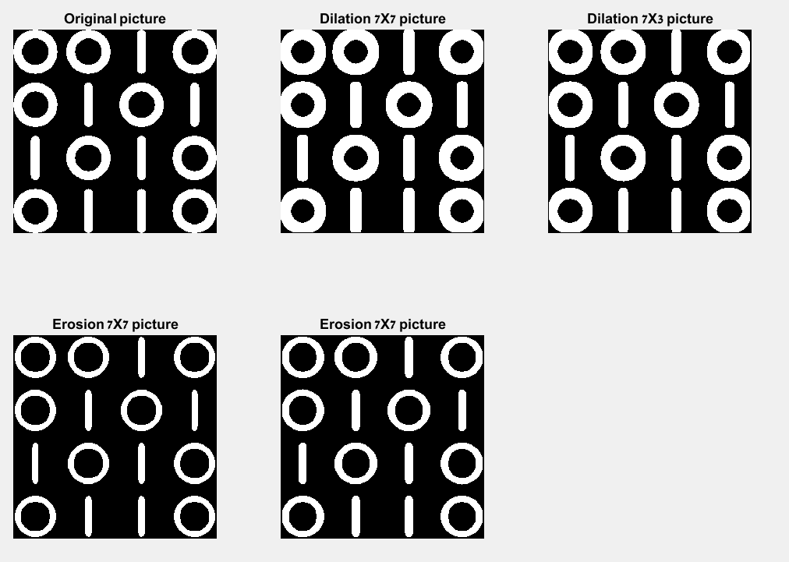 פלט:

2. הרכבה של הפונקציות (Opening, Closing)

תוכנית:

%% Lab 6 - Morphological

clear;clc;

pic1=imread('text0.jpg');

pic1=im2bw(pic1);

figure(1)

subplot(1,3,1);

imshow(pic1)

title('Original picture');

%%----------------------------------------

subplot(1,3,2);

[m,n]=size(pic1);

pic_3X3_Dilation=zeros(m,n);

for i=4:m-4

for j=4:n-4

if pic1(i,j)==1

for x=-3:3

for y=-3:3

pic_3X3_Dilation(i+x,j+y) = 1;

end

end

end

end

end

pic_7X7_Erosion=zeros(m,n);

for i=4:m-4

for j=4:n-4

flag=0;

for x=-3:3

for y=-3:3

if pic_3X3_Dilation(i+x,j+y) == 1

flag=flag+1;

end

end

end

if flag==49

pic_7X7_Erosion(i,j)=1;

end

end

end

imshow(pic_7X7_Erosion)

title('Closing 7X7 picture');

%%----------------------------------------

%%----------------------------------------

[m,n]=size(pic1);

pic_7X7_Erosion=zeros(m,n);

for i=4:m-4

for j=4:n-4

flag=0;

for x=-3:3

for y=-3:3

if pic1(i+x,j+y) == 1

flag=flag+1;

end

end

end

if flag==49

pic_7X7_Erosion(i,j)=1;

end

end

end

pic_3X3_Dilation=zeros(m,n);

for i=4:m-4

for j=4:n-4

if pic_7X7_Erosion(i,j)==1

for x=-3:3

for y=-3:3

pic_3X3_Dilation(i+x,j+y) = 1;

end

end

end

end

end

subplot(1,3,3);

imshow(pic_7X7_Erosion)

title('Opening 7X7 picture');

פלט:

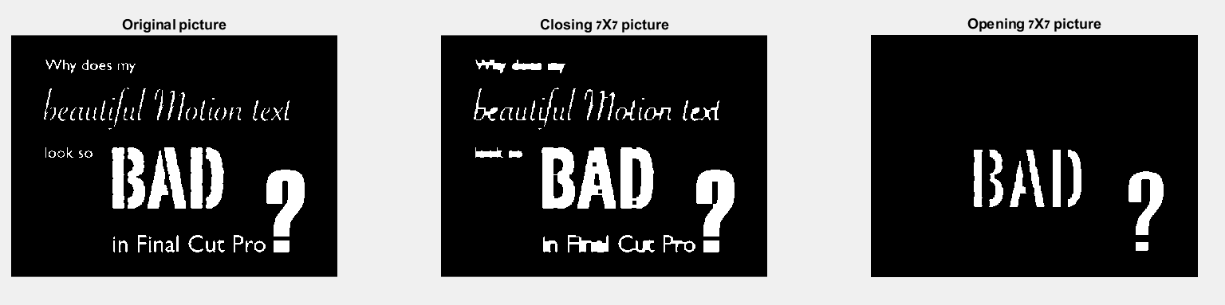

3. שיפור תמונה בעזרת קומבינציה של פילטרים:

תוכנית :

%%----------------------------------------

subplot(1,4,4);

[m,n]=size(pic_3X1_Dilation);

pic_7X7_Erosion1=zeros(m,n);

for i=4:m-4

for j=4:n-4

flag=0;

for x=-1:1

for y=-1:1

if pic_7X7_Erosion(i+x,j+y) == 1

flag=flag+1;

end

end

end

if flag==9

pic_7X7_Erosion1(i,j)=1;

end

end

end

imshow(pic_7X7_Erosion1)

title('Step 3: Erosion 3X3 picture');

%% Lab 6 - Morphological

clear;clc;

pic1=imread('Apple.jpg');

pic1=im2bw(pic1);

figure(1)

subplot(1,4,1);

imshow(pic1)

title('Original picture');

grey = 150.0;

subplot(1,4,2);

[m,n]=size(pic1);

pic_3X1_Dilation=zeros(m,n);

for i=4:m-4

for j=4:n-4

if pic1(i,j)==1

for x=-3:3

for y=-1:1

pic_3X1_Dilation(i+x,j+y) = 1;

end

end

end

end

end

imshow(pic_3X1_Dilation)

title('Setp 1 :Dilation 7X3 picture');

%%----------------------------------------

subplot(1,4,3);

[m,n]=size(pic_3X1_Dilation);

pic_7X7_Erosion=zeros(m,n);

for i=4:m-4

for j=4:n-4

flag=0;

for x=-1:1

for y=-1:1

if pic_3X1_Dilation(i+x,j+y) == 1

flag=flag+1;

end

end

end

if flag==9

pic_7X7_Erosion(i,j)=1;

end

end

end

imshow(pic_7X7_Erosion)

title('Step 2: Erosion 7X7 picture');

%%----------------------------------------

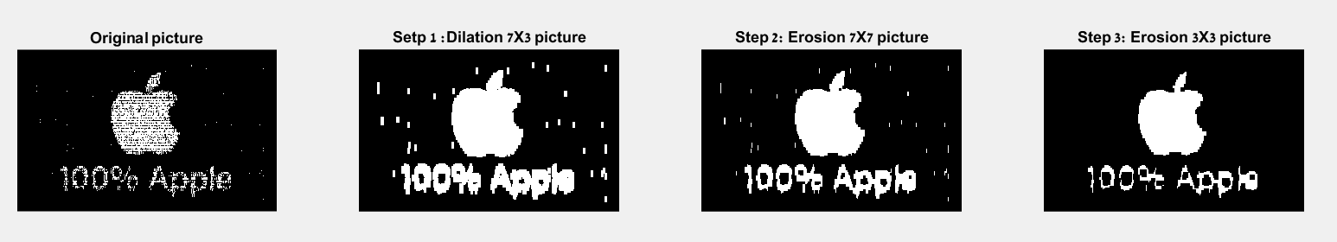פלט :