Computability and Complexity Theory – Exercise 1
Turing Machines
ID:302188347
Collaboration statement:
שיתפתי פעולה עם עצמי אך כתבתי את הפתרונות בעצמי ולא נעזרתי בפתרון כתוב כלשהו בזמן כתיבת התשובות.

Problem 1: (Elementary concepts, 25 points)
- Write the following sets formally:
Example: The set of all strings over Σ of length less or equal to 5 may be written formally as {w∈Σ* : |w|≤5}.
  - The set of all strings over {0,1} of even length:
{w∈Σ* | |w| mod 2 = 0}
    - Does it contain infinite length strings? No.
    - What is the shortest string in the set? ε.
  - The set of all strings over {0,1} that have an even number of "0":
{w∈ Σ* | #₀(w) mod 2 = 0}
  - The set containing the empty string:
{ ε }
  - The set of all bipartite graphs (A bipartite graph G is a graph whose vertices can be divided into two disjoint sets and such that every edge connects a vertex in to a vertex in ):
{G: G=(V,E) is a graph and V=V₁ ∪ V₂, s.t. ∀ (w,t) and ∀ (t,w), w∈V₁ and t∈V₂}

- Let K = {L⊆{0,1}*: ∀ w∈L |w|≤ 4 and |w| is odd}.
  - Let L₁,L₂∈K.
    - Is L₁∩L₂∈K? à No.
    - Is L₁L₂∈K? (L₁L₂ is the concatenation of L₁ and L₂) à No.
    - Is ∈K ( denotes the empty set)? à Yes.
    - Is {0,00,000}∈K? à No.
  - Let L∈K.
    - Give a tight upper bound on |L| (i.e., how large can |L| be?):
10. The set may contain strings of length 1 or 3. Assume L contains all the possible strings, hence we’ve got 2¹ strings of length 1 and 2³ strings of length 3 thus $\left|L\right|=2^{1}+2^{3}=10$
    - What is the concatenation of L and ? .
    - What is the concatenation of L and {ε}? L.
  - What is |K|? 1024. Explain:
The size of the “biggest” language is 10, hence K is the set of languages constructed from those 10 options thus K is the power set of the biggest language which yields 2¹⁰ = 1024.
- Write down the complement of the following language:
L = { P⊆{0,1}*: P is a legal encoding of a C program, and P terminates on all inputs that start with '0' bit}
L-COMP = { P⊆{0,1}*: (P is not a legal encoding of a C program) ∪ (P does not terminate on all inputs that start with '0' bit)}

Problem 2: (25 points) Let M be a Turing machine with:
Q = {q₀,q₁,q_{acc},q_{rej}} , Σ = {0,1} , Γ = {0,1,_} and δ remains undefined.
For each of the following pairs of configurations, C_{i} and C_{i+1}, determine whether it is possible under some definition of δ that C_{i} will yield C_{i+1}. If possible, define the specific transition that will cause M to go from C_{i} to C_{i+1}. If not, explain why.

  - C_{i} = 011q₀100
C_{i+1} = 01q₁1100
δ (q₀,1)=(q₁,1,L)
  - C_{i} = 011q₁001
C_{i+1} = 0110q₀01
δ (q₁,0)=(q₀,0,R)
  - C_{i} = 011q₀01
C_{i+1} = 01q_{acc}101
δ (q₀,0)=(q_{accept},0,L)
  - C_{i} = 010q₀100
C_{i+1} = 0101q₀00
No. There’s this and “a” cannot exist on the same machine as they define different behaviors for the same input.
  - (0 points, not to be submitted)
C_{i} = 111q₀110
C_{i+1} = 11q₀0110
_______________________
_______________________
  - (0 points, not to be submitted)
C_{i} = 011q_{acc}110
C_{i+1} = 0101q₀10
_______________________
_______________________
  - (0 points, not to be submitted)
C_{i} = 101q₁101
C_{i+1} = 1010q₃01
_______________________
_______________________
  - (0 points, not to be submitted)
C_{i} = 010q₁101
C_{i+1} = 0100q₀01
_______________________
_______________________

Problem 3: (25 points)

Let L = {$w∈{\left\{0,1\right\}}^{}:∨w∨$ is even and w does not contain '11' as a subsequence}.
Draw a state diagram of a Turing machine M that decides the language L (reminder: a Turing machine decides a language L if M accepts every w∈L and rejects every w∉L).
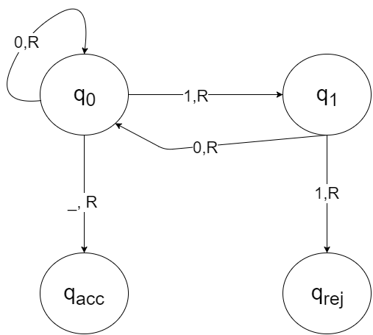
Explain in words each component of the construction.
q_{acc} and q_{rej} are self-describing and doesn’t have any logic following them.
q₀ is the starting state. While M reads ‘0’ it will stay on q₀ (Read 0 and write 0). If M reads “space” it assumes M reached the end of its input and will direct to q_{acc}.
q₁ is reached iff ‘1’ was read from the tape. If M will read another ‘1’ then the input considered invalid thus q₁ will redirect towards q_{rej.} If “0” is being read then the input is still valid and q₁ will redirect towards q₀.

For each of the input strings below give the configurations sequence of M on the corresponding inputs:
- 1001
_______________________________________________________________
- 0110
_______________________________________________________________
- 100
_______________________________________________________________
Problem 4: (25 points)

Consider the following Turing machine:
Q = {q₀,q₁,q₂,q₃,q_{acc}} , Σ = {0,1} , Γ = {0,1,#,_} and
δ : Q×Γ g Q×Γ×{L,R} is defined as follows:

δ(q₀,0) = (q₁,#,R)
δ(q₀,1) = (q₂,#,R)
δ(q₁,0) = (q₁,0,R)
δ(q₁,1) = (q₂,0,R)
δ(q₂,0) = (q₁,1,R)
δ(q₂,1) = (q₂,1,R)

δ(q₁,_) = (q₃,0,L) δ(q₃,0) = (q₃,0,L)
δ(q₂,_) = (q₃,1,L) δ(q₃,1) = (q₃,1,L) δ(q₃,#) = (q_{acc},0,R)

- What does this TM output on input 11100101011?
_________________________________

- Describe (in words) the function computed by this Turing machine. Your description should be clear and unambiguous.
______________________________________________________________________________________________________________________________________________________________________________________________________

Problem 5: (0 points, not to be submitted)

Provide a detailed description (including Q, Σ, Γ and δ) of a Turing machine that, given an input x over {0,1}, outputs 0y, where y is identical to x except the last character, which is negated (for example, on input 01110 the machine should output 001111). You may assume that the input contains at least one symbol.

Problem 6: (0 points, not to be submitted)
Let L⊆{0,1}* be some language. Define
Max(L) = {w∈L : there is no x∈{0,1}* of size > 0 such that wx∈L }.
- Define Max(L) for each of the following languages:
  - L₁ = {0^{n}1^{n}0^{i} |$n≥0,i=0$}
  - L₂ = {0^{n}1^{n}0^{i} |$n≥0,i≥0$}
- L₃ = {0^{n}1^{n}0^{i} |$n≤2,i≤2$}

