**AIM:-** Design an automatic night lighting system such the system is only activated when the master control switch is pressed.

1. Below 300 lux led glows with full brightness.
2. Above 300 lux led glows with 50% brightness.

**Circuit Diagram:-**

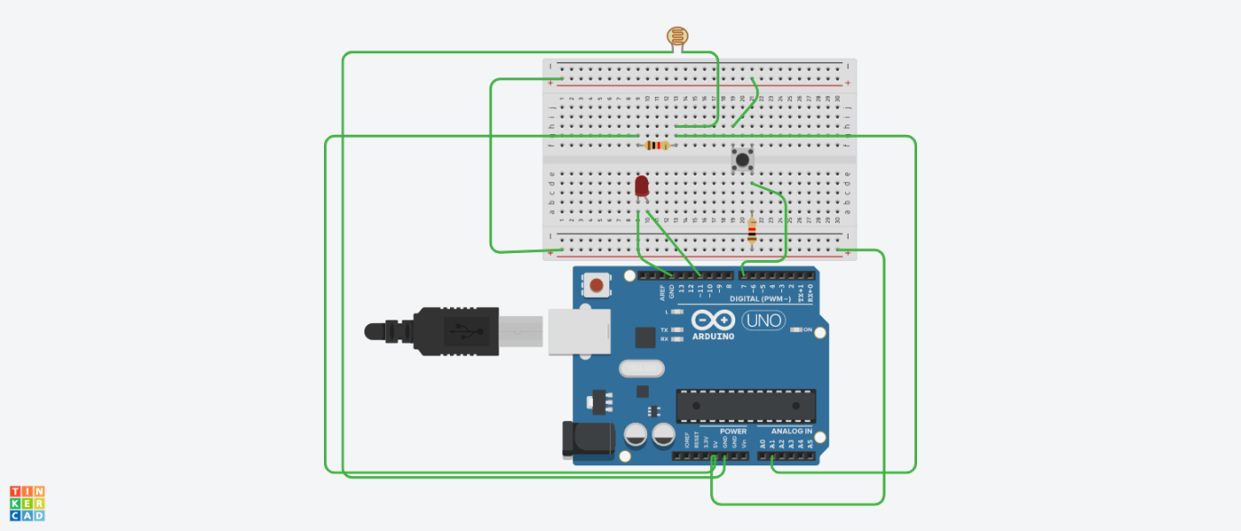

**Concept Used:-**

1. A light dependent resistor(LDR) or a photoresistor is a device whose resistivity is a function of incident electromagnetic radiation.
2. An electric switch that interrupts the electron flow in a circuit.
3. The Arduino board can supply a power of 5V as digital output signal through 14 pins present in it as digital input or output pins.

**Learning and Observations:-**

1. I learnt about different components in an Arduino.
2. The basic importance of Arduino was known.
3. I also learnt the function of LDR in controlling brightness of LED.

**Observations:-**

When we pass electric signals to the Arduino through our code, the brightness of LED changes accordingly.

**Sources of Error:-**

1. The connecting wires may not be connected properly.
2. There may be some error in writing program.
3. Wrong attachment of wires in terminals of breadboard.

**Precautions:-**

1. Attach the USB cable and connecting wires carefully.
2. Once the USB cable has been inserted then Arduino shoud not be touch with bare hands.

**Learning Outcomes:-**

1. I learnt how to make connections using breadboard and Arduino.
2. I learnt how to use LDR and control the brightness along with using a switch.