**Module-I Financial Management**

In a nutshell, financial management –

* Endeavors to reduce the cost of finance
* Ensures sufficient availability of funds
* Deals with the planning, organizing, and controlling of financial activities like the procurement and utilization of funds

Financial management is the activity concerned with planning, raising, controlling and administering of funds used in the business.” – **Guthman and Dougal**

“Financial management is that area of business management devoted to a judicious use of capital and a careful selection of the source of capital in order to enable a spending unit to move in the direction of reaching the goals.” – **J.F. Brandley**

“Financial management is the operational activity of a business that is responsible for obtaining and effectively utilizing the funds necessary for efficient operations.”- **Massie**

**The scope of Financial Mangement**

The introduction to financial management also requires you to understand the scope of financial management. It is important that financial decisions take care of the [shareholders](https://www.toppr.com/guides/business-studies/sources-of-business-finance/equity-shares-and-preference-shares/)‘ interests.

Further, they are upheld by the maximization of the wealth of the shareholders, which depends on the increase in net worth, capital invested in the business, and plowed-back profits for the growth and prosperity of the organization.

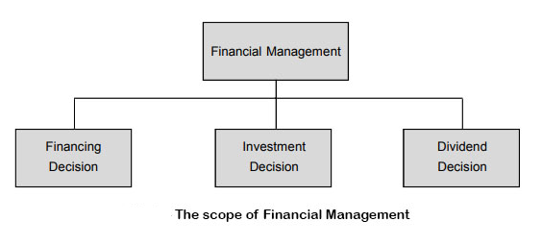The scope of financial management is explained in the diagram below:

Financial Management means planning, organizing, directing and controlling the financial activities such as procurement and utilization of funds of the enterprise. It means applying general management principles to financial resources of the enterprise.

**Scope/Elements**

1. Investment decisions includes investment in fixed assets (called as capital budgeting). Investment in current assets are also a part of investment decisions called as working capital decisions.
2. Financial decisions - They relate to the raising of finance from various resources which will depend upon decision on type of source, period of financing, cost of financing and the returns thereby.
3. Dividend decision - The finance manager has to take decision with regards to the net profit distribution. Net profits are generally divided into two:
   1. Dividend for shareholders- Dividend and the rate of it has to be decided.
   2. Retained profits- Amount of retained profits has to be finalized which will depend upon expansion and diversification plans of the enterprise.

**Objectives of Financial Management**

The financial management is generally concerned with procurement, allocation and control of financial resources of a concern. The objectives can be-

1. To ensure regular and adequate supply of funds to the concern.
2. To ensure adequate returns to the shareholders which will depend upon the earning capacity, market price of the share, expectations of the shareholders.
3. To ensure optimum funds utilization. Once the funds are procured, they should be utilized in maximum possible way at least cost.
4. To ensure safety on investment, i.e, funds should be invested in safe ventures so that adequate rate of return can be achieved.
5. To plan a sound capital structure-There should be sound and fair composition of capital so that a balance is maintained between debt and equity capital.

**Functions of Financial Management**

1. **Estimation of capital requirements:** A finance manager has to make estimation with regards to capital requirements of the company. This will depend upon expected costs and profits and future programmes and policies of a concern. Estimations have to be made in an adequate manner which increases earning capacity of enterprise.
2. **Determination of capital composition:** Once the estimation have been made, the capital structure have to be decided. This involves short- term and long- term debt equity analysis. This will depend upon the proportion of equity capital a company is possessing and additional funds which have to be raised from outside parties.
3. **Choice of sources of funds:** For additional funds to be procured, a company has many choices like-
   1. Issue of shares and debentures
   2. Loans to be taken from banks and financial institutions
   3. Public deposits to be drawn like in form of bonds.

Choice of factor will depend on relative merits and demerits of each source and period of financing.

1. **Investment of funds:** The finance manager has to decide to allocate funds into profitable ventures so that there is safety on investment and regular returns is possible.
2. **Disposal of surplus:** The net profits decision have to be made by the finance manager. This can be done in two ways:
   1. Dividend declaration - It includes identifying the rate of dividends and other benefits like bonus.
   2. Retained profits - The volume has to be decided which will depend upon expansional, innovational, diversification plans of the company.
3. **Management of cash:** Finance manager has to make decisions with regards to cash management. Cash is required for many purposes like payment of wages and salaries, payment of electricity and water bills, payment to creditors, meeting current liabilities, maintainance of enough stock, purchase of raw materials, etc.
4. **Financial controls:** The finance manager has not only to plan, procure and utilize the funds but he also has to exercise control over finances. This can be done through many techniques like ratio analysis, financial forecasting, cost and profit control, etc.

**A financial manger** is a person who takes care of all the important financial functions of an organization. The person in charge should maintain a far sightedness in order to ensure that the funds are utilized in the most efficient manner. His actions directly affect the Profitability, growth and goodwill of the firm.

**Following are the main functions of a Financial Manager:**

1. **Raising of Funds**

In order to meet the obligation of the business it is important to have enough cash and liquidity. A firm can raise funds by the way of equity and debt. It is the responsibility of a financial manager to decide the ratio between debt and equity. It is important to maintain a good balance between equity and debt.

1. **Allocation of Funds**

Once the funds are raised through different channels the next important function is to allocate the funds. The funds should be allocated in such a manner that they are optimally used. In order to allocate funds in the best possible manner the following point must be considered

* + The size of the firm and its growth capability
  + Status of assets whether they are long-term or short-term
  + Mode by which the funds are raised

These financial decisions directly and indirectly influence other managerial activities. Hence formation of a good asset mix and proper allocation of funds is one of the most important activity

1. **Profit Planning**

Profit earning is one of the prime functions of any business organization. Profit earning is important for survival and sustenance of any organization. Profit planning refers to proper usage of the profit generated by the firm.

Profit arises due to many factors such as pricing, industry competition, state of the economy, mechanism of demand and supply, cost and output. A healthy mix of variable and fixed factors of production can lead to an increase in the profitability of the firm.

Fixed costs are incurred by the use of fixed factors of production such as land and machinery. In order to maintain a tandem it is important to continuously value the depreciation cost of fixed cost of production. An opportunity cost must be calculated in order to replace those factors of production which has gone thrown wear and tear. If this is not noted then these fixed cost can cause huge fluctuations in profit.

1. **Understanding Capital Markets**

Shares of a company are traded on stock exchange and there is a continuous sale and purchase of securities. Hence a clear understanding of capital market is an important function of a financial manager. When securities are traded on stock market there involves a huge amount of risk involved. Therefore a financial manger understands and calculates the risk involved in this trading of shares and debentures.

Its on the discretion of a financial manager as to how to distribute the profits. Many investors do not like the firm to distribute the profits amongst share holders as dividend instead invest in the business itself to enhance growth. The practices of a financial manager directly impact the operation in capital market.

**Finance Functions**

**Investment Decision**

One of the most important finance functions is to intelligently allocate capital to long term assets. This activity is also known as capital budgeting. It is important to allocate capital in those long term assets so as to get maximum yield in future. Following are the two aspects of investment decision

1. Evaluation of new investment in terms of profitability
2. Comparison of cut off rate against new investment and prevailing investment.

Since the future is uncertain therefore there are difficulties in calculation of expected return. Along with uncertainty comes the risk factor which has to be taken into consideration. This risk factor plays a very significant role in calculating the expected return of the prospective investment. Therefore while considering investment proposal it is important to take into consideration both expected return and the risk involved.

Investment decision not only involves allocating capital to long term assets but also involves decisions of using funds which are obtained by selling those assets which become less profitable and less productive. It wise decisions to decompose depreciated assets which are not adding value and utilize those funds in securing other beneficial assets. An opportunity cost of capital needs to be calculating while dissolving such assets. The correct cut off rate is calculated by using this opportunity cost of the required rate of return (RRR)

**Financial Decision**

Financial decision is yet another important function which a financial manger must perform. It is important to make wise decisions about when, where and how should a business acquire funds. Funds can be acquired through many ways and channels. Broadly speaking a correct ratio of an equity and debt has to be maintained. This mix of equity capital and debt is known as a firm’s capital structure.

A firm tends to benefit most when the market value of a company’s share maximizes this not only is a sign of growth for the firm but also maximizes shareholders wealth. On the other hand the use of debt affects the risk and return of a shareholder. It is more risky though it may increase the return on equity funds.

A sound financial structure is said to be one which aims at maximizing shareholders return with minimum risk. In such a scenario the market value of the firm will maximize and hence an optimum capital structure would be achieved. Other than equity and debt there are several other tools which are used in deciding a firm capital structure.

**Dividend Decision**

Earning profit or a positive return is a common aim of all the businesses. But the key function a financial manger performs in case of profitability is to decide whether to distribute all the profits to the shareholder or retain all the profits or distribute part of the profits to the shareholder and retain the other half in the business.

It’s the financial manager’s responsibility to decide a optimum dividend policy which maximizes the market value of the firm. Hence an optimum dividend payout ratio is calculated. It is a common practice to pay regular dividends in case of profitability Another way is to issue bonus shares to existing shareholders.

**Liquidity Decision**

It is very important to maintain a liquidity position of a firm to avoid insolvency. Firm’s profitability, liquidity and risk all are associated with the investment in current assets. In order to maintain a tradeoff between profitability and liquidity it is important to invest sufficient funds in current assets. But since current assets do not earn anything for business therefore a proper calculation must be done before investing in current assets.

Current assets should properly be valued and disposed of from time to time once they become non profitable. Currents assets must be used in times of liquidity problems and times of insolvency.

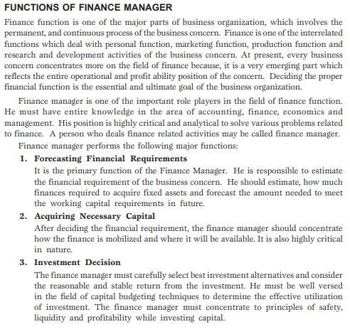

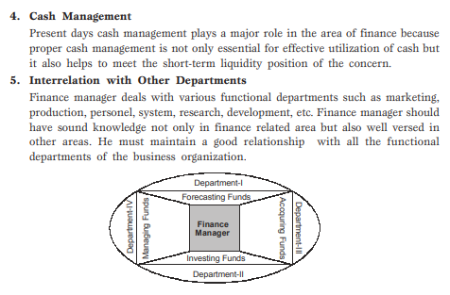

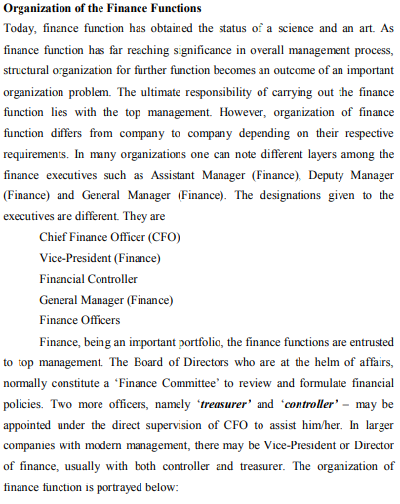

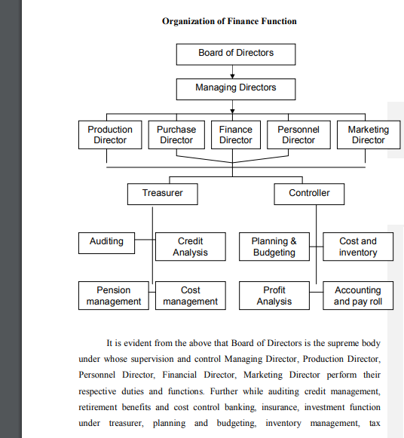

Finance Manager – Functions

* 1. Forecasting of Cash Flow. This is necessary for the successful day to day operations of the business so that it can discharge its obligations as and when they rise. In fact, it involves matching of cash inflows against outflows and the manager must forecast the sources and timing of inflows from customers and use them to pay the liability.
  2. Raising Funds: the Financial Manager has to plan for mobilising funds from different sources so that the requisite amount of funds are made available to the business enterprise to meet its requirements for short term, medium term and long term.
  3. Managing the Flow of Internal Funds: Here the Manager has to keep a track of the surplus in various bank accounts of the organisation and ensure that they are properly utilised to meet the requirements of thebusiness. This will ensure that liquidity position of the company is maintained intact with the minimum amount of external borrowings.
  4. To Facilitate Cost Control: The Financial Manager is generally the first person to recognise when the costs for the supplies or production processes are exceeding the standard costs/budgeted figures. Consequently, he can make recommendations to the top management for controlling the costs.
  5. To Facilitate Pricing of Product, Product Lines and Services: The Financial Manager can supply important information about cost changes and cost at varying levels of production and the profit margins needed to carry on the business successfully. In fact, financial manager provides tools of analysis of information in pricing decisions and contribute to the formulation of pricing policies jointly with the marketing manager.
  6. Forecasting Profits: The Financial manager is usually responsible for collecting the relevant data to make forecasts of profit levels in future.
  7. Measuring Required Return: The acceptance or rejection of an investment proposal depends on whether the expected return from the proposed investment is equal to or more than the required return. An investment project is accepted if the expected return is equal or more than the required return. Determination of required rate of return is the responsibility of the financial manager and is a part of the financing decision.
  8. Managing Assets: The function of asset management focuses on the decision-making role of the financial manager. Finance personnel meet with other officers of the firm and participate in making decisions affecting the current and future utilization of the firm's resources. As an example, managers may discuss the total amount of assets needed by thefirm to carry out its operations. They will determine the composition or a mix of assets that will help the firm best achieve its goals. They will identify ways to use existing assets more effectively and reduce waste and unwarranted expenses. The decision-making role crosses liquidity and profitability lines. Converting the idle equipment into cash improves liquidity. Reducing costs improves profitability.
  9. Managing Funds: In the management of funds, the financial manager acts as a specialised staff officer to the Chief Executive of the company. The manager is responsible for having sufficient funds for the firm to conduct its business and to pay its bills. Money must be located to finance receivables and inventories,
  10. make arrangements for the purchase of assets, and to identify the sources of long-term financing. Cash must be available to pay dividends declared by the board of directors. The management of funds has therefore, both liquidity and profitability aspects.

**Interfaces of Finance with other Business Functions**

**Marketing – Finance Interface**

The Marketing Manager takes many decisions which have a signiﬁcant impact on the proﬁtability of the ﬁrm. For example, he should have a clear understanding of the impact of the credit extended to the customers on the proﬁts of the company. Otherwise in his eagerness to meet the sales targets he is likely to extend liberal terms of credit which may put the proﬁt plans out of gear. Similarly, he should weigh the beneﬁts of keeping a large inventory of ﬁnished goods in anticipation of sales against the costs of maintaining that inventory. Other key decisions of the Marketing Manager which have ﬁnancial implications are pricing, product, promotion and advertisement, choice of product mix and distribution policy.

**Production – Finance Interface**

In any manufacturing ﬁrm, the Production Manager controls a major part of the investment in the form of equipment, materials and men. He should so organize his department that the equipments, under his control are used most productively, the inventory of work-in-process or unﬁnished goods and stores and spares is optimized and the idle time and work stoppages are minimized. If the production manager can achieve this, he would be holding the cost of the output under control and thereby help in maximizing proﬁts. He has to appreciate the fact that whereas the price at which the output can be sold is largely determined by factors external to the firm like competition, government regulations, etc. the cost of production is more amenable to his control. Similarly, he would have to make decisions regarding make or buy, buy or lease, etc. for which he has to evaluate the ﬁnancial implications before arriving at a decision.

**Top Management – Finance Interface**

The top management, which is interested in ensuring that the ﬁrm’s long-term goals are met, ﬁnds it convenient to use the ﬁnancial statements as a means for keeping itself informed of the overall effectiveness of the organization. We have so far brieﬂy reviewed the interface of ﬁnance with the non-ﬁnance functional disciplines like production, marketing, etc. Besides these, the ﬁnance function also has a strong linkage with the functions of the top management. Strategic planning and management control are two important functions of the top management. Finance function provides the basic inputs needed to undertake these activities.

With the recent liberalization of many economies, abolition of the ofﬁce of the Controller of Capital Issues who used to ﬁx issue prices beforehand and efforts of these economies towards globalization, ﬁnance managers are presently facing some new challenges as indicated below:

**Other Challenges in Financial Management**

**TreasuryOperations:**  
Short-term fund management must be more sophisticated. As finance manager, you could make speculative gains by anticipating interest rate movements.

**ForeignExchange:**  
You will have to weigh the costs and beneﬁts of transacting in foreign exchange particularly now that most of the economies are going global and the future value of the currencies is becoming difﬁcult to predict.

**FinancialStructuring:**  
An optimum mix between debt and equity will be essential. Firms will have to tailor ﬁnancial instruments to suit their and investors’ needs. Pricing of new issues is an important task for the Finance Manager’s portfolio now.

**MaintainingSharePrices:**  
In the premium equity era, ﬁrms must ensure that share prices stay healthy. You will have to devise appropriate dividend and bonus policies.

**EnsuringManagementControl:**  
Equity issues at premium mean management may lose control if it is unable to take up its share entitlements. Strategies to prevent this are vital.

