**Consume of high fat diet inhibited the NTPDase, 5’-nucleotidase and acetylcholinesterase activities in the peripheral tissues testing**

Rosilene Rodrigues Kaizera

aInstituto Federal de Educação, Ciência e Tecnologia do Rio Grande do Sul, Campus Sertão, Rodovia RS 135, Km 25, Distrito Engenheiro Luiz Englert, 99170-000, Sertão, RS, Brazil.

Corresponding author:

Rosilene Rodrigues Kaizer

Instituto Federal de Educação, Ciência e Tecnologia do Rio Grande do Sul, Campus Sertão, Distrito Engenheiro Luiz Englert, 99170-000 – Sertão, RS, Brasil. Email: [rosikaizer@gmail.com](mailto:rosikaizer@gmail.com) Fax: +55-54-3345-8086

**Abstract**

High fat consumption is a significant risk factor to development metabolic diseases, leading to establishment of chronic inflammatory responses. Atherosclerosis, is characterized for the formation of atheromatous plaque, where the platelets accumulation can promoting interruption on blood flow. This study aim was evaluate the effect of intake of high fat diets on the purinergic and cholinergic markers in peripheral tissues of rats. The rats were loaded into 4 groups and during three months received diets, as: control, saturated, saturated/unsaturated and unsaturated diets. The results show a significant inhibition of overall enzymes activities, mainly in after the long-term exposure to saturate and the saturated/unsaturated diets. The cholesterol, LDL and glucose levels were enhanced in saturated group. Moreover, the HDL level was significantly less in rats that intake saturated/unsaturated diet. The inhibition of NTPDase, increase the ATP and ADP levels that elicit the inflammatory response and the promotion of atherosclerosis. The inhibition of 5’-nucleotidase and AChE leads to an increase of the Adenosine and Acetylcoline (ACh) levels, which would be interpreted as a defense mechanism of the organism against the chronic inflammation of arteries. Thus, we can suggest that the NTPDase, 5’-nucleotidase and AChE acts as intrinsic control of atherosclerotic lesion and neuroinflammation.

**Key-words:** atherosclerosis, inflammatory response, cholesterol, purinergic, cholinergic.

**Acknowledgments**

This study was supported by CNPq, FAPERGS, CAPES, Federal University of Santa Maria, and FINEP research grant “Rede Instituto Brasileiro de Neurociência (IBN-Net)”.

**1.0 Introduction**

In nowadays, the intake of high fat diets is predominant factor to development the metabolic syndrome. The metabolic syndrome is related to several diseases, such as type 2 diabetes and cardiovascular diseases[1]. It’s known that the hypercholesterolemia is responsible for the development of ischemic heart disease, angina and myocardial infarction[2].In fact, the low-density lipoprotein is a carrier of cholesterol in the bloodstream and is associated with the promotion of atherosclerosis[3]. Atherosclerosis is a chronic inflammatory disease of arteries, related to endothelial cell activation, promoting the plaque progression and formation of atheroma, a characteristic lesion of artery endothelium[4,5].

Platelets activation has key roles in thrombus formation and hemostasis, however also demonstrated the importance in the formation of atherosclerotic lesions[6]. Models of atherosclerosis present a characteristic relation between activated platelets and leukocytes in the promotion of the atherosclerotic lesions[7]. In fact, platelets activation elicits the inflammatory response, through of the released of inflammatory and immunemodulating factors, and can be related with the promotion of several diseases[8,9]. Thus, the development of formation of the atheromatous plaque and potential rupture or the interruption of blood flow is considered crucial for the development of acute coronary syndromes and ischemic stroke[5,10].

Actually, extracellular adenine nucleotides as ATP, ADP and adenosine regulate the vascular STRUCT-250 response to endothelial injury. ADP induces the platelets aggregation and promotes the coagulation cascade (Table 1). At same time, the adenosine, product of AMP hydrolysis, is potent inhibitor acting in the regulation of platelet aggregation[11]. After regulates the platelet activation through purinergic receptors the receptor-mediated signalling is terminated (Figures 1 and 2) by the coordinated action in cascade of ecto-nucleotidases, including NTPDase (E.C. 3.6.1.5) (CD39, ecto-apyrase, ATP diphosphohydrolase) that hydrolyses ATP and ADP to AMP, which is subsequently hydrolyzed by the ecto-5’-nucleotidase Chart 1 (E.C. 3.1.3.5) in adenosine[12].

As well are known, the progression of the atheroma plaque reduces the vasal lumen altering the blood flow[5]. Interesting, cholinergic mechanisms play a role in the modulation of cerebral blood flow[13]. The enzyme Acetylcholinesterase (AChE, 3.1.1.7) is the main mechanism of controlling the cholinergic function, through the degradation of acetylcholine (ACh) in to metabolites, choline and acetate[14,15]. Moreover, AChE is found in the several tissues such as blood cells[16], and the ACh in blood has been related to immune modulation[17].

STRUCT-250 Thus, due to the fact that the ectonucleotidases as well as AChE control the levels of immunomodulatory factors, ATP, adenosine and Ach (Scheme 1), and considering that the high fat diets are related of the atherosclerotic inflammation, the aim of this study was evaluate the effect of fat diets on the purinergic and cholinergic status in peripheral tissues of rats to determine the potential of induced the neuronal inflammation and contribute to development of neurodiseases (Schemes 2, 3 and Chart 2).

**2.0 Experimental Procedures**

**2.1 Animals**

Twenty-day-old rat pups weighing 60g obtained from our breeding colony were used. The animals were maintained on a 12:12 light/dark cycle, in an air-conditioned (22 ± 1ºC) colony room, with free access to water and food, and were weighed weekly. All animal procedures were approved by the Institutional Ethical Committee of the Federal University of Santa Maria (Protocol number 23/2006).

**2.2 Materials**

Acetylthiocholine iodide, and 5,5’-dithio-bis-2-nitrobenzoic acid (DTNB) were purchased from Sigma Chemical Co (St Louis, MO, USA). All other reagents used in the experiments were of analytical grade and of the highest purity.

**2.3 Treatment**

The newly weaned rat pups were submitted to long-term exposure, three months, to the different diet high saturated and unsaturated fat. The animals were treated with five different diets: (1) the control group consumed Laboratory chow (Supra-RS, Brazil); (2) diet standard group (Std); (3) diet high in saturated fat group (Sat); (4) diet high in saturated/unsaturated fat group (Sat/Uns); (5) diet high in unsaturated fat group (Uns) (Table 1). The animals were euthanized 24h after the last meal and the blood was collected.

Protein content varied STRUCT-291 from 8.61 to 34.33 mg⋅g-1 dry wt. Among the genotypes, highly drought tolerant JDRL-4 elevated the soluble protein (34.33 mg⋅g-1 dry wt.) under drought, whereas JDSL-13 susceptible (8.61 mg⋅g-1 dry wt.) showed minimum protein content. Carried out significantly reduced protein content in drought susceptible genotypes as compared to drought tolerant genotypes in cotton subjected to drought stress and studied comparatively increase protein concentration in peanut genotypes under drought stress.

**2.4 Platelet-rich Plasma Preparation**

The platelets were prepared by the method of Pilla et al. (1996)[18], modified by Lunkes et al. (2004)[19]. Total blood was collected by cardiac punction and placed into a flask with 0.129 M sodium citrate as anticoagulant. The total blood-citrate system was centrifuged at 160 x g for 40 min to remove residual blood cells. The platelet-rich plasma (PRP) was centrifuged at 1400 x g for 20 min and washed twice by centrifugation at 1400 x g with 3.5 mmol/L HEPES isosmolar buffer containing 142 mmol/L NaCl, 2.5 mmol/L KCl, and 5.5 mmol/L glucose. The washed platelets were resuspended in HEPES isosmolar buffer and adjusted to 0.4 – 0.45 mg of protein per milliliter.

**2.5 LDH**

The integrity of the platelet preparations was confirmed by determining the lactate dehydrogenase (LDH) activity which was obtained platelet lysis with 0.1 % Triton X-100 and comparing it with that of an intact preparation, using the Labtest kit.

**2.6 Assay of NTPDase and 5’-nucleotidase activities**

Struct-255 In platelets, the determination of ectonucleotidase activities was carried out using the PRP preparation according to Pilla et al., (1996)[18]. Briefly, to determine the NTPDase activity, 20 µL of the PRP preparation (8-10 µg of protein) was added to the system mixture, which contained 5 mM CaCl2, 100 mM NaCl, 5 mM KCl, 6 mM glucose and 50 mM tris-HCl buffer, pH 7.4. The reaction was started by the addition of 20 µL of ATP or ADP (1 mM final concentration) as substrates. For AMP hydrolysis, the 5’-nucleotidase activity was determined as described above, except that 5 mM CaCl2 was replaced by 10 mM MgCl2 and the nucleotide final concentration added was 2 mM AMP18. For platelets, 20 µL of the enzyme preparation (8-10 µg of protein) was added to the reaction mixture and pre-incubated for 10 min at 37ºC STRUCT-276.

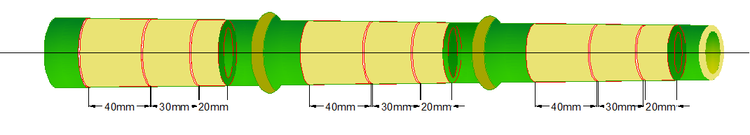

(a) Sectioning way 1 of bamboo rings.

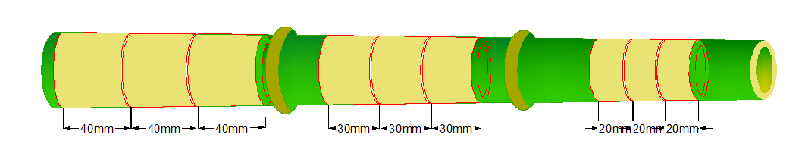

(b) Sectioning way 2 of bamboo rings.

Both reactions were stopped by the addition of 200 µL of 10% trichloroacetic acid (TCA) to provide a final concentration of 5%. After chilling on ice for 10 min, 100 µL samples were taken for assay of released inorganic phosphate (Pi) by the method of Chan et al., (1986)[20], using malachite green as the colorimetric reagent and KH2PO4 as standard. Controls were carried out by adding the platelets preparation after TCA addition to correct for non-enzymatic nucleotide hydrolysis. All samples were run in triplicate. Enzyme activities are reported as nmol Pi released/(min mg) of protein STRUCT-276.

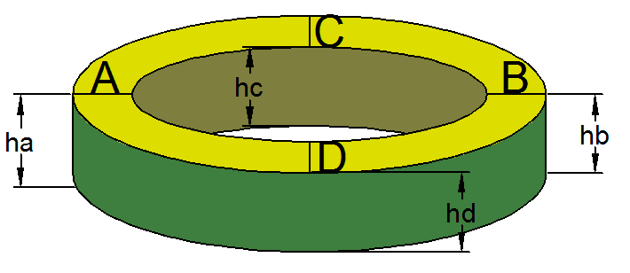

**2.7 Sample of blood collection**

The blood was collected in vaccuntainer tubes using EDTA as anticoagulant. The samples were hemolized with phosphate buffer, pH 7.4 containing Triton X -100 (0.03%) and appropriate storage.

**2.8 Determination of Erythrocyte AChE**

Erythrocyte AChE activity was determined by the modification of Ellmann´s et al. (1961)[21] method as described by Worek et al. (1999)[22]. Whole blood dilutions were prepared by adding 100 L blood to 10 mL sodium/potassium phosphate buffer (0.1 mM), pH 7.4 containing Triton X -100 (0.03%). After carefully mixed, the samples were frozen immediately and kept until analysis. The hemolizate (500 L), phosphate buffer 0.1 mM pH 7.4, DTNB (0.3 mM), and ethopropazine (0.02 mM), a selective butyrylcholinesterase (BChE) inhibitor, were pre-incubated during 10 min at 37º C. The reaction was started by the addition of substrate AcSCh (0.45 mM), and color development was measured at 436 nm.

The specific activity of erythrocyte AChE was calculated from the quotient between AChE activity and hemoglobin content, and the results were expressed as mU/ mol Hb.

**2.9 Protein determination**

Protein was measured by the Coomassie blue method according to Bradford (1976)[23] using bovine serum albumin as standard.

**3.0 Statistical analysis**

Data were analyzed by analysis of variance (One-way ANOVA) followed by the Tukey-Kramer multiple range test, and p<0.05 was considered to represent a significant difference in the analysis. All data were expressed as mean ± S.D.

**4.0 Results**

Overall, was found a significant decrease of the enzymes activities in both peripheral tissue preparations, for platelets and erythrocytes, in young rats exposed to high fat diets (Figures 1 and 2). The AChE activity in erythrocytes was decreased in 39.2% in the saturated group, in comparison to the control group. At the same time, the AChE activity was inhibited in the groups that consumed the saturated/unsaturated 24.5% and unsaturated (22.9%) diets, respectively, when compared to the control group (p<0.05) (Figure 1).

As shown the Figure 2, the ATP hydrolysis was inhibited in 58% and 68% in the rats that consumed the saturated and saturated/unsaturated diets, respectively, in comparison to the control group. For the ADP hydrolysis was observed a decreased of the 39.1% and 20% after the exposure to saturated and saturated/unsaturated diets, when compared to the control group, respectively. To 5’-nucleotidase activity, the results were consistent with the ATP and ADP hydrolysis, where was found an inhibition of the enzyme activity of the 33.1% and 21.7% in rats exposed to saturated and saturated/unsaturated diets, in comparison to the control group, respectively (Figure 2).

The mean plasma levels parameters, as hematocrit, glucose, cholesterol, cholesterol ester concentrations in lipoprotein fractions, triglycerides, creatine and urea was measured in young rats that consumed different diets (Table 2). The rats that intake saturated diet showed higher levels of cholesterol (32%), LDL-cholesterol and glucose (21%), when compared to the control group. At the same time, the rats exposed to saturated diet show a decreased in the levels of HDL-cholesterol (23%), hematocrit (13%), triglycerides (44%) and urea (36.8%), in comparison with the control group. Although the exposure to the saturated/unsaturated diet showed an enhanced of 320% in the LDL-cholesterol levels, the triglycerides was inhibited in 55.6%, both in comparison to the control group (Tables 2, 3).

**5.0 Discussion**

This study shows that the intake of high fat diets promotes alterations in plasma level parameters in young rats. In fact, the cholesterol and low-density lipoproteins (LDLs), as well as, glucose were significant higher in rats that intake saturated diet. At same time, the intake of conjugated different fats, saturated and unsaturated, shows a significant enhanced in the LDL-cholesterol levels (320%). In fact, recent studies have demonstrated the relevance of the association between the cholesterol levels and high fat diets on the neuroinflammatory response and the etiology of Alzheimer’s Disease[24, 25].

Additionally, the results obtained show the inhibition of hydrolysis of the adenine nucleotides and ACh in peripheral tissue markers of young rats exposed to high fat diets. Kaizer et al., (2008)[26], was demonstrated that the peripheral assays can contribute to determine the status of central nervous system, in this case the peripheral marker showed a similar behavior when compared to the results obtained in erythrocytes and cerebral preparations from cholinergic system (Table 4 and Figure 3). Extracellular ATP, ADP and adenosine, their product of hydrolysis, are responsible for the vascular response to endothelial injury[27]. ADP has a putative role in the control of platelets activation, so the presence of enzymes that hydrolyze this diphosphate nucleoside in blood flow is essential to controlling the platelet aggregation and thrombus formation[18].

STRUCT-262 Sections were applied for the double immunofluorescence Equation (1). The sections were placed in the oven for 1h at 37 °C, and then were blocked with solution containing 10 % normal serum Eq. (2), 3%(w/v) bovine serum albumin (BSA), 0.1% Triton X-100, and 0.05% Tween-20. After 2h incubation, the sections were incubated with primary antibodies against Vimentin(rabbit,1:50;Abcam),mouse antibody anti-NeuN(a marker of neuron, 1:200; Millipore), anti-glial fibrillary acid protein (GFAP) (a marker of astrocytes,1:200; Sigma), anti-Iba1 (a marker of microglial,1:200; Millipore). After washing with phosphate buffer solution (PBS) three times for 5 min each, corresponding secondary antibodies were added in dark room Equations (3) and (4) and incubated for 2 h at 4 °C. Finally, the sections were washed as previous and were assayed using Leica microscope (Leica, DM 5000B; Leica CTR 5000; Germany) Equation (5).

$A=πr^{2}$ (1)

${\left(x+a\right)}^{n}=\sum_{k=0}^{n}{\left({n \atop k}\right)x^{k}a^{n-k}}$ (2)

${\left(1+x\right)}^{n}=1+\frac{nx}{1!}+\frac{n\left(n-1\right)x^{2}}{2!}+…$ (3)

$a^{2}+b^{2}=c^{2}$ (4)

$\sin{α}±\sin{β}=2\sin{\frac{1}{2}\left(α±β\right)}\cos{\frac{1}{2}\left(α∓β\right)}$ (5)

In this case, the enzyme NTPDase inhibits the platelet aggregation by the hydrolysis of ATP and ADP, as also through the formation of inhibitor of aggregation metabolite adenosine, as well as through the blocking the bind to von Willebrand Factor (vWF), inhibiting the activation of platelet receptor complex glycoprotein (GP) Ib-V-IX[28]. In according to this fact, the hydrolysis of tri and diphosphate nucleoside acts as the modulator the platelet responsiveness to the prothrombotic agonist ADP, thus the NTPDase activity can be used as a potential anti-aggregatory agent, preventing the thrombotic lesions[29,30] STRUCT-261. $$x=\frac{-b±\sqrt{b^{2}-4ac}}{2a}$$

However, in this study we found an inhibition of NTPDase activity in platelets obtained from young rats after intake of high fat diets, resulting in a decreased in the ATP and ADP hydrolysis. Thus, the enhanced in the ADP levels elicit the platelet activation and the formation of thrombus. In addition, it’s known that the ATP levels are low in physiological conditions where promotes the homeostatic responses, so high extracellular ATP concentrations elicit the excessive activation of purinergic receptors in immune and non-immune cells[5,31]. The high ATP levels active the cascade of events to production of proinflammatory mediators that induced the tissue damage and the secretion of immune cells promoting the chronic STRUCT-268 inflammation[5].

 $a^{2}+b^{2}=c^{2}$ (6)

Additionally, the association between the NTPDase inhibition with the enhanced in the cholesterol, LDL-cholesterol and glucose levels, after the intake of fats diets can contributes to atheroma development STRUCT-268.

 

$x^{2}=πr^{2}$ $A=\frac{π}{2}$

The increase of plaque lesion reduces the vassal lumen interrupting the blood flow, which with the artery endothelium calcification associated to plaque progression can result in an eventual rupture of the vassal[4,32]. Moreover, considering that the cholesterol is a predominant factor to promotion of atherosclerosis and is regulated by the high-density lipoprotein (HDL), responsible to remove the excess of cholesterol into the bloodstream[5], we can suggest that the decrease of HDL levels after the long-term intake of high fat diets can accelerate the atherosclerosis.

The indentation hardness is calculated as STRUCT-258:

$σ=\frac{ P }{S}$, (7)

where *σ* is indentation hardness when it is pressed into the depth of 3 mm (MPa, precision of 0.1 MPa); *P* is the indentation load when it is pressed into the depth of 3 mm 3 mm

Given that the ACh has a recognized role as an anti-inflammatory molecule, responsible to inhibit the inflammatory process through the reduction of the lymphocyte proliferation and pro-inflammatory cytokine secretion[33,34]. It became clear that the inhibition of AChE activity support an anti-inflammatory effect, in order to increase the ACh levels and minimizing the inflammatory response. In fact, the same mechanism was observed in the increase of adenosine levels obtained through the 5’-nucleotidase activity inhibition.

There are therefore, support to the hypothesis that the high fat consumption elicit the aggregation promoting an inflammatory and prothrombogenic response, through the inhibition of NTPDase resulting to increase of extracellular ATP and ADP levels and high cholesterol levels. Additionally, the increase of ACh and adenosine levels can be interpreted as an overall protective effect against the inflammatory response and the establishment of atherosclerosis lesions. Taken together, these results demonstrated the potential use the both NTPDase and AChE, as modulators of atherosclerosis, showing the neuroprotector role of these enzymes.

**6.0 References**

1. Grundy SM (2005) A constellation of complications: the metabolic syndrome. Clin. Cornerstone., 7, 36-45.
2. Duarte MMF, Loro VL, Rocha JBT, Leal DBR, De Bem AF, Dorneles A, Morsch VM, Schetinger MRC (2007) Enzymes that hydrolyze adenine nucleotide of patients with hypercholesterolemia and inflammatory process. FEBS J., 11, 2707-2714.
3. Jamkhande PG, Chandak PG, Dhawale SC, Barde SR, Tidke PS, Sakhare RS (2014) Therapeutic approaches to drug targets in atherosclerosis. Saudi Pharm. J., 22, 179-190.
4. Hansson GK, Hermansson A (2011) The immune system in atherosclerosis. Nat. Immunol., 12, 204-212.
5. Ferrari D, Vitiello L, Idzko M, la Sala A (2015) Purinergic signaling in atherosclerosis. Trends Mol. Med., 21, 184-192.
6. Jarre A, Gowert NS, Donner L, Münzer P, Klier M, Borst O, Schaller M, Lang F, Korth C, Elvers M (2014) Pre-activated blood platelets and a pro-thrombotic phenotype in APP23 mice modeling Alzheimer’s disease. Cell. Signal., 26, 2040-2050.
7. Burger PC, Wagner DD (2003) Platelet P-selectin facilitates atherosclerotic lesion development. Blood., 101, 2661-2666.
8. Bergmeier W, Wagner DD (2007), Inflammation, in: Platelets (Second Edition), pp., 713-725.
9. Mezouar S, Frère C, Darbousset R, Mege D, Crescence L, Dignat-George F, Panicot-Dubois L, Dubois C (2016) Role of platelets in cancer and cancer-associated thrombosis: Experimental and clinical evidences. Thromb. Res., 139, 65-76.
10. Meiklejohn DJ, Vickers MA, Morrison ER, Dijkhuisen R, Moore I, Urbaniak SJ, Greaves M (2001) In vivo platelet activation in atherothrombotic stroke is not determined by polymorphisms of human platelet glycoprotein IIIa or Ib. Br. J. Haematol., 112, 621–631.
11. Birk AV, Bubman D, Broekman MJ, Robertson HD, Drosopoulos FHF, Marcus AJ, Szeto HH (2002) Role of a novel soluble nucleotide phophohydrolase from sheep plasma in inhibition of platelet reactivity., J Lab Clin Med., 139, 116-124.
12. Zimmermann H (2000) Extracellular metabolism of ATP and other nucleotides. Naunyn-Schmeidebergs Arch. Pharmacol., 362, 299-309.
13. Sato A, Sato Y, Uchida S (2001) Regulation of regional cerebral blood flow by cholinergic fibers originating in the basal forebrain. Int. J. Dev. Neurosci., 19, 327-337.
14. Appleyard ME (1992) Secreted acetylcholinesterase: non-classical aspects of a classical enzyme. Trends Neurosci., 15, 485–90.
15. Tayebati SK, El-Assouad D, Ricci A, Amenta F (2002) Immunological and immunocytochemical characterization of cholinergic markers in human peripheral blood lymphocytes, J. Neuroimmunol., 132,147–155.
16. Paleari L, Grozio A, Cesario A, Russo P (2008) The cholinergic system and cancer. Semin. Cancer Biol., 18, 211–7.
17. Brenner T, Nizri E, Irony-Tur-Sinai M, Hamra-Amitay Y, Wirguin I (2008) Acetylcholinesterase inhibitors and cholinergic modulation in Myasthenia Gravis and neuroin- flammation. J. Neuroimmunol., 201–202:121–127.
18. Pilla C, Emanuelli T, Frasetto SS, Battastini AMO, Dias RD, Sarkis JJF (1996) ATP diphosphohydrolase activity (apyrase E.C. 3.6.1.5) in human blood platelets. Platelets., 7, 225-230.
19. Lunkes GIL, Lunkes DS, Morsch VM, Mazzanti CM, Morsch ALB, Miron VR, Schetinger MRC (2004) NTPDase and 5’-nucleotidase activities in rats with allozan-induced diabetes. Diabetes Res. Clin. Pract., 65, 1-6.
20. Chan K, Delfert D, Junger KD (1986) A direct colorimetric assay for Ca2+-ATPase activity. Anal. Biochem., 157, 375-380.
21. Ellman GL, Courtney DK, Andres V, Feather-Stone RM (1961) A new and rapid colorimetric determination of acetylcholinesterase activity. Biochem. Pharmacol., 7, 88-95.
22. Worek F, Mast U, Kiderlen D, Diepold C, Eyer P (1999) Improved determination of acetylcholinesterase activity in human whole blood. Clin. Chim. Acta, 288, 73-90.
23. Bradford MM (1976) A rapid and sensitive methodfor the quantification of microgram quantities of protein utilizing the principle of protein-dye binding. Anal. Biochem., 72, 218-254.
24. Husain I, Akhtar M, Vohora D, Abdin MZ, Islamuddin M, Akhtar MJ, Najmi AK (2017) Rosuvastatin attenuates high-salt and cholesterol diet induced neuroinflammation and cognitive impairment via preventing nuclear factor KappaB pathway. Neurochem. Res. doi: 10.1007/s11064-017-2264-2.
25. Kaizer RR, Spanevello RM, Costa E, Morsch VM, Schetinger MRC (2017) Effect of high fat diets on the NTPDase, 5’-nucleotidase and acetylcholinesterase activities in the central nervous system. Int. J. Dev. Neurosci. doi: 10.1016/j.ijdevneu.2017.02.007.
26. Kaizer RR, Corrêa MC, Gris LRS, da Rosa CS, Bohrer D, Morsch VM, Schetinger MRC (2008) Effect of Long-Term Exposure to Aluminum on the Acetylcholinesterase Activity in the Central Nervous System and Erythrocytes. Neurochem. Res., 33, 2294-2301.
27. Schetinger MRC, Morsch VM, Bonan CD, Wyse ATS (2007) NTPDase and 5’-nucleotidase activities in physiological and disease conditions: New perspectives for human health. BioFactors 31, 77-98.
28. Varga-Szabo D, Pleines I, Nieswandt B (2008) Cell adhesion mechanisms in platelets. Atherioscler. Thromb. Vasc. Biol., 28, 403-412.
29. Marcus AJ, Broekman MJ, Pinsky DJ (2002) COX inhibitors and thrombo-regulation. N. Engl. J. Med. 347, 1025-6.
30. Marcus AJ, Broekman MJ, Drosopoulos JHF, Islam N, Pinsky DJ, Sesti C, Levi R (2003) Heterologous cell-cell interactions: thromboregulation, cerebroprotection and cardioprotection by CD39 (NTPDase-1). J Thromb Haemost., 1, 2497-2509.
31. Horvat A, Stanojevic I, Drakulic D, Velickovic N, Petrovic S, Milosevic M (2010) Effect of acute stress on NTPDase and 5’-nucleotidase activities in brain synaptosomes in different stages of development. Int. J. Devel. Neurosc., 28, 175-182.
32. Ross R (1999) Mechanisms of disease: atherosclerosis – an inflammatory disease. N. Engl. J. Med., 340, 115-126.
33. Nizri E, Hamra-Amitay Y, Sicsic C, Lavon I, Brenner T (2006) Anti-inflammatory properties of cholinergic up-regulation: a new role for acetylcholinesterase inhibitors, Neuropharmacology, 50, 540–547.
34. Tonin AA, Calado AM, Bottari NB, Dalenogare D, Thomé GR, Duarte T, Duarte MM, Morsch VM, Schetinger MR, Alves LC, Tinucci-Costa M, Da Silva AS (2016) Novel markers of inflammatory response and hepatic dysfunction in canine leishmaniasis STRUCT-271, Comp. Immunol. Microbiol. Infect. Dis., 44, 61-64.

.

.

Figure Captions

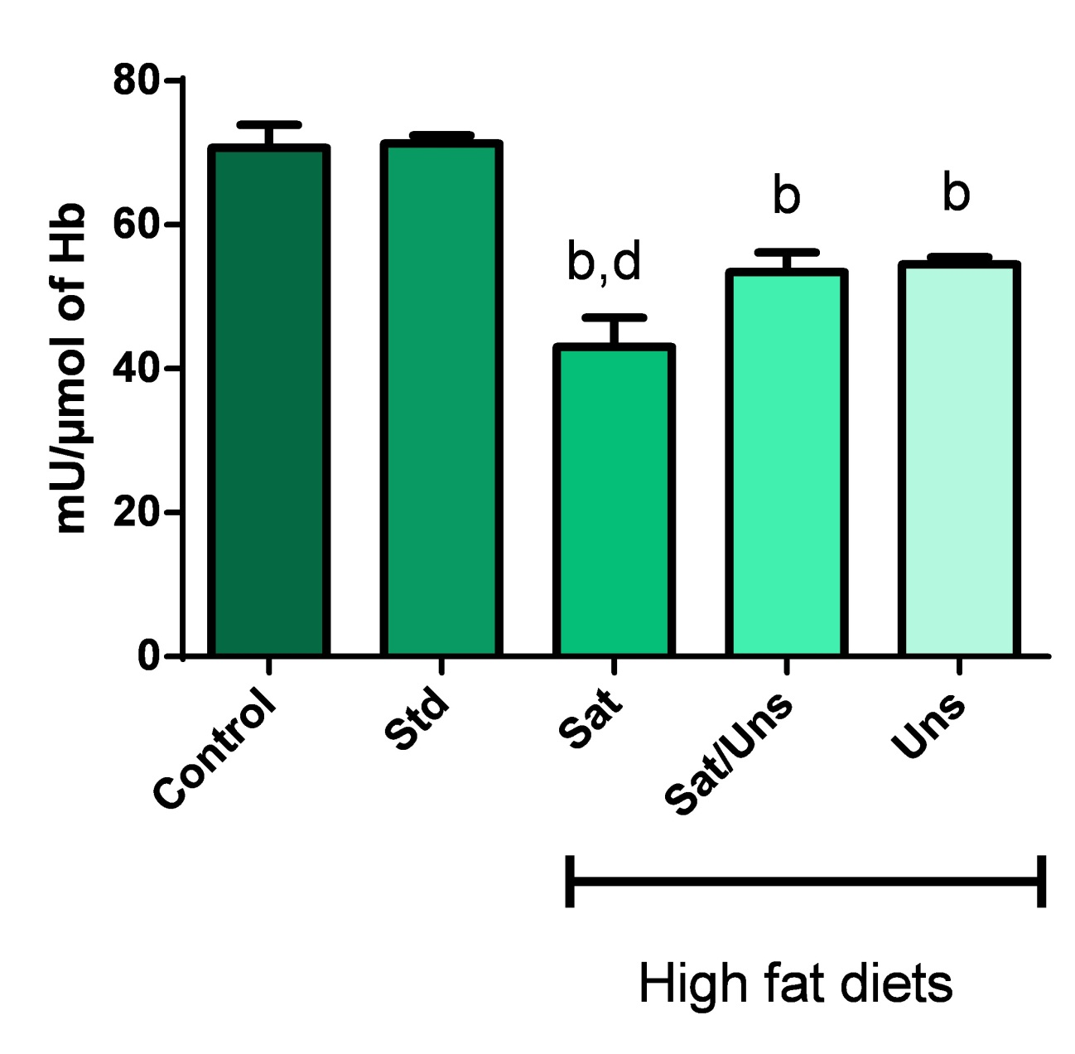

**Figure 1**: Effect of different diets in AChE activity in erythrocytes of young rats STRUCT-245. Each column represents mean ± S.D. (n=5) as percent of control. AChE control value for erythrocytes was 18.68 ± 1.03, respectively, and was expressed as mU/µmol of Hb. bDifferent from the control and standard groups. dDifferent from the unsaturated group. ANOVA – Tukey-Kramer’s Test.

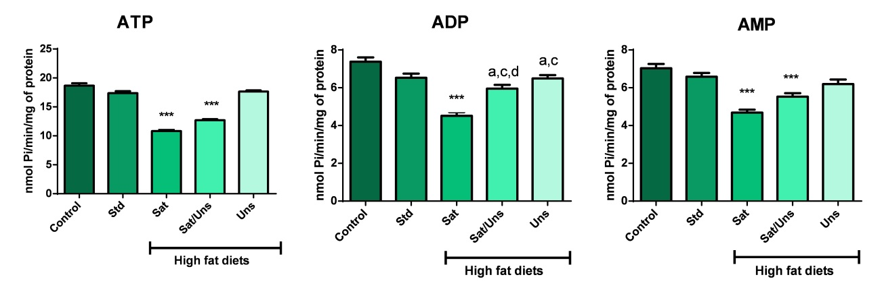

**Figure 2**: ATP, ADP and AMP hydrolysis in platelets of young STRUCT-245 rats exposed to different diets.  
Each column represents mean ± S.D. (n=5) as percent of control. ATP, ADP and AMP hydrolysis control values for platelets were 18.68 ± 1.03, 7.37 ± 0.56 and 7.03 ± 0.55, respectively, were expressed as nmol Pi/min/mg protein. *** Different from the all groups (p<0.05). aDifferent from the control group. cDifferent from the saturated group. ANOVA – Tukey-Kramer’s Test (Adapted from Wilhelm M (2014) Atrial fibrillation in endurance athletes. Eur J Prev Cardiol 21:1040–8. doi: 10.1177/2047487313476414).



**Figure 3.** The parallel diagram depicts development of LV-EDV from baseline to follow-up over five years. LV volumes did not change significantly in the follow-up period STRUCT-275.

*LV-EDV: left ventricular end-diastolic volume*

The parallel diagram depicts development of LV-MM from baseline to follow-up. 17 of 18 athletes had an increase of LV-MM. In the subgroup analysis, mean LV-MM differences between baseline and follow-up for athletes with constant or higher training volume was 17.8 ± 3 g, and for athletes with decreased training volume it was 11.2 ± 5 g.

Table Captions

**Table 1:** Athletes’ characteristics and physical examination

|  |  |  |
| --- | --- | --- |
| **Parameter** | **Baseline** | **Follow-up** |
| Age (years) | 37.7 ± 12 [19; 60] | 42.7 ± 13 [23; 65] |
| Weight (kg) | 69.9 ± 9 [50; 82] | 70.3 ± 9 [47; 84] |
| Height (cm) | 176 ± 9 [159; 198] | 176 ± 9 [159; 198] |
| Body surface area (m²) | 1.8 ± 0.2 [1.5; 2.1] | 1.9 ± 0.2 [1.4; 2.1] |
| Total training years (years) | 8.6 ± 4 [4; 20] | 13.7 ± 4 [9; 26] |
| Training volume/week (h) | 14.5 ± 4 [8; 25] | 13.3 ± 4 [5; 19] |
| Lifetime training hours   * total * follow-up period | 7002 ± 5414 [3120; 26000] | 10461 ± 6121 [4940; 30680]  3460 ± 1170 [1300; 5928] |
| NT-proBNP (ng/l) | 39.6 ± 29 [19.9; 138] | 40.1 ± 32 [19.9; 146] |
| VO2max (ml/kg/min) | 58.4 ± 8 [40; 69] | 57.2 ± 9 [41; 72] |
| AnT |  |  |
| * treadmill (km/h) | 14.1 ± 2 [11.4; 17.5] | 13.3 ± 2 [10.8; 17.6] |
| * bicycle ergometer (W/kg body weight) | 3.1 ± 0.7 [2.1; 3.6] | 3.1 ± 0.7 [2.1; 3.6] |

Table 2: Plasma, Glucose, Cholesterol, Cholesterol Ester concentrations in Lipoprotein Fractions, Triglycerides, Creatine and Urea in young rats exposed to High Fat Diets STRUCT-289 and STRUCT-283.

|  |  |  |  |  |  |
| --- | --- | --- | --- | --- | --- |
|  | **Groups** | | | | |
| **Control** | **Standard** | **Saturated** | **Sat/Uns** | **Unsaturated** |
| **Cholesterol** | 81,8 ± 5,0 | 84,5 ± 5,4 | 108,0 ± 13,3 b | 94,3 ± 9,8 | 61,3 ± 13,0 *** |
| **HDL-cholesterol** | 53,7 ± 3,0 | 60,2 ± 4,9 | 41,5 ± 1,5 *** | 50,5 ± 3,7 | 53,8 ± 4,9 |
| **LDL-cholesterol** | 8,8 ± 4,4 | 10,8 ± 4,9 | 46,2 ± 1,9 *** | 37,0 ± 8,1 *** | 4,3 ± 1,1 |
| **Triglycerides** | 105,8 ± 7,4 | 118,2 ± 35,4 a | 59,3 ± 24,3 b | 47,0 ± 8,3 b | 50,2 ± 10,9 b |
| **Glucose** | 105,2 ± 7,5 | 103,3 ± 3,8 | 127,3 ± 11,2 | 112,2 ± 18,4 | 93,7 ± 2,9 |
| **Hematocrit** | 47,5 ± 1,6 | 41,5 ± 1,3 a | 41,3 ± 1,2 a | 47,0 ± 1,3 b,c | 49,0 ± 2,7 b,c |
| **Creatine** | 0,62 ± 0,1 | 0,64 ± 0,2 | 0,74 ± 0,1 | 0,60 ± 0,1 | 0,54 ± 0,1 |
| **Urea** | 35,3 ± 8,2 | 22,3 ± 2,2 a,c | 32,2 ± 5,7 | 27,2 ± 1,3 | 27,6 ± 0,9 |

Mean values ± standard deviation and [range] in square brackets. To avoid type I error accumulation in multiple testing, only seven selected tests and Bonferroni correction (*α loc =* 0.007) were performed.Descriptive statistic was applied for all data with no p-value given.

Table 3. GO functional enrichment for target genes involved in neuron or brain development.

|  |  |  |
| --- | --- | --- |
| GO: term | Count | Target genes |
| GO:0048812-neuron projection morphogenesis | 18 | IGF1R//NTN1//NUMBL//ULK1//SLITRK4//NRN1//NEUROG2//CHL1//EPHA5//KIF5A//UNC5C//MAPK8IP3//FOXB1//FOXG1//VEGFA//VIM//WEE1//CNTNAP1// |
| GO:0048699-generation of neurons | 31 | NEUROG2//CHL1//NTN1//PRKG1//FOXG1//VEGFA// NUMBL//IGF1R//ULK1//SLITRK4//NRN1//EPHA5//KIF5A//UNC5C//MAPK8IP3//FOXB1//SKI//FGFR1//VIM//STRN//LEF1//LHX8//CNTNAP1//JAG1//DPYSL2//PBX1//MYCN//TNFRSF21//WEE1//SIRT2//VLDLR// |

|  |  |  |
| --- | --- | --- |
| GO: term | Count | Target genes |
| GO:0031175-neuron projection development | 22 | IGF1R//NTN1//NUMBL//ULK1//SLITRK4//NRN1//NEUROG2//CHL1//EPHA5//KIF5A//UNC5C//MAPK8IP3//FOXB1//FGFR1//VIM//FOXG1//PRKG1//STRN//WEE1//CNTNAP1//VEGFA//VLDLR// |
| GO:0030182-neuron differentiation | 27 | IGF1R//NTN1//NUMBL//ULK1//SLITRK4//NRN1//NEUROG2//CHL1//EPHA5//KIF5A//UNC5C//MAPK8IP3//FOXB1//FGFR1//VIM// FOXG1//PRKG1//STRN//LEF1//LHX8//CNTNAP1//VEGFA//JAG1//DPYSL2//PBX1//WEE1//VLDLR// |
| GO:0097485-neuron projection guidance | 9 | NEUROG2//CHL1//EPHA5//KIF5A//NTN1//UNC5C//MAPK8IP3//FOXG1//VEGFA/ |
| GO:0007420-brain development | 16 | LEF1//NUMBL//ULK1//EPHA5//FOXB1//FGFR1//SKI//FOXG1//LHX8//NEUROG2//E2F1//PRKG1//MAPK8IP3//ABR//IGF1R//UNC5C |

|  |  |  |  |
| --- | --- | --- | --- |
| **Procedural details** | | | |
| Pre-dilatation balloon parameter | | | |
| Non-compliant balloon | 4 (67%) | 12 (52%) | 0.44 |
| Cutting balloon | 2 (33%) | 17 (74%) | 0.09 |
| Balloon diameter, mm | 2.7 ± 0.4 | 3.0 ± 0.6 | 0.08 |
| Max inflation pressure, atm | 19.3 ± 1.6 | 17.4 ± 3.8 | 0.42 |
| PCB parameter | | | |
| PCB length, mm | 20.0 ± 6.1 | 18.2 ± 4.3 | 0.45 |
| PCB diameter, mm | 2.8 ± 0.5 | 3.0 ± 0.6 | 0.46 |
| PCB inflation pressure, atm | 10.0 ± 1.4 | 11.5 ± 2.2 | 0.17 |

|  |  |  |
| --- | --- | --- |
| Stenosis, % | 5.17 ± 8.16 | 0.22 |
| Lumen volume, mm3 | 71.43 ± 38.51 | 0.17 |
| Lumen perimeter, mm2 | 190.07 ± 61.12 | 0.13 |
| THS, mm2 | 3.03 ± 2.13 | 0.001 |
| %THS, % | 1.52 ± 0.80 | 0.001 |

Values are expressed as n (%) or the mean ± standard deviation.

Table 4: GO functional enrichment for target genes involved in neuron (adapted from Bland JM, Altman DG (1995) Multiple significance tests: the Bonferroni method. BMJ 310:170.).



CABG: coronary artery bypass graft, Chronic kidney disease: estimated glomerular filtration rate < 60 ml/min/1.73m², PCB: paclitaxel-coated balloon.

**Schemes**



**Scheme 1**: Effect of different STRUCT-245 diets in AChE activity in erythrocytes of young rats. Each column represents mean ± S.D. (n=5) as percent of control.



**Scheme 2**: Effect of different diets in STRUCT-245 AChE activity in erythrocytes of young rats. Each column represents mean ± S.D. (n=5) as percent of control.



**Scheme 3**: Effect of different diets in AChE activity STRUCT-245 in erythrocytes of young rats. Each column represents mean ± S.D. (n=5) as percent of control.

**Charts**



**Chart 1**: Effect of different diets in AChE activity in erythrocytes of young rats. Each column represents mean ± S.D. (n=5) as percent of control STRUCT-245.



**Chart 2**: Effect of different diets in AChE activity in erythrocytes of young rats. Each Colour coordinates *L\**, and *a\** versus *b\**, of 21 tropical () and 2 reference () woods STRUCT-290 & Struct-272.