Golden Dragon
GD Star Rating
WordPress Rating Plug-in User Guide

Plugin Version: 1.0.5
Release Date: 4.december 2008.

Written by: Milan Petrovic

Official Blog: http://wp.gdragon.info/
Plugin Page: http://wp.gdragon.info/plugins/gd-star-rating/
Support Forum: http://forum.gdragon.info/viewforum.php?f=9
Google Code Development: http://code.google.com/p/gd-star-rating/
Google Groups Discussion: http://groups.google.com/group/gd-star-rating
Support Email: starrating@gdragon.info
Table Of Contents
Introduction 5
Requirements 5
Features 5
Planned Features 5
Included Translations 5
Included Graphics 6
Stars Styles 6
Supported stars sizes: 6
Included stars styles 6
Trend Icons 6
Included icons 6
Rating Types 7
Implemented: 7
To be implemented: 7
Setting Debug Enviroment 8
Using The Plugin 9
Intro 9
Rating block 9
Rating Header 9
Stars 9
Rating Text 9
Rendering of rating block 9
Automatic rendering 9
Shortcode rendering 10
Function in theme template file rendering 10
Post/Page Edit: Sidebar Widget 10
Widgets 11
GD Star Rating 11
Main Options 11
Trend 11
Filter 11
Template 12
GD Blog Rating 12
Shortcodes 13
Shortcode: STARREVIEW 13
Shortcode: STARRATER / STARRATINGBLOCK 13
Shortcode: STARRATING 13
Using manual functions 14
wp_gdsr_render_article 14
wp_gdsr_render_comment 14
wp_gdsr_render_review 14
wp_gdsr_render_widget 14
wp_gdsr_rating_text_article 15
wp_gdsr_blog_rating 15
wp_gdsr_new_comment_review 15
wp_gdsr_show_comment_review 15
wp_gdsr_show_article_review 16
wp_gdsr_show_article_rating 16
Theme Integration 17
Comment Review Rating 17
Expanding comment form 17
Displaying rating with comments 17
WordPress 2.7 17
Articles Panel 18
Users 19
IP’s 20
Ban New IP’s 20
Ban Single IP’s 20
Ban IP Range 20
Ban IP Masked 20
Banned 20
Tools 21
Stars and Trends Graphics 21
Database Cleanup 21
Date Based Post Locking 21
Global Voting Rules Update 21
Plugin Settings 22
General 22
Administration Settings 22
Administration Panel 22
Plugin Features 22
Integrate 23
Widgets 23
Post Edit 23
Comment Edit 23
Articles Rating (Posts and Pages) 23
Rating 23
Restrict 23
Vote Waiting Message 24
Review 24
Comments Rating 24
Review 24
Statistics 25
Trend Calculations 25
Bayesian Estimate Mean 25
Preview 25
Templates 26
Template Elements 26
Articles (Posts and Pages) 26
Comments 26
Advanced Features 27
Moderation 27
Vote Rules 27
Time Restrictions 27
Graphics Sets 28
Stars 28
Trends 28
Appendix 30
1. Elements for StarRating shortcode, manual function & Widget 30
2. Custom Template Elements 31
3. Post/Page Template Elements 31
4. Comments Template Elements 31
5. Time Restrictions 31
1. Remaining elements 31
2. Total remaining elements 32
3. Date elements 32
User Guide Changelog 33

Introduction
GD Star Rating is WordPress plugin that can be used to add rating capabilities to posts, pages and comments on your blog. But, there is a lot more to this plugin compared to any other similar plugin.

Requirements
Plugin is developed and tested only for WordPress 2.5.0 or newer. There is no plan to add support for older versions. Current WordPress 2.6 is also supported, but some of the features could be a problem. As long as you don’t change location of your wp-content folder, things will work just fine. If you move this folder, then tinyMCE3 editor button will not work, and you must created shortcode manually.

Features
The following list contains full list of features:
- Rating of posts and pages
- Rating of comments
- Review Rating
- AJAX voting
- IP Banning
- Voting rules on post/page base
- Moderation of votes on post/page base
- Different star styles and sizes
- Separate saving of voting data for registered users and regular visitors
- Logging of each vote
- Saving cookies with votes
- Calculation of voting trend data for each post, page and comment
- Rating multi instance support widget
- WordPress shortcode support
- WordPress editor button and tinyMCE3 plugin for shortcode
- Multi language support
- Setting number of stars for voting (up to 20)
- Control Panel
- Manual placement functions of the rating code
- Category support for posts
- User Guide

Planned Features
Beside the implemented (or in work) features, there are still some things that will be added later:
- Widget for comments votes
- New methods of rating

Included Translations
- English
- Serbian
- Spanish
- French

Included Graphics

Stars Styles
Each stars style comes in different sizes.

Supported stars sizes:
Currently 4 sizes are supported:
- Mini: 12px
- Small: 20px
- Medium: 30px
- Big: 46px

Included stars styles
Stars can be in PNG, JPG or GIF format. PNG can be with full transparency (32bit PNG). GIF supports only 1 bit for transparency, just like 8bit PNG.
- Oxygen (32bit PNG)
- Crystal (32bit PNG)
- Darkness (32bit PNG)
- Starscape (32bit PNG)
- Soft (32bit PNG)
- Pumpkin (32bit PNG)

Additional sets can be downloaded from official blog download page.

Trend Icons
Trend icons are used to represent post rating and voting trends. Each set has three icons for rise, fall and no change. Trend icons have no preset sizes, but included will be 16x16 px.

Included icons
Icons types are the same as for the stars.
- Fam Fam Fam (32bit PNG)
- Fam Fam Fam Arrows (32bit PNG)
- Fam Fam Fam Mini (32bit PNG)
Additional sets can be downloaded from official blog download page.

Rating Types
Currently plugin supports 3 types of ratings, and 3 more will be implement in the future.

Implemented:
- Article Rating (Posts and Pages): This is the main type of rating. It’s used on posts and pages (articles from now on). One article can have one rating. Rating is recorded for users (registered blog users logged in) and visitors (not logged in).
- Article Review Rating: Review rating is no-votes rating. Rating is set only through admin panel (plugins control pages) or on edit screen for each post or page (sidebar control). This value represents rating added by the article author or editor.
- Comments Rating: This is the rating for comments. Each comment can have rating block active. Rules for comments are not per comment but per post. So, all comments for one post have the same rules.
- Comments Review Rating: This is single rating value added by the comment author and is not connected to any other rating value. With this author can rate the post. This type of rating needs to be integrated into the theme.

To be implemented:
- Multiple Rating (v1.1.0)
- Recommend Article Rating (v1.2.0)
- Recommend Comments Rating (v1.2.0)

Setting Debug Enviroment
In some cases, there are some very strange bugs that are very hard to reproduce. The only way to find this bugs and fix them, is to see what happens on the backend and what queries are executed against the database. So, if you have such bug, you can enable and set debugging, and when the problem occurs, you need to send me debug file so I can check the queries and whatever happens with the plugin
Plugin has built in class and function for easier debugging of the live blog. Debug system needs one writeable text file, and it needs to be activated from Settings panels’ general tab. So, here are the step by step instructions for that:
- Create empty text file anywhere on your server. Path to that file must be accessible by web server. If you use Windows, you can set this file wherever you want. And if you name your file debug.txt, than path could be c:\debug.txt. On Linux servers things are slightly different, but more or less the same. Easiest is to create this debug file in wordpress installation wp-content folder.
- This file must be writeable. On Windows this is default behavior, but on Linux servers you need to set access rights.
- Change plugin config file gd-star-config.php, and on line 11 for define command set the value for STARRATING_LOG_PATH to the path of your debug file.
- Enable debug from the settings panel. On the general tab you have Debugging section, and you need to check only checkbox there.
If everything is set right, debug file will start filling with debug data. If not, then file is either non writeable or you have set path wrong.
You can send me debug file once the error you have encountered occurs and I will try to fix the problem. You can send this file to my email address.
Notice:
Blog performance could be lowered when the debug mode is active, so don't leave it active too long, only when you are sure that you have found the bug, and you try to reproduce it so the file can get the necessary data to fix the bug.

Using The Plugin
I will try to explain in details how the plugin works and how you can use it and set it to fit your needs.

Intro
When you first install plugin it should work right away and it should display stars for all posts/pages and comments. Rating displayed with both comments and posts/pages basically looks the same, but it can be set differently, so the rating for comments and articles can have different number of stars, different styles, text and anything else.


Rating block
The rating block you see is called exactly like that RATING BLOCK. Here is the example of how typical block looks like:

Rating Header
In the above picture, rating header is a text: “Please, rate this post:” This is the text, always rendered above the stars. You can add custom CSS class to this element, and you can change its position, color and other properties. Rating text supports html markup.

Stars
This is the main part of the rating block and contains the actual stars. All visitors will see current rating displayed by the block, and if the visitor/user can vote, then when hovers over the stars, a new (usually red) stars will appear as a selected rating. When visitor/user clicks on the desired rating value, vote is recorded by the plugin.

Rating Text
Third part of the block is a description of current rating, and this text supports templates to format it. Also, this text can be rendered left, right, top or bottom to the stars. How the templates work, we will see later. Rating text, like header supports adding custom CSS class.

Rendering of rating block
For rating block to appear, plugin must know where to render it. There are three types of rendering stars:

Automatic rendering
This rendering is controlled by the plugin, and is more or less the same for articles and comments. With this, block is always rendered at the end of the article or comment.
For article, plugin can insert rating code in individual posts or pages, for posts in the archives and on the front page. This is controlled on the settings page in the admin control panel. By default all 4 options are checked and active. For comments this is much simpler, and either rating is rendered automatically or is not.
For comments, rating block can be inserted only at the end of the comment. This is controlled by the setting in the control panel comments tab.

Shortcode rendering
If you don’t like where the rating block is placed automatically by the plugin, you can turn off these options and you can add shortcode in your posts, and with that you can determine the place where plugin places the block.
Shortcodes for this are [STARRATER] or [STARRATINGBLOCK].
Shortcode rendering can’t be used for comments.

Function in theme template file rendering
This last method is here for the theme designers or advanced user and this method requires changes to the theme files and calling the function that will render the block. It’s very important that this call must be made from inside the post/page loop. Function name for this: wp_gdsr_render_article().
For comments function name is: wp_gdsr_render_comment().
If you don’t use any of this, then the rating block and stars will not be rendered. You can even have multiple rating blocks in the same article, but they will act the same, so there is no point in that.

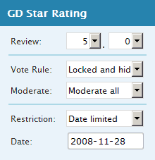
Post/Page Edit: Sidebar Widget
For each post or page, WordPress edit page have sidebar widget with rating/review settings for that post or page.
You can set review, vote and moderation rules and time restrictions for voting.
If you are creating new post, default values from settings will be used to fill in the widget controls.

Widgets
Currently there is only one widget that can be used to display rating data.

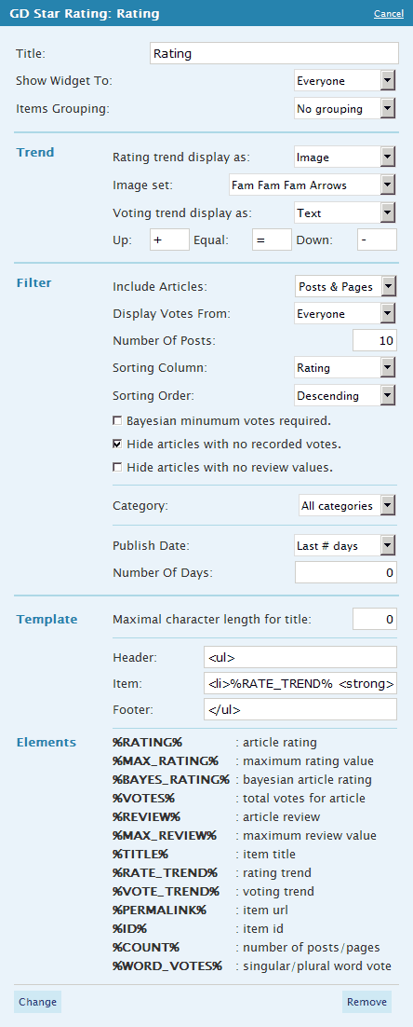
GD Star Rating
This widget can be used to display top rated posts and pages. But there is a lot more to this widget, large number of options you can set. Widget supports multiple instances, so you can have more than one in sidebars with different settings. Also, widget supports template output, and you can set it to look any way you want using lists, tables or anything else.
Settings for a widget are divided into several collapsible groups. Some of the options are depending on some other options, and you need to experiment for a while until you find the combination of features that will render widget the way you need it.

Main Options
Main options include title for the widget, display and grouping. Display can be used to show widget to only visitors or only to logged users. Grouping option is interesting feature allowing you to display ratings on user or category basis.
If you choose user grouping, widget will display users rather than posts, and rating will be average rating for all posts from that user. This way you can rank post authors by the rating of their articles. If you choose category grouping, widget will display categories, and average rating for all posts in that category.

Trend
This group contains options for setting the render style for the trend. Plugin can calculate voting and rating trends, and they can be displayed using text or using images. You can select here what you prefer. If you select text, you can set each trend element, and if you select image you can select image set you want to use. Trend parameters can be set on the Settings page, Statistics tab.

Filter
Filter options include various filter that can help you narrow down post you want to show using categories, dates and other criteria, and also by setting sorting options. Filter is mostly self explanatory, but I want to go in more details in filtering using the post publish date.
Publish date have 3 types of date filtering:
- Last # days: Only articles published in last number of days will be used. Number of days is inserted in input box. If you set this to 0, than all articles will be used.
- Exact month: select moth you want, and only articles from that month will be displayed
- Date range: set the range of dates, and all dates within the range will be used.

Template
You can limit the length of title if you want to fit the list better in the space you have available. You can set 3 elements for template. Header and footer will be rendered only once, on top and bottom of the widget and they can’t include any template elements. Item is a template used for rendering of each result record. This part can contain different template elements. Full list is in Appendix 2 and Appendix 3.

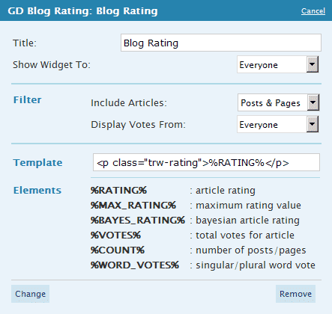
GD Blog Rating
This widget calculated total rating for the blog and all the posts are considered. You can set what values should be used and template to render the widget.
Default template uses some predefined CSS classes, but you can use whatever you want here.

Shortcodes
Current version has only one shortcode implemented. Bellow you can see shortcode details and all options for the shortcode explained.

Shortcode: STARREVIEW
This shortcode is used to render post review rating stars. This shortcode has no attributes.

Shortcode: STARRATER / STARRATINGBLOCK
This shortcode is used to render rating stars for the post or page in custom location. This shortcode has no attributes.

Shortcode: STARRATING
This shortcode is used to render table with voting summary for post and/or pages. It has a lot of attributes that can be used to make table look exactly the way you want it. Best way to add shortcode is to use visual editor integrated plugin. Plugin is represented by red star button. Depending on the selected options, plugin will generate shortcode with all necessary parameters.
If you want to create shortcode by yourself, it's important to know that if you omit some of the parameters, default value for that parameter will be used. The list of all parameters and their default values is in the table in Appendix 1.
This shortcode also supports template rendering, but for now there can be only one template stored, and the template can't be passed as a parameter for a shortcode, because that will cause too much complications to store and to parse it in the post where you add shortcode. But, for that one template you can use pretty much all the template elements as you can use for the widget, plus some more. You can use template elements from Appendix 2 and Appendix 3.

Using manual functions
Automatic rendering is controlled by plugin. But in many cases you might need to do things 'your own way'. For this I have created few functions, and more will come. These functions are similar to the shortcode use.
All function cans return string with rendered values, or they can echo rendered values. Default is to use render. This is the last parameter for each call.

wp_gdsr_render_article
Renders rating stars block for posts and pages
This method will display rendering stars for post or page. This must be used in a post loop or will not work. This is the same as using STARRATER shortcode.

Parameters:
$echo: set to true and plugin will echo the result, if set to false plugin will return the result.

wp_gdsr_render_comment
Renders rating stars block for comments
This method will display rendering stars for comment. This must be used in a comment loop or will not work. This is the same as using STARRATERCOMMENT shortcode.

Parameters:
$echo: set to true and plugin will echo the result, if set to false plugin will return the result.

wp_gdsr_render_review
Renders posts and pages review stars
This method will render stars for post review rating. This is the same as using STARREVIEW shortcode. Function has no parameters.

Parameters:
$echo: set to true and plugin will echo the result, if set to false plugin will return the result.

wp_gdsr_render_widget
Renders content like the sidebar widget does
This method will render widget like content. This method requires a number of parameters. If no parameters are passed, then the default widget parameters will be used. Parameters are in the form of array. For rendering items you can specify exact template you want to use for header of the widget, each item and footer. Template strings can be HTML encoded or not. For this use, I recommend decoded HTML strings.
Template can contain specific strings that will be replaced with actual values (hence the template). $widget parameter is an associative array with exactly the same elements as for the StarRating shortcode. Full list is in Appendix 1.

Parameters:
$widget: associative array with settings.
$echo: set to true and plugin will echo the result, if set to false plugin will return the result.

wp_gdsr_rating_text_article
Renders only rating text for posts and pages
This function will render only star rating text of rating block. You can't use it to vote, but only to display votes and rating. Optional parameter $cls can be used to add custom CSS class to rendered block.

Parameters:
$cls: custom CSS class to add to rendered block.
$echo: set to true and plugin will echo the result, if set to false plugin will return the result.

wp_gdsr_blog_rating
Returns object with average blog rating
Return average rating, Bayesian mean estimate, votes count and active rating posts.

Parameters:
$select: types of articles to use. Allowed values:
- postpage: both posts and pages
- post: only posts
- page: only pages
$show: use votes from users, visitors or both:
- total: all recorded votes
- visitors: visitor votes only
- users: users votes only

wp_gdsr_new_comment_review
Renders rating stars used by comment review as a comment form element
This function renders stars according to the comment review settings. $value is the initial value displayed by the stars. This block is not using ajax, but the selected value is saved along with all the other comment form data.

Parameters:
$value: initial rating value.
$echo: set to true and plugin will echo the result, if set to false plugin will return the result.

wp_gdsr_show_comment_review
Returns the stars with comment review for a single comment
This function renders review rating set by the comment author. This can be added to a comment loop, or anywhere outside the loop, but then must include the comment_id to use and to show review from.

Parameters:
$comment_id: ID for the comment to display rating from. If this is set to 0, than it must be used within the comment loop, and id of current comment will be used.
$zero_render: set to true will render empty stars if no rating saved, if this is false than function will return empty string.
$use_default: set to true tell this function to render stars using default settings for stars set on settings panel, false tells to use $size and $style parameters.
$size: size of the stars to render, must be valid value: 12, 20, 30, 46
$style: name of the stars set to use, name of the folder for the set
$echo: set to true and plugin will echo the result, if set to false plugin will return the result.

wp_gdsr_show_article_review
Returns the stars with post review for a single post
This function renders review rating set by the post or page author. This can be added to the loop, or anywhere outside the loop, but then must include the post_id to use and to show review from.

Parameters:
$post_id: ID for the article to display rating from. If this is set to 0, than it must be used within the loop, and id of current article will be used.
Other parameters are the same as in the wp_gdsr_new_comment_review function.

wp_gdsr_show_article_rating
Returns the stars with post average rating for a single post
This function renders actual rating for a post or page. This can be added to the loop, or anywhere outside the loop, but then must include the post_id to use and to show rating from.

Parameters:
All parameters are the same as in the wp_gdsr_new_comment_review function.

Theme Integration
You can use all function described in previous chapter in your theme as long as you are careful where do you place them (some work only inside the loop). Here I will describe some more specific integration’s that require more than simply calling a function.

Comment Review Rating
My Starscape (http://www.starscapetheme.com/) theme contains integration of this feature from version 1.5.4. You need to do 2 things:

Expanding comment form
You need to add call to wp_gdsr_new_comment_review() function for the active rating stars to appear. Here is the example of the additional field in file comments.php:
if (function_exists(wp_gdsr_new_comment_review)) {
echo ‘<label>Rating</label>’;
wp_gdsr_new_comment_review();
}

Displaying rating with comments
Also, you need to display ratings within the comment loop. For this you will use function wp_gdsr_show_comment_review(). Block is practically the same as the code above:
if (function_exists(wp_gdsr_show_comment_review)) {
wp_gdsr_show_comment_review();
}

WordPress 2.7
As for the new WordPress 2.7, if your theme uses new threading model, than changes must go into comment walker object that’s responsible to render comments. This depends on the theme and I can’t go into many details right now. Basically, walker method responsible for rendering each comment is start_el.

Articles Panel
Articles panel is main page for rating management. This page is made to be similar to WordPress posts and pages panel, and some elements are almost exactly the same. On top you have filter elements:
- Search Posts
- Post / Page filter
- Categories and months filter
- Pager

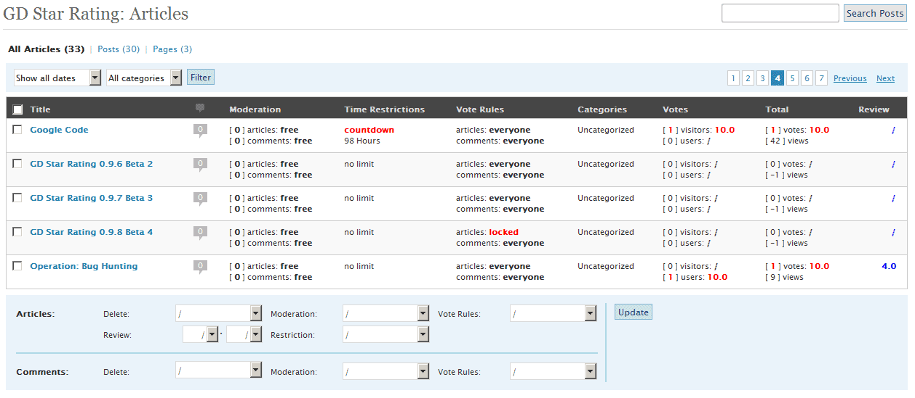
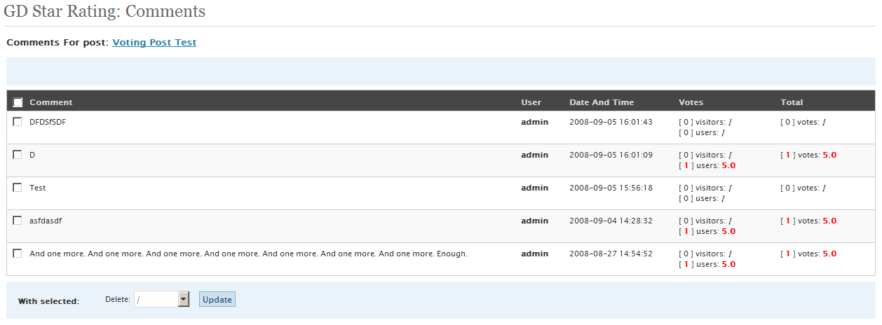
Each row represents one post. First column contains checkboxes for selecting multiple posts. Second column are comments counts. If you click on this you will get similar page with comments ratings for selected post like on the picture on the right. This page will allow you to moderate ratings, or to delete them.
Moderation column shows you moderation status, and number of ratings waiting for moderation. If you click on this number (if not 0) than you will get to moderation page where you can approve or delete votes.
Time Restrictions column shows if the posts have limited voting time. Vote Rules shows who can vote for a post and for the comments belonging to that post. After that you can see post categories.
Voter‘s column shows number of votes and rating from visitors and users. Total column shows total rating and votes for the post and also number of views for that page or post. Last column is post review value.
Bellow the table you can find control panel that you can use to set options for posts you have selected (checked) in the table. You can select more than one parameter to change for both posts and comments.

Users
This panel displays the list of all users that have voted for any of the post or comment.

IP’s
With this panel you can control banning of IP addresses. All banned IP’s will be filtered, and voting will not be allowed for any visitor or user coming from banned IP.
For now, this only works with regular IPv4 protocol addresses.

Ban New IP’s
This tab contains three different segments for banning new IP’s:

Ban Single IP’s
You need to enter list of single IP’s to ban, each one in one line of the textarea. If the IP is valid and not yet in the database, it will be added.

Ban IP Range
Here you can specify range of IP addresses to ban. Range is based only on last IP address element. If the range is not valid, it will be ignored. Also, for last ranged number, FROM must be lower then TO.

Ban IP Masked
This is very specific IP filtering, where you can set a mask for IP addresses. Masked element needs to be left blank or to have XXX instead of number.

Examples:
- 143.12.XXX.XXX: all addresses that start with 143.12 will be banned
- 143.XXX.56.123: addresses that start with 143 and ends with 56.123 will be banned

Banned
This is the list of all banned IP address, ranges and masks. You can delete IP’s from this list.

Tools
This panel contains various tools you can use on their own.

Stars and Trends Graphics
If you add new stars set, you need to let plugin know about it. To avoid constant scanning of folder for new sets, this option is here to activate scanning only when needed. You can see the last scan date and time.

Database Cleanup
In most cases you will not need to use these options. They are here to clean the plugin tables in the database from wrong log entries or obsolete data.
- Remove all invalid votes from vote’s log: this will remove all votes from log that are not connected to existing posts or have some other info invalid.
- Remove all invalid votes from trends log: this will do the same, but for trends log.
- Remove data for old and deleted posts: if you delete some of your posts that have votes data recorded, with this option you can purge rating tables from such obsolete posts.

Date Based Post Locking
Select a date, and all posts older than this date will be locked from further voting. This goes for all posts and all comments associated to this posts.

Global Voting Rules Update
All posts and comments will be set to rules you want.

Plugin Settings
All the settings are divided into several tabs.

General
First tab contains administration pages settings, plugin features and stars preview.

Administration Settings
With this set of options you can control maximum screen width that will affect all the grids rendered by plugin and make them easier to read if you use large monitor resolutions. Also, you can set number of rows displayed on one page for grids.
Advanced settings are settings not too important for most users, so if you want them too, check this option. 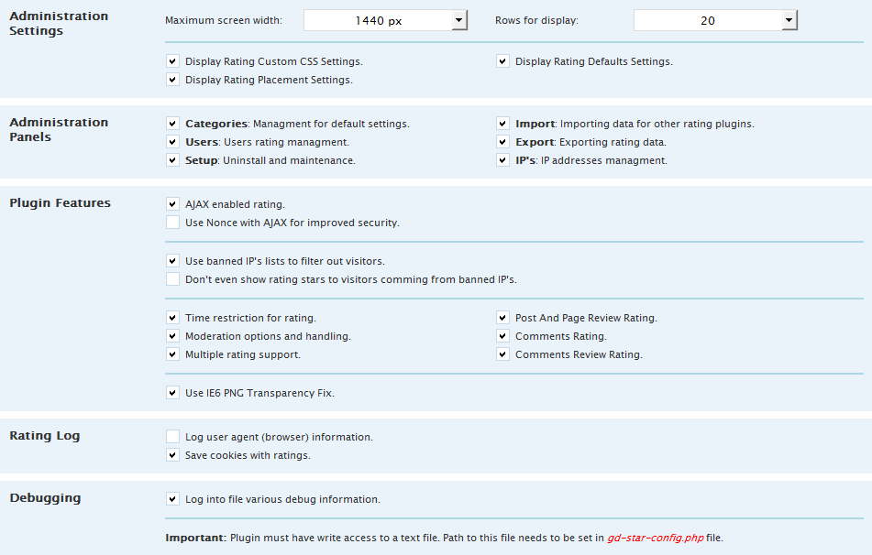

Administration Panel
These options will activate or deactivate some of the panels that you might not need.

Plugin Features
If you don't need all the plugin features, you can disable the one you don't use.
Ajax is recommended to be on, because you will avoid many problems with non ajax voting. For improved security you can enable Nonce feature. You can enable or disable IP filtering and even hide rating block from banned IP’s.
IE6 PNG Transparency Fix will be used only with MS Internet Explorer 6 browsers, regardless if it's on or off will not affect any other browser.

Integrate
This tab control integration of the plugin in other WordPress pages.
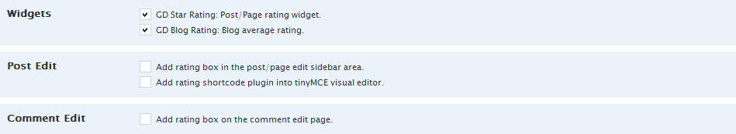

Widgets
Here you can activate or deactivate rating widgets. List has two widgets shown, but the second one is not done yet.

Post Edit
This controls sidebar widget on the post/page edit page. Also controls visual TinyMCE editor plugin for adding shortcode into the post.

Comment Edit
This will add star rating for the comment author review of the post.

Articles Rating (Posts and Pages)
Options here are divided into groups. Some settings in these groups could be hidden, and you need to enable advanced settings on the general tab to see all the settings.
Screenshot bellow shows full set of options on this tab.

Rating
Rating block has 3 parts. First is the Header, always rendered at the top of the rating block. Bellow the header, you can see the rating stars and on bottom is rating text. Rating text can be rendered all around the rating stars, and it can be placed on top, bottom, left or right of the stars. It can also be hidden, or hidden if no votes are recorded for that post. Rating block can be aligned. Rating header text can contain full HTML code for formatting the text.
Also, complete rating block and rating header can have custom CSS class added to change the way they look. These CSS options are advanced settings and they are hidden if you don't activate advanced settings option on general tab.
Default settings for voting and moderation rules are automatically added to each new post or page. More details about the rules will be in the next chapter. Timer restrictions settings are also here.
For articles, rating code can be inserted automatically. With 5 checkboxes you control where the rating block will be automatically inserted into the posts or pages.

Restrict
You can use cookies to record votes and help to prevent multiple voting, and you can also prevent recording votes from author of the post or page. This way authors can rate their own posts.

Vote Waiting Message
Here you can set what will be displayed while the voter sees after placing voting. You can use text and animation with additional CSS class.
You can see preview of the settings you choose before you decide on what you like. By default text size will be 12px, but you can modify this using additional CSS class.

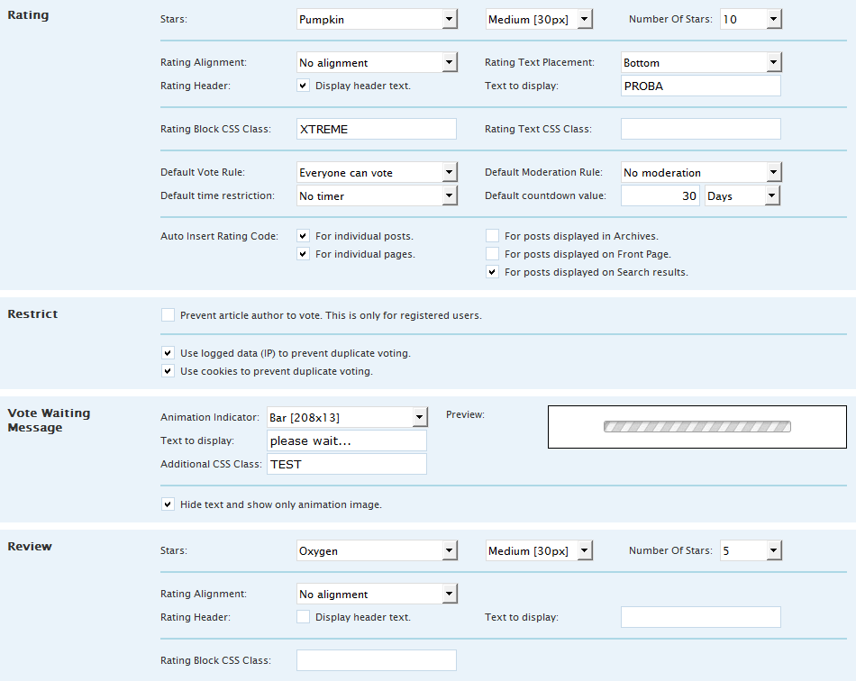Review
Posts and pages support special type of rating, called review rating. Settings are pretty much the same as for the regular rating. Rating block for review rating can't be inserted automatically in the post, and you need to use shortcode to add rating code to the post.

Comments Rating
Basically, comments settings are very much the same as the settings for articles. There are less options then for articles, because some of the features are not used with comments.
Restricting and vote waiting message are pretty much the same.

Review
Comment review is similar to post review, but in this case is controlled by the comment author, and it should be used for comment author to give review rating of the post. This needs to be added into the theme, and the comment form needs to be expanded to include this extra field.
With this settings block you can control the number of stars and style for review rating.
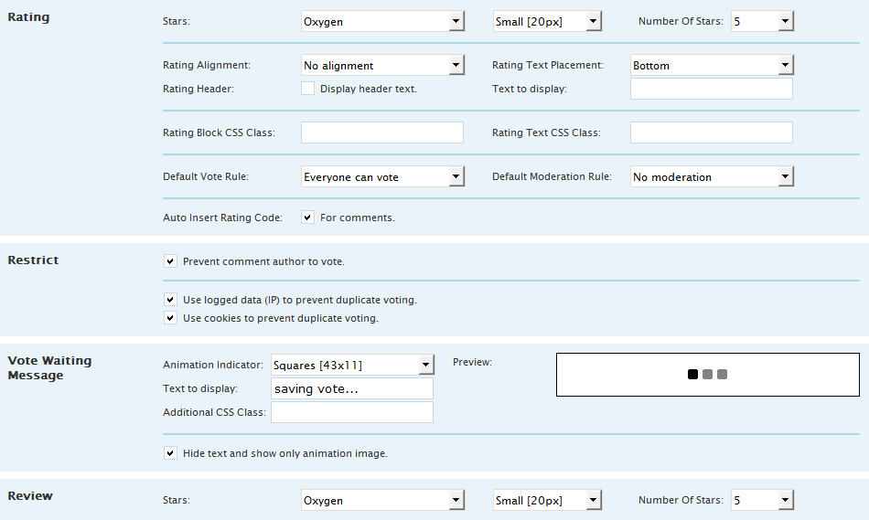

Statistics
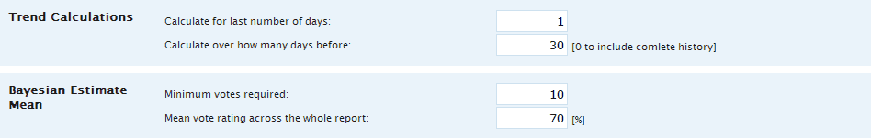
Statistics settings currently have two groups of settings.

Trend Calculations
Trend calculations need two parameters. First is last number of days you need trend calculated for. The second is referent number of days you want to use for calculation.

Bayesian Estimate Mean
This is rating calculation that uses different mathematical formula from simple mean that's used in most cases. This is the method of rating used by IMDb website for Top movies list. Best results this rating has if post has more than minimal votes set here. And the other value is mean vote value for the whole report (all posts rating). Both this numbers can be set the way you want.

Preview
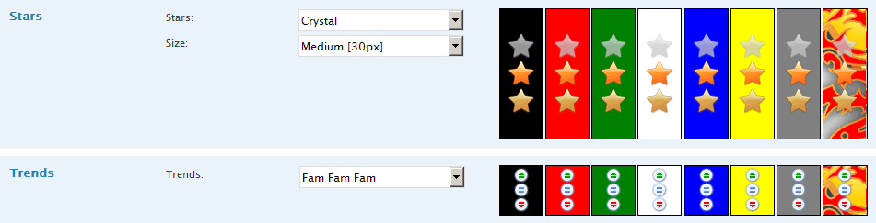

Templates
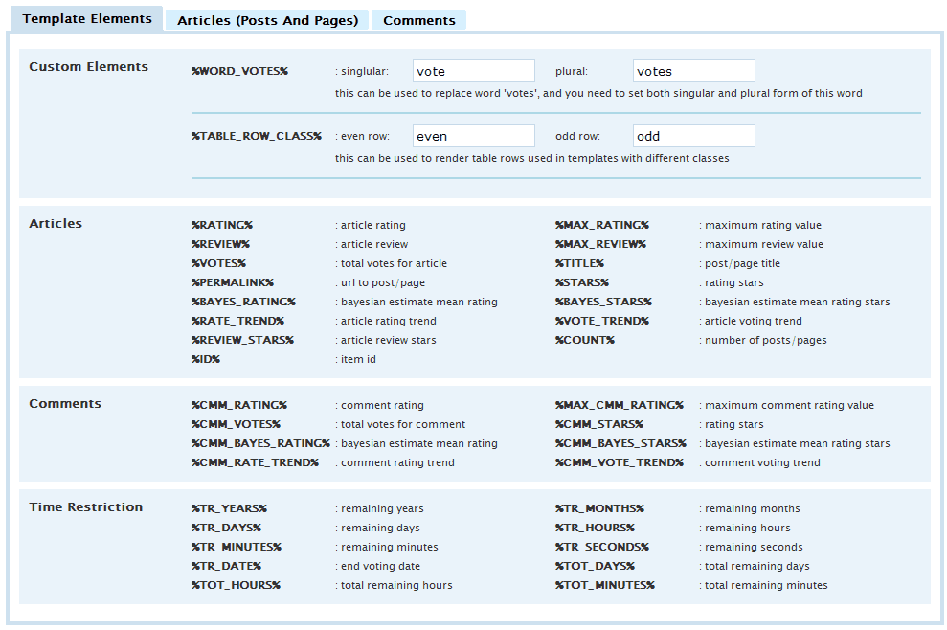
Templates panel contains settings for various templates used by plugin. Templates can contain HTML tags with styles, CSS or whatever you want, and template elements that will be replaced by actual content by plugin. List of different template elements can be found in Appendix.

Template Elements
There are some custom template elements that you can set on the Templates panel. They are located on the first tab.
Word Votes custom element is used to set the singular and plural values for the word vote.
Table Row Class is element for CSS class for even and odd rows in table row.

Articles (Posts and Pages)
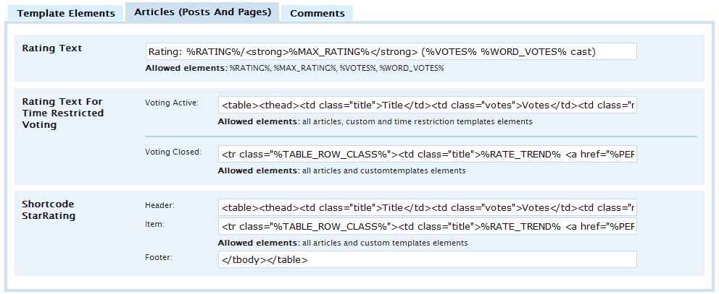
For each template you can see the list of allowed elements.
Main template is for the rating text used by every rating block.
Beside that one, you can set two templates needed for rating text for time restricted posts. Basic value is the same as for the rating text with modifications to display remaining time before the rating for the post is closed. After that plugin uses voting closed value.
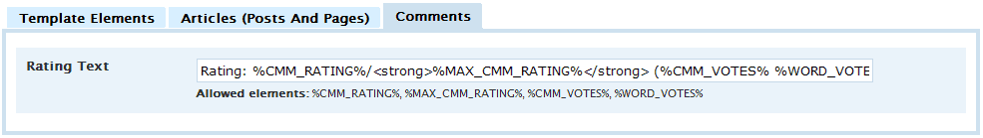
Shortcode template is used to render StarRating shortcode. This template has 3 parts. Header and footer can’t contain any template elements, and item can contain almost all template elements supported by the plugin.

Comments
Currently only rating text template used for comments rating block.

Advanced Features

Moderation
For each post you can set if you want to moderate votes for user or visitors or both. They can vote once, and that vote is stored, but will not appear until you approve it. Articles panel contains all options needed for setting this, and to see how many votes are waiting.

Vote Rules
Vote rules are used to determine who can vote, and whether to show or hide rating for specific article. You can set that only visitors or only users can vote, you can lock voting, and you can lock and hide rating block for posts.

Time Restrictions
In many cases you need to limit voting by setting the total time available for voting after the publishing of post or you can set deadline date until the voting is allowed.
Countdown restriction lets you set the amount of time from the moment the post is published until the rating for that post is closed. You can specify the number of days, hours or minutes for countdown. Date restriction lets you set the date until the voting is valid. Date must be in the future, or rating will be automatically locked.
In both cases plugin will have recalculated values for both types of restrictions so you can use that as values for template.

Graphics Sets
Sets for trends and stars are stored in two places:
- Plugin folder: this is the folder where the plugin is located, and there you have folders stars and trends where the default sets are located. I don’t recommend adding anymore sets in these folders, because if you use WordPress plugin upgrade system, all that will be lost when you update to newer plugin version.
- Additional folder: You need to create gd-star-rating folder in wp-content folder. And in this new folder create two more folders: stars and trends. Structure you need to have looks like this:
- wp-content/gd-star-rating/stars
- wp-content/gd-star-rating/trends

Each set must be in its own folder, and make sure not to use folder names like the folder names used for default icon sets.


Stars
Stars must be created in 4 sizes. Each size requires one image file. Also, you need to create additional description file with some info about the set. Here are the star sizes, image dimensions and file name (xxx in file name is extension):
- 12 pixels (image size: 12x36) (file name: stars12.xxx)
- 20 pixels (image size: 20x60) (file name: stars20.xxx)
- 30 pixels (image size: 30x90) (file name: stars30.xxx)
- 46 pixels (image size: 46x138) (file name: stars46.xxx)

Files can be in PNG, GIF or JPG format. PNG can be used for true 32bit format with real transparency. But this is not supported by some older browsers including MS Internet Explorer 6.

Each image contains three elements used to create rating stars. On the image on the right you have large version of the set with all 3 parts. Top element is rating star background image. Middle element is image used for hover effect when a user wants to vote. Bottom element is used to render actual rating value.
You need to use basically the same size and position of elements you want to use (stars, boxes, hearts…) so the transition of elements looks nice. I have included Photoshop PSD file with oxygen stars as a template. Also, images you use must have square dimensions. You can’t use element with 46x50 size.
Description file is required, and this file must be named ‘stars.gdsr’. Use example I have included to create your own description for you sets. Only first two lines are required. All the other lines can be removed if you want. Type line must have set extension for the stars in your set.

Trends
Trends image is different than stars and it requires only one image that includes all 3 trend states. Also, one trend set is only for one size, you can’t have one set with different sizes like stars have. File name must be trend.xxx, with xxx being extension. Top image in the set is for trend rising state, middle is for trend stagnation, and the bottom is for trend falling.
Description file is required, and this file must be named ‘trend.gdsr’. Use example I have included to create your own description for you sets. Only first three lines are required. All the other lines can be removed if you want. Type line must have set extension for the stars in your set. Size line must have set width dimension of the image. Trend elements must be with square dimensions, you can’t have 16x20 elements in the set.
I have included Photoshop PSD file template.

Appendix
There could be some inaccuracies with following info, but it will be improved.

1. Elements for StarRating shortcode, manual function & Widget
At this point some of the following parameters might not be supported by the widget rendering code. This goes for stars rendering but the widget will soon get support for that also.
Parameter | Description | Default
rows | number of posts (rows) to show | 10
select | what to display: posts, pages or both  postpage | post | page | postpage
column | what to use for sorting  rating | votes | id | post_title | review | count | bayes | rating
order | sorting order  asc | desc | desc
category | id of the category for filtering results | 0
show | use recorded votes from user, visitors or both  total | visitors | users | total
hide_empty | exclude posts with no recorded votes  0: include all | 1: exclude empty | 1
hide_noreview | exclude posts with no review  0: include all | 1: exclude empty | 0
bayesian_calculation | exclude posts with no valid bayesian criteria rating  0: include all | 1: exclude | 0
publish_date | limit posts with date filter  lastd: last number of days | month | range | lastd
publish_days | number of last day for filtering (publish_date is set to lastd)  0: no limit | 0
publish_month | month to limit post filter in format YYYYMM (publish_date set to month) | 200808
publish_range_from | start date for filter (publish_date set to range) | YYYYMMDD
publish_range_to | to date for filter (publish_date set to range) | YYYYMMDD
div_class | additional CSS class for table
grouping | grouping posts by user or category, average value for posts  post: no grouping | user | category | post
trends_rating | how to display rating trends, like text or image  txt | img | txt
trends_rating_rise | character for trend rising | +
trends_rating_same | character for trend stagnation | =
trends_rating_fall | character for trend falling | -
trends_rating_set | image set for trend | famfamfam
trends_voting | how to display voting trends, like text or image  txt | img | txt
trends_voting_rise | character for trend rising | +
trends_voting_same | character for trend stagnation | =
trends_voting_fall | character for trend falling | -
trends_voting_set | image set for trend | famfamfam
rating_stars | image stars set for rating | oxygen
rating_size | image stars size for rating  12: mini | 20: small | 30: normal | 46: big | 20
review_stars | image stars set for review | oxygen
review_size | image stars size for review  12: mini | 20: small | 30: normal | 46: big | 20

2. Custom Template Elements
Element | Description
%WORD_VOTES% | Custom template element for vote/votes word
%TABLE_ROW_CLASS% | CSS class added to table rows for alternating styles

3. Post/Page Template Elements
Element | Description
%RATING% | Calculated Rating for the record
%MAX_RATING% | Maximum rating value allowed
%BAYES_RATING% | Bayesian mean estimate calculation for the rating
%VOTES% | Number of recorded votes
%REVIEW% | Review value set for the post or page
%MAX_REVIEW% | Maximum review value allowed
%TITLE% | Post title, or user/category title with grouping activated
%PERMALINK% | Url to post, or user/category with grouping activated
%RATE_TREND% | Rating trend indicator
%VOTE_TREND% | Voting trend indicator
%ID% | Post ID, or user/category ID with grouping activated
%COUNT% | If grouping is activated, number of posts, if not than is 1
%STARS% | Rating stars
%BAYES_STARS% | Bayesian rating stars
%REVIEW_STARS% | Review value stars

4. Comments Template Elements
Element | Description
%CMM_RATING% | Calculated Rating for the record
%CMM_MAX_RATING% | Maximum rating value allowed
%CMM_BAYES_RATING% | Bayesian mean estimate calculation for the rating
%CMM_VOTES% | Number of recorded votes
%CMM_RATE_TREND% | Rating trend indicator
%CMM_VOTE_TREND% | Voting trend indicator
%CMM_STARS% | Rating stars
%CMM_BAYES_STARS% | Bayesian rating stars

5. Time Restrictions

1. Remaining elements
Element | Description
%TR_YEARS% | Years part of total remaining time until closing the rating
%TR_MONTHS% | Months part of total remaining time until closing the rating
%TR_DAYS% | Days part of total remaining time until closing the rating
%TR_HOURS% | Hours part of total remaining time until closing the rating
%TR_MINUTES% | Minutes part of total remaining time until closing the rating
%TR_SECONDS% | Seconds part of total remaining time until closing the rating

2. Total remaining elements
Element | Description
%TOT_DAYS% | Total remaining days until closing the rating
%TOT_HOURS% | Total remaining hours until closing the rating
%TOT_MINUTES% | Total remaining minutes until closing the rating

3. Date elements
Element | Description
%TR_DATE% | Rating expiry date

User Guide Changelog

1.0.5 [4.december 2008]
For plugin 1.0.5 release.

1.0.2 [10.november 2008]
For plugin 1.0.2 release. Contains new screenshots for settings panel, and is expanded with new settings options, comments review and theme integration.

1.0.0 [31.october 2008]
For plugin first stable 1.0.0 Halloween Edition release.

