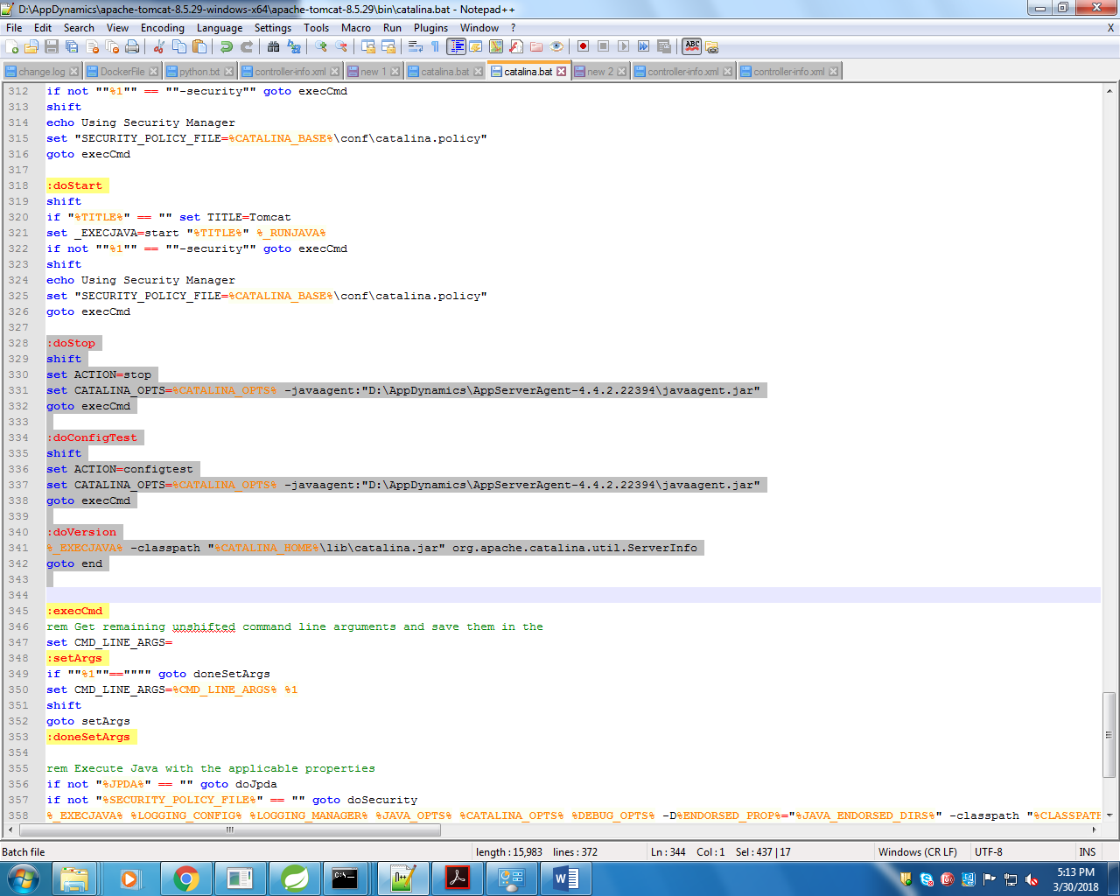

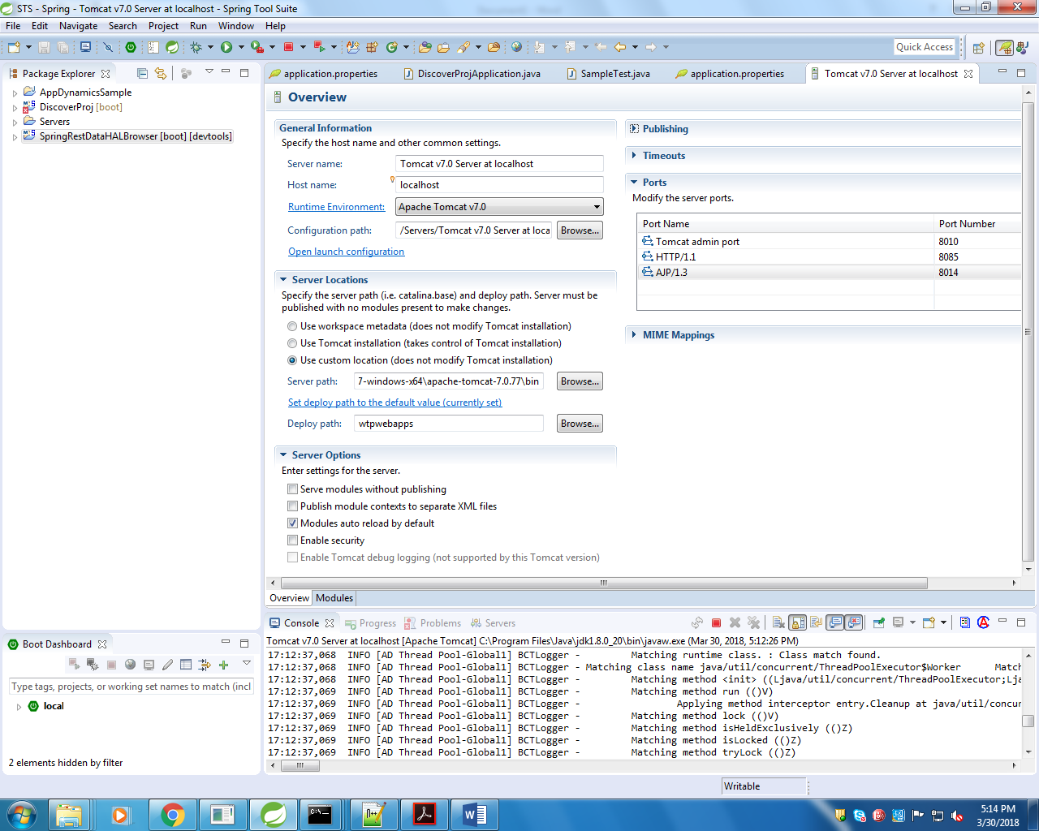

Use custom location (does not modify Tomcat installation)

Open laumch configuration

-Dcatalina.base="D:\SpringBoot_PrernaThakur\STS\.metadata\.plugins\org.eclipse.wst.server.core\tmp0" -Dcatalina.home="D:\AppDynamics\apache-tomcat-7.0.77-windows-x64\apache-tomcat-7.0.77" -Dwtp.deploy="D:\SpringBoot_PrernaThakur\STS\.metadata\.plugins\org.eclipse.wst.server.core\tmp0\wtpwebapps" -Djava.endorsed.dirs="D:\AppDynamics\apache-tomcat-7.0.77-windows-x64\apache-tomcat-7.0.77\endorsed" -javaagent:"D:\AppDynamics\AppServerAgent-4.4.2.22394\javaagent.jar"