Garph
graph = {
'A': ['B', 'C'],
'B': ['D', 'E'],
'C': ['F', 'G'],
'D': ['H'],
'E': [],
'F': [],
'G': ['P'],
'H': [],
'P': []
}

Question 1:
def BFS(graph, start, goal):
visited = []
queue = [[start]]

while queue:
path = queue.pop(0)
node = path[-1]

if node not in visited:
visited.append(node)

if node == goal:
print("BFS Transition Path:", visited)
return path

for neighbor in graph[node]:
new_path = list(path)
new_path.append(neighbor)
queue.append(new_path)
def DFS(graph, start, goal):
visited = []
stack = [[start]]

while stack:
path = stack.pop()
node = path[-1]

if node not in visited:
visited.append(node)

if node == goal:
print("DFS Transition Path:", visited)
return path

for neighbor in graph[node]:
new_path = list(path)
new_path.append(neighbor)
stack.append(new_path)
bfs_path = BFS(graph, 'A', 'P')
print("BFS Final Path:", bfs_path)

dfs_path = DFS(graph, 'A', 'P')
print("DFS Final Path:", dfs_path)
Output (Question 1):
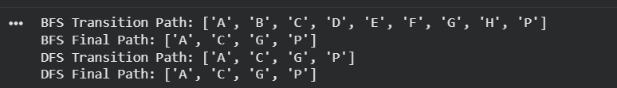

Question 2:
def second_largest(arr):
arr = list(set(arr))

if len(arr) < 2:
return None

arr.sort()
return arr[-2]

print("Second Largest:", second_largest([10, 20, 5, 20, 8]))
print("Second Largest:", second_largest([5, 5, 5]))

Output (Question 2):


Question 3:
def DLS(graph, node, goal, limit):

if node == goal:
return True

if limit == 0:
return False

for neighbor in graph[node]:
if DLS(graph, neighbor, goal, limit - 1):
return True

return False

print("Depth 3:", DLS(graph, 'A', 'P', 3))
print("Depth 2:", DLS(graph, 'A', 'P', 2))

Output (Question 3):
