

AMERICAN INTERNATIONAL UNIVERSITY–BANGLADESH (AIUB)
FACULTY OF SCIENCE & TECHNOLOGY
Spring 2025-26

Computer Graphics
MID TERM LAB ASSIGNMENT

Topic 1: Bangladesh Tribute Scene
Topic 2: Simple Village Scenery

Submitted To:
Kazi Asif Ahmed

Submitted By
Avijit Biswas Ankur
24-56911-1
Section: F

Submission Date: 14-March-2026
Topic 1: Bangladesh Tribute Scene
1. Source Code

#include <GL/glut.h>
#include <cmath>

/* -------- PUT PIXEL -------- */
void putPixel(int x,int y)
{
glBegin(GL_POINTS);
glVertex2i(x,y);
glEnd();
}

/* -------- DDA LINE -------- */
void lineDDA(int x1,int y1,int x2,int y2)
{
float dx=x2-x1;
float dy=y2-y1;

float steps=fabs(dx)>fabs(dy)?fabs(dx):fabs(dy);

float xinc=dx/steps;
float yinc=dy/steps;

float x=x1,y=y1;

for(int i=0;i<=steps;i++)
{
putPixel(round(x),round(y));
x+=xinc;
y+=yinc;
}
}

/* -------- BRESENHAM LINE -------- */
void lineBresenham(int x1,int y1,int x2,int y2)
{
int dx=abs(x2-x1);
int dy=abs(y2-y1);

int sx=(x1<x2)?1:-1;
int sy=(y1<y2)?1:-1;

int err=dx-dy;

while(true)
{
putPixel(x1,y1);

if(x1==x2 && y1==y2)
break;

int e2=2*err;

if(e2>-dy)
{
err-=dy;
x1+=sx;
}

if(e2<dx)
{
err+=dx;
y1+=sy;
}
}
}

/* -------- MIDPOINT CIRCLE -------- */
void drawCirclePoints(int xc,int yc,int x,int y)
{
putPixel(xc+x,yc+y);
putPixel(xc-x,yc+y);
putPixel(xc+x,yc-y);
putPixel(xc-x,yc-y);
putPixel(xc+y,yc+x);
putPixel(xc-y,yc+x);
putPixel(xc+y,yc-x);
putPixel(xc-y,yc-x);
}

void midpointCircle(int xc,int yc,int r)
{
int x=0;
int y=r;
int d=1-r;

while(x<=y)
{
drawCirclePoints(xc,yc,x,y);

if(d<0)
d+=2*x+3;
else
{
d+=2*(x-y)+5;
y--;
}

x++;
}
}

/* -------- RECTANGLES -------- */
void rectBres(int x1,int y1,int x2,int y2)
{
lineBresenham(x1,y1,x2,y1);
lineBresenham(x2,y1,x2,y2);
lineBresenham(x2,y2,x1,y2);
lineBresenham(x1,y2,x1,y1);
}

/* -------- SHAHEED MINAR -------- */
void drawShaheedMinar()
{
/* Sun (Red) */
glColor3f(1,0,0);
midpointCircle(400,300,90);

/* Monument Structure */
glColor3f(1,1,1);

/* Center pillars */
rectBres(360,200,380,420);
rectBres(420,200,440,420);

/* Top structure */
lineBresenham(380,420,360,470);
lineBresenham(360,420,340,470);
lineBresenham(420,420,440,470);
lineBresenham(440,420,460,470);
rectBres(340,470,460,490);

/* Side pillars */
rectBres(300,200,340,370);
rectBres(460,200,500,370);

rectBres(250,200,270,320);
rectBres(530,200,550,320);

/* Steps (DDA) */
glColor3f(0.8,0.8,0.8);

lineDDA(200,140,600,140);
lineDDA(580,160,600,140);
lineDDA(200,140,220,160);

lineDDA(220,160,580,160);
lineDDA(220,160,240,180);
lineDDA(570,180,580,160);

rectBres(240,200,570,180);
}
/* -------- BANGLADESH FLAG -------- */

void drawBangladeshFlag()
{
/* Flag green color */
glColor3f(0,0.6,0);

/* Flag frame using Bresenham */
rectBres(580,330,680,400);

/* Red circle slightly left of center */
glColor3f(1,0,0);
midpointCircle(620,365,18);

/* Flagpole using DDA */
glColor3f(0.9,0.4,0.1);
lineDDA(580,400,580,160);
}
/* -------- STAR (BRESENHAM ONLY) -------- */

void drawStar(int x,int y,int s)
{
glColor3f(1,1,1); // white star

lineBresenham(x, y+s, x-s, y-s);
lineBresenham(x, y+s, x+s, y-s);

lineBresenham(x-s, y-s, x+s, y);
lineBresenham(x+s, y-s, x-s, y);

lineBresenham(x-s, y, x+s, y);
}

/* -------- BIRD (MIDPOINT CIRCLE ARCS) -------- */

void drawBird(int xc,int yc,int r)
{
glColor3f(1,1,1); // black birds

int x=0;
int y=r;
int d=1-r;

while(x<=y)
{
/* left wing arc */
if(x<y)
putPixel(xc-x,yc+y);

/* right wing arc */
if(x<y)
putPixel(xc+x,yc+y);

if(d<0)
d+=2*x+3;
else
{
d+=2*(x-y)+5;
y--;
}

x++;
}
}

/* -------- DISPLAY -------- */
void display()
{
glClear(GL_COLOR_BUFFER_BIT);
glPointSize(3);

drawShaheedMinar();
drawBangladeshFlag();

/* Stars */

drawStar(140,540,12);
drawStar(200,520,10);
drawStar(260,550,11);
drawStar(320,530,10);
drawStar(380,545,12);
drawStar(450,525,9);
drawStar(500,550,11);

/* Birds */

drawBird(520,500,10);
drawBird(560,520,9);
drawBird(600,540,11);
drawBird(650,510,10);
drawBird(690,530,9);
drawBird(730,550,11);
drawBird(580,470,10);
drawBird(630,480,9);
drawBird(680,460,10);

glFlush();
}
/* -------- INIT -------- */
void init()
{
glClearColor(0.1,0.1,0.1,1);
gluOrtho2D(0,800,0,600);
}

/* -------- MAIN -------- */
int main(int argc,char** argv)
{
glutInit(&argc,argv);
glutInitDisplayMode(GLUT_SINGLE|GLUT_RGB);
glutInitWindowSize(800,600);
glutCreateWindow("Bangladesh Tribute Scene ");

init();

glutDisplayFunc(display);
glutMainLoop();

return 0;
}

2. Screenshot of output

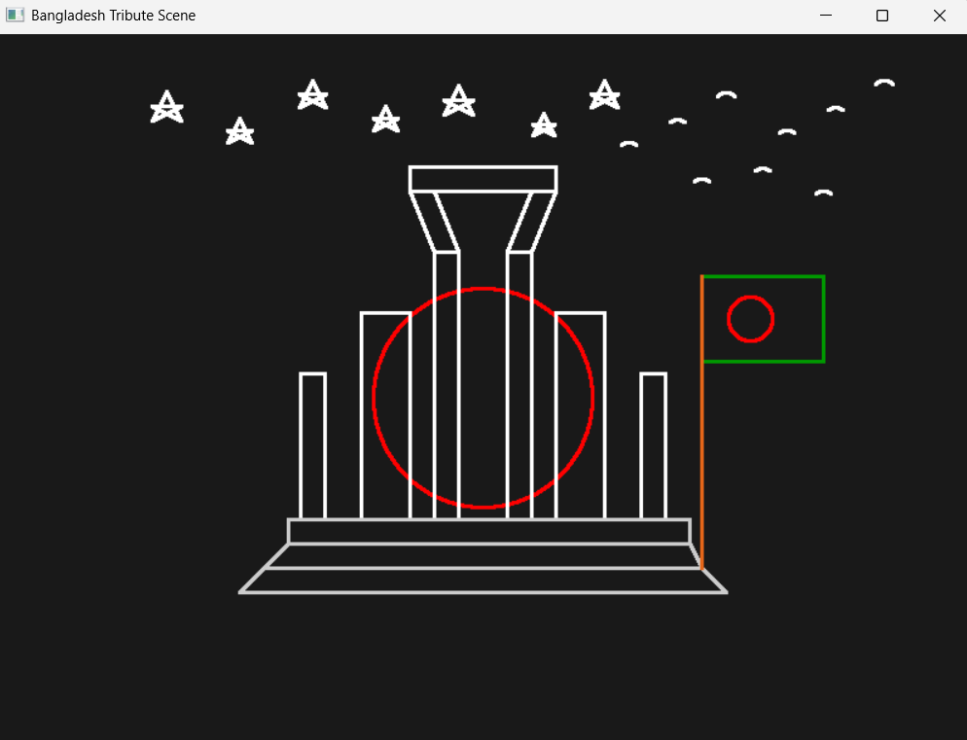

3. Short description

This OpenGL program creates a tribute scene of the Shaheed Minar along with the Bangladesh flag, stars, and birds using basic computer graphics algorithms. The program mainly uses three algorithms: the DDA Line Algorithm, the Bresenham Line Algorithm, and the Midpoint Circle Algorithm. Each algorithm is applied to different parts of the drawing to efficiently generate the required shapes.

The DDA (Digital Differential Analyzer) line algorithm is used to draw simple straight lines by incrementally calculating intermediate points between two coordinates. In this program, the DDA algorithm is used for the steps of the Shaheed Minar and the flagpole. For example, when drawing the step line from (200,140) to (600,140), the first few plotted points are (200,140), (201,140), (202,140), (203,140), and (204,140).

The Bresenham Line Algorithm is used to draw the pillars of the monument, rectangles, stars in the sky, and the flag frame. This algorithm is efficient because it uses integer calculations instead of floating-point operations. For instance, when drawing a pillar line from (360,200) to (380,420), some of the initial plotted points include (360,200), (361,201), (362,203), (363,204), and (364,206).

The Midpoint Circle Algorithm is used to draw circular shapes such as the red sun behind the Shaheed Minar, the red circle of the Bangladesh flag, and the curved wings of birds. For example, when drawing a circle with center (400,300) and radius 90, the first few plotted points are (400,390), (401,390), (402,389), (403,389), and (404,388). Due to the eight-way symmetry of the algorithm, these points are mirrored to form the complete circle.

In conclusion, the program demonstrates how classic computer graphics algorithms can be used together to create a meaningful and visually appealing scene representing the Shaheed Minar with the Bangladesh flag.

Topic 2: Simple Village Scenery
1. Source Code

#include <GL/glut.h>
#include <math.h>
void circle(float cx,float cy,float r)
{
glBegin(GL_POLYGON);
for(int i=0;i<100;i++)
{
float angle=2*3.1416*i/100;
float x=r*cos(angle);
float y=r*sin(angle);
glVertex2f(cx+x,cy+y);
}
glEnd();
}

// -------- HOUSE --------
void drawHouse(float x)
{
glColor3f(0.95,0.80,0.55);
glBegin(GL_QUADS);
glVertex2f(x-0.15,-0.05);
glVertex2f(x+0.15,-0.05);
glVertex2f(x+0.15,0.15);
glVertex2f(x-0.15,0.15);
glEnd();

glColor3f(0.9,0.15,0.15);
glBegin(GL_TRIANGLES);
glVertex2f(x-0.18,0.15);
glVertex2f(x+0.18,0.15);
glVertex2f(x,0.30);
glEnd();

glColor3f(0.6,0.2,0.1);
glBegin(GL_QUADS);
glVertex2f(x+0.06,0.22);
glVertex2f(x+0.10,0.22);
glVertex2f(x+0.10,0.32);
glVertex2f(x+0.06,0.32);
glEnd();

glColor3f(0.5,0.2,0.1);
glBegin(GL_QUADS);
glVertex2f(x-0.03,-0.05);
glVertex2f(x+0.03,-0.05);
glVertex2f(x+0.03,0.05);
glVertex2f(x-0.03,0.05);
glEnd();

glColor3f(1,1,0);
glPointSize(5);
glBegin(GL_POINTS);
glVertex2f(x+0.02,0.0);
glEnd();

glColor3f(1,1,1);
glBegin(GL_QUADS);
glVertex2f(x-0.12,0.03);
glVertex2f(x-0.06,0.03);
glVertex2f(x-0.06,0.10);
glVertex2f(x-0.12,0.10);
glEnd();

glBegin(GL_QUADS);
glVertex2f(x+0.06,0.03);
glVertex2f(x+0.12,0.03);
glVertex2f(x+0.12,0.10);
glVertex2f(x+0.06,0.10);
glEnd();

glColor3f(0.7,0.7,0.7);
glBegin(GL_LINES);
glVertex2f(x-0.12,0.065); glVertex2f(x-0.06,0.065);
glVertex2f(x-0.09,0.03); glVertex2f(x-0.09,0.10);

glVertex2f(x+0.06,0.065); glVertex2f(x+0.12,0.065);
glVertex2f(x+0.09,0.03); glVertex2f(x+0.09,0.10);

glEnd();
}
void drawFlower(float x,float y)
{
glColor3f(0,0.6,0);
glBegin(GL_LINES);
glVertex2f(x,y);
glVertex2f(x,y+0.03);
glEnd();

glColor3f(1,0,0);
circle(x,y+0.035,0.01);

glColor3f(1,1,0);
circle(x,y+0.035,0.004);
}

void smoke(float x,float y)
{
glColor3f(0.9,0.9,0.9);
circle(x,y,0.015);
circle(x+0.02,y+0.02,0.015);
circle(x+0.04,y+0.04,0.015);
}

void display()
{
glClear(GL_COLOR_BUFFER_BIT);

// SKY
glColor3f(0.53,0.81,0.98);
glBegin(GL_QUADS);
glVertex2f(-1,0); glVertex2f(1,0);
glVertex2f(1,1); glVertex2f(-1,1);
glEnd();

// GROUND
glColor3f(0.6,0.8,0.3);
glBegin(GL_QUADS);
glVertex2f(-1,-0.2); glVertex2f(1,-0.2);
glVertex2f(1,0); glVertex2f(-1,0);
glEnd();

drawFlower(-0.3,-0.06);
drawFlower(-0.2,-0.05);
drawFlower(-0.1,-0.07);
drawFlower(0.2,-0.06);
drawFlower(0.3,-0.05);
drawFlower(0.4,-0.06);

// RIVER
glColor3f(0.2,0.5,0.9);
glBegin(GL_QUADS);
glVertex2f(-1,-1); glVertex2f(1,-1);
glVertex2f(1,-0.2); glVertex2f(-1,-0.2);
glEnd();

// MOUNTAINS
glColor3f(0.3,0.7,0.2);
glBegin(GL_TRIANGLES);
glVertex2f(-1,0); glVertex2f(-0.7,0.35); glVertex2f(-0.4,0);
glVertex2f(-0.6,0); glVertex2f(-0.2,0.4); glVertex2f(0.2,0);
glVertex2f(0,0); glVertex2f(0.4,0.35); glVertex2f(0.8,0);
glEnd();

// SUN
glColor3f(1,0.9,0);
circle(0.8,0.8,0.1);

glBegin(GL_LINES);
for(int i=0;i<12;i++)
{
float a=2*3.1416*i/12;
glVertex2f(0.8,0.8);
glVertex2f(0.8+0.15*cos(a),0.8+0.15*sin(a));
}
glEnd();

// CLOUDS
glColor3f(1,1,1);
circle(-0.6,0.8,0.07);
circle(-0.52,0.83,0.07);
circle(-0.44,0.8,0.07);

circle(0.1,0.8,0.07);
circle(0.18,0.83,0.07);
circle(0.26,0.8,0.07);

// BIRDS
glColor3f(0,0,0);
glBegin(GL_LINES);

glVertex2f(-0.15,0.75); glVertex2f(-0.12,0.78);
glVertex2f(-0.12,0.78); glVertex2f(-0.09,0.75);

glVertex2f(0.00,0.82); glVertex2f(0.03,0.85);
glVertex2f(0.03,0.85); glVertex2f(0.06,0.82);

glVertex2f(0.18,0.74); glVertex2f(0.21,0.77);
glVertex2f(0.21,0.77); glVertex2f(0.24,0.74);

glVertex2f(-0.35,0.83); glVertex2f(-0.32,0.86);
glVertex2f(-0.32,0.86); glVertex2f(-0.29,0.83);

glVertex2f(0.40,0.80); glVertex2f(0.43,0.83);
glVertex2f(0.43,0.83); glVertex2f(0.46,0.80);

glVertex2f(-0.55,0.78); glVertex2f(-0.52,0.81);
glVertex2f(-0.52,0.81); glVertex2f(-0.49,0.78);

glEnd();

drawHouse(-0.7);
drawHouse(0.5);

smoke(-0.62,0.34);
smoke(0.58,0.34);

// TREE 1
glColor3f(0.55,0.27,0.07);
glBegin(GL_QUADS);
glVertex2f(-0.90,-0.05); glVertex2f(-0.84,-0.05);
glVertex2f(-0.84,0.08); glVertex2f(-0.90,0.08);
glEnd();

glColor3f(0.1,0.55,0.2);
circle(-0.92,0.12,0.07);
circle(-0.82,0.12,0.07);
circle(-0.87,0.17,0.08);

// TREE 2
glColor3f(0.55,0.27,0.07);
glBegin(GL_QUADS);
glVertex2f(0.70,-0.05); glVertex2f(0.76,-0.05);
glVertex2f(0.76,0.08); glVertex2f(0.70,0.08);
glEnd();

glColor3f(0.1,0.55,0.2);
circle(0.68,0.12,0.07);
circle(0.78,0.12,0.07);
circle(0.73,0.17,0.08);

// FENCE
glColor3f(0.5,0.3,0.1);
glBegin(GL_LINES);

for(float i=-0.9;i<-0.5;i+=0.05)
{
glVertex2f(i,-0.05);
glVertex2f(i,0.02);
}

glVertex2f(-0.9,-0.02);
glVertex2f(-0.5,-0.02);

for(float i=0.35;i<0.75;i+=0.05)
{
glVertex2f(i,-0.05);
glVertex2f(i,0.02);
}

glVertex2f(0.35,-0.02);
glVertex2f(0.75,-0.02);

glEnd();

// DOCK
glColor3f(0.86,0.63,0.24);
glBegin(GL_QUADS);
glVertex2f(-0.2,-0.2);
glVertex2f(0.1,-0.2);
glVertex2f(0.05,-0.5);
glVertex2f(-0.25,-0.5);
glEnd();

glColor3f(0.75,0.50,0.20);
glBegin(GL_LINES);
glVertex2f(-0.18,-0.23); glVertex2f(0.08,-0.23);
glVertex2f(-0.14,-0.28); glVertex2f(0.04,-0.28);
glVertex2f(-0.10,-0.33); glVertex2f(0.0,-0.33);
glVertex2f(-0.06,-0.38); glVertex2f(-0.04,-0.38);
glEnd();

// BOAT
glColor3f(0.65,0.32,0.12);
glBegin(GL_POLYGON);
glVertex2f(0.35,-0.48);
glVertex2f(0.65,-0.48);
glVertex2f(0.60,-0.58);
glVertex2f(0.40,-0.58);
glEnd();

glColor3f(0.8,0.4,0.2);
glBegin(GL_QUADS);
glVertex2f(0.38,-0.48);
glVertex2f(0.62,-0.48);
glVertex2f(0.60,-0.51);
glVertex2f(0.40,-0.51);
glEnd();

glColor3f(0.5,0.25,0.1);
glBegin(GL_QUADS);
glVertex2f(0.49,-0.48);
glVertex2f(0.51,-0.48);
glVertex2f(0.51,-0.30);
glVertex2f(0.49,-0.30);
glEnd();

glColor3f(1,1,1);
glBegin(GL_TRIANGLES);
glVertex2f(0.50,-0.30);
glVertex2f(0.50,-0.46);
glVertex2f(0.65,-0.38);
glEnd();

// WATER WAVES
glColor3f(0.8,0.9,1.0);
glBegin(GL_LINES);
glVertex2f(-0.8,-0.35); glVertex2f(-0.7,-0.35);
glVertex2f(-0.4,-0.5); glVertex2f(-0.3,-0.5);
glVertex2f(0.1,-0.4); glVertex2f(0.2,-0.4);
glVertex2f(0.5,-0.6); glVertex2f(0.6,-0.6);
glVertex2f(0.75,-0.45); glVertex2f(0.85,-0.45);
glEnd();

// FLAG
glColor3f(0.7,0.7,0.7);
glBegin(GL_LINES);
glVertex2f(0.15,0.20);
glVertex2f(0.15,-0.05);
glEnd();

glColor3f(0,0.5,0);
glBegin(GL_QUADS);
glVertex2f(0.15,0.20);
glVertex2f(0.27,0.20);
glVertex2f(0.27,0.13);
glVertex2f(0.15,0.13);
glEnd();

glColor3f(1,0,0);
circle(0.21,0.165,0.02);

glFlush();
}

void init()
{
glClearColor(1,1,1,1);
gluOrtho2D(-1,1,-1,1);
}

int main(int argc,char** argv)
{
glutInit(&argc,argv);
glutInitDisplayMode(GLUT_SINGLE|GLUT_RGB);
glutInitWindowSize(900,600);
glutCreateWindow("Village Scenery");
init();
glutDisplayFunc(display);
glutMainLoop();
}

2. Screenshot of output

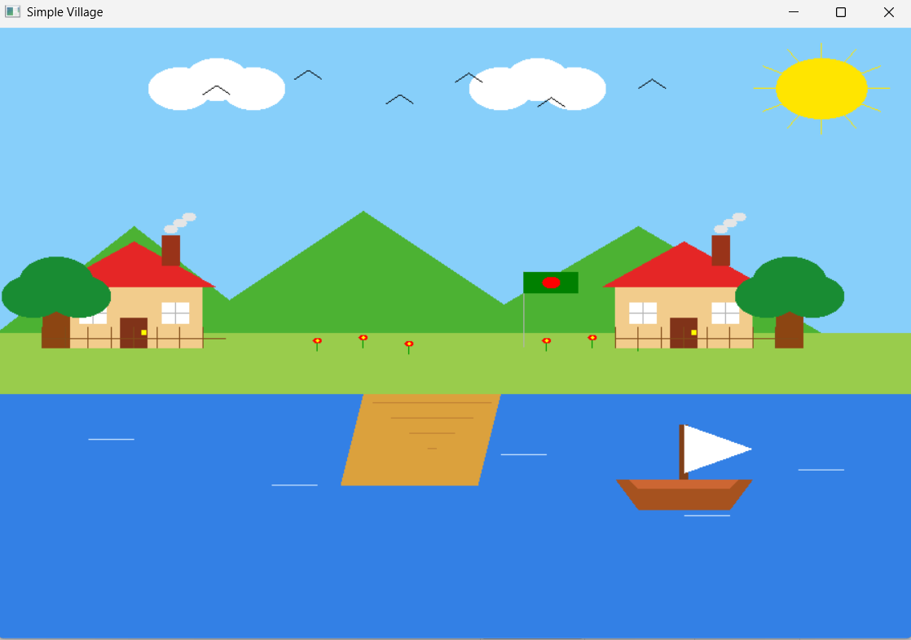

3. Short description

This OpenGL program creates a simple village scene using different OpenGL primitives. The GL_QUADS primitive is used to draw rectangular objects such as the sky background, ground, river, house walls, doors, windows, tree trunks, dock, boat deck, and the flag. The GL_TRIANGLES primitive is used for triangular shapes like the house roof, mountains in the background, and the boat sail. GL_LINES are used to draw objects made of straight line segments, such as birds in the sky, fence lines, water waves, the flag pole, and window frames. A custom circle() function is used to draw round shapes like the sun, clouds, tree leaves, flowers, and smoke, where the circle is approximated using GL_POLYGON with many vertices. A small GL_POINTS primitive is also used for details like the door handle.

The scene is arranged using a 2D coordinate system ranging from -1 to 1 in both x and y directions using gluOrtho2D(-1,1,-1,1). All objects are positioned by specifying their vertex coordinates within this coordinate space. For example, the houses are placed at x = -0.7 and x = 0.5, while the trees are placed near the sides of the scene. The mountains are positioned in the background above the ground, and the river is placed at the bottom part of the screen. Different objects are sized by adjusting their vertex positions and circle radius values, which helps keep the proportions natural. This arrangement creates a layered village environment with background elements like mountains and sky, middle elements like houses and trees, and foreground elements like the river, dock, and boat.

