**Some of the insights for better development, scalability and durability of a REACT project.**

Author- Venkat Avinash Karra

**Contents:**

* Introduction (DRY)
* Redux and Sagas
* Adaptive Styling & and VS Responsive Styling
* Scalability & Maintainance
* Folder Structure & for API ?
* Why MaterialUI ?
* Units (px, em, rem)
* Thinking in React
* Future Insights (PWA)

Introduction

What is clean code, and why do I care?

Clean code is a consistent style of programming that makes your code easier to write, read, and maintain. Often a developer spends time on a problem, and once the problem is solved, they make a pull request. I contend that you aren’t done just because your code “works.”

Now is your chance to clean it up by removing dead code (zombie code), refactoring, and removing any commented-out code! Strive for maintainability. Ask yourself, “Will someone else be able to understand these code six months from now?”

In simpler terms, write code that you would be proud to take home and show your mother.

Why do you care? Because if you’re a good developer, you’re lazy. Hear me out – I mean that as a compliment. A good developer, when faced with a situation where they must do something more than once, will generally find an automated (or better) solution to complete the task at hand. So, because you’re lazy, subscribing to clean-code techniques will decrease the frequency of changes from pull-request code reviews and the need to come back to the same piece of code over and over.

Clean code passes the “smell test”

Clean code should pass the smell test. What do I mean by that? We’ve all looked at code (our own or others’) and said, “Something’s not quite right here.” Remember, if it doesn’t feel right, it probably isn’t. Code that’s well thought out just comes together. If it feels like you’re trying to fit a square peg into a round hole, then pause, step back, and take a break. Nine times out of 10, you’ll come up with a better solution.

Clean code is DRY

DRY is an acronym that stands for “Don’t Repeat Yourself.” If you are doing the same thing in multiple places, consolidate the duplicate code. If you see patterns in your code, that is an indication it is prime for DRYing. Sometimes this means standing back from the screen until you can’t read the text and literally looking for patterns.

Occasionally, DRYing your code may actually increase code size. However, DRYing your code also generally improves maintainability. Be warned that it’s possible to go too far with DRYing up your code, so know when to say when.

Naming things

We should all give serious thought to variable names, function names, and even filenames.

**Here are a few guidelines**:

* Boolean variables, or functions that return a boolean value, should start with “is,” “has” or “should.”

Eg:

// Dirty

const done = current >= goal;

// Clean

const isComplete = current >= goal;

* Functions should be named for what they do, not how they do it. In other words, don’t expose details of the implementation in the name. Why? Because how you do it may change some day, and you shouldn’t need to refactor your consuming code because of it. For example, you may load your config from a REST API today, but you may decide to bake it into the JavaScript tomorrow.

// Dirty

const loadConfigFromServer = () => {

...

};

// Clean

const loadConfig = () => {

...

};

**Here are some best practices to follow when architecting your React applications:**

* Use small functions, each with a single responsibility. This is called the single responsibility principle. Ensure that each function does one job and does it well. This could mean breaking up complex components into many smaller ones. This also will lead to better testability.
* Be on the lookout for leaky abstractions. In other words, don’t impose your internal requirements on consumers of your code.
* Follow strict linting rules. This will help you write clean, consistent code.

Clean code doesn’t (necessarily) take longer to write

I hear the argument all the time that writing clean code will slow productivity. That’s a bunch of hooey. Yes, initially you may need to slow down before you can speed up, but eventually your pace will increase as you are writing fewer lines of code.

And don’t discount the “rewrite factor” and time spent fixing comments from code reviews. If you break your code into small modules, each with a single responsibility, it’s likely that you’ll never have to touch most modules again. There is time saved in “write it and forget it.”

Practical examples of dirty code vs. clean code

DRY up this code

Look at the code sample below. Go ahead and step back from your monitor as I described above. Do you see any patterns? Notice that the component **Thingie** is identical to **ThingieWithTitle** with the exception of the **Title** component. This is a perfect candidate for DRYing.

// Dirty

import Title from './Title';

export const Thingie = ({ description }) => (

<div class="thingie">

<div class="description-wrapper">

<Description value={description} />

</div>

</div>

);

export const ThingieWithTitle = ({ title, description }) => (

<div>

<Title value={title} />

<div class="description-wrapper">

<Description value={description} />

</div>

</div>

);

Here we’ve allowed the passing of children to **Thingie**. We’ve then created **ThingieWithTitle** that wraps **Thingie**, passing in the **Title** as its children.

// Clean

import Title from './Title';

export const Thingie = ({ description, children }) => (

<div class="thingie">

{children}

<div class="description-wrapper">

<Description value={description} />

</div>

</div>

);

export const ThingieWithTitle = ({ title, ...others }) => (

<Thingie {...others}>

<Title value={title} />

</Thingie>

);

I hope that I’ve helped you see the benefits of writing clean code and that you can even use some of the practical examples presented here. Once you embrace writing clean code, it will become second nature. You (and your future self) will soon appreciate the “write it and forget it” way of life.

Redux and Sagas

Redux is used mostly for application state management. To summarize it, Redux maintains the state of an entire application in a single immutable state tree (object), which can’t be changed directly. When something changes, a new object is created (using actions and reducers). It also acts as global state of the application and also helps is persistence of data in session.

As any redux developer could tell you, the hardest part of building an app are asynchronous calls — how do you handle network requests, timeouts, and other callbacks without complicating the redux actions and reducers?

To manage this complexity, I’ll describe a few different approaches for handling asynchronicity in your app, ranging from simple approaches like redux-thunk, to more full-featured libraries like redux-saga.

[Redux-saga](https://redux-saga.js.org/) is a redux middleware library, that is designed to make handling side effects in your redux app nice and simple. It achieves this by leveraging an ES6 feature called [Generators](https://developer.mozilla.org/en/docs/Web/JavaScript/Reference/Statements/function*), allowing us to write asynchronous code that looks synchronous, and is very easy to test.

So why should we use redux-saga? Contrary to redux-thunk, you don’t end up in callback hell, you can test your asynchronous flows easily and your actions stay pure. Redux-saga is [a library](https://www.google.com/url?q=https://github.com/redux-saga/redux-saga&sa=D&ust=1507757792424000&usg=AFQjCNEYddF5eevgabzuSB6t9EBRAWQsaw) that aims to make side effects easier and better by working with sagas. Sagas are a design pattern that comes from the distributed transactions world, where a saga manages processes that need to be executed in a transactional way, keeping the state of the execution and compensating failed processes.

In the context of Redux, a saga is implemented as a middleware (we can’t use a reducer because this must be a pure function) to coordinate and trigger asynchronous actions (side-effects). Redux-saga does this with the help of [ES6 generators](https://www.google.com/url?q=https://developer.mozilla.org/en-US/docs/Web/JavaScript/Reference/Statements/function*&sa=D&ust=1507757792427000&usg=AFQjCNEgLx9YmBNg9rzNXzCKVhdbELhgtA) as follows:

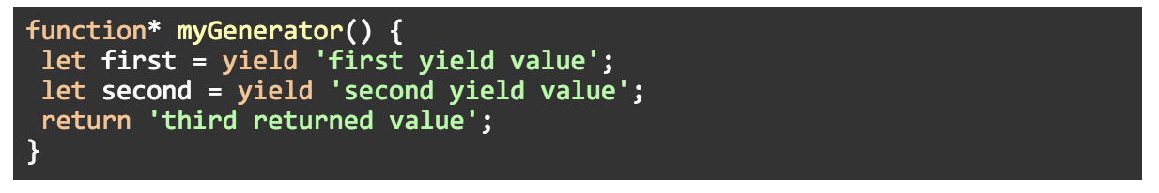

Generators are functions that can be paused and resumed, instead of executing all the statements of the function in one pass.

When you invoke a generator function, it will return an iterator object. With each call of the iterator’s *next()* method, the generator’s body will be executed until the next *yield* statement and then pause:

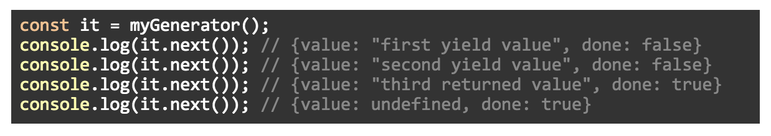

This can make asynchronous code easy to write and understand. For example, instead of doing this:

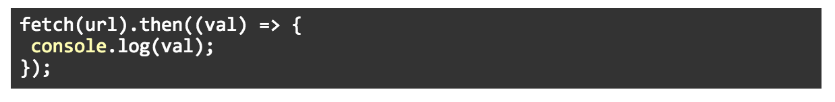

With generators, we could do this:



Back to redux-saga, we generally have a saga whose job is to watch for dispatched actions:

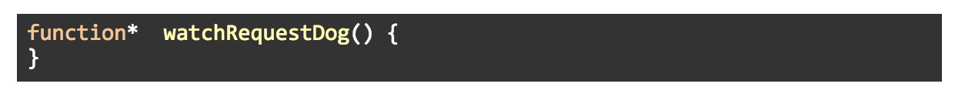

To coordinate the logic we want to implement inside the saga, we can use a helper function like [takeEvery](https://www.google.com/url?q=https://redux-saga.js.org/docs/api/%23takeeverypattern-saga-args&sa=D&ust=1507757792431000&usg=AFQjCNGVN_8Gok4Xtqz27qvg7i638H73Pw" \t "_blank) to spawn a new saga to perform an operation:

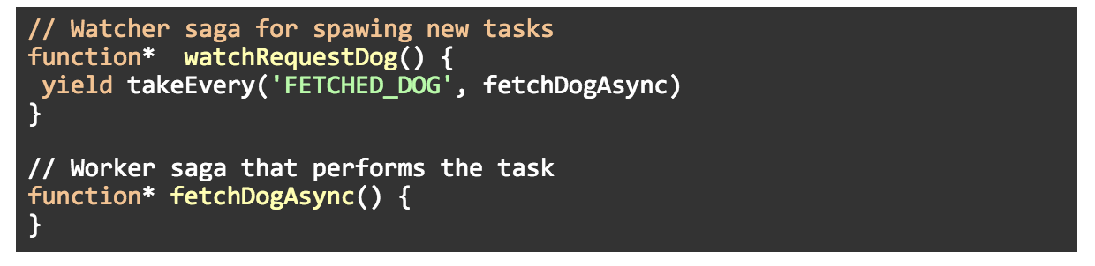

If there are multiple requests, *takeEvery*will start multiple instances of the worker saga. In other words, it handles concurrency for you.

Notice that the watcher saga is another layer of indirection that gives more flexibility to implement complex logic (but may be unnecessary for simple apps).

Now, we could implement the *fetchDogAsync()* function with something like this (assuming we had access to the *dispatch*method):

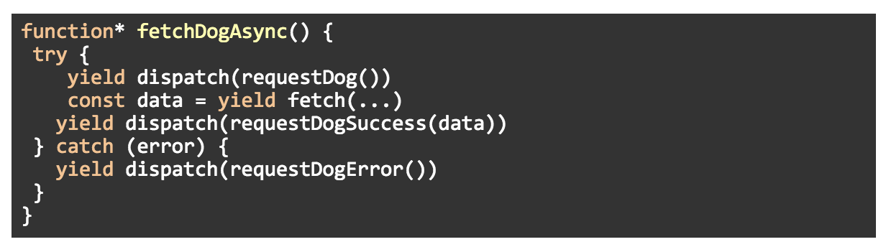

But redux-saga allows us to yield an object that declares our intention to perform an operation rather than yielding the result of executing the operation itself. In other words, the above example is implemented in redux-saga in this way:

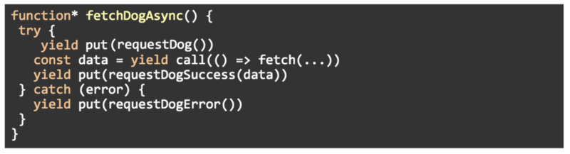

Instead of invoking the asynchronous request directly, the method *call* will return only a plain object describing the operation so redux-saga can take care of the invocation and returns the result to the generator.

The same thing happens with the *put* method. Instead of dispatching an action inside the generator, *put* returns an object with instructions for the middleware to dispatch the action.

Sources-

* americanexpress.io
* logrocket.com