Exercise 2— Structured Prediction for Parts-of-Speech Classfication
Avichai Ben-David, 203455126, avichai
Maor Ivgi, 204083141, maor_i

MLE Estimation
In order to measure performance differences between different sizes of training data, we used two measures: LogLikelihood and Test Error. We also tried few more measurements like learning time (minor difference as we can see below), Percentage of sentences we got completely right (which was very similar to our Test Error) and Train error. In order to account for the randomality in the data choice and prove our invariance to different training\test sets, we repeated the measurements 5 times, and averaged the results.

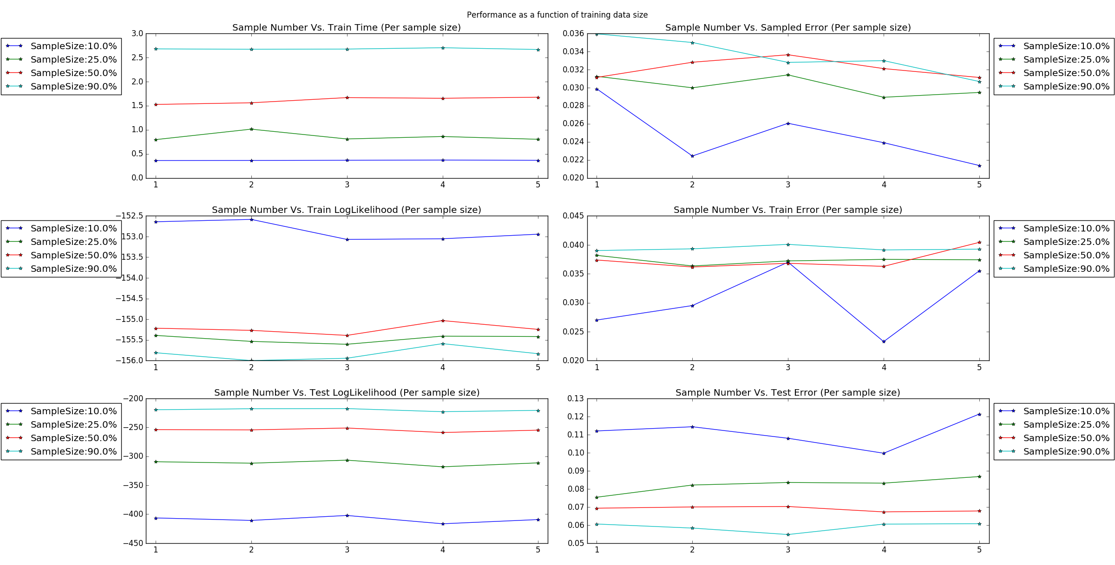
Legend: Each graphs plots a different result for each of the training data sample size |(in percentage of the entire corpus), colors match in all subplots. X axis is the repetitions (1-5).
Top Left: Training time (sec) Vs. repetition
Middle Left: Training data LL After ML estimation
Bottom Left: Test data LL After ML estimation
Top Right: Train error percentage
Middle Right: Sampled data error percentage
Bottom Right: Test data error percentage

In order to calculate LL of the test data given the ML estimation, we used the formula derived in class, normalized by the number of sentences (number of iterations in the original multiplication in the formula). We know that our motivation was to maximize this value (since log is a monotonic function and we want to maximize the likelihood). We can clearly see that the LL was significantly increased with respect to the size of the training set. We concluded that given more data, our estimation of the world was improved over unseen data (drawn from the same distribution under the HMM assumption), and it ‘seemed’ more likely.
This result is not strictly replicated in the training set LL, as we we can, and will discuss later.

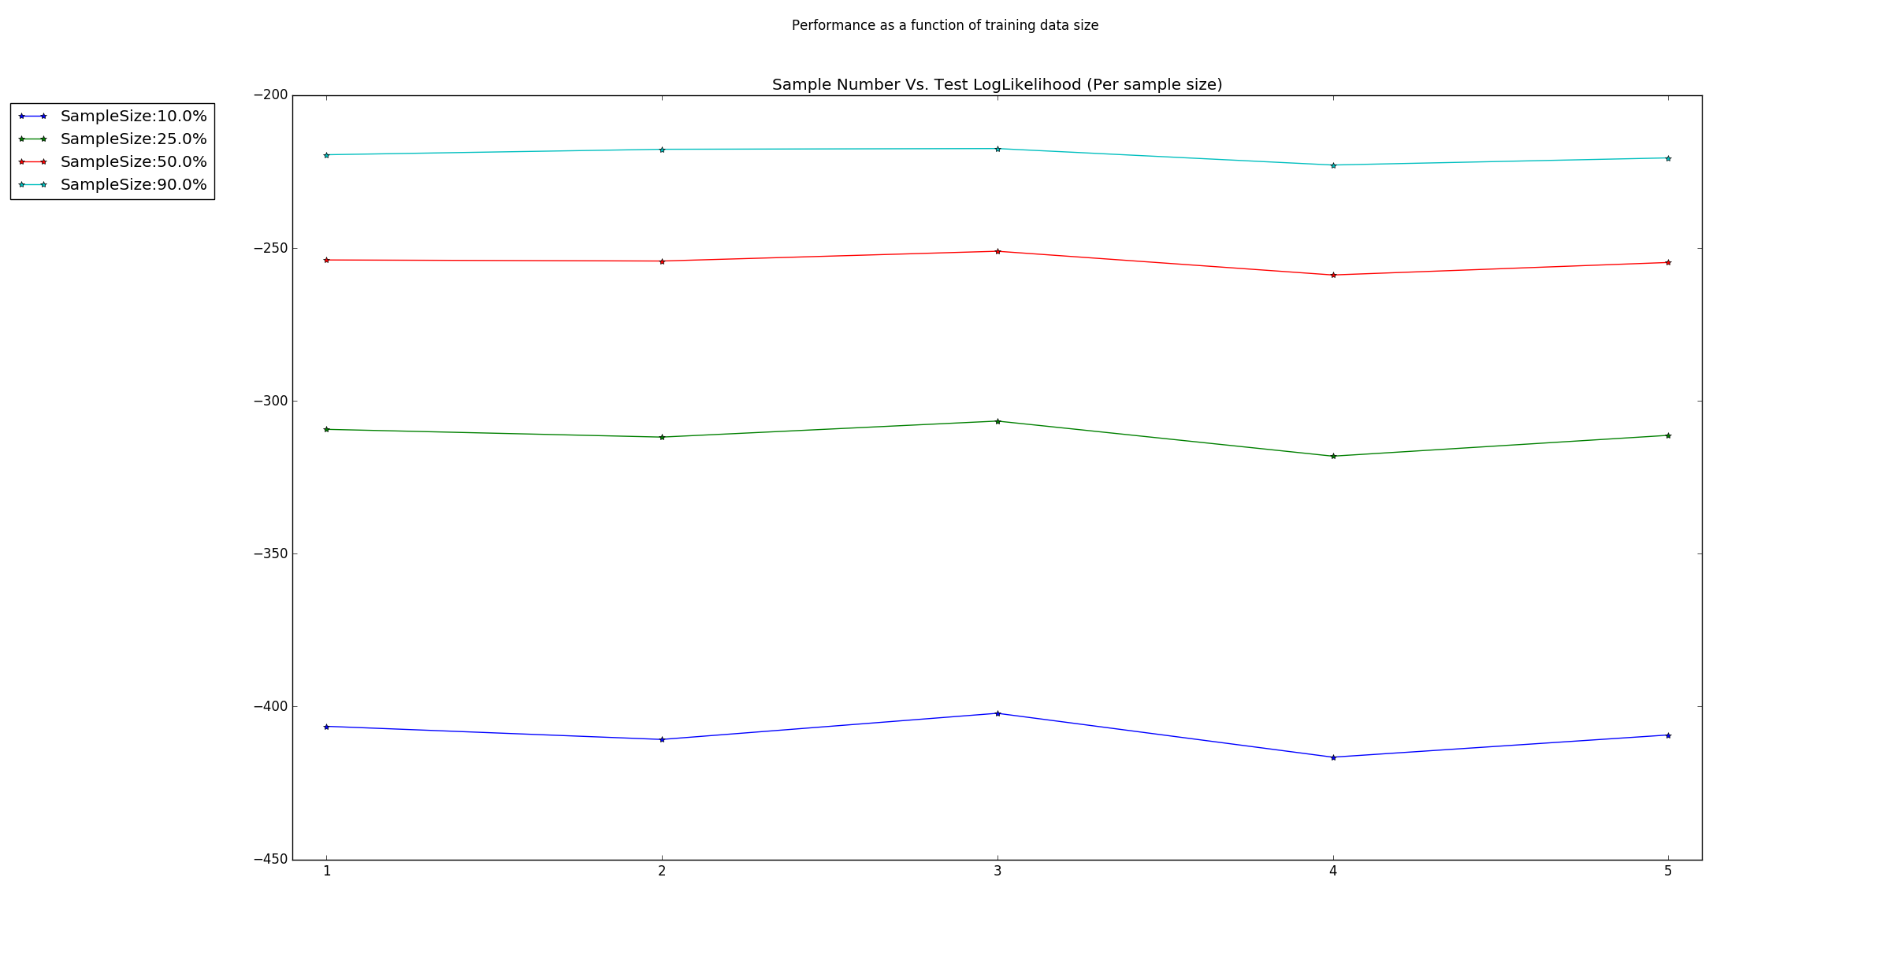

To calculate an estimator test error, we ran the Viterbi algorithm for inference using the estimated distributions on the test data, and measured the number of words (single POS in a sentence) we got wrong, divided by the total count of words in the test data. Other possible ways to measure this error would have been to count number of correct sentences, number of correct transitions or ‘punish’ more on longer sequences of being wrong. Looking at the results there could be no doubt left – more train data equals better results.
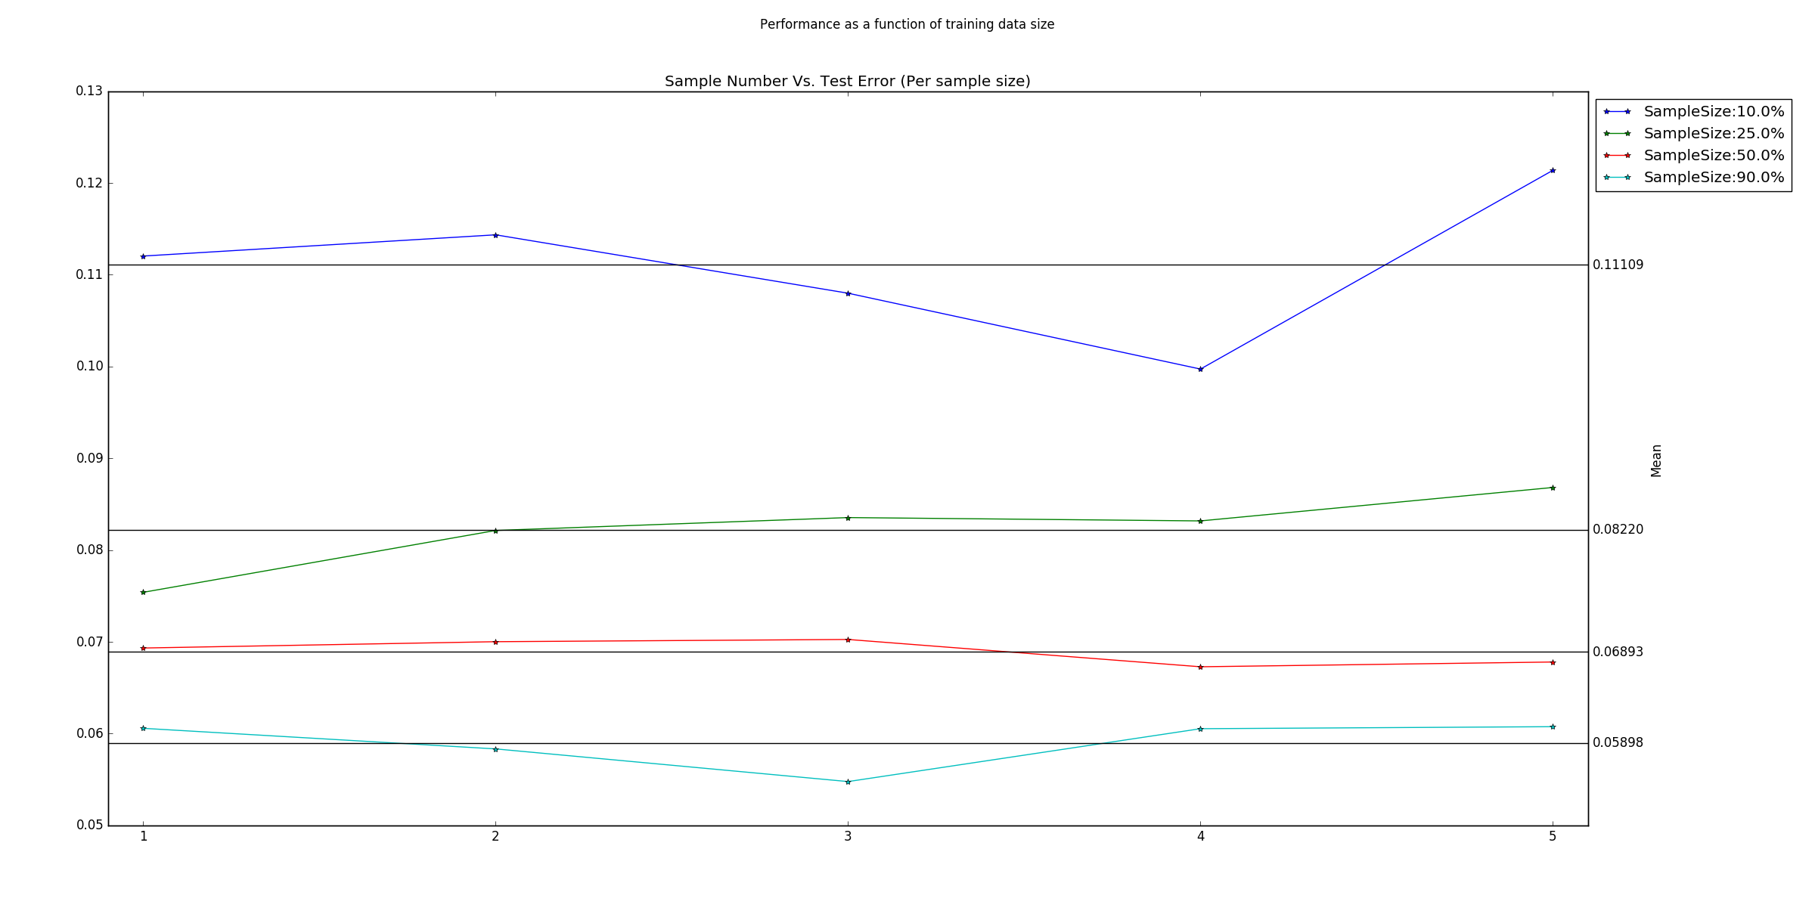

Inference
There are actually two parts of this question – first, we had to verify that the non-general Viterbi works properly, and then, we had to make sure the general version works as well.

To test the initial version of the algorithm, we used two techniques. First, we measured our train error (using the same method that was described in the previous question) and make sure it is very close to zero, both in absolute difference and compared to the test error. This should be true regardless the percentage of data used to train. Also, we sampled new data using the estimated distribution, and measured our error on it.

The point in measuring the error on sampled data was that if everything was done correctly (assuming sampling is done correctly), our error should be very small, and very similar to the train data error. This should be the case regardless of the distribution estimators. When fixing distribution parameters and using them both to sample data and to infer, the results should show good correspondence, I.e, low errors. Since our estimators were the argmax for the LL on the train set, it means sampled data should be completely matching to our estimation of the generative model of the training data, thus result in similar error rates. As we can see below, our assumptions were matched.

As we can see in the graph below, the train error was indeed very small, although it gets a bit higher when more data is involved. This is to be expected since more data means more generality needed to fit everything (we can’t be too ‘overfitted’). This is the same effect we see in the LL calculated over the train data.

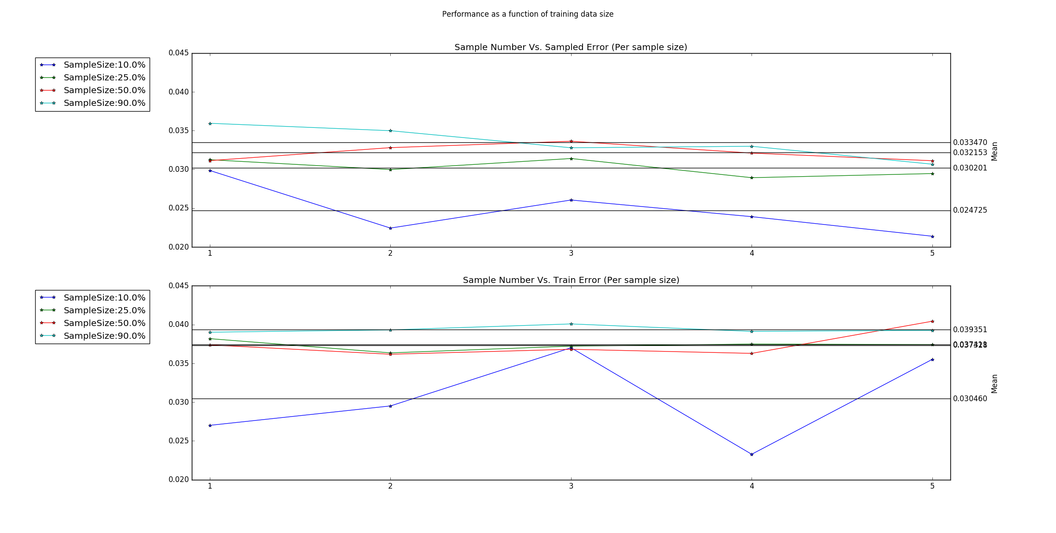
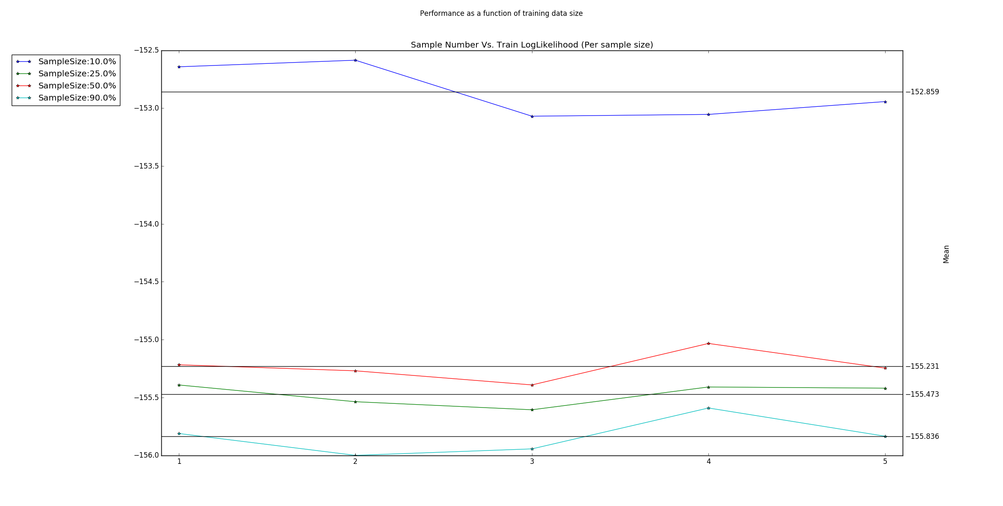
Next, we moved to the general Viterbi algorithm. Testing it was easy – we built the phi mapping and weight function which corresponds to the former algorithm, and measured both algorithms results on the data sets (train, sampled and test). In fact, as we expected the result were almost the same, except a small improvement when moving to the general inference algorithm. This improvement could be explained by numeric differences. In the first implementation, we didn’t use log-space so when working with a lot of data, underflow could occur which will affect the results (especially in long sentences). The general form however is immutable to this problem since it uses log-space in all the ‘problematic’ parts.

Alternative Models:
Three models, Different rates, different training data sets, average vs. last.

In our research we’ve created two more models in addition to the HMM
model.

The features of the first model (which we referred to as the ‘characteristic’ model) were:
1. Word suffixes (in particular, ‘ed’ and ‘ing’ suffixes).
2. Whether a word is all alphabetic characters or not.
3. Whether a word begins with an upper case letter.
4. Are there more than one upper cased letter in a word.
We looked at the vector space of phi’s range as a S by S by 5 matrix (where S is the size of the suppX). For each word, we calculated the 5 features, and placed True in the corresponding places in the corresponding cell (when t==0, the entire row of Xt was used)

We chose those features to impose some linguistic priors on the model. On their own, we expected to see mediocre results at best. However, we conjectured that combined with the original HMM model, those features could improve results on some for the POS’s, help improving the final test results. We called the combined model – the ‘Complex’ model. As we can see below, TODO

More models...TODO

As we can see although we got a large error (with respect to the MLE results for example) we clearly see that the model learned some of the data

More thoughts (pairs too big, word vs relative location in sentence)
Problems with run-time
Improvments: dynamic rate
Perceptron vs MLE
Talk about curves calc
Second degree HMM

