**GET GITHUB REPOSITORY**

Visual Design (Screen Minimized for taking screenshots)

Initial Screen before Search:

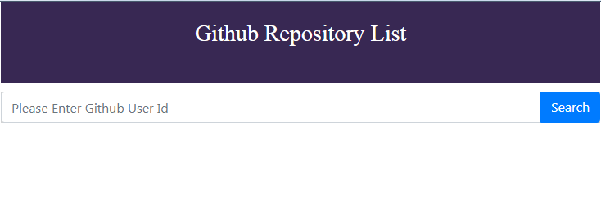

After Search:

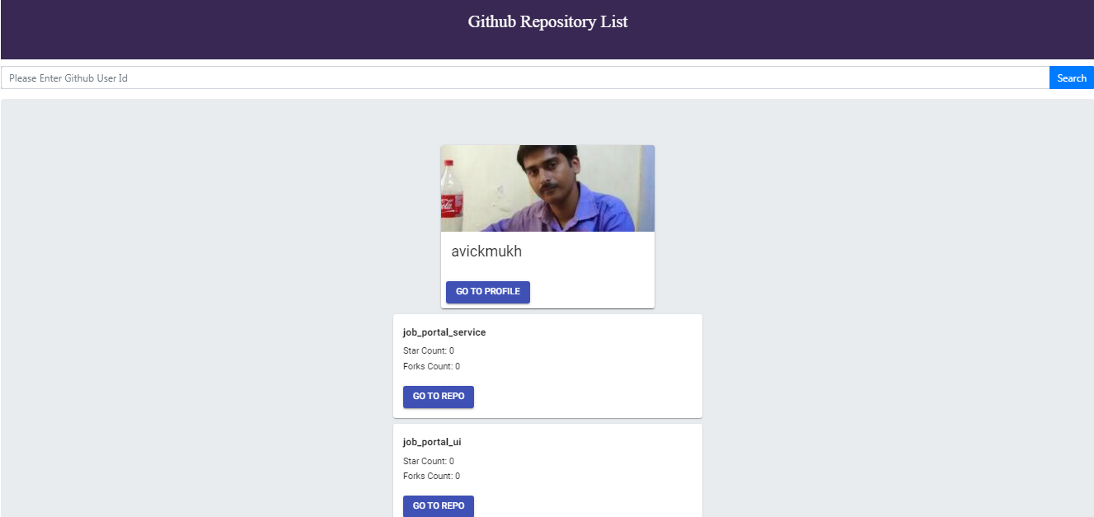

**Component Design:**

**GitRepo**

**GitRepo**

**GitRepo**

**App (Component)**

**UserProfile**

**LoaderComponent ( Global Component)**

**react-spinners/clipLoader ( Third Party Package)**

**SearchUser**

**react-bootstrap/Form (used for searching github profile)**

**GitRepoList**

**HeaderComponent**

**Index.js (starting File)**

**React Components:**

|  |  |  |  |  |
| --- | --- | --- | --- | --- |
| **Thirdparty package components:**   |  | | --- | | React-redux Components | | React-bootstrap Components | | React-spinners Components | | material-ui Components | |
| **Custom React components:**   |  | | --- | | UserProfile Component | | SearchUser Component | | LoaderComponent Component | | GitRepo Components | | HeaderComponent Component | | GitRepoList Component | |

**Redux Actions:**

|  |  |  |  |
| --- | --- | --- | --- |
| **Actions** | **Payload** | **Description** | **Side Effect** |
| GET_REPO_LIST_BY_USER_NAME | username | This action is used to get the github repo list by github username. It will change the reducer is isLoading flag to true | This action will call saga function getRepoListByUserName()  Saga will call api end point and get the result. If result is success then dispatch GET_REPO_LIST_BY_USER_NAME_SUCCESS action with list of repos and in error it will dispatch GET_REPO_LIST_BY_USER_NAME_ERROR action |
| GET_REPO_LIST_BY_USER_NAME_SUCCESS | repoData | This action will update the reducer state with repos and isLoading false |  |
| GET_REPO_LIST_BY_USER_NAME_ERROR | error | This action will update the reducer state |  |
| CLEAN |  | It will reset the reducer state to initial value |  |

**UNIT TESTING:**

For testing Jest and enzyme are used. Testing configuration on setupTest.js file and test cases inside src/tests folder.

Assumptions and Note:

1. Currently we are showing empty only for invalid username.
2. Error message notification is pending.
3. We used fetch to call the github endpoints.
4. Code base and how to run instructions mentioned in github page.