Alex Vickers

IST 441

Exercise 1

1.

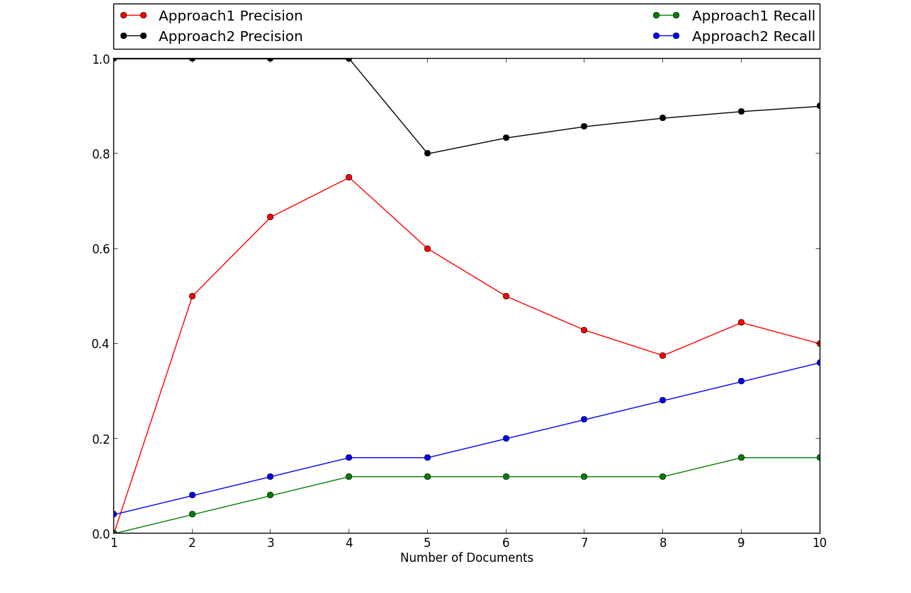

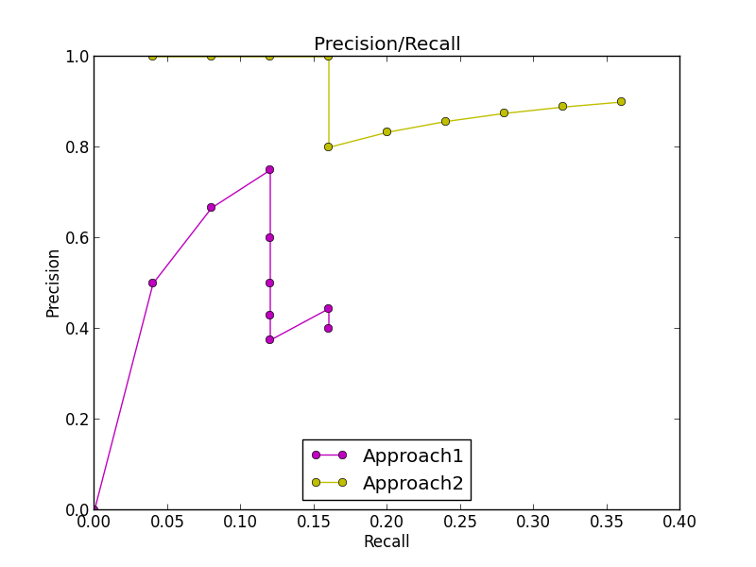

Based on the resulting graphs, it seems that approach 2 is best. Approach 2 performed better in precision, recall, and precision/recall than approach 1.

2. 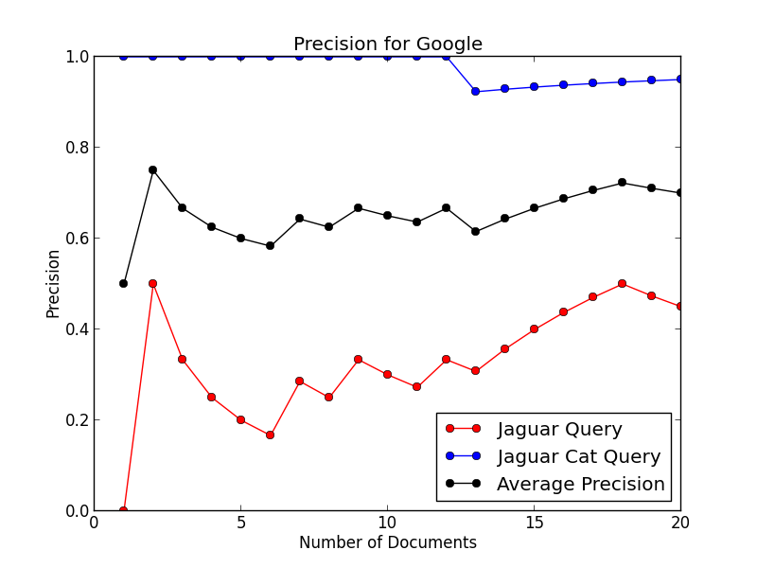

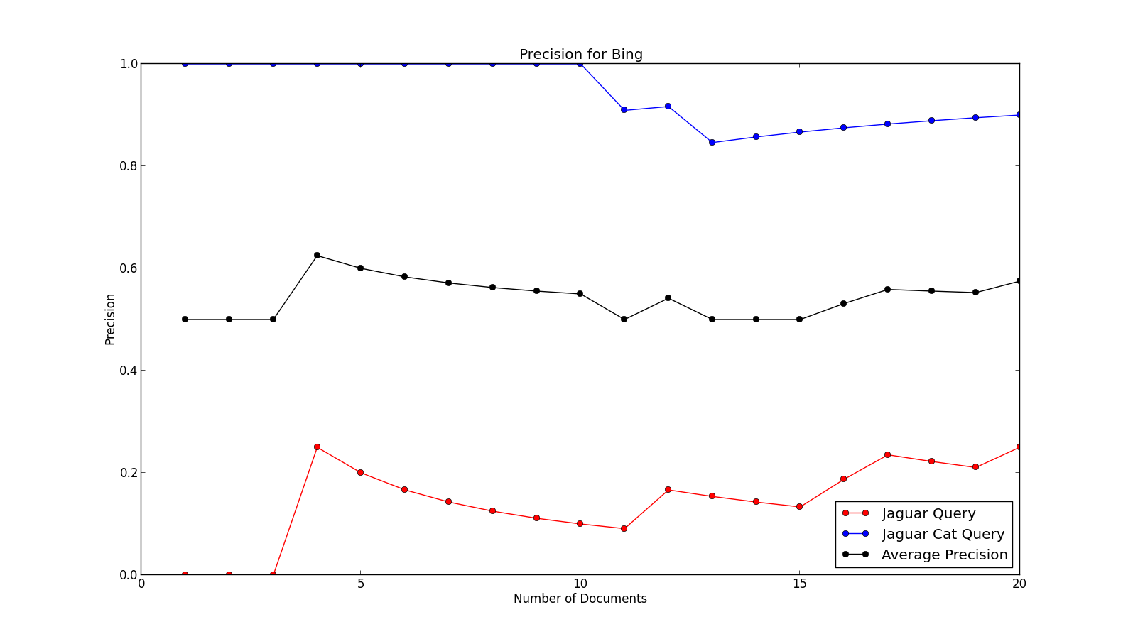

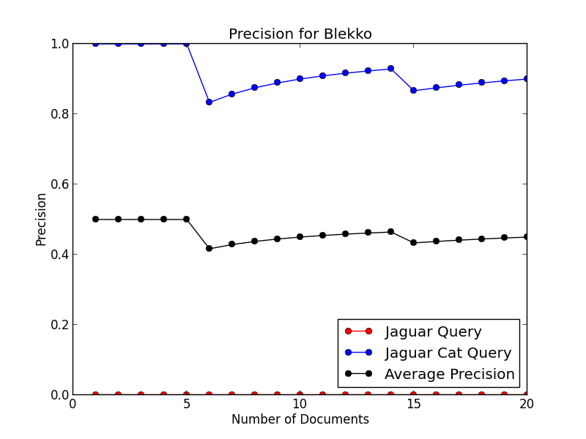

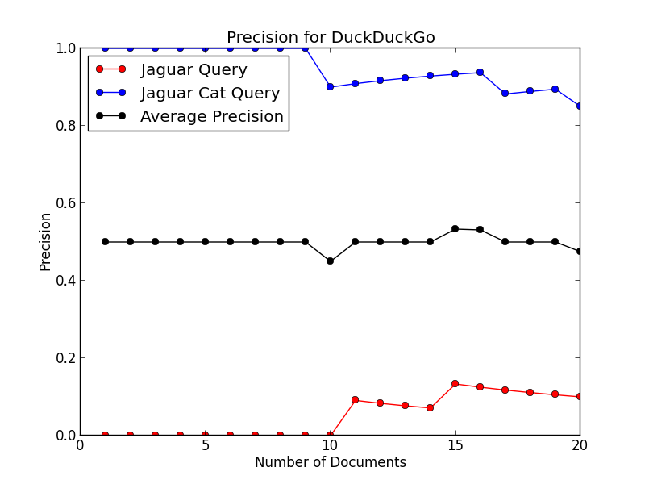

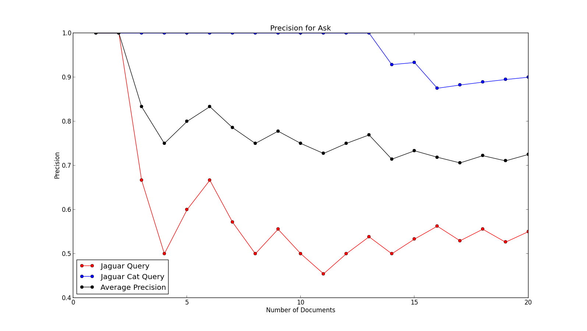

Based on the resulting graphs, Ask.com surprisingly averaged the best results for both queries. After that Google slightly edged out Bing, with DuckDuckGo and Blekko bringing up the rear. Despite Ask.com slightly edging out Google I still preferred Google, mainly due to familiarity with the search engine as I use it daily.