Paper Title
Author Name¹ Author Name² Author Name³
¹Department, University, Country, {name1,name3}@university.org
Company, Country, name2@company.com

Abstract
This template gives the guidelines on how to prepare a pa- per for submission to the Analytic Virtual Integration of Cyber-Physical Systems Workshop (AVICPS). Templates are available for both the LaTeX and the Microsoft Word environment. If there are any questions or suggestions regarding this template, please send an email to davbr@berkeley.edu.
Keywords keyword1, keyword2

Introduction

Title and Authors
The title should be centered using font Times New Roman with size 17pt. Words should be capitalized in the title, e.g., "This is an Example of a Correct Title".
The author information should at least include name, affiliation (department, university, country). Addresses and emails are optional but strongly recommended.

Abstract and Keywords
The abstract should be written as one paragraph. It is not recommended to exceed 150 words.
Appropriate keywords describing the content of the paper should be supplied as a comma separated list.

Fonts
Use Times New Roman with font size 10pt for the body text. To emphasize a text or a word, use italic font style. For verbatim text, including code examples, use font Courier New with size 9.5pt.

Lists
Bullets should be created using style "Bullets", not standard bullets. For example:

The 4th Analytic Virtual Integration of Cyber-Physical Systems Workshop December 3, 2013, Vancouver, Canada.
Copyright is held by the author/owner(s). The proceedings are published by
Linköping University Electronic Press. Proceedings available at:
http://dx.doi.org/10.3384/ecp13090
AVICPS website:
http://www.analyticintegration.org/
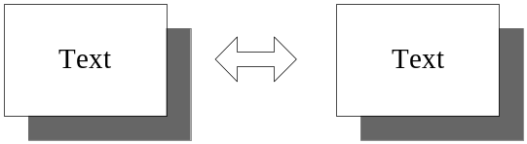

Figure 1. An example of a figure that fits into one column.

- The first text item.
- The second text item.
Numbered items should be created using style "Numbering". For example:
- The first text item.
- The second text item.

Paragraphs
The first paragraph after each subsection is not indented. Use style "Body Text First".
The second and all other paragraphs within a section should be indented. Use style "Body Text Indented".

Section Headings
Section headings should be numbered. Words in the headings should be capitalized. Use style "Heading 1".

Sub-Section
Subsections are numbered. Use style "Heading 2 SubSection".

Sub-Sub-Section
It is possible to use sub-sub-sections (style "Heading 3; SubSubSection"). If possible, however, use only sections and sub-sections.

Figures
Figures should be numbered and include a description text. All figures should be referenced within the body text using the capitalized word "Figure" followed by the figure number. For example, Figure 1 shows a figure located inside one column and Figure 2 illustrates how a figure can span over two columns.
All figures should have a single line separating the figure and the caption text.
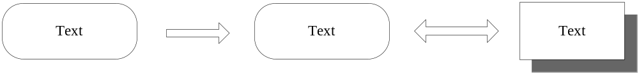

Figure 2. Another example of a figure that spans over two columns.

Bibliographic References
The bibliographic reference list should be shown at the end of the paper, starting with an unnumbered heading "References". The list of references should be sorted in alphabetic order according to the first author's surname.
Citations are stated within the body text using the number of the reference enclosed within brackets, e.g., [2]. If more than one reference is cited at the same place, the list should be sorted and within brackets, e.g., [1,3,4].

Output Format
The paper should be submitted as a PDF-file using page size A4 (not US Letter!). All fonts should be included in the PDF-file.
Note: When using PDF-generators such as Adobe Acrobat PDF generator, remember to enable high-quality output. If this option is not enabled, figures and photos may be reduced in quality, resulting in poor quality when printed.
Acknowledgements
The templates and instructions were created by David Broman. The LaTeX template and related class file is based on ACM SIGPLAN templates created by Paul C. Anagnostopoulos. The LaTeX templates is allowed to be used in the AVICPS workshop with permission from SIGPLAN executive committee 2013. No other usage is permitted.
References
- Iain S. Duff and John K. Reid. An Implementation of Tarjan’s Algorithm for the Block Triangularization of a Matrix. ACM Transactions on Mathematical Software, 4(2):137–147, 1978.
- Constantinos C. Pantelides. The Consistent Initialization of Differential-Algebraic Systems. SIAM Journal on Scientiﬁc and Statistical Computing, 9(2):213–231, 1988.
- Benjamin C. Pierce. Types and Programming Languages. The MIT Press, 2002.
- Gordon D. Plotkin. A Structural Approach to Operational Semantics. Technical report, Department of Computer Science, University of Aarhus, 1981.

Footnotes should be numbered and located at the bottom of the column.

