User Guide

1. When user open contacts management, below landing page gets shown.

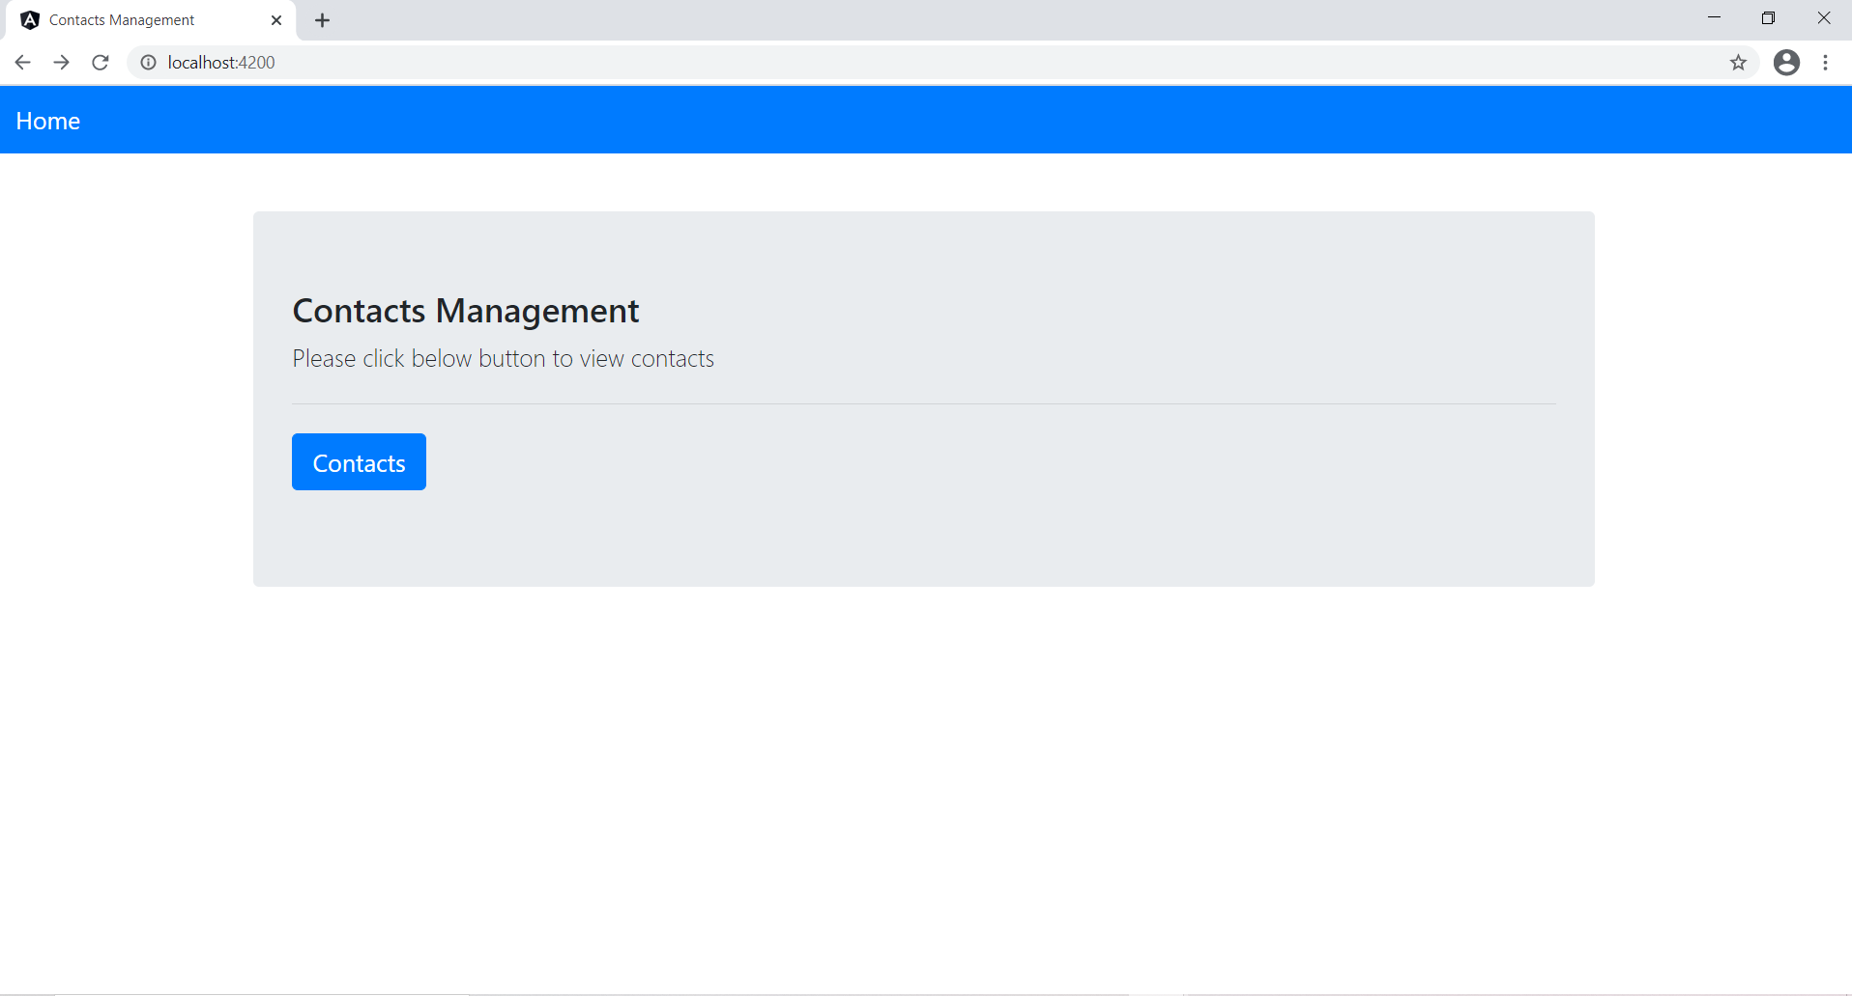

1. When user click on contacts button, contacts list gets display.

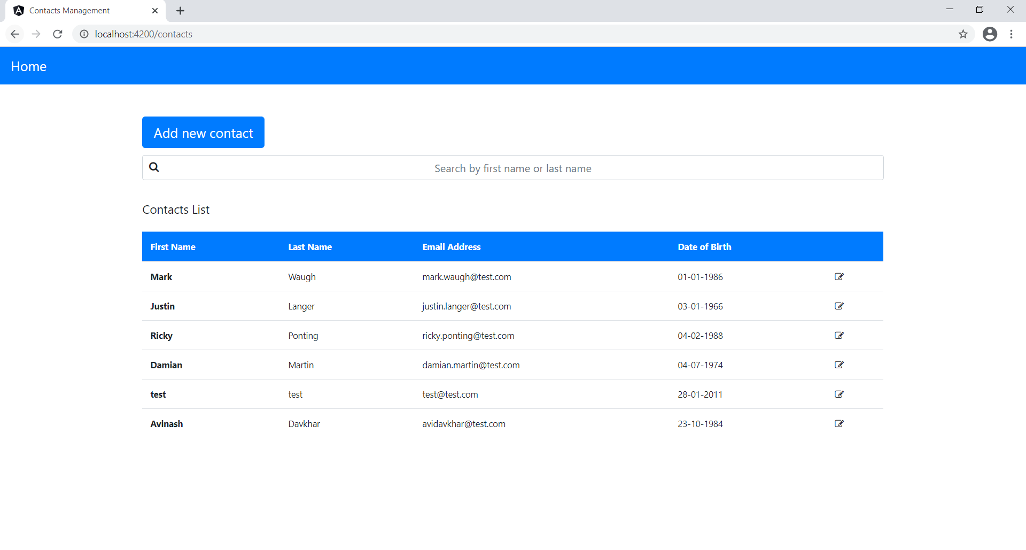

1. User could add new contact by clicking Add new contact button, then following page gets display.

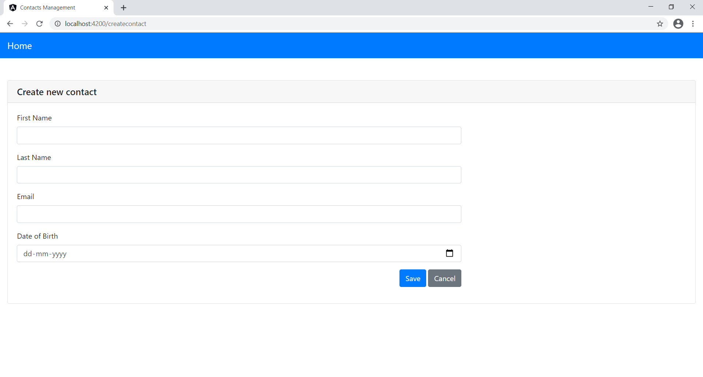

* 1. If user didn’t enter any details and try to save the contact, following validation messages gets display.

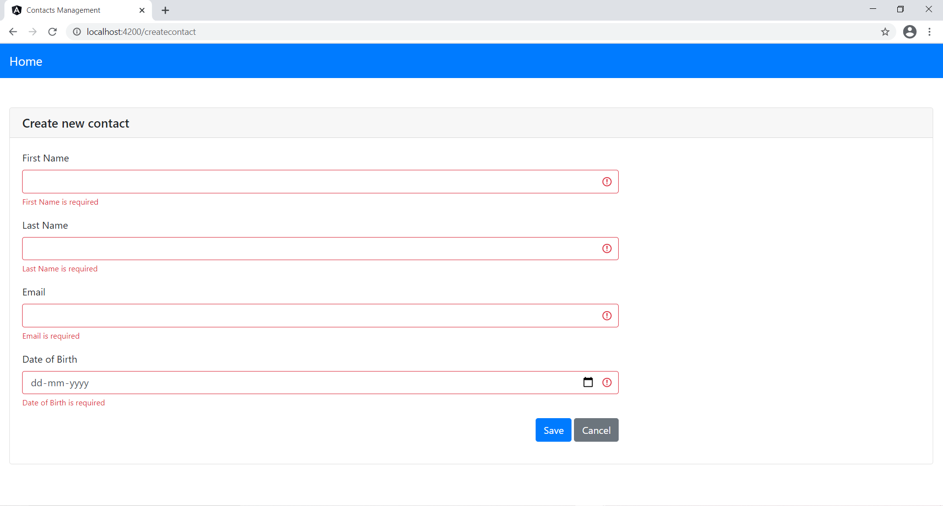

* 1. Once user enters correct details and click on save button, given below message get display on page.

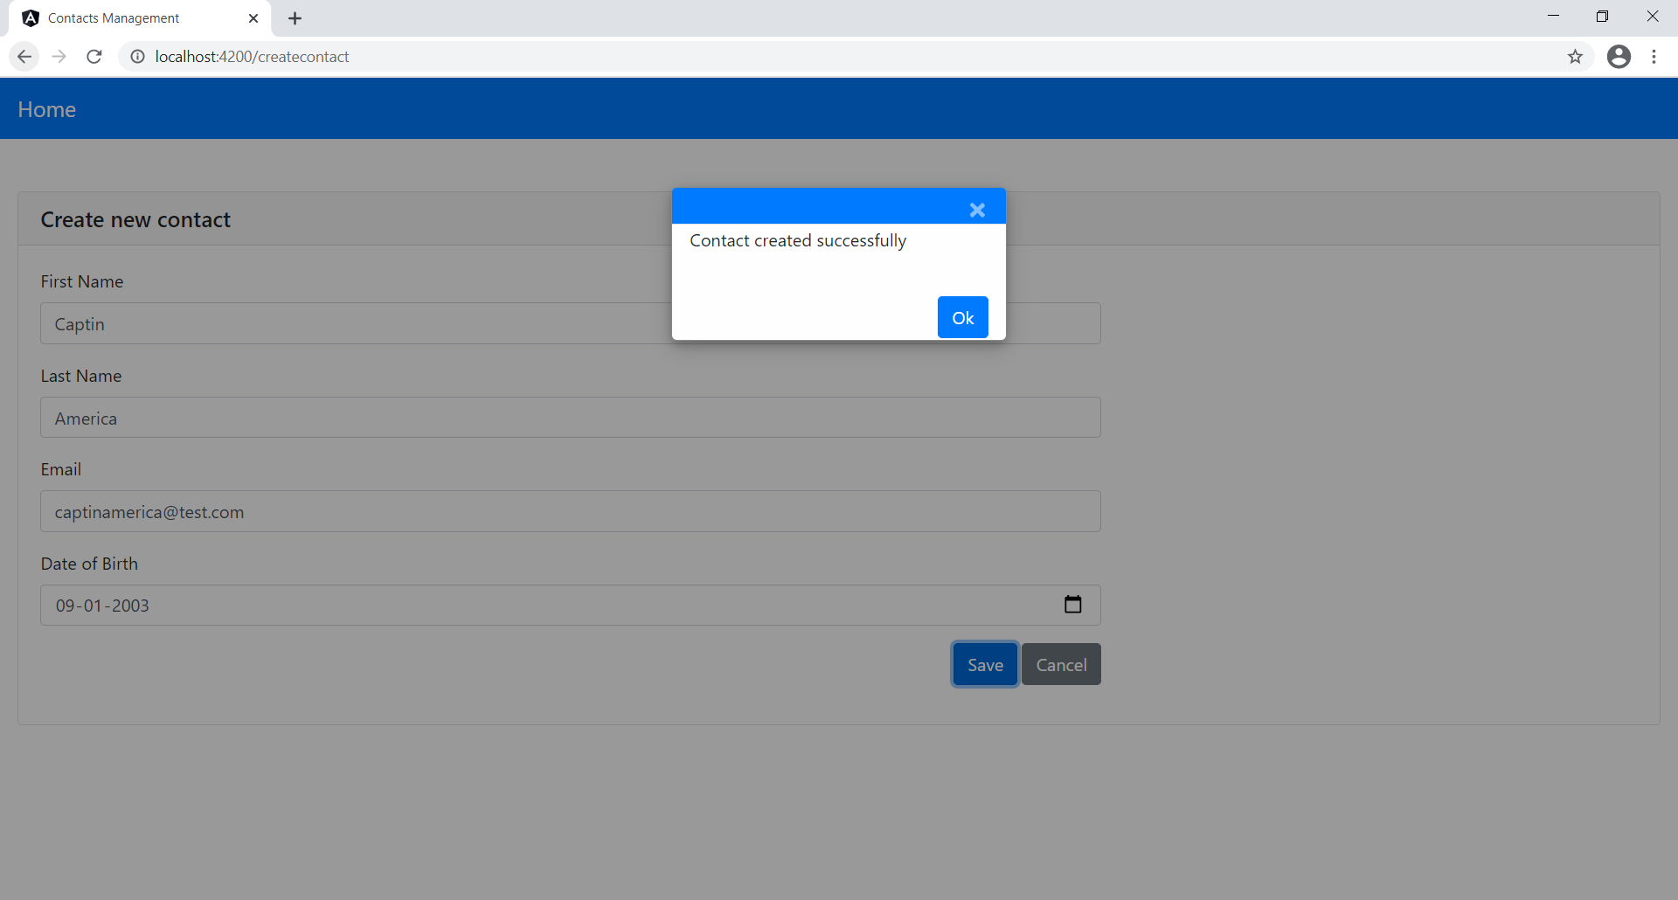

1. User could edit a contact by clicking on edit icon and after editing the contact details, once click on save button, then following message gets displayed on page.

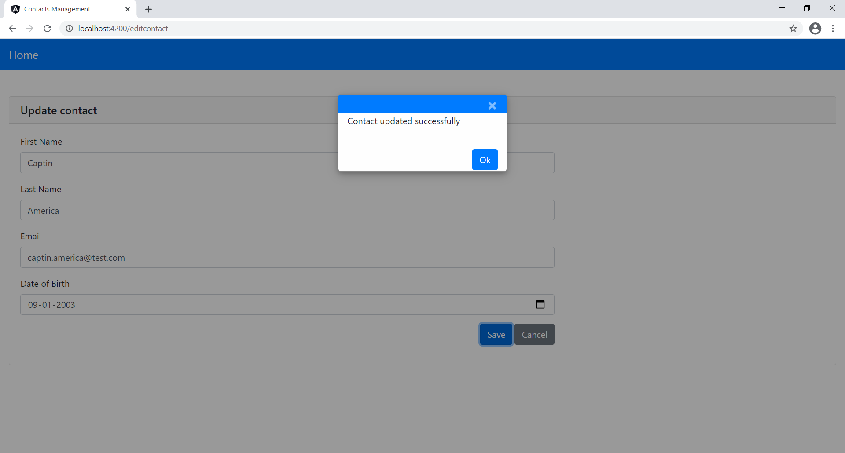

1. User could search contacts by either by entering first name or last name. Matching records gets display.

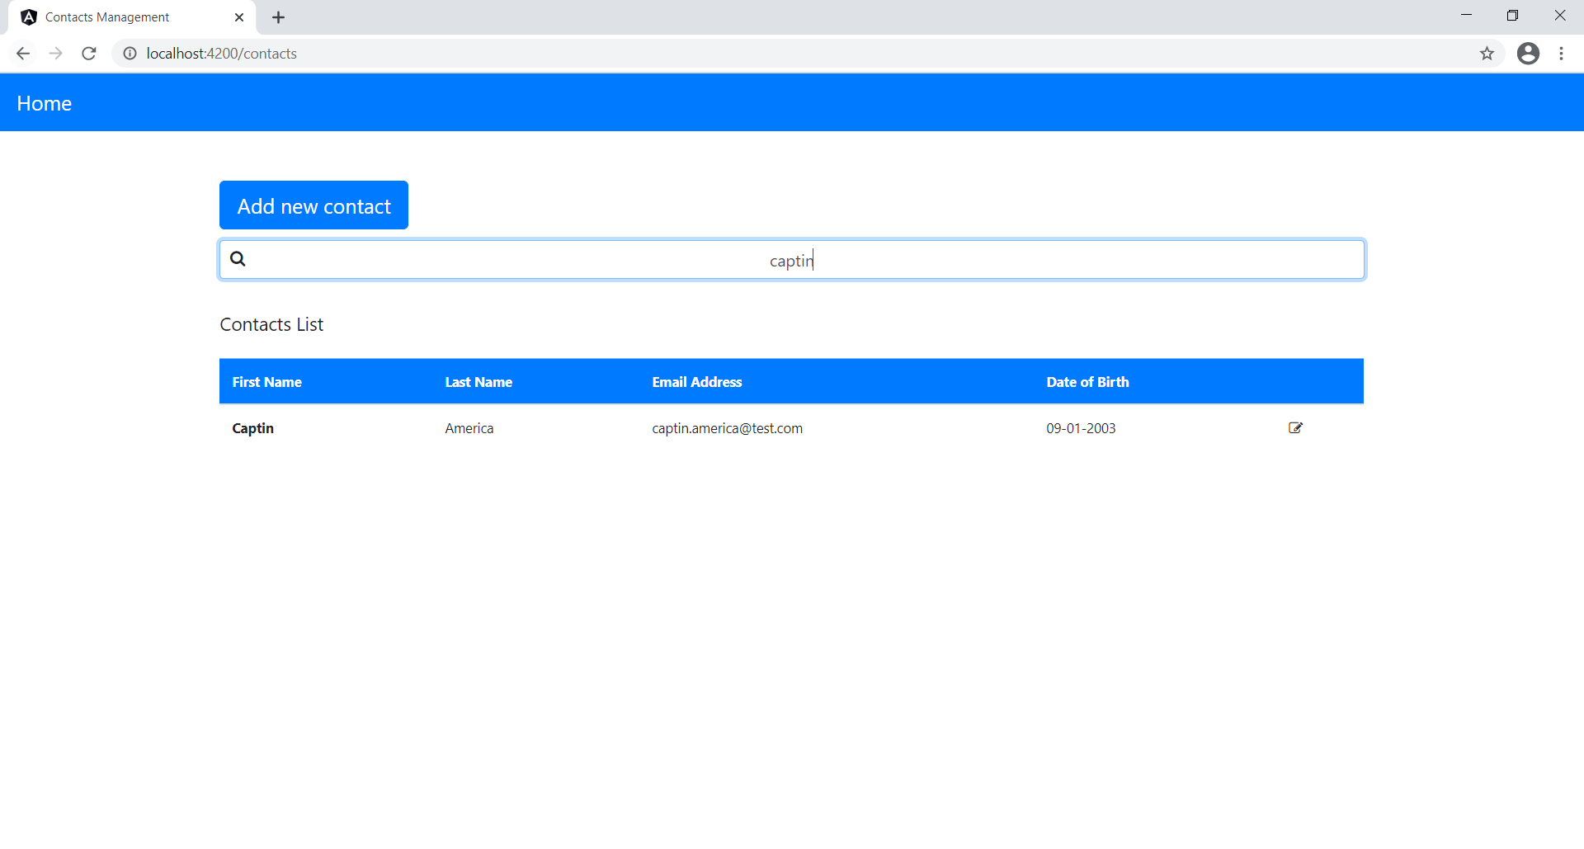

1. If user enter a existing email address of any other user while creating or editing contact, then bewlow error message gets display.

