**Smart Farming: “A Soil Nutrient Monitoring System”**

A Capstone Project Presented to the Faculty of

College of Information and Communications Technology

Iloilo State College of Fisheries

Main Poblacion, Barotac Nuevo, Iloilo

In Partial Fulfillment

Of the Requirements for the Degree

in Bachelor of Science in Information Technology

John Michael B. Manlupig

Joy M. Espinosa

John Ryan S. Bayona

Willbert S. Cabatingan

Christian Emmanuel M. Teodosio

**TABLE OF CONTENTS**

**CHAPTER**

**I** **INTRODUCTION**

Overview of the Current State of Technology 1

Statement of the Objectives 6

General Objective

Specific Objectives

Conceptual Framework 7

Significance of the Study 9

Scope & Limitation of the Study 10

Definition of Terms 11

**Chapter I**

**Introduction**

*Background of the Study*

Soil is a major source of nutrients for plant growth. Nutrients supplied by the soil are called mineral nutrients. The non-mineral nutrients such as carbon (C), hydrogen (H) and oxygen (O) come from air and water during photosynthesis. Soil mineral nutrients are separated into two groups: the macro and micronutrients. The macronutrients are further broken down into two groups, the primary and the intermediate nutrients. The primary nutrients are required by plants in relatively large proportions. These are the most famous; the nitrogen (N), phosphorus (P) and potassium (K) commonly referred to as NPK. The intermediate nutrients are required by plants in medium quantities, these are calcium (Ca) magnesium (Mg) and sulphur (S).

The micronutrients are required in relatively small proportions. They include iron (Fe), boron (B), manganese (Mn), copper (Cu), zinc (Zn), molybdenum (Mo), nickel (Ni) and chlorine (Cl). It is important to note that though the soil nutrients are separated into different groups (based on the quantity required by the plant), each nutrient is equally important. A shortage of any nutrient can limit the growth and yield of a plant. This is in accordance with Liebegs law of the minimum. (Efretuei, A., 2016)

The Department of Agriculture (DA) is the government agency responsible for the promotion of agricultural development by providing the policy framework, public investments, and support services needed for domestic and export-oriented business enterprises. As stipulated in the Philippine Development Plan (PDP) 2017-2022, Chapter 8, Expanding Economic Opportunities in Agriculture, Forestry, and Fisheries, the agriculture, forestry, and fisheries (AFF) sector is pivotal in generating employment for about a third of the country’s labor force, thereby reducing poverty and inequality for three-fourths of the poor who are in the rural areas.

**Problems Identified:**

Crops cannot receive accurate dosages of nutrients if done manually by the farmer/gardener. This can cause the crops to be either malnourished or die from too much nutrition. Measuring the state of the crops can be tedious as well.

* The farmer/gardener would take more time making sure to distribute the correct dosage of NPK nutrients before watering the crops.
* Measuring the current state of the crops such as the temperature, humidity, soil moisture and soil NPK levels can be tedious.
* Crops should not be watered with nutrients if it’s soil contains sufficient moisture and/or NPK nutrients.

*Statement of Objectives*

This study aims to design and develop a web application with embedded hardware for soil nutrient management.

Specifically, this study aims to:

1. Be able to distribute precise amounts of NPK nutrients into the container before watering the plants.
2. Monitor the current state of the crops such as temperature, humidity, soil moisture and soil NPK level.
3. Prevent the user from watering and distributing nutrients to the crops if it’s soil contains sufficient amounts of moisture and/or NPK nutrients.

Conceptual Framework

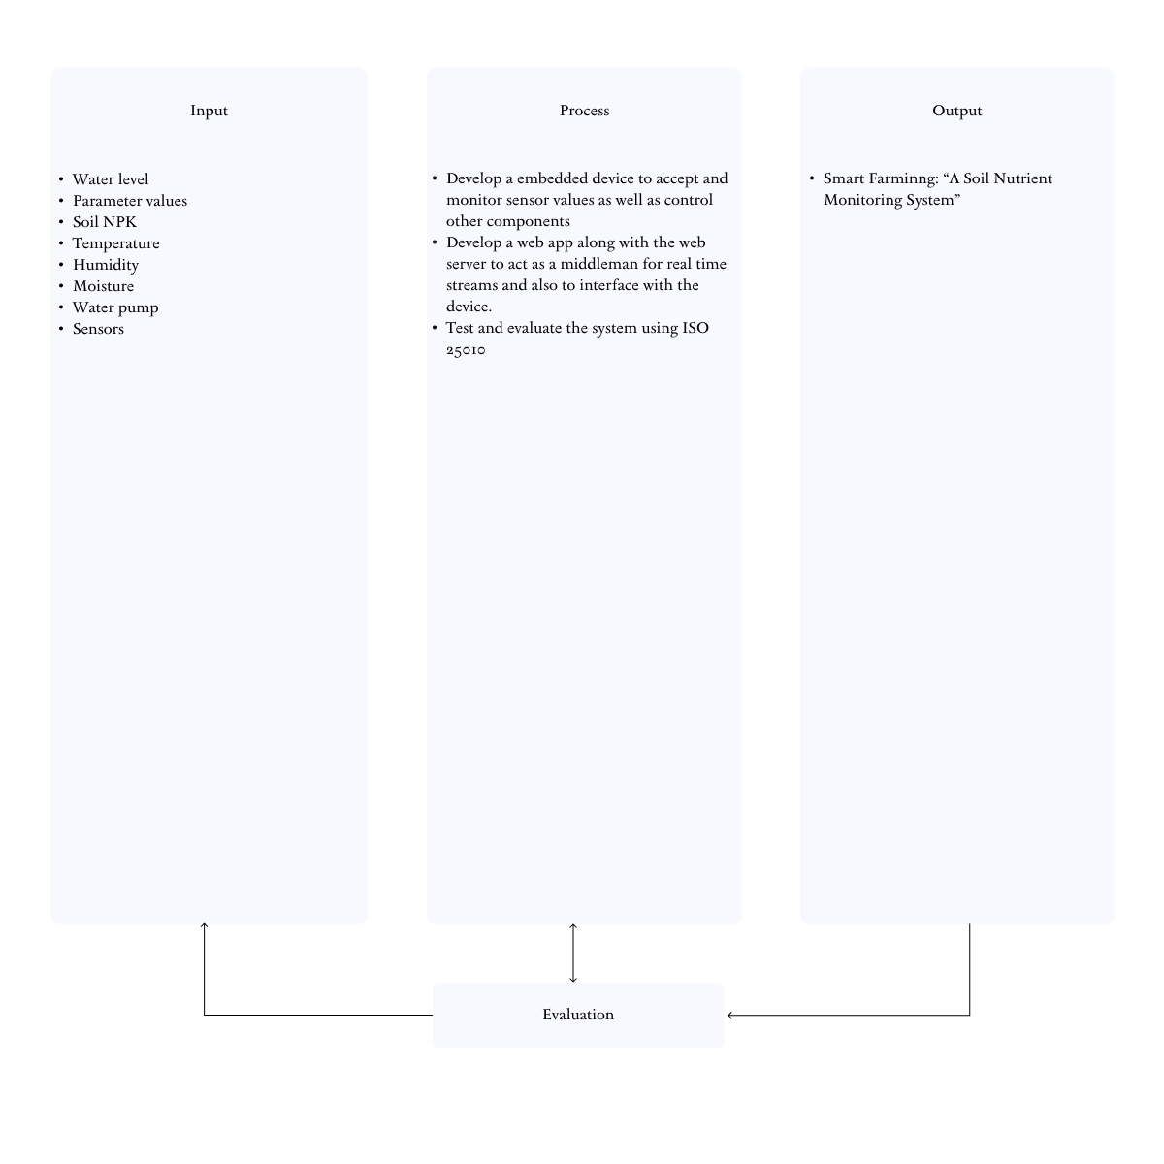

***Figure 1.*** *Conceptual Framework of the Study*

Figure 1 shows the conceptual framework diagram of a system designing the Smart Farming: “A Soil Nutrient Monitoring System”.

The inputs include water level, parameter values, soil NPK, temperature, humidity, moisture, water pump and sensors. The processes are to develop a device to accept and monitor sensor values as well as control other components and create a web app to interface with the device. The web app will also be the web server to contain the data inside the hardware’s memory as well as setup protocols for real time streaming of data.

Construction of a prototype on how the system works, testing and evaluating using ISO 2510 are the system’s processes. The output shows the development of the Smart Farming: “Soil Nutrient Monitoring System”.

The monitoring feature allows the user(s) to be notified and informed of the garden crops’ current states. Monitoring also provides feedback to control systems which can automatically regulate water via the water pump. Automation of several tasks as well as saving presets saves time and money for management.

On the other hand, NPK Sensors will be used to monitor the current nutrient levels in the soil. If the amount of nutrients is beyond the limit condition, water will not be distributed when the user(s) turn it on to prevent it from being sent to the crops.

Based on the existing theories, the concepts lead to the development of the Soil Nutrient Monitoring System for any concerned agencies/individuals that can make use of this system.

*Significance of the Study*

The study would be of great benefit to the following:

*DA - Technical Staff* -This project would benefit the DA - Staff in creating better automated management solutions for crops and garden gardens.

*ISCOF - Dingle Productive Enterprises* . This project will help increase production in their crop yields with lesser labor and arable agricultural land allocation.

*Farmers and Gardeners* - This project can potentially enable farmers to scale the amount of crops they can raise without needing to scale up the amount of human resources. Which can lead to better profits and less prone to human errors.

*Agriculture Students* - This project will help agriculture students by providing information on the various factors that affect plant growth, such as climate, water, pH level and nutrients. Students have wider opportunities to conduct experiments and research using the dynamic features of the system.

*The Researcher* - This endeavor offered a researcher an opportunity to value the project’s importance in enriching the knowledge and skills which served as the contribution to new technology related to farming.

*Future Researchers* - This project will serve as a reference to a similar study or project in the future.

*Scope and Limitation of the Study*

The study focuses on designing and developing a Soil Nutrient Monitoring System for Iloilo State College of Fisheries - Dingle Campus greenhouse farm. The system’s core features are:

* Distributing water with specific dosage amounts of NPK nutrients using a peristaltic pump.
* Monitoring several factors pertaining the health and status of the crops such as the room temperature, soil NPK level, moisture, and humidity.
* Preventing watering and distributing nutrients if the soil has sufficient amounts of moisture and/or NPK nutrients.

The mentioned components will be created with a Raspberry Pi 4 as it’s base. Ultrasonic water level sensors will be used to determine the volume level inside each nutrient and mixture water container. The system will use 12-volt, 5-volt and 3.3-volt power supplies.

*Definition of Terms*

For clarity and understanding, the following terms are defined:

*Raspberry Pi* - A low-cost Linux and ARM-based computer on a small circuit board sponsored by the charitable Raspberry Pi Foundation in the UK. Raspbian is the Debian-based Linux OS that is provided with the device.

*Dispenser* - One that dispenses or gives out, especially a machine or container, allows the contents to be removed and used in convenient or prescribed amounts. (American Heritage Dictionary, 2011)

*Peristaltic Pump* - A pump in which fluid is forced along by waves of contraction produced mechanically on flexible tubing. (Merriam Webster Dictionary)

*Nutrient* - is a substance used by an organism to survive, grow, and reproduce. The requirement for dietary nutrient intake applies to animals, plants, fungi, and protists. Nutrients can be incorporated into cells for metabolic purposes or excreted by cells to create non-cellular structures, such as hair, scales, feathers, or exoskeletons.

*Sensor* - a device that responds to a physical stimulus (such as heat, light, sound, pressure, magnetism, or a particular motion) and transmits a resulting impulse (as for measurement or operating a control). (Merriam Webster Dictionary)

*PWA (Progressive Web App) -* is a type of application software delivered through the web, built using common web technologies including HTML, CSS and JavaScript. It is intended to work on any platform that uses a standards-compliant browser, including both desktop and mobile devices. (<https://web.dev/progressive-web-apps>)

*Water* - a clear, colorless, odorless, tasteless, odorless liquid essential for plant and animal life and constitutes, in an impure form, rain, oceans, rivers, lakes, etc. It is a neutral substance, an effective solvent for many compounds, and is used as a standard for many physical properties. (Collins English Dictionary, 2014)

As used in this study, it refers to the liquid used to give the plants moisture and nutrients when mixed with nutrient solutions.

**Chapter II**

**Review of Related Literature**

*OneSoil*

OneSoil is an app for precision farming. It enables farmers to monitor crops remotely, find problem spots in fields, add notes, apply variable fertilizer rates, create seeding prescriptions, and monitor crop rotation. It also checks the weather forecast, and calculates nitrogen, phosphorus, and potassium fertilizer rates. (<https://onesoil.ai/en/>)

*Soil Test Pro*

Soil Test Pro is an app for testing and sampling soil. It also includes GPS Field Mapping, Grid Sampling or Zone Sampling, and Field Boundary tools. It has both a web and mobile version of their app for a complete nutrient management system and it also works offline. (<https://soiltestpro.com/>)

*Ag PhD Soils*

Ag PhD Soils is a Do-It-Yourself soil sampling mobile application where soil is sampled by acres. They have a Data and Precision AG Solution with zone-based sampling, variable-rate prescriptions, high-frequency satellite imagery, mixed fleet telematics devices and on-farm weather stations. (<https://agphdsoils.com/>)

*Soil-app: a tool for soil analysis interpretation*

Soil-app is a web application with a friendly click-point interface built through packages lodged in R software. The app is an advanced model of an open-source platform to support teaching and learning activities in soil analyses and fertilizer recommendations. Soil-app includes soil test interpretation, soil amendment calculations (lime and gypsum), the fertilizer rate for the most important crops in Brazil, an NPK blend calculator, and NPK blend evaluation. It also includes experimental statistical analysis as applied to soil science. Soil-app is a user-friendly and high-performance tool, garnering fast adoption by both students and professionals. (<http://www.scielo.br/scielo.php?script=sci_arttext&pid=S0103-90162021000101404>)

*Mrittikā: a soil nutrient analysis and recommendation software*

mrittikā is a soil nutrient analysis and recommendation software. It works thanks to the collaboration of agricultural entrepreneurs and farmers: the entrepreneurs offer soil testing services to the farmers, then analyse the results and finally recommend the best possible fertilizers to the farmers. (<http://www.fao.org/e-agriculture/news/mrittik%C4%81-soil-nutrient-analysis-and-recommendation-software>)

|  |  |  |  |  |  |  |
| --- | --- | --- | --- | --- | --- | --- |
|  | One Soil | Soil Test Pro | Ag PhD Soils | Soil-app: a tool for soil analysis interpretation | Mrittikā: a soil nutrient analysis and recommendation software | Smart Farming: “A Soil Nutrient Monitoring System” |
| Nutrient Dispenser |  |  |  | X |  | X |
| Temperature Monitor | X |  |  |  |  | X |
| Humidity Monitor | X |  |  |  |  | X |
| Moisture Monitor | X |  |  |  |  | X |
| Usage Reports | X | X | X |  |  | X |
| User Manual | X | X | X | X | X | X |
| NPK Nutrient Monitor | X | X | X | X | X | X |

Table 1. Review of Related Literature & Systems

*Summary*

The diagram above shows the different applications that have their own distinctive features, similarities, and goals, such as One Soil, Soil Test Pro, Ag PhD Soils, Soil-app: a tool for soil analysis interpretation, and Mrittikā: a soil nutrient analysis and recommendation software. The developed systems and applications have similarities which are common to the previous studies such as, mobile and web application, nutrient monitoring, user manual and usage reports. The system will be available for all mobile and web users.

**Chapter III**

**Methodology**

*Project Description*

The proposal Smart Farming: “A Soil Nutrient Monitoring System” application monitors the state of the crops in a garden such as it’s nutrients, humidity, temperature and moisture. It is also able to distribute water and nutrients with precise doses.

The system will be available in the Web, Desktop, iOS and Android platforms. The researchers have chosen to support cross-platform to make sure that there is accessibility for almost every user with different devices. To cover these platforms, a Progressive Web Application will be made in order for it to be accessible as a mobile, desktop and web application.

*Process Development*

The waterfall model is a linear project management approach, where stakeholder and customer requirements are gathered at the beginning of the project, and then a sequential project plan is created to accommodate those requirements. The waterfall model is so named because each phase of the project cascades into the next, following steadily down like a waterfall. It’s a thorough, structured methodology and one that’s been around for a long time, because it works. Some of the industries that regularly use the waterfall model include construction, IT and software development. However, the term “waterfall” is usually used in a software context.

Waterfall Methodology Overview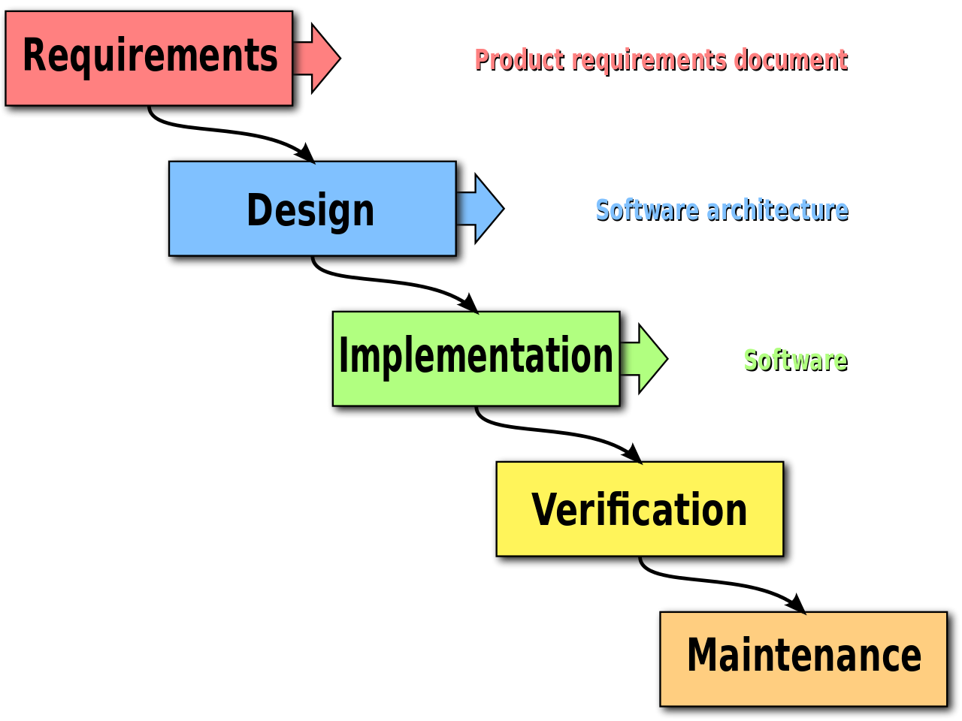

Requirements

Design

Implementation

Verification

Maintenance

***Figure 2.*** *Agile Methodology*

*Requirement gathering and documentation*

In this stage, comprehensive information about what the project should be gathered. This information can be gathered in a variety of ways, from interviews to questionnaires to interactive brainstorming. By the end of this phase, the project requirements should be clear, and should have a requirements document that has been distributed to the team.

*System Design*

Using the established requirements, the team designs the system. No coding takes place during this phase, but the team establishes specs such as programming language or hardware requirements.

*Implementation*

Coding takes place in this phase. Programmers take information from the previous stage and create a functional product. They typically implement code in small pieces, which are integrated at the end of this phase or the beginning of the next.

*Testing*

Once all coding is done, testing of the product can begin. Testers methodically find and report any problems. If serious issues arise, the project may need to return to phase one for reevaluation.

*Maintenance*

The product has been delivered to the client and is being used. As issues arise, your team may need to create patches and updates to address them. Again, big issues may necessitate a return to phase one.

*Requirements Analysis*

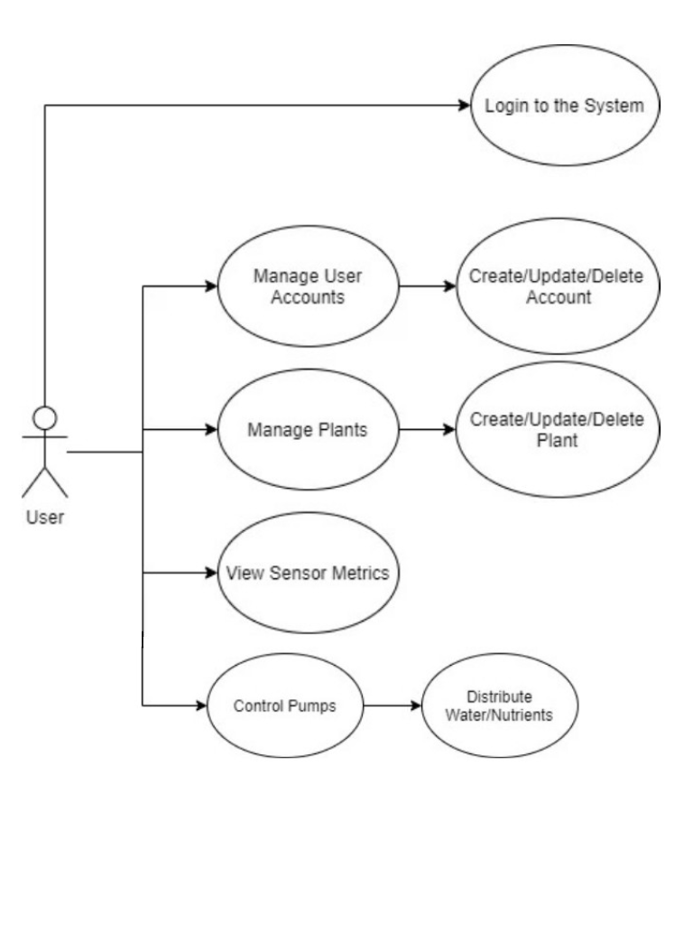

***Figure 3.*** *UML Use Case Diagram for the User of Smart Farming: “A Soil Nutrient Monitoring System”*

It describes how the user will use the system. The actor (user) must login first and then interact with the various features of the application to manage the crops as well as the other various features that are available in the system.

*Equipment Layout*

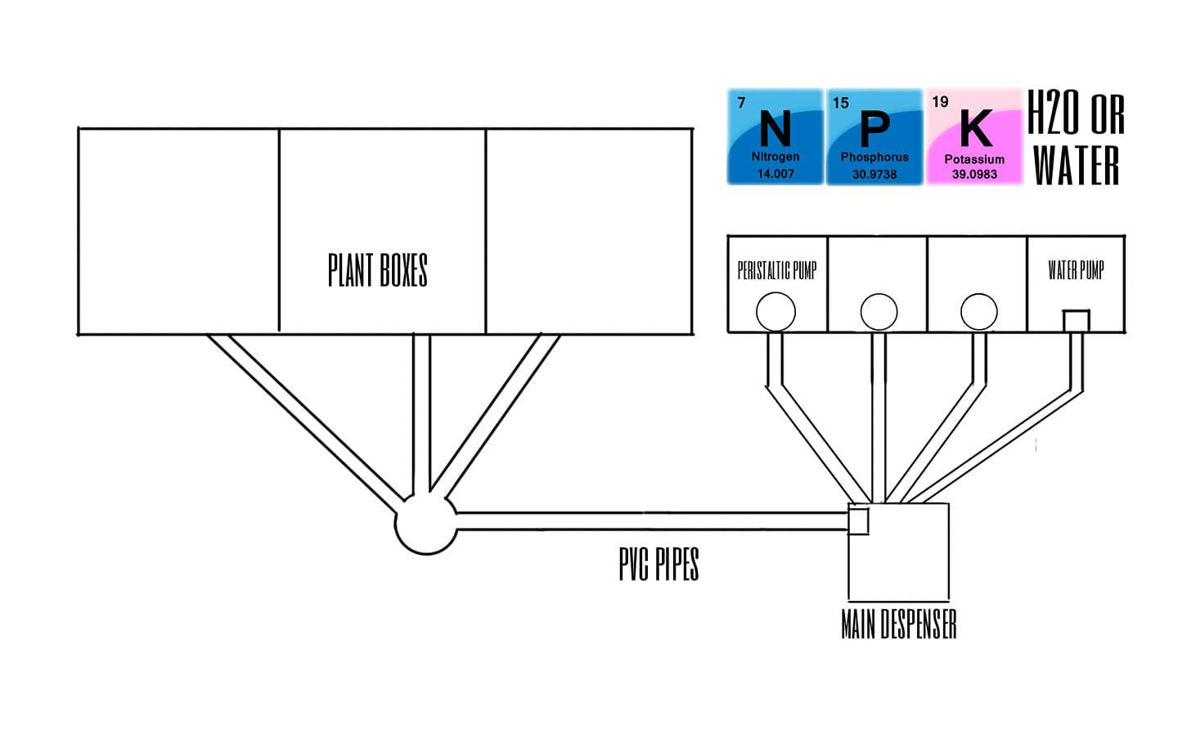

***Figure 4.*** *Design Prototype of Smart Farming: “A Soil Nutrient Monitoring System”*

The design above shows how the nutrients and water will be stored and distributed to the system. The three boxes with circles are containers for Nitrogen, Phosphorus and Potassium. Peristaltic pumps will be used to distribute precise amounts to the main container. There is also another separate water container just in case clean water needs to be added without any nutrients to the main container.

*Circuit Diagram*

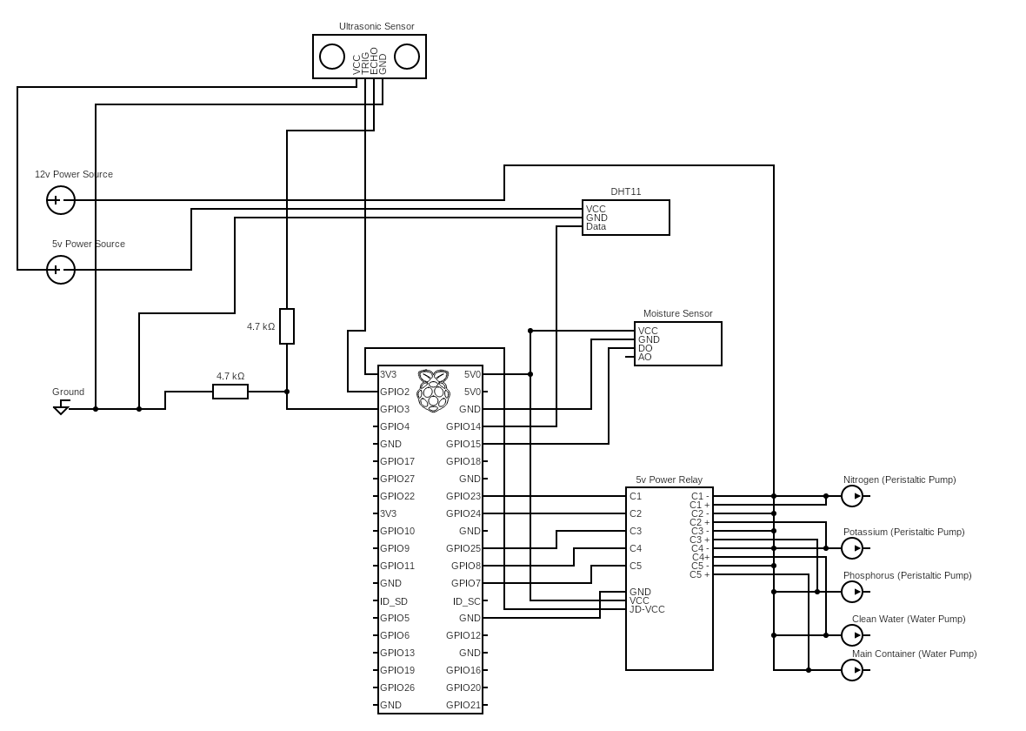

***Figure 5.*** *Circuit Diagram of Smart Farming: “A Soil Nutrient Monitoring System”*

The diagram above explains how the sensors are connected to their respective power sources and to the Raspberry Pi. The following is a brief explanation of each component:

1. Ultrasonic Sensor - Is used to measure the water level by emitting sound and measuring the time it takes to come back.
2. DHT11 - A sensor for measuring the temperature and humidity of the surroundings.
3. Power Relay - Is a relay board for controlling current in devices, this is used for turning devices on or off programmatically.

*Operation and Testing*

Smart Farming: “A Soil Nutrient Monitoring System” primarily provides help for the users to be more productive, get more accurate feedback and be able to tend to crops in a more precise manner compared to farming manually.

To test the system, the researchers choose;

**Black Box Testing** – Test the System to determine the errors and malfunction of the application. Black testing is a method of software testing that examines the functionality of an application without peering into its internal structure or workings.

**White Box Testing** – Test and determine the internal structures of the System and its work as an application, as opposed to its functionality.

*Project Evaluation*

**Product Quality**

The system was evaluated to check its conformance to ISO 25010:2011 software quality model was adopted for the evaluation of a particular user of Smart Farming: "A Soil Nutrient Monitoring System". In particular, it used Functional Suitability, Performance Efficiency, Compatibility, Usability, Reliability, Securing, Maintainability, Portability for product quality. For quality in use, Effectiveness, Efficiency, Satisfaction, Freedom from risk, Context Coverages. Thirty-four (34) sub-characteristic were used to solicit judgement of the evaluators. These sub- characteristics are:

**Functional Suitability** – in this degree to which a product or system provides functions that meet stated and implied needs when used under specified conditions. The sub-characteristics includes: (1) Functional completeness – the set of functions covers all the specified task and user objective. (2) Functional correctness – application provides the correct results with the needed degree of precisions. (3) Functional appropriateness – the functions facilitate the accomplishment of specified tasks and objectives.

**Performance Efficiency** – represents the performance relative to the number of resources used under stated conditions. The sub-characteristics include: (1) Time behavior – the response and processing times throughput rates of products of systems when performing functions and meeting requirements. (2) Resource utilization – the amount and types of resources used by a product or a system, when performing its function and meets requirements. (3) Capacity – the maximum limits of a product or system parameter meet requirements.

**Compatibility** – which a product, system or component can exchange information with other products. The sub-characteristics include: (1) Co-existence – a product performs its required functions efficiently while sharing a common environment and resources with other products, without detrimental impact on any other product. (2) Interoperability – two or more systems, products or components can exchange information and use the information that has been exchanged.

**Reliability** – to which an application component performs specific functions under specified conditions for a specified period of time. The sub-characteristics include: (1) Maturity – to which an application meets needs for reliability under normal operation. (2) Availability – to which an application is operational and accessible when required for use. (3) Fault tolerance – to which an application operates as intended despite the presence of hardware or software faults. (4) Recoverability – to which an application can recover the data directly affected and re-establish the desired state of the system.

**Maintainability** – the degree of effectiveness and efficiency with which an application can be modified to improve it, correct it or adapt it to change in environment and in requirements. The sub-characteristics include: (1) Modularity – to which an application is composed of discrete components such that a change to one component has minimal impact on other components. (2) Analyzability – the ability to diagnose the deficiencies or causes of failures. (3) Testability – tests can be performed to determine accuracy of the system.

**Usability** – application can be used by specified users to achieve specific goals with effectiveness, efficiency and satisfaction in a specified context of use. The sub-characteristics includes: (1) appropriateness recognizability – to which users can recognize whether a product or system is appropriate for their needs. (2) Learnability –to which an application enables the user to learn how to use it with effectiveness, efficiency in an emergency situation. (3) Operability – to which an application is easy to operate, control and appropriate to use. (4) User error protection – to which an application or system protects the user against making errors. (5) User interface esthetics – to which a user interface enables pleasing and satisfying interaction for the user. (6) Accessibility – to which an application can be used by people with the widest range of characteristics and capabilities to achieve specific goals in a specified context of use.

**Portability** – that application can be transferred from one hardware, software or other operational usage environment to another. The sub-characteristics include: (1) Adaptability – application can effectively and efficiently be adapted for different or evolving hardware, software or other operational or usage environments. (2) Installability – in which applications can be successfully installed and/or uninstalled in a specified environment. (3) Replaceability – in which an application can replace another specified software product for the same purpose and the same environment.

*Quality in use*

**Effectiveness** – accuracy and completeness with which users achieve specified goals.

**Efficiency** – resources expended in relation to the accuracy and completeness with which users achieve goals.

**Satisfaction** – degree to which user needs are satisfied when a product or a system is used in a specified context of use. The sub-characteristics include: (1) Usefulness – which a user is satisfied with their perceived achievement of pragmatic goals, including the results of use and consequences of use. (2) Pleasure – which a user obtains pleasure from fulfilling their personal needs.

**Freedom from Risk** – which a product or a system mitigates the potential risk to economic status, human life, health or environment. The sub-characteristic includes: (1) Health Safety Risk Mitigation – a product or a system mitigates the potential risk to people intended contexts of use.

**Context Coverages** – degree to which a product or system can be with effectiveness, efficiency, freedom from risk and satisfaction in both specified context of use and in context beyond initially explicitly identified. The sub-characteristics includes: (1) Context Completeness – system can be used with effectiveness, efficiency, freedom from risk and satisfaction in all specified contexts of use. (2) Flexibility – system can be used with effectiveness, efficiency, freedom from risk and satisfaction in contexts beyond those initially specified in the requirements.