loading the data 1
loading file 1
remove TP electrode 1
Arrange the data 1
button pressed and video state 1
focus level 2
std analysis 2
plot histogram 11
calculate mean level 12

loading the data
Avigail's Path

loading file
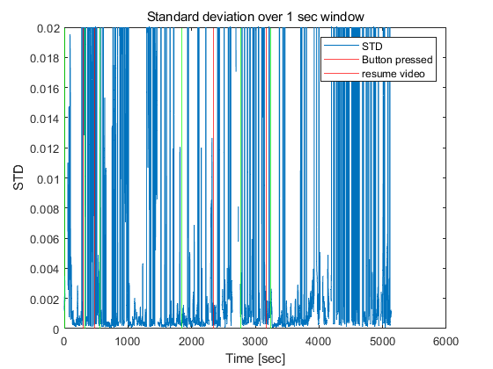

remove TP electrode

Arrange the data

button pressed and video state
out_button = zeros(1,2);

focus level

std analysis
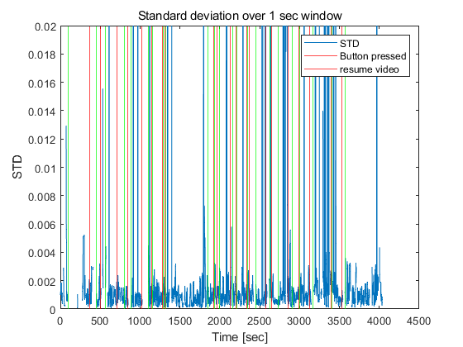
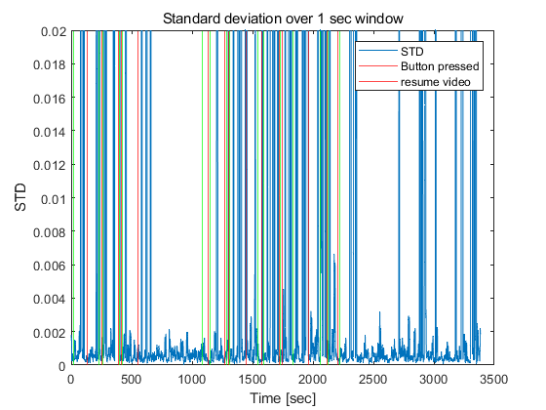
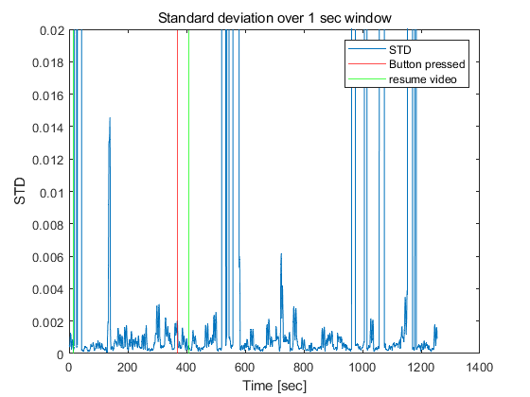
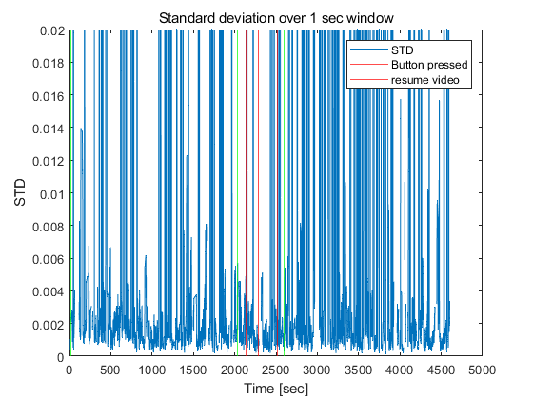
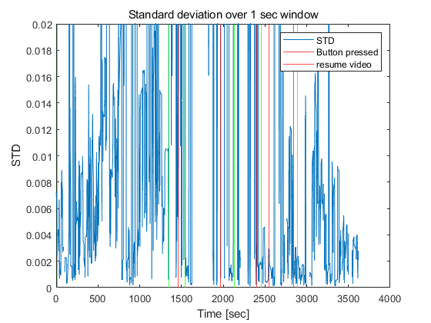
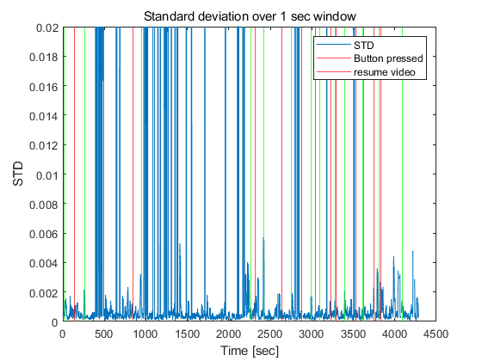
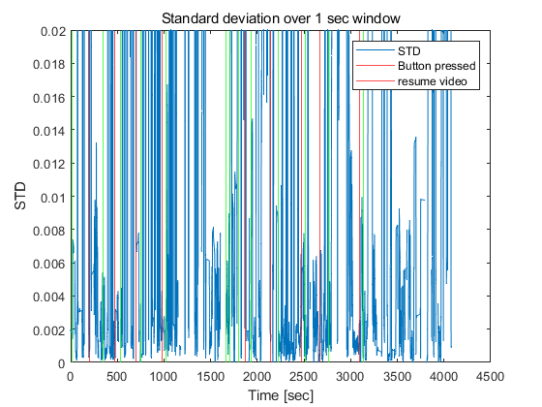
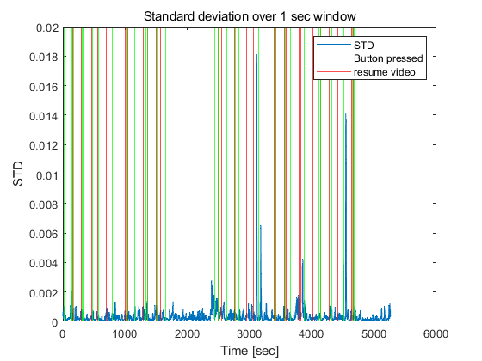
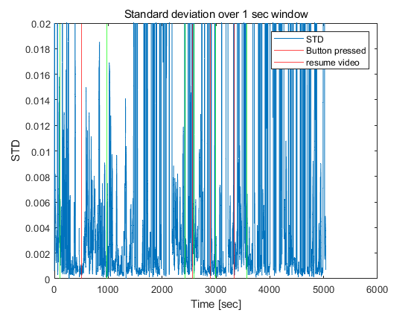
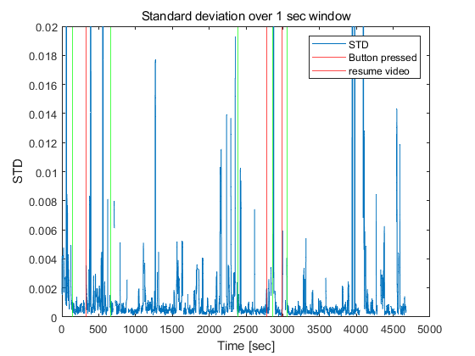
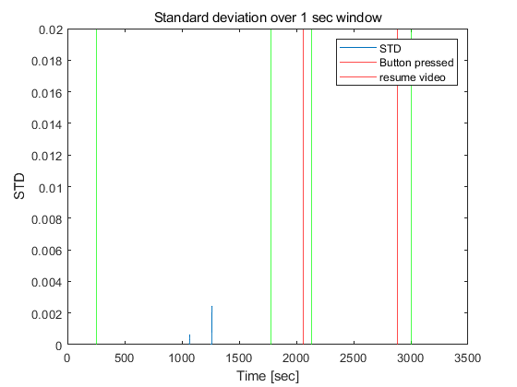
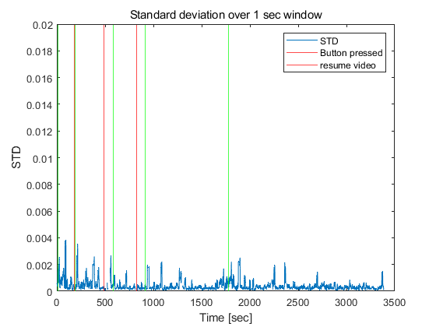
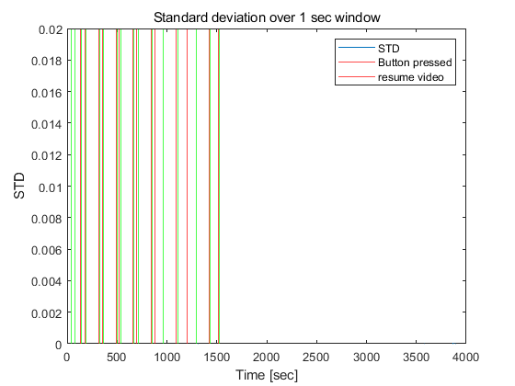
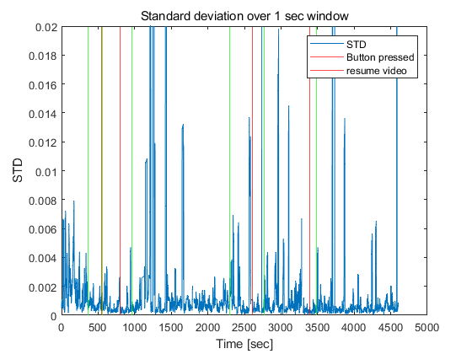
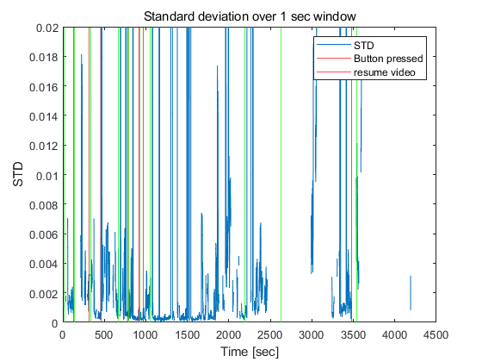
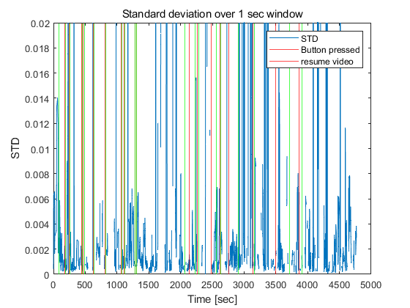
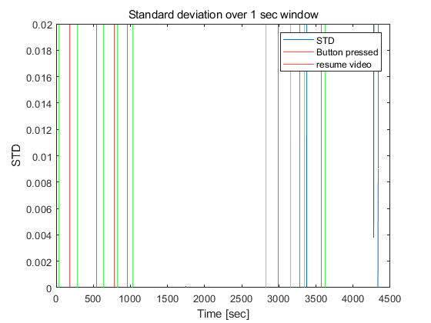
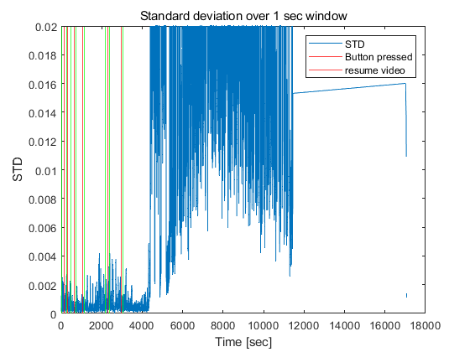

plot histogram
mean_pressed = mean(before_pressed);
mean_after_pressed = mean(after_pressed);
edges = 0:0.1:5;
All = [before_pressed;after_pressed];
edges = 0:max(All(:))/20:max(All(:));
if before_pressed
[N_before(s,:), edges_before(s,:), N_after(s,:), edges_after(s,:)] = plot_before_and_after_pressed(recordings_file(s).name, edges, before_pressed, after_pressed, ms_time);
Max(s,1) = edges_before(s,(find(N_before(s,:) == max(N_before(s,:)),1,'first'))+1);
Max(s,2) = edges_after(s,(find(N_after(s,:) == max(N_after(s,:)),1,'first'))+1);
All = [before_pressed;after_start_video];
edges = 0:max(All(:))/20:max(All(:));
[N_before(s,:),edges_before(s,:), N_resume(s,:), edges_resume(s,:)] = plot_before_pressed_and_after_video_resume(recordings_file(s).name, edges, before_pressed, after_start_video, ms_time);
Max(s,3) = edges_resume(s,(find(N_resume(s,:) == max(N_resume(s,:))))+1);
end

calculate mean level
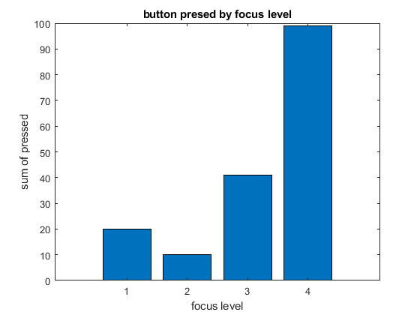
Published with MATLAB® R2022a

