- To make "python main.py" run and returns results – I was needed to change the ports on main.py file from:
# request_current_from_ammeter(5001, b'MEASURE_GREENLEE') # Request from Greenlee Ammeter
# request_current_from_ammeter(5002, b'MEASURE_ENTES') # Request from ENTES Ammeter
# request_current_from_ammeter(5003, b'MEASURE_CIRCUTOR') # Request from CIRCUTOR Ammeter

To:
request_current_from_ammeter(5000, b'MEASURE_GREENLEE -get_measurement') # Request from Greenlee Ammeter
request_current_from_ammeter(5001, b'MEASURE_ENTES -get_data') # Request from ENTES Ammeter
request_current_from_ammeter(5002, b'MEASURE_CIRCUTOR -get_measurement') # Request from CIRCUTOR Ammeter

according to the readme file, I changed both ports and commands and then saw the results of the ammeters
also removed the comment from this code:
greenlee:
port: 5000
command: "MEASURE_GREENLEE -get_measurement"
entes:
port: 5001
command: "MEASURE_ENTES -get_data"
circutor:
port: 5002
command: "MEASURE_CIRCUTOR -get_measurement"
- Removed the -current flag from circutor ammeter file, the logic of the measure didn’t change. Now its just like the readme defined it
- Changed main.py ports to fit the other files ports:
def run_greenlee_emulator():
greenlee = GreenleeAmmeter(5000)
greenlee.start_server()

def run_entes_emulator():
entes = EntesAmmeter(5001)
entes.start_server()

def run_circutor_emulator():
circutor = CircutorAmmeter(5002)
circutor.start_server()

- At this point, I was not needed to add new labraries
- Unified Measurement API – changed request_current_from_ammeter function to return the data instead only print it. That’s way we can get the data for analyzing the results in our tests. Added test_framework.py file – we load the config file, get the ammeters from there (and the ports and commands), do the request using request_current_from_ammeter and return the response.
- Measurement Sampling – changed the test_framework.py file to not only call once to request_current_from_ammeter but using this 3 params from the config file + changed the config file to have default parameters.
testing:
sampling:
measurements_count: 5
total_duration_seconds: 4
sampling_frequency_hz: 1
Added import time to test_framework.py file
- Result Analysis – added import to statitics labriary for calculating mean, median, and standard deviation, also the _analyze_measurements function returns the min and max values.
return {
"count": len(values),
"mean": statistics.mean(values),
"median": statistics.median(values),
"standard_deviation": statistics.stdev(values) if len(values) > 1 else 0.0,
"minimum": min(values),
"maximum": max(values),
}
- Imported pathlib for get to the root dir of the project and create there report dir, the main goal is to save the results there.
- python -m pip install pyyaml – handle config file
python -m pip install matplotlib – for png plots
- needed the servers to stay alive so I can run the tests file, so I added while loop to run until pause, I also changed the treads to be regular treads so they keep the socket for all ports open all the time.
- I updated reame file with the correct commands for the tests + the graph and the results.
- python examples/run_tests.py -> results on terminal + pictures at report directory (currently override between runs).
Results for example (we have 1 for each type):
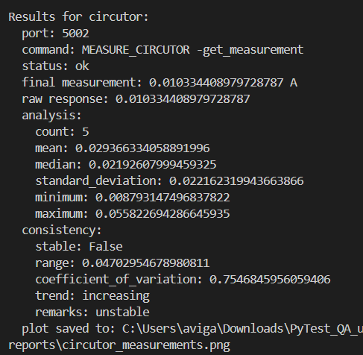
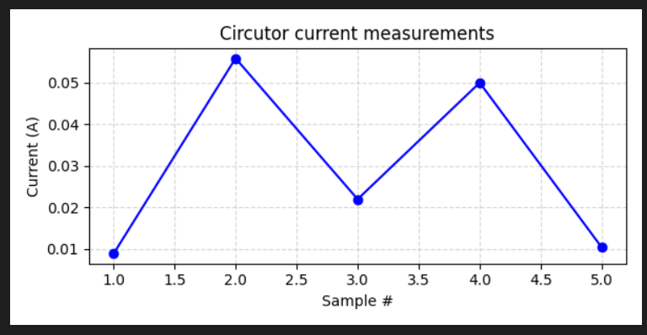
- Result Management – when we run "python examples/run_tests.py" (after python main.py) we can see in results directory new json file that contains the data of the all ammeters that tested. I decided to put them together in the same file, but we could of create 3 different files/ uniqe directory with 3 files in it.

