Color Blind Safe Accessibility

## Background

This module demonstrates the importance of selecting the right colors for UI elements by utilizing colors that are color-blind safe.

A working version of this app is available at: <https://github.com/milk-modules/Apps/tree/master/accessible/DemoApp02>

Further reading: <http://mkweb.bcgsc.ca/colorblind/>

## Prerequisite

1. Android Studio is installed on the development workstation
2. A working Android emulator is available for testing

## Activity Instructions

1. Project Creation
   1. Follow the screens below to create a new project:

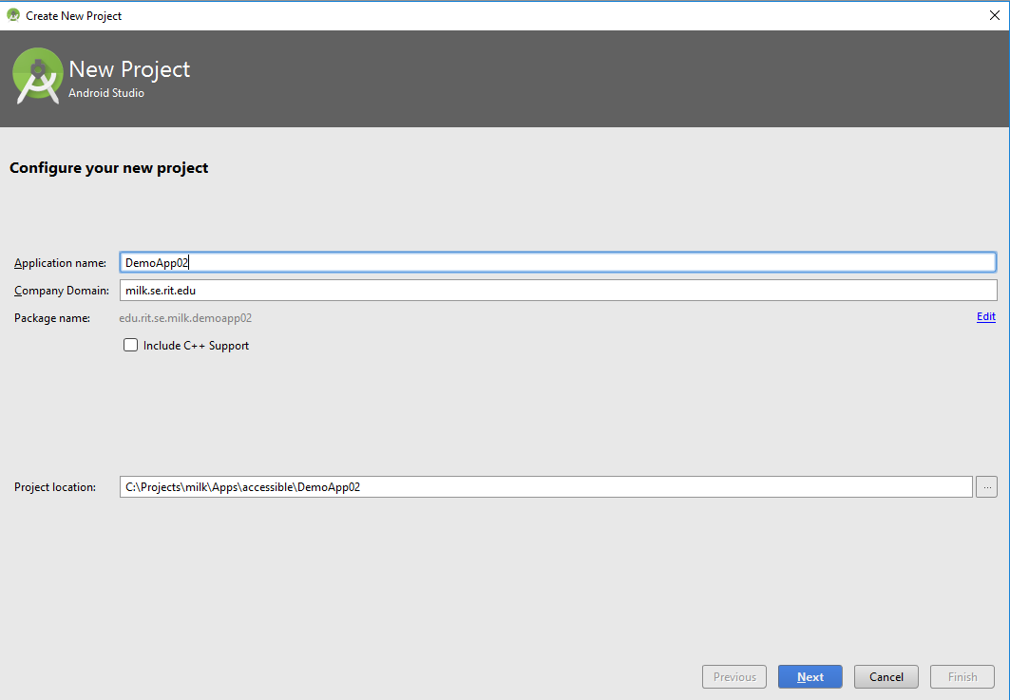

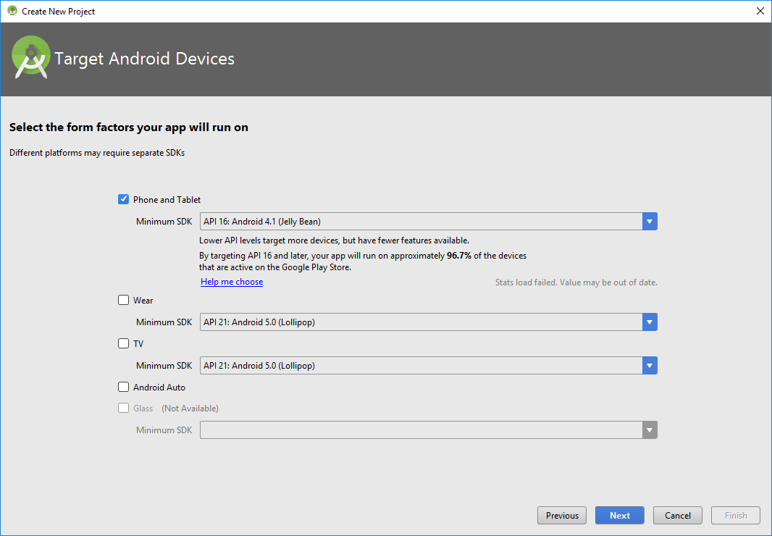

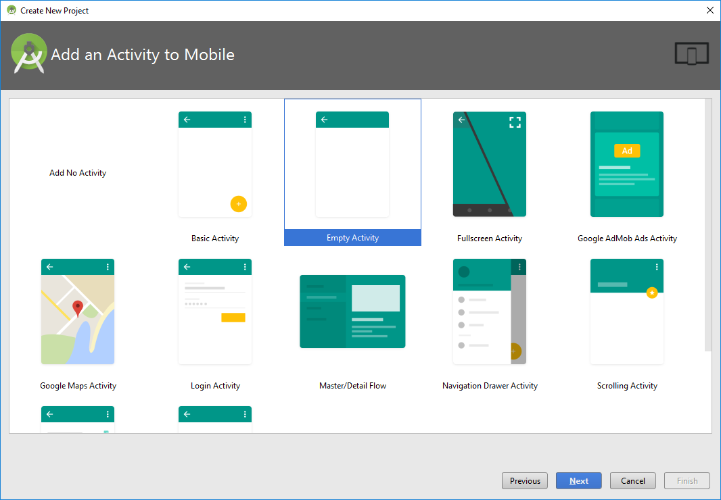

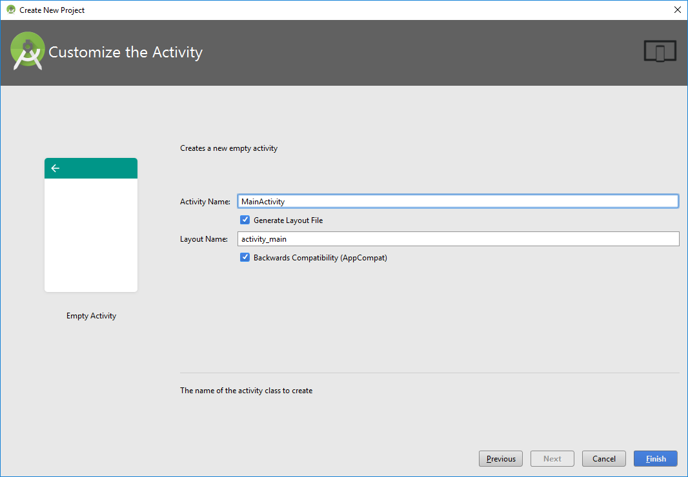

1. Create ‘Utility’ class

This class contains utility methods.

**import** android.view.View;  
**import** java.util.Random;  
  
  
**class** Utility {  
 **static int** GenerateRandomInteger(**int** Min, **int** Max)  
 {  
 Random random = **new** Random();  
 **return** random.nextInt(Max - Min +1) + Min;  
 }  
  
 **static float** ConvertToDP(View view, **int** value)  
 {  
 **return** value * view.getResources().getDisplayMetrics().**density**;  
 }  
}

1. Create ‘CircleEventListener’ interface

This interface is used to implement event handler functionality

**public interface** CircleEventListener {  
 **void** CirclePopped();  
}

1. Create ‘Circle’ class

The purpose of this class is to creates and move a circle upwards on the screen. On tap of a circle it fires an event that will be handled by the main class (MainActivity).

**import** android.content.Context;  
**import** android.graphics.Canvas;  
**import** android.graphics.Color;  
**import** android.graphics.Paint;  
**import** android.graphics.Rect;  
**import** android.util.DisplayMetrics;  
**import** android.view.MotionEvent;  
**import** android.view.View;  
**import** android.view.ViewGroup;  
  
**public class** Circle **extends** View {  
 **private float x** = -1;  
 **private float y** = -1;  
 **private boolean isPoppable** = **false**;  
  
 **private float circleRadius**;  
  
 **private int circleColor** = Color.***TRANSPARENT***;  
 **private int textColor** = Color.***TRANSPARENT***;  
  
 **private final** Paint **mPaint** = **new** Paint(Paint.***ANTI_ALIAS_FLAG***);  
 **private** CircleEventListener **listener**;  
  
 @Override  
 **protected void** onDraw(Canvas canvas) {  
 *// super.onDraw(canvas);* **if**(**y** != -1 || **x** != -1) {  
 **mPaint**.setStyle(Paint.Style.***FILL***);  
 **mPaint**.setColor(**circleColor**);  
  
 canvas.drawCircle(**x**, **y**, **circleRadius**, **mPaint**);  
  
 **if**(**isPoppable**) {  
 Paint paint = **new** Paint();  
 paint.setColor(**textColor**);  
 paint.setTextSize(64f);  
 paint.setAntiAlias(**true**);  
 paint.setTextAlign(Paint.Align.***CENTER***);  
  
 canvas.drawText(**"*"**, **x**, **y** + **circleRadius** / 2, paint);  
 }  
 }  
 }  
  
 **public** Circle(Context context, **int** fillColor, **int** maxWidth, **boolean** poppable) {  
 **super**(context);  
 **circleColor** = fillColor;  
 **textColor** = Color.***BLACK***;  
 **isPoppable** = poppable;  
 }  
  
 **public void** setCircleEventListener (CircleEventListener listener) {  
 **this**.**listener** = listener;  
 }  
  
  
 **public void** Move(){  
 **circleRadius** = Utility.*ConvertToDP*(((View) **this**.getParent()),20);  
  
 **if**(**y**== -1 || **x**==-1){  
 **int** containerHeight = ((View) **this**.getParent()).getMeasuredHeight();  
 **int** containerWidth = ((View) **this**.getParent()).getMeasuredWidth();  
  
 *//The initial horizontal position of the screen is random  
 //The formula is to prevent the circle from being partially drawn outside the screen* **x** = Utility.*GenerateRandomInteger*(((**int**) **circleRadius**), containerWidth - ((**int**) **circleRadius**));  
  
 *//The initial vertical position of the circle is at the bottom of the screen* **y** = containerHeight - **circleRadius**;  
 }  
 **else** {  
 **y** = **y** - **circleRadius**\*2;  
 }  
  
 invalidate();  
 }  
  
  
 @Override  
 **public boolean** onTouchEvent(MotionEvent event) {  
 **float** touchX = event.getX();  
 **float** touchY = event.getY();  
 **switch** (event.getAction()){  
 **case** MotionEvent.***ACTION_DOWN***:  
 circleTouched(touchX,touchY);  
 **break**;  
 }  
 **return super**.onTouchEvent(event);  
 }  
  
 **private void** circleTouched(**float** touchX, **float** touchY) {  
 **if** (Math.*sqrt*(Math.*pow*(touchX - **x**, 2) + Math.*pow*(touchY - **y**, 2)) < **circleRadius** & **isPoppable**) {  
 **circleColor** = Color.***TRANSPARENT***;  
 **textColor** = Color.***TRANSPARENT***;  
 **if** (**listener** != **null**)  
 **listener**.CirclePopped();  
 }  
 }  
}

1. Update ‘activity_main.xml’

Update the xml with the following code.

*<?***xml version="1.0" encoding="utf-8"***?>*<**RelativeLayout xmlns:android="http://schemas.android.com/apk/res/android"  
 xmlns:tools="http://schemas.android.com/tools"  
 android:id="@+id/activity_main"  
 android:layout_width="match_parent"  
 android:layout_height="match_parent"  
 android:paddingBottom="@dimen/activity_vertical_margin"  
 android:paddingLeft="@dimen/activity_horizontal_margin"  
 android:paddingRight="@dimen/activity_horizontal_margin"  
 android:paddingTop="@dimen/activity_vertical_margin"  
 tools:context="edu.rit.se.milk.demoapp02.MainActivity"**>  
  
 <**LinearLayout  
 android:orientation="vertical"  
 android:layout_width="match_parent"  
 android:layout_height="match_parent"  
 android:layout_alignParentTop="true"  
 android:layout_alignParentLeft="true"  
 android:layout_alignParentStart="true"**>  
  
 <**Switch  
 android:text="Alternate Rendering"  
 android:layout_width="match_parent"  
 android:layout_height="wrap_content"  
 android:id="@+id/switchAccessibility"  
 android:focusable="false"**/>  
  
 <**RelativeLayout  
 android:layout_width="match_parent"  
 android:layout_height="match_parent"  
 android:id="@+id/layoutCircle"  
 android:gravity="top"  
 android:layout_gravity="top"  
 android:layout_weight="442"**>  
  
 </**RelativeLayout**>  
  
 <**RelativeLayout  
 android:layout_width="match_parent"  
 android:layout_height="wrap_content"  
 android:layout_gravity="bottom"  
 android:layout_weight="1"**>  
  
 <**TextView  
 android:text="Tap start to play"  
 android:layout_width="match_parent"  
 android:layout_height="wrap_content"  
 android:id="@+id/textViewStatus"  
 android:layout_alignParentTop="false"  
 android:layout_alignParentLeft="true"  
 android:layout_alignParentStart="false"  
 android:textAlignment="center"  
 android:textStyle="normal|bold"  
 android:layout_alignParentRight="true"  
 android:layout_alignParentEnd="true"  
 android:layout_below="@+id/buttonGame"  
 android:layout_alignParentBottom="false"  
 android:textSize="24sp"  
 android:gravity="center"**/>  
  
 <**Button  
 android:text="Start"  
 android:layout_width="match_parent"  
 android:layout_height="wrap_content"  
 android:id="@+id/buttonGame"  
 android:onClick="startButton_onClick"  
 android:layout_alignParentLeft="true"  
 android:layout_alignParentTop="true"  
 android:layout_alignParentStart="true"  
 android:gravity="center"** />  
 </**RelativeLayout**>  
  
 </**LinearLayout**>  
</**RelativeLayout**>

1. Update ‘MainActivityclass

Update the class with the following code.

**import** android.app.AlertDialog;  
**import** android.content.DialogInterface;  
**import** android.graphics.Color;  
**import** android.support.v7.app.AppCompatActivity;  
**import** android.os.Bundle;  
**import** android.view.View;  
**import** android.widget.Button;  
**import** android.widget.CompoundButton;  
**import** android.widget.RelativeLayout;  
**import** android.widget.Switch;  
**import** android.widget.TextView;  
  
**import** java.util.ArrayList;  
**import** java.util.List;  
**import** java.util.Timer;  
**import** java.util.TimerTask;  
  
**public class** MainActivity **extends** AppCompatActivity **implements** CircleEventListener {  
  
  
 RelativeLayout **layoutCircle**;  
 Button **buttonStart**;  
 TextView **textViewScore**;  
 Switch **switchRendering**;  
  
 Timer **circleMoveTimer**, **circleGenerateTimer**;  
 **int hitsValid** = 0, **hitsTotal** = 0;  
 List<Circle> **circleList**;  
  
 @Override  
 **protected void** onCreate(Bundle savedInstanceState) {  
 **super**.onCreate(savedInstanceState);  
 setContentView(R.layout.***activity_main***);  
  
 **layoutCircle** = (RelativeLayout) findViewById(R.id.***layoutCircle***);  
 **layoutCircle**.setOnClickListener(  
 **new** View.OnClickListener() {  
 @Override  
 **public void** onClick(View v) {  
 **hitsTotal**++;  
 **textViewScore**.setText(**"Successful Hits: "** + **hitsValid** + **" Misses: "** + (**hitsTotal** - **hitsValid**));  
 }  
 }  
 );  
 **buttonStart** = (Button) findViewById(R.id.***buttonGame***);  
 **textViewScore** = (TextView) findViewById(R.id.***textViewStatus***);  
 **switchRendering** = (Switch) findViewById(R.id.***switchAccessibility***);  
  
 **switchRendering**.setOnCheckedChangeListener(**new** CompoundButton.OnCheckedChangeListener() {  
 **public void** onCheckedChanged(CompoundButton buttonView, **boolean** isChecked) *//Line A* {  
 reset();  
  
 String message;  
 **if** (isChecked)  
 {  
 message = **"Circles will be rendered as seen by a color blind (Deuteranope) person"**;  
 }  
 **else** {  
 message = **"Circles will be rendered as seen by a non-color blind person"**;  
 }  
  
 AlertDialog.Builder builder = **new** AlertDialog.Builder(MainActivity.**this**);  
 builder  
 .setTitle(MainActivity.**this**.getTitle())  
 .setMessage(message+**"\n\nTap the GREEN circle to score points!\nHint: It's the circle with a '*' inside!\n\nGood Luck!"**)  
 .setIcon(android.R.drawable.***ic_dialog_info***)  
 .setPositiveButton(android.R.string.***yes***, **new** DialogInterface.OnClickListener() {  
 **public void** onClick(DialogInterface dialog, **int** which) {  
 **buttonStart**.callOnClick();  
 }  
 })  
 .show();  
 }  
 });  
 }  
  
 **public void** startButton_onClick(View v) {  
 reset();  
  
 **circleMoveTimer** = **new** Timer();  
 **circleMoveTimer**.schedule(**new** TimerTask() {  
 @Override  
 **public void** run() {  
 runOnUiThread(**new** Runnable() {  
 @Override  
 **public void** run() {  
 **for** (Circle c : **circleList**) {  
 c.Move();  
 }  
 }  
 });  
 }  
 }, 0, 700);  
  
 **circleGenerateTimer** = **new** Timer();  
 **circleGenerateTimer**.schedule(**new** TimerTask() {  
 @Override  
 **public void** run() {  
 runOnUiThread(**new** Runnable() {  
 @Override  
 **public void** run() {  
 generateCircle();  
 }  
 });  
 }  
 }, 0, 900);  
 }  
  
 **private void** reset() {  
 **buttonStart**.setText(**"New Game"**);  
 **hitsTotal** = 0;  
 **hitsValid** = 0;  
 **circleList** = **new** ArrayList<Circle>();  
 **textViewScore**.setText(**"Successful Hits: "** + **hitsValid** + **" Misses: "** + (**hitsTotal** - **hitsValid**));  
 **layoutCircle**.removeAllViews();  
 **if** (**circleGenerateTimer** != **null**) {  
 **circleGenerateTimer**.cancel();  
 }  
  
 **if** (**circleMoveTimer** != **null**) {  
 **circleMoveTimer**.cancel();  
 }  
 }  
  
  
 **private void** generateCircle() {  
 **int** randomColor = Utility.*GenerateRandomInteger*(1, 4);  
 **int** color = Color.***GRAY***;  
 **boolean** poppable = **false**;  
 **switch** (randomColor) { *//Alternate colors are based on Deuteranope color vision* **case** 1:  
 color = **switchRendering**.isChecked() ? Color.*parseColor*(**"#ADADDE"**) : Color.*parseColor*(**"#14D2DC"**);  
 poppable = **false**;  
 **break**; *//Teal* **case** 2:  
 color = **switchRendering**.isChecked() ? Color.*parseColor*(**"#95955D"**) : Color.*parseColor*(**"#0AB45A"**);  
 poppable = **true**;  
 **break**; *//Green* **case** 3:  
 color = **switchRendering**.isChecked() ? Color.*parseColor*(**"#44449F"**) : Color.*parseColor*(**"#8214A0"**);  
 poppable = **false**;  
 **break**; *//Purple* **case** 4:  
 color = **switchRendering**.isChecked() ? Color.*parseColor*(**"#000000"**) : Color.*parseColor*(**"#000000"**);  
 ;  
 poppable = **false**;  
 **break**; *//Black* }  
  
 Circle circle = **new** Circle(**this**, color, **layoutCircle**.getWidth(), poppable);  
 circle.setCircleEventListener(**this**);  
  
 **circleList**.add(circle);  
  
 **layoutCircle**.addView(circle);  
 }  
  
  
 @Override  
 **public void** CirclePopped() {  
 **hitsValid**++;  
 **textViewScore**.setText(**"Successful Hits: "** + **hitsValid** + **" Misses: "** + (**hitsTotal** - **hitsValid**));  
 }  
}