Speech-based accessibility

## Background

This module demonstrates the use of a UI element’s *contentDescription* attribute to provide speech-based accessibility.

A working version of this app is available at: <https://github.com/milk-modules/Apps/tree/master/accessible/DemoApp01>

## Prerequisite

1. Android studio is installed on the development workstation
2. A working Android emulator is available for testing
3. TalkBack is enabled on the emulator.
   1. Details on installing and activating TalkBack: <https://milk-modules.github.io/activities/general/Android_TalkBack_Install.pdf>

## Activity Instructions

There two approaches that you can take to perform this activity:

1. End-to-End development of the app by following all the below steps
2. Using a pre-created version of this project and only applying the *contentDescription* functionality:
   1. Download the code for DemoApp01 from: <https://github.com/milk-modules/Apps/tree/master/non-accessible>
   2. Perform ONLY step #3
3. Project Creation
   1. Follow the screens below to create a new project:

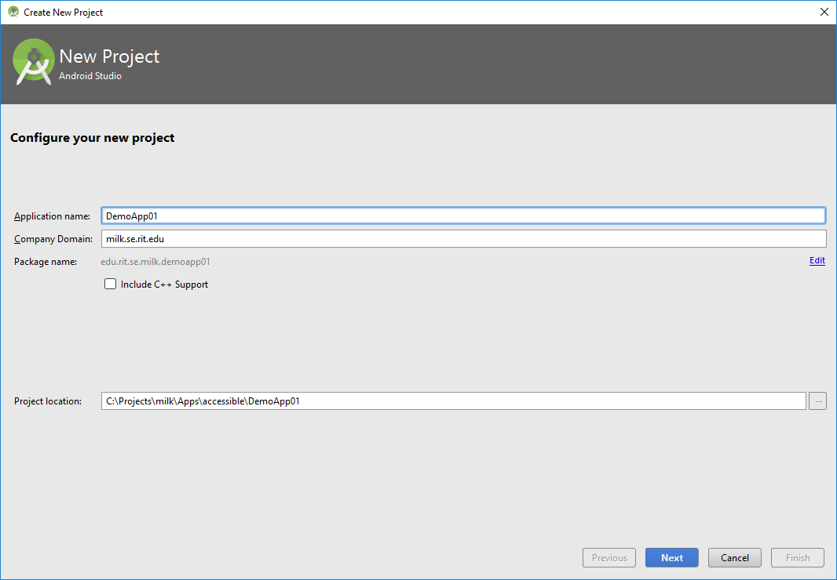

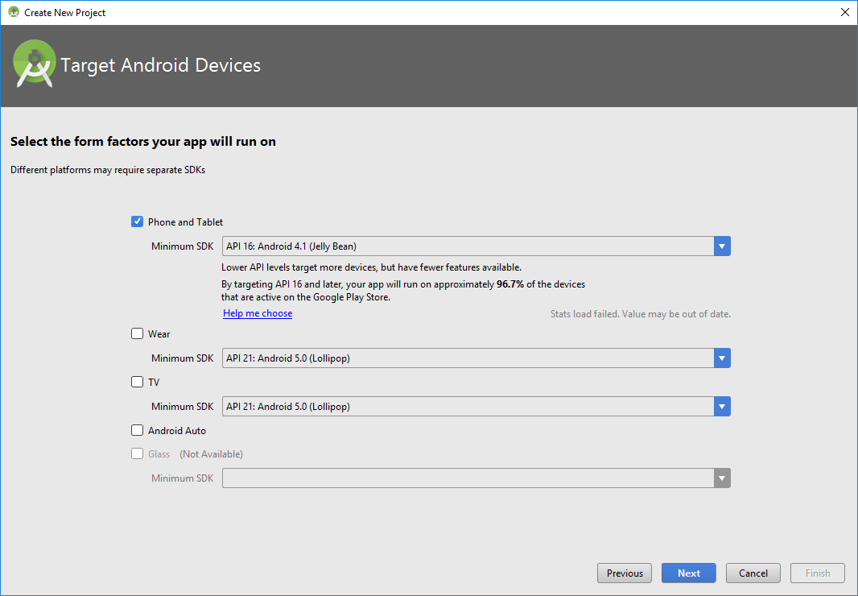

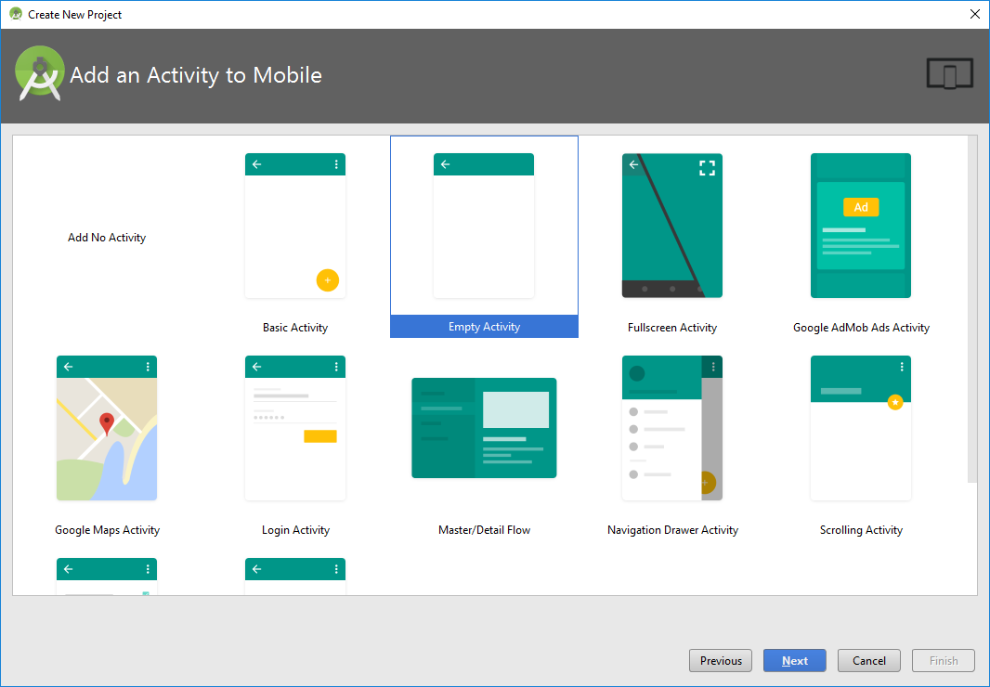

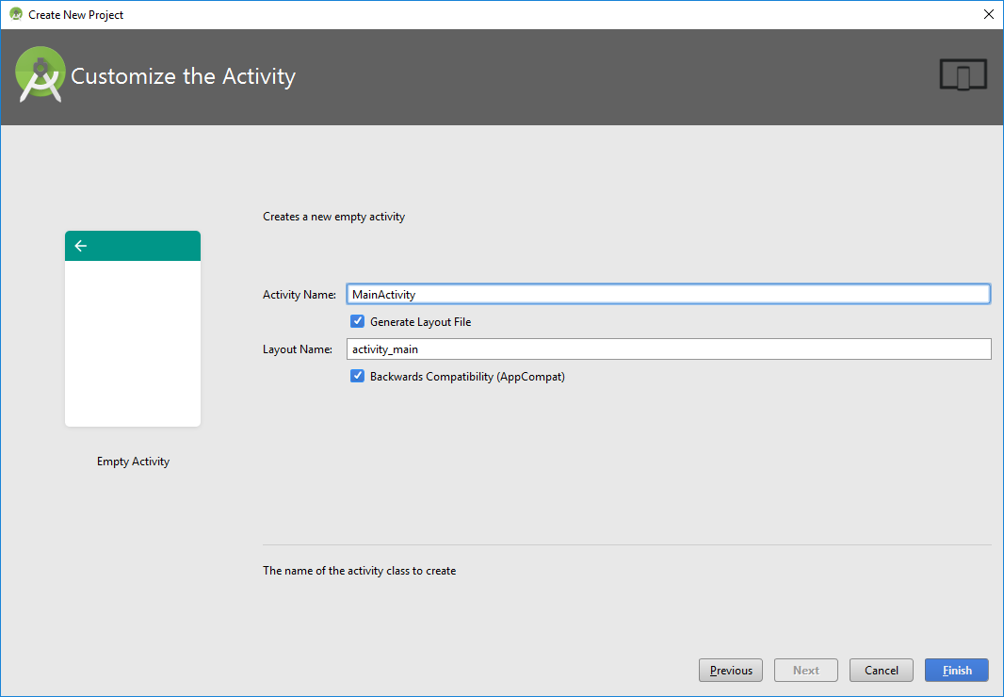

1. Construct User Interface
   1. From the Palette tool window, add the following UI controls into the screen layout.
      1. Update the following properties of the existing Relative Layout:
         * layout_width="match_parent"
         * layout_height="match_parent"
      2. Within the existing Relative Layout add:
         1. **Switch**
            * Update the following properties:

text="Alternate Rendering"

layout_width="match_parent"

layout_height="wrap_content"

id="@+id/switchAccessibility"

focusable="false"

* + - 1. **Relative Layout**:
         * Update the following properties:

layout_width="match_parent"

layout_height="wrap_content"

id="@+id/layoutContents"

layout_weight="100"

* + - * + Add the following UI controls:

**Button**:

Update the following properties:

text="&#60;&#60;--"

layout_width="wrap_content"

layout_height="wrap_content"

layout_alignParentTop="true"

layout_alignParentLeft="true"

layout_alignParentStart="true"

layout_marginTop="146dp"

id="@+id/buttonLeft"

background="@android:drawable/btn_default"

gravity="center"

layout_gravity="left|center"

layout_marginLeft="50dp"

**TextView**

* Update the following properties:

text="Tap the Back or Next button to proceed"

layout_width="match_parent"

layout_height="wrap_content"

id="@+id/textView"

textAppearance="@android:style/TextAppearance.DeviceDefault.Medium"

layout_above="@+id/buttonRight"

layout_marginBottom="36dp"

textStyle="normal|bold"

textAlignment="center"

layout_alignParentLeft="false"

layout_alignParentStart="false"

layout_alignParentRight="false"

layout_alignParentEnd="false"

gravity="center_horizontal"

**Button**

Update the following properties:

text="--&#62;&#62;"

layout_width="wrap_content"

layout_height="wrap_content"

id="@+id/buttonRight"

layout_gravity="right"

background="@android:drawable/btn_default"

gravity="center"

layout_alignTop="@+id/buttonLeft"

layout_alignParentRight="true"

layout_alignParentEnd="true"

layout_marginRight="50dp"

* + - 1. **Relative** **Layout**
         * Update the following properties:

layout_width="match_parent"

layout_height="wrap_content"

layout_weight="1"

* + - * + Add the following UI controls:

**TextView**:

Update the following properties:

layout_width="match_parent"

layout_height="wrap_content"

id="@+id/textViewStatus"

layout_alignParentTop="true"

layout_alignParentLeft="true"

layout_alignParentStart="true"

textAlignment="center"

textStyle="normal|bold"

layout_alignParentRight="true"

layout_alignParentEnd="true"

text="Status:"

gravity="bottom"

Following is the hierarchical layout of the controls on the screen:

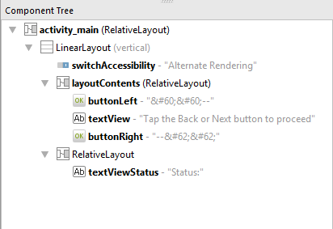

Following is the rendering of controls on the screen:

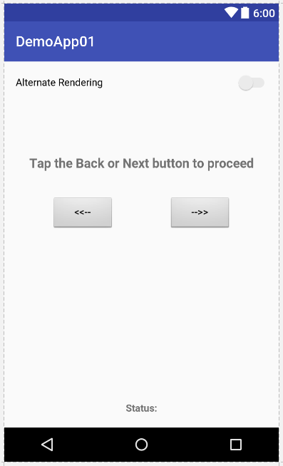

1. Set Content Description

The “contentDescription” property of a control is utilized for accessibility purposes. The text associated with this property defines the content of this control and is used by Android’s TalkBack feature.

Select the Button with id “buttonLeft”. Set contentDescription to “Back”

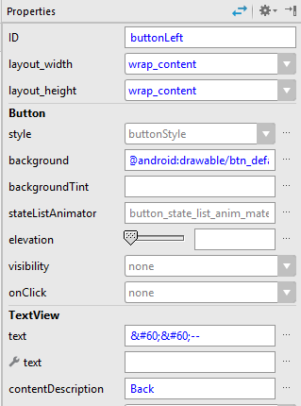

Select the Button with id “buttonRight”. Set contentDescription to “Next”

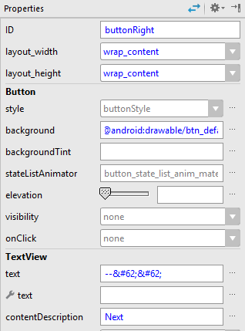

1. Code

Open MainActivity.java and add the following code:

* 1. Declare the following variables:

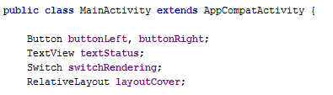

* 1. Add the following code inside the **onCreate** method:

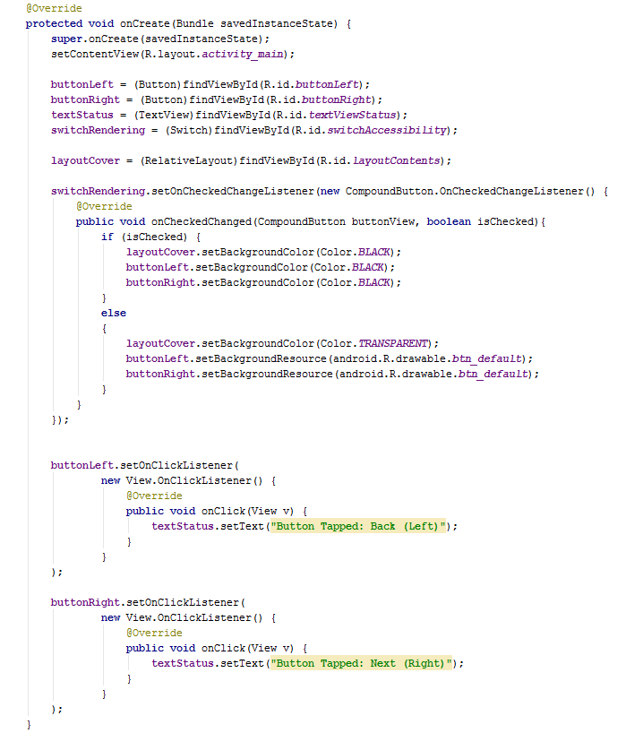

The above code achieves the following:

1. Handles the onCheckedChange event of the Switch control to:
   1. Set the color of all the controls to Black so that none of the controls are visible when the switch is checked (i.e. set to “On”)
   2. Sets the colors of all the controls to their original colors when the switch is unchecked (i.e. set to “Off”)