# Android TalkBack – Install & Activation Steps

By default, TalkBack is not installed on an Android emulator. Follow the steps below to install and turn on TalkBack.

Prerequisite:

1. Android platform tools are installed (this is usually located in the same directory as the Android SDK e.g: C:\Android\sdk\platform-tools )
2. Have a working Android emulator
3. Download the TalkBack apk file that is compatible with the version of Android on the emulator. Download location: http://www.apkmirror.com/apk/google-inc/talkback/

Install Steps:

1. Start the android emulator
2. Open command prompt
3. Set the current directory to point to platform tools:
   1. C:\>**cd C:\Android\sdk\platform-tools**
4. Verify that the emulator is connected:
   1. C:\Android\sdk\platform-tools>**adb devices**
5. Install the TalkBack APK:
   1. C:\Android\sdk\platform-tools>**adb install "C:\APK_Files\com.google.android.marvin.talkback_5.0.7-50007000_minAPI16(nodpi)_apkmirror.com.apk"**

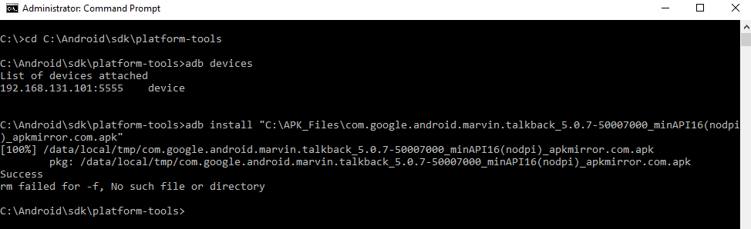

Activation Steps:

1. Navigate to the “Settings” screen of the device
2. Scroll until you see the “Accessibility” menu item. Tap/click this menu item
3. Tap/click the menu item called “TalkBack”
4. Tap/click the switch on the of the screen to turn the feature on
5. A few message/dialog boxes will be shown asking for confirmation. Tap/click OK

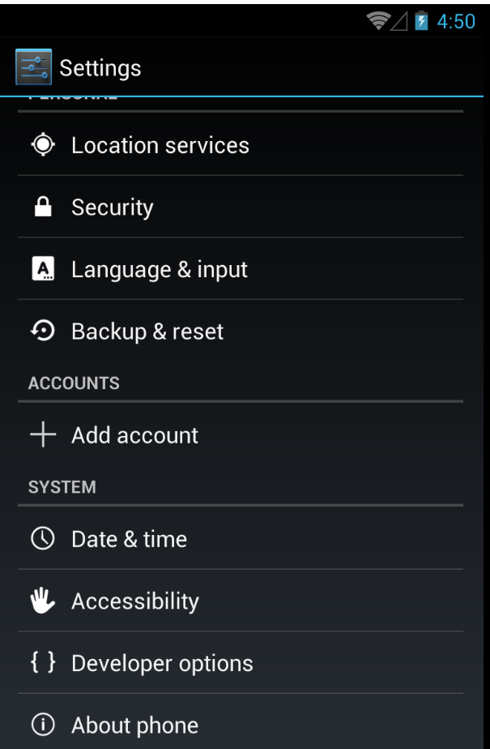 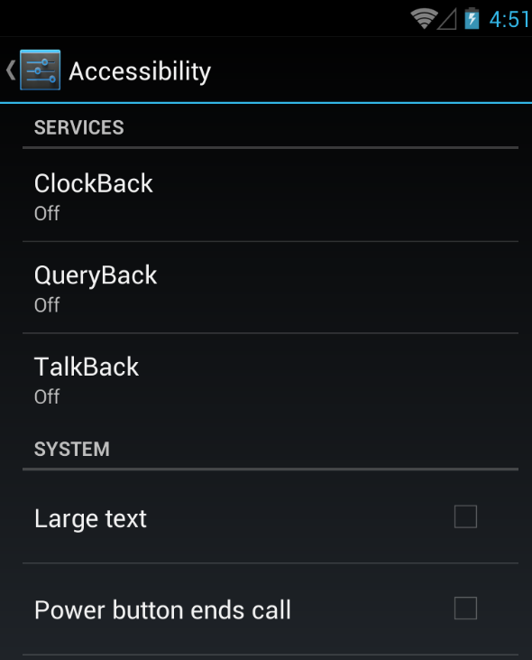

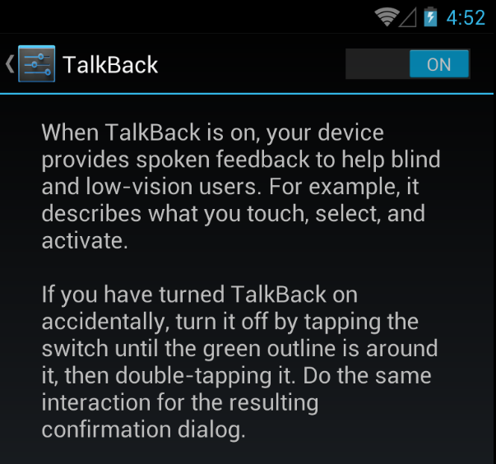

Other Information:

Please read the following to understand available gestures to help you navigate the device when TalkBack is turned on.

https://support.google.com/accessibility/android/answer/6151827?hl=en