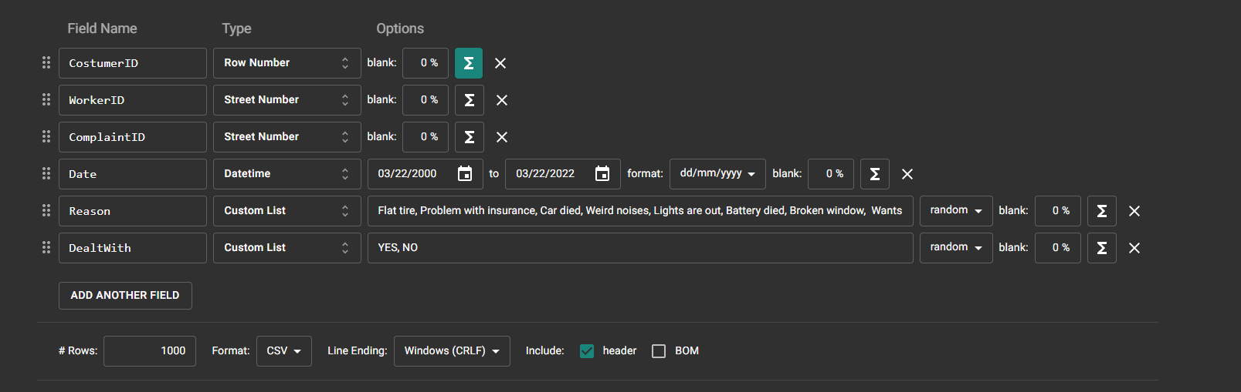

Where we first created a table with 1000 values and then made another table where the row number formula was:

this + 1000

In order to get the next 1000 row numbers.