Intro to Git for beginners, session 2

Introduction
OSU libraries teaches Git in two sessions:
- Intro to Git for beginners, session1, which covers chapters 1-9 (skipping 6) from the Software Carpentry lesson Version Control with Git
- Intro to Git for beginners, session 2, which covers chapters 6 and 11 from the Software Carpentry lesson Version Control with Git, plus other material that instructors have developed for the lesson with other resources (see References for details). This is the lesson that you find today in this document.

This is a beginner lesson that assumes that you are very new at working with Git, but that you have some previous knowledge, acquired in the Intro to Git for beginners, session 1:
- How to set up Git with your name and e-mail (git config --global user.name "Alfredo Linguini", git config --global user.email "a.linguini@ratatouille.fr")
- How to set up Git to name the default branch main (git config --global init.defaultBranch main)
- How to create a repository (git init)
- How to track changes in a repository, and the role of the staging area (git add filename.txt, git commit -m “Commit message”)
- How to check the status of Git (git status)
- How to explore the log of commits in a basic way (git log)
- How to visualize the differences between files in different commits (git diff, git diff HEAD filename.txt, git diff un1qe1d filename.txt)
- How to revert to previous versions (git restore filename.txt, git restore -s un1qe1d filename.txt)
- How to create a remote repository with GitHub and connect the local and remote repositories (git remote add origin https://github.com/username/recipes.git)
- How to push local changes to a remote (git push origin main)
- How to pull changes in the remote repository to the local repository (git pull origin main)
- How to clone a remote repository (git clone https://github.com/username/recipes.git ~Desktop/path/)
- How to fix conflicts when collaborating with others
If it has been some time since you took session 1, no worries, we will have a short recap.

In this lesson we will cover:

- Git’s version control model
- Hashes and references
- Git checkout
- Branches
- Ignoring things
- Forks and pull requests
- Licensing, if we have time

Recap
To start working, we want to have a repository with a few commits. For more information on all these steps check the Software Carpentry lesson Version Control with Git. If you are struggling to follow up with this section of the lesson we recommend that you take “Session 1” (or study the Version Control with Git page by yourself) before taking this “Session 2”.

Let’s start by setting up Git with our name and email,

$ git config --global user.name "Alfredo Linguini"
$ git config --global user.email "a.linguini@ratatouille.fr"

Also, let’s make sure that the default branch name for our repository is “main”, instead of “master”, which evoques the racist practice of slavery.

$ git config --global init.defaultBranch main

For these of you using Windows, we recommend this configuration so that you will not get warning messages due to how different operating systems encode their line endings.

$ git config --global core.autocrlf true

Now we create a folder where we will start our repository

$ cd ~/Desktop
$ mkdir articles
$ cd articles

Then we initialize a Git repository

$ git init

And we create a couple of files, with some content on them

$ nano introduction.md

# Introduction
## Topic of interest
## Literature review

Add and commit the file

git add introduction.md
git commit -m “Start a template of the introduction”

Now let’s do the same for the results file

$ nano results.md

# Results
## Section 1
## Section 2

$ git add results.md
$ git commit -m "Start template for the results section"

Git’s version control model
Git uses something called “directed acyclig graph” (DAG). What this means is that, instead of using a linear model in which each version comes after another (version 1, version 2, version 3, etc), it uses a model in which each version has a set of “parent” versions.

This means that more than one snapshot can point to the same parent snapshot. For example, when we create different branches. Let’s say that you are working on your project and you want to add a feature, but also, somebody reported a bug. Creating a branch means that we can work on different lines of development in parallel so that they are temporarily unrelated to each other.

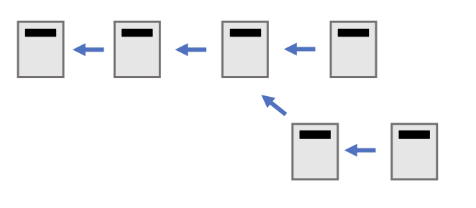

And it also means that one snapshot could have more than one parent. For example, when we merge branches. Let’s say that we are happy about our new feature and we also managed to fix the bug. We want to incorporate all these changes to our main line of development, by merging them.

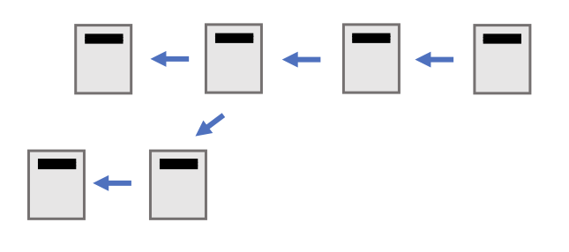

Hashes and references
We talked in Session 1 about how Git saves certain information about each version. Let’s review these pieces of metadata, and get a bit deeper into it.

For a given snapshot, Git will save
- Who made the changes (name and e/mail)
- Time when the changes were made
- Commit message

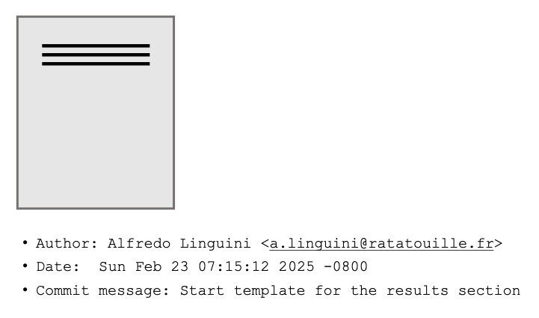

Each snapshot or commit, is also given an identifier. This identifier is a hash function (a SHA-1, you can find information about this in the SHA-1 wikipedia page if you want to learn more). A hash function takes a big piece of data and turns it into a short string of 40 hexadecimal strings.
- This hash uniquely identifies each snapshot and allows us to interact with it.
- The identifier is immutable, because it is a hash that depends on the content of the commit
- The relationships between commits are kept in Git using this ID. So, a commit references its parents by their ID.

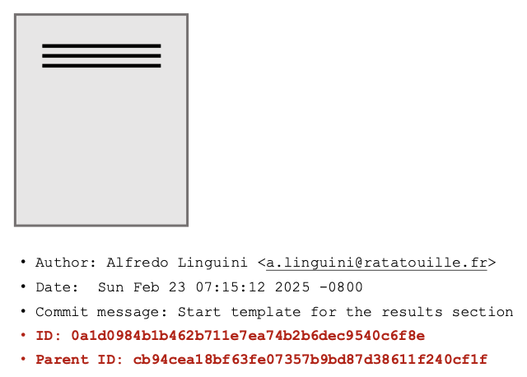

These hashes are inconvenient, because they are long strings and don’t mean anything to a human. That is why git maintains a set of references. References are a map of human readable names so that we can refer to particular commits instead of having to use the hexadecimal strings.

The actual commits are immutable, and their identifiers cannot change. However, references are mutable. For example, let’s say that we have a reference for a branch. At one moment, this reference may point to a certain version, and once we create a new commit, this reference is updated, and points somewhere else. This visualization shows abbreviated IDs (only the first seven characters of the 40 character string), and the reference “main”, which is the name of the default branch.

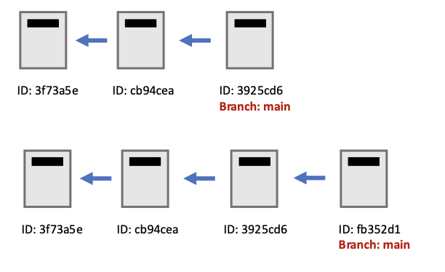
A Git repository is a combination of these objects it stores, our commits, and references. When we use git commands we are adding objects and adding or updating references.

Let’s take a look at all this information as git shows it to us.

$ git log

commit 0a1d0984b1b462b711e7ea74b2b6dec9540c6f8e (HEAD -> main)
Author: Clara Llebot <clara.llebot@oregonstate.edu>
Date: Sun Feb 23 07:15:12 2025 -0800
Start template for the results section
commit 1bf3397d139918fd0db55011883f9e329cfe117c
Author: Clara Llebot <clara.llebot@oregonstate.edu>
Date: Sat Feb 22 07:58:34 2025 -0800
Start a template of the introduction
We can see the author, date and commit message, as well as the commit ID, and the references (in parentheses, after the commit ID). During this lesson we are actually going to use a variation of the git log command that will allow us to see the information summarized in lines, and with useful visualizations of the branches

$ git log --all --graph --decorate

* commit 0a1d0984b1b462b711e7ea74b2b6dec9540c6f8e (HEAD -> main)
| Author: Clara Llebot <clara.llebot@oregonstate.edu>
| Date: Sun Feb 23 07:15:12 2025 -0800
|
| Start template for the results section
|
* commit 1bf3397d139918fd0db55011883f9e329cfe117c
Author: Clara Llebot <clara.llebot@oregonstate.edu>
Date: Sat Feb 22 07:58:34 2025 -0800

Start a template of the introduction

The references we see right now are:
HEAD is used to refer to where we are looking at right now, the current checked out commit.
“main” is the branch name reference, which points to the last commit of a branch.

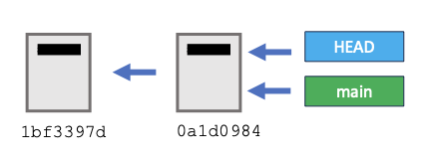

Checkout
The command checkout allows us to choose which commit, which version, we are looking at in our working directory. When using checkout git will move the reference HEAD to a different commit, and it will also modify the contents of our directory with the contents of that commit.

For example, if now we type:

$ git checkout 1bf3397d139918fd0db55011883f9e329cfe117c

Note: switching to '1bf3397d139918fd0db55011883f9e329cfe117c'.
You are in 'detached HEAD' state. You can look around, make experimental changes and commit them, and you can discard any commits you make in this state without impacting any branches by switching back to a branch.

If you want to create a new branch to retain commits you create, you may do so (now or later) by using -c with the switch command. Example:

git switch -c <new-branch-name>

Or undo this operation with:

git switch -

Turn off this advice by setting config variable advice.detachedHead to false

HEAD is now at 1bf3397 Start a template of the introduction

The comments that Git gives us after the git checkout command will be easier to understand in a moment.

If we look into our directory, we will see that the file “introduction.md” is there, but the file “results.md” is not there, because “results.md” was added during the second commit.

Git log has changed:

$ git log --all --graph --decorate

* commit 0a1d0984b1b462b711e7ea74b2b6dec9540c6f8e (main)
| Author: Clara Llebot <clara.llebot@oregonstate.edu>
| Date: Sun Feb 23 07:15:12 2025 -0800
|
| Start template for the results section
|
* commit 1bf3397d139918fd0db55011883f9e329cfe117c (HEAD)
Author: Clara Llebot <clara.llebot@oregonstate.edu>
Date: Sat Feb 22 07:58:34 2025 -0800

Start a template of the introduction

You can see that the reference “main” is still in commit 0a1d0984, because that is still the last commit of that branch. But the HEAD reference has changed. It points now to the first commit 1bf3397d.
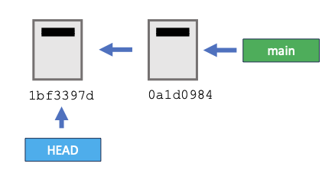

Usually HEAD and “main” (or the most recent commit of whichever branch we are in) will point to the same commit. This state is considered to be “attached”. If we make a new commit in the attached state both the HEAD and “main” pointers will advance to it together. When HEAD does not point to the head of a branch then we get a message that we are in “detached HEAD” state. Because we are not in a branch anymore, if we make changes to the file and commit them, these new commits will not be part of any branches.

$ nano introduction.md

# Introduction
## Topic of interest
## Literature review
## Hypotheses

$ git add introduction.md
$ git commit -m "Add structure for hypotheses in the introduction"
$ git log --all --graph --decorate

* commit fabd7a5e96da2a7eaccbc48fbff09f7abff154f5 (HEAD)
| Author: Clara Llebot <clara.llebot@oregonstate.edu>
| Date: Mon Feb 24 11:30:23 2025 -0800
|
| Add structure for hypotheses in the introduction
|
| * commit 0a1d0984b1b462b711e7ea74b2b6dec9540c6f8e (main)
|/ Author: Clara Llebot <clara.llebot@oregonstate.edu>
| Date: Sun Feb 23 07:15:12 2025 -0800
|
| Start template for the results section
|
* commit 1bf3397d139918fd0db55011883f9e329cfe117c
Author: Clara Llebot <clara.llebot@oregonstate.edu>
Date: Sat Feb 22 07:58:34 2025 -0800

Start a template of the introduction

This shows clearly that there are three commits. Commit 0a1d0984 is the last commit of the branch main. Commit fabd7a5 is the commit that we are seeing right now in our directory (HEAD). This commit is not part of the main branch because only the commit that it points to, and all the parent commits are part of this branch. Both of these commits have as a parent the initial commit 1bf3397d.

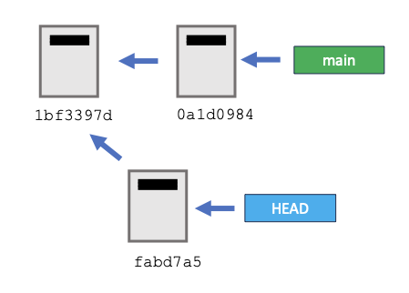

Working on “detached head” state can be useful if, for example, you want to experiment on an earlier state of your work.

If you want to go back to attached head you can use the checkout command again:

$ git checkout 0a1d0984

Warning: you are leaving 1 commit behind, not connected to
any of your branches:
fabd7a5 Add structure for hypotheses in the introduction
If you want to keep it by creating a new branch, this may be a good time to do so with:
git branch <new-branch-name> fabd7a5
HEAD is now at 0a1d098 Start template for the results section

You can see now that our directory has two files, introduction.md and results.md, and that the introduction does not have any mention of hypotheses.

What this warning is telling us is that because the commit is not part of a branch (because it was created in detached head state) it will be harder to find later. If we don’t want to keep the changes we made and we think they are not useful, we can move on, and leave this as is. If the commits we made were useful, then git suggests that we create a new branch and add the commit. In the next chapter we will look at branches.

An important thing to keep in mind here is that we are still in detached head space.

$ git status

HEAD detached at 0a1d098
nothing to commit, working tree clean

To get back to attached head:

$ git checkout main
$ git status

On branch main
nothing to commit, working tree clean

So, because we were in detached head space, we will continue being in detached head space until we checkout a branch. Checking out the same commit that has the branch reference is not enough. By checking out the branch we are ensuring that we go back to attached head space. The way that the git log command shows the difference is subtle, so it is better to use the git status command.

When we are in attached head an arrow points from HEAD to main:

$ git log --all --graph --decorate

* commit 0a1d0984b1b462b711e7ea74b2b6dec9540c6f8e (HEAD -> main)
| Author: Clara Llebot <clara.llebot@oregonstate.edu>
| Date: Sun Feb 23 07:15:12 2025 -0800

When we are in detached head there is a comma separating the two references:
$ git log --all --graph --decorate

* commit 0a1d0984b1b462b711e7ea74b2b6dec9540c6f8e (HEAD, main)
| Author: Clara Llebot <clara.llebot@oregonstate.edu>
| Date: Sun Feb 23 07:15:12 2025 -0800

Note that git checkout changes the contents of your working directory. It can be dangerous if you have changes in your working directory that you did not commit. For example, add a Section 3 into our results.md file, but do not add or commit, and then try to checkout a previous version of the repository.

$ nano results.md

# Results
## Section 1
## Section 2
## Section 3

$ git checkout 1bf3397

error: Your local changes to the following files would be overwritten by checkout:
results.md
Please commit your changes or stash them before you switch branches.
Aborting

Git refuses to checkout because your changes would be overwritten. Remember that you can use git status and git diff to check the status of git and the differences between your working directory and what we have committed to our repository (see Version Control with Git if you need to review these commands).

There are flags that we can use to force git to delete the changes and checkout. In this case, we will add and commit to keep the changes.

$ git add results.md
$ git commit -m "Structure the results to include a third section"
$ git log --all --graph --decorate

* commit adff1e405c86008dc220890dfda38baa7e08703a (HEAD -> main)
| Author: Clara Llebot <clara.llebot@oregonstate.edu>
| Date: Mon Feb 24 12:42:46 2025 -0800
|
| Structure the results to include a third section
|
* commit 0a1d0984b1b462b711e7ea74b2b6dec9540c6f8e
| Author: Clara Llebot <clara.llebot@oregonstate.edu>
| Date: Sun Feb 23 07:15:12 2025 -0800
|
| Start template for the results section
|
* commit 1bf3397d139918fd0db55011883f9e329cfe117c
Author: Clara Llebot <clara.llebot@oregonstate.edu>
Date: Sat Feb 22 07:58:34 2025 -0800

Start a template of the introduction

Another way of using checkout is using it to revert to the previous state of a file. In this case git will overwrite what we have done in this file with the version of that file in HEAD without giving us an error message, and we will lose our changes. This use can be useful, to get rid of changes that we don’t want to keep. But make sure that you use this command carefully to avoid losing your work.

$ nano results.md

# Results
## Section 1
## Section 2
## Section 3
## Section 4

$ git checkout results.md

Updated 1 path from the index

$ cat results.md

# Results
## Section 1
## Section 2
## Section 3

Branches
Create a new file methods.md to play with branches. In this file we will document the experiments we are reporting in our article. For example, Experiment A.

$ nano methods.md

# Methods
## Experiment A

$ git add methods.md
$ git commit -m "Create structure for methods and experiment A"
$ git log --all --graph --decorate

* commit 139a948b3b98905d6390fac3836cdff11562c4b9 (HEAD -> main)
| Author: Clara Llebot <clara.llebot@oregonstate.edu>
| Date: Mon Feb 24 13:24:10 2025 -0800
|
| Create structure for methods and experiment A
|
* commit adff1e405c86008dc220890dfda38baa7e08703a
| Author: Clara Llebot <clara.llebot@oregonstate.edu>
| Date: Mon Feb 24 12:42:46 2025 -0800
|
| Structure the results to include a third section
|
* commit 0a1d0984b1b462b711e7ea74b2b6dec9540c6f8e
| Author: Clara Llebot <clara.llebot@oregonstate.edu>
| Date: Sun Feb 23 07:15:12 2025 -0800
|
| Start template for the results section
|
* commit 1bf3397d139918fd0db55011883f9e329cfe117c
Author: Clara Llebot <clara.llebot@oregonstate.edu>
Date: Sat Feb 22 07:58:34 2025 -0800

Start a template of the introduction

Our main branch is pointing to this last commit we just created. Now we will create a new branch.

The command git branch will list the branches that we have in our repository right now.

$ git branch

* main

We only have one branch right now, and we are on it.
If we run git branch with a name next to it, git will create a new branch using that name

$ git branch experimentB
$ git branch

experimentB
* main

Notice that the branch we are in (main) is shown with an asterisk next to it, and in green. The branch experimentB points to the commit where we were working.

$ git log --all --graph --decorate

* commit 139a948b3b98905d6390fac3836cdff11562c4b9 (HEAD -> main, experimentB)
| Author: Clara Llebot <clara.llebot@oregonstate.edu>
| Date: Mon Feb 24 13:24:10 2025 -0800
|
| Create structure for methods and experiment A
|

The two branches, main and experimentB point to this last commit. Notice that HEAD points to main. This means that if I create a new commit, this commit will be added to the main branch.

To switch to the new branch experimentB:

$ git checkout experimentB
$ git log --all --graph --decorate

* commit 139a948b3b98905d6390fac3836cdff11562c4b9 (HEAD -> experimentB, main)
| Author: Clara Llebot <clara.llebot@oregonstate.edu>
| Date: Mon Feb 24 13:24:10 2025 -0800
|
| Create structure for methods and experiment A
|

Now HEAD points to experimentB. Both experimentB and main, at this time, point to the same commit, so right now the contents of the two branches are the same. If I create a new commit, then HEAD and experimentB will be updated to point to that commit, and main will remain where it is.

Now we will edit methods, and add experiment B content, and add and commit.

$ nano methods.md

# Methods
## Experiment A
## Experiment B
Explanation of details of Experiment B.

$ git add methods.md
$ git commit -m "Add description of experiment B"
$ git log --all --graph --decorate

* commit 07cadc9cc542ee04c327ddb8988bb347432840d0 (HEAD -> experimentB)
| Author: Clara Llebot <clara.llebot@oregonstate.edu>
| Date: Mon Feb 24 13:44:47 2025 -0800
|
| Add description of experiment B
|
* commit 139a948b3b98905d6390fac3836cdff11562c4b9 (main)
| Author: Clara Llebot <clara.llebot@oregonstate.edu>
| Date: Mon Feb 24 13:24:10 2025 -0800
|
| Create structure for methods and experiment A
|

Here we see that HEAD and experimentB are pointing to the recent commit we just made, while main points to the previous commit.

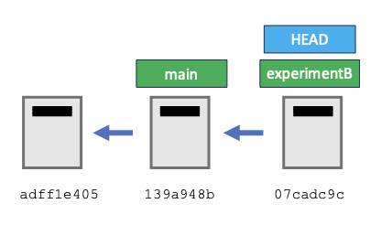

If we switch to branch main, then we see that HEAD now is pointing to main:

$ git checkout main
$ git log --all --graph --decorate

* commit 07cadc9cc542ee04c327ddb8988bb347432840d0 (experimentB)
| Author: Clara Llebot <clara.llebot@oregonstate.edu>
| Date: Mon Feb 24 13:44:47 2025 -0800
|
| Add description of experiment B
|
* commit 139a948b3b98905d6390fac3836cdff11562c4b9 (HEAD -> main)
| Author: Clara Llebot <clara.llebot@oregonstate.edu>
| Date: Mon Feb 24 13:24:10 2025 -0800
|
| Create structure for methods and experiment A
|

And the contents of methods do not include any mention to Experiment B.

$ cat methods.md

# Methods
## Experiment A

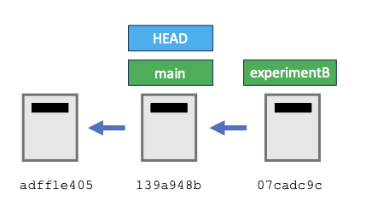

Now suppose that another collaborator working on the article decides to report Experiment C in the methods section. This collaborator can create a different experimentC to complete that work.

$ git branch experimentC
$ git checkout experimentC
$ git log --all --graph --decorate

* commit 07cadc9cc542ee04c327ddb8988bb347432840d0 (experimentB)
| Author: Clara Llebot <clara.llebot@oregonstate.edu>
| Date: Mon Feb 24 13:44:47 2025 -0800
|
| Add description of experiment B
|
* commit 139a948b3b98905d6390fac3836cdff11562c4b9 (HEAD -> experimentC, main)
| Author: Clara Llebot <clara.llebot@oregonstate.edu>
| Date: Mon Feb 24 13:24:10 2025 -0800
|
| Create structure for methods and experiment A
|

$ nano methods.md

# Methods
## Experiment A
## Experiment C
Description of the elements of experiment C.
$ git add methods.md
$ git commit -m "Start description of experiment C"
$ git log --all --graph --decorate

* commit 5a30cfafa907d94e8ddf8d050c1c55252f1b63b6 (HEAD -> experimentC)
| Author: Clara Llebot <clara.llebot@oregonstate.edu>
| Date: Mon Feb 24 15:05:13 2025 -0800
|
| Start description of experiment C
|
| * commit 07cadc9cc542ee04c327ddb8988bb347432840d0 (experimentB)
|/ Author: Clara Llebot <clara.llebot@oregonstate.edu>
| Date: Mon Feb 24 13:44:47 2025 -0800
|
| Add description of experiment B
|
* commit 139a948b3b98905d6390fac3836cdff11562c4b9 (main)
| Author: Clara Llebot <clara.llebot@oregonstate.edu>
| Date: Mon Feb 24 13:24:10 2025 -0800
|
| Create structure for methods and experiment A
|

This is a bit hard to read, it takes a lot of space, so we can add --oneline to our git log command to visualize it in a more compact way.

$ git log --all --graph --decorate --oneline

* 5a30cfa (HEAD -> experimentC) Start description of experiment C
| * 07cadc9 (experimentB) Add description of experiment B
|/
* 139a948 (main) Create structure for methods and experiment A
* adff1e4 Structure the results to include a third section
* 0a1d098 Start template for the results section
* 1bf3397 Start a template of the introduction

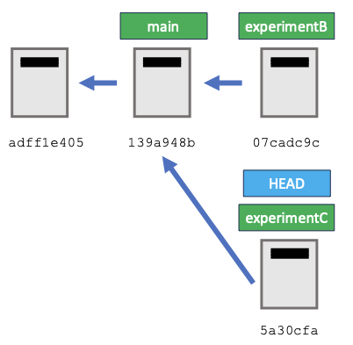

We could, from here, keep adding commits to any of the three branches (main, experimentB, experimentC).

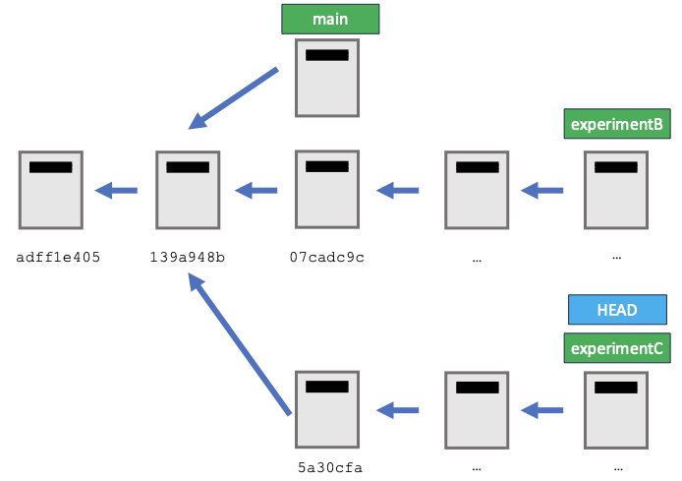

Merge
Merge is the opposite of branch. We use merge to combine the information from two branches. For example, let’s say that we decide that we definitely want to report experiment B in our article, and that we want the work we did on experiment B to be part of the main branch. First, we need to go to the branch where we want the content to be merged. In this case we will go to main. Then, we use git merge.

$ git checkout main
$ git merge experimentB

Updating 139a948..07cadc9
Fast-forward
methods.md | 2 ++
1 file changed, 2 insertions(+)

This fast-forward means that in this case, what really happened is that the main reference has moved so that now it points to the same place as experimentB.

$ git log --all --graph --decorate --oneline

* 5a30cfa (experimentC) Start description of experiment C
| * 07cadc9 (HEAD -> main,experimentB) Add description of experiment B
|/
* 139a948 Create structure for methods and experiment A
* adff1e4 Structure the results to include a third section
* 0a1d098 Start template for the results section
* 1bf3397 Start a template of the introduction

Our methods file has the content from experimentB.

$ cat methods.md

# Methods
## Experiment A
## Experiment B
Explanation of details of Experiment B.

Now let’s try the same with the branch experimentC

$ git checkout main
$ git merge experimentC

Auto-merging methods.md
CONFLICT (content): Merge conflict in methods.md
Automatic merge failed; fix conflicts and then commit the result.

This is very similar to what we saw in Session 1 when we were collaborating and finding conflicts. There was parallel development in both branches, so Git cannot just do a fast forward. And when Git tried to merge the two documents, it encountered lines that could not be merged automatically and needed to be reviewed by a person. We see that the error is in methods.md, so we open the file and check the conflict.

$ nano methods.md

# Methods
## Experiment A
<<<<<<< HEAD
## Experiment B
Explanation of details of Experiment B.
=======
## Experiment C
Description of the elements of experiment C.
>>>>>>> experimentC

We can see the conflict markers <<<<<<< HEAD, =======, and >>>>>>> experimentC. Here we will need to make a decision on what is the best way to report these experiments. In this case we could just remove the markers, and it looks like the document would proceed logically. But maybe we want to do something else, such as:

# Methods
## Experiment A
## Other experiments
Combined description of the elements of experiment B and C.

$ git add methods.md
$ git commit -m “Fix conflict, experimentsBC combined”

$ git log --all --graph --decorate --oneline

* bf22e0b (HEAD -> main) Fixed conflict, experimentsBC combined
|\
| * 5a30cfa (experimentC) Start description of experiment C
* | 07cadc9 (experimentB) Add description of experiment B
|/
* 139a948 Create structure for methods and experiment A
* adff1e4 Structure the results to include a third section
* 0a1d098 Start template for the results section
* 1bf3397 Start a template of the introduction

Note that at this point all the commits that we have been working on are part of the branch main, so the branches experimentB and experimentC are no longer useful. We can delete these references. For now, let’s delete only the experimentB branch.

$ git branch -d experimentB

Deleted branch experimentB (was 07cadc9).

$ git log --all --graph --decorate --oneline

* bf22e0b (HEAD -> main) Fixed conflict, experimentsBC combined
|\
| * 5a30cfa (experimentC) Start description of experiment C
* | 07cadc9 Add description of experiment B
|/
* 139a948 Create structure for methods and experiment A
* adff1e4 Structure the results to include a third section
* 0a1d098 Start template for the results section
* 1bf3397 Start a template of the introduction

Branches with remote repositories

Option 1: create a remote repository
We saw how to create a remote repository and link it with our local repository in the section Remotes in Github of the Version Control with Git lesson. If we have time, go ahead and create a repository. This is the summary of what you would do:
- Log into github.com
- Create a new repository. Make sure to choose a public repository, and to not include a readme, a gitignore or a license.
- Under the note “Quick setup — if you’ve done this kind of thing before” choose HTTPS and copy the url. It will look like https://github.com/username/articles.git
- In your terminal type
  - $ git remote add origin https://github.com/username/articles.git
- If you haven’t set up an authentication token before, do so now.
  - Go to the top right of the GitHub page, and click on your photo (or your initials, if you haven’t added a photo) and choose Settings. These are the settings for your account, not the settings for your repository.
  - Click on “developer settings”, the last option on the left menu.
  - Click on “personal access tokens”, again the last option on the left menu.
  - Choose Tokens (classic).
  - On the top right click on “Generate new token” and then “Generate new token (classic)”
  - Authenticate if asked
  - Create a token
    - Note: add a note that will remind you of why you chose this token. For example, Git workshop yyyy-mm-dd
    - Choose an expiration. For example, “7 days”
    - Select “public repo”. This is the only functionality that we will need for today’s workshop.
    - Click on the green button at the end “Generate token”
    - Copy the token and keep it securely, the same way you would for any other password. For example, save it in a password manager.
- Push the information from the local repository to the remote repository
  - $ git push origin main
  - If asked for a username and password add your GitHub username and the token you just created as password.
  - Enumerating objects: 24, done.
  - Counting objects: 100% (24/24), done.
  - Delta compression using up to 12 threads
  - Compressing objects: 100% (20/20), done.
  - Writing objects: 100% (24/24), 2.48 KiB | 2.48 MiB/s, done.
  - Total 24 (delta 2), reused 0 (delta 0), pack-reused 0
  - remote: Resolving deltas: 100% (2/2), done.
  - To https://github.com/username/articles.git
  - * [new branch] main -> main

Option 2: create a remote repository
If we don’t have time to create a remote repository create a fake remote repository in another folder.

$ cd ..
$ mkdir remote
$ cd remote
$ git init –bare
$ cd ..
$ cd articles
$ git remote add origin ../remote
$ git push origin main

Enumerating objects: 24, done.
Counting objects: 100% (24/24), done.
Delta compression using up to 12 threads
Compressing objects: 100% (20/20), done.
Writing objects: 100% (24/24), 2.48 KiB | 2.48 MiB/s, done.
Total 24 (delta 2), reused 0 (delta 0), pack-reused 0
To ../remote
* [new branch] main -> main

Push branches with remote repositories
Now that we have a remote repository git created new references for these branches.

$ git log --all --graph --decorate --oneline

* bf22e0b (HEAD -> main, origin/main) Fixed conflict, experimentsBC combined
|\
| * 5a30cfa (experimentC) Start description of experiment C
* | 07cadc9 Add description of experiment B
|/
* 139a948 Create structure for methods and experiment A
* adff1e4 Structure the results to include a third section
* 0a1d098 Start template for the results section
* 1bf3397 Start a template of the introduction

In red there is a new reference for the remote, origin/main.
We can only interact with the branches in our local repository. And the new commits will be pushed to the remote repository. These references will let us know where we are. For example, if we make changes to our local repository,

$ nano discussion.md

# Discussion
Main ideas from the discussion

$ git add discussion.md
$ git commit -m “Start discussion notes”
$ git log --all --graph --decorate --oneline

* ec36ac4 (HEAD -> main) Start discussion notes
* bf22e0b (origin/main) Fixed conflict, experimentsBC combined
|\
| * 5a30cfa (experimentC) Start description of experiment C
* | 07cadc9 Add description of experiment B
|/
* 139a948 Create structure for methods and experiment A
* adff1e4 Structure the results to include a third section
* 0a1d098 Start template for the results section
* 1bf3397 Start a template of the introduction

$ git push origin main

* ec36ac4 (HEAD -> main, origin/main) Start discussion notes
* bf22e0b Fixed conflict, experimentsBC combined
|\
| * 5a30cfa (experimentC) Start description of experiment C
* | 07cadc9 Add description of experiment B
|/
* 139a948 Create structure for methods and experiment A
* adff1e4 Structure the results to include a third section
* 0a1d098 Start template for the results section
* 1bf3397 Start a template of the introduction

After we push the information we see the reference origin/main move up to the last commit.

Right now our remote repository does not know anything about the experimentC branch. If we want to add that to our remote repository, we can push this branch too.

$ git push origin experimentC
$ git log --all --graph --decorate --oneline

* ec36ac4 (HEAD -> main, origin/main) Start discussion notes
* bf22e0b Fixed conflict, experimentsBC combined
|\
| * 5a30cfa (origin/experimentC, experimentC) Start description of experiment C
* | 07cadc9 Add description of experiment B
|/
* 139a948 Create structure for methods and experiment A
* adff1e4 Structure the results to include a third section
* 0a1d098 Start template for the results section
* 1bf3397 Start a template of the introduction

Since the branch experimentC is not that useful, I am going to delete it from my local repository.

$ git branch -d experimentC
$ git log --all --graph --decorate --oneline

* ec36ac4 (HEAD -> main, origin/main) Start discussion notes
* bf22e0b Fixed conflict, experimentsBC combined
|\
| * 5a30cfa (origin/experimentC) Start description of experiment C
* | 07cadc9 Add description of experiment B
|/
* 139a948 Create structure for methods and experiment A
* d6180e6 Structure the results to include a fourth section
* adff1e4 Structure the results to include a third section
* 0a1d098 Start template for the results section
* 1bf3397 Start a template of the introduction

The branch has disappeared from the local repository, but it is still present in the remote repository. We may be OK having the branch there, without cluttering our local branch list. To see the list of local branches and remote branches we can do:

$ git branch

* main

$ git branch -r

origin/experimentC
origin/main

And if we really want to remove the remote branch:

$ git push origin :experimentC

To https://github.com/username/articles.git
- [deleted] experimentC

Fetch, merge and pull

Now let’s make a change into the GitHub repository. This could be, for example, a collaborator pushing changes from their local repositories into this remote repository.

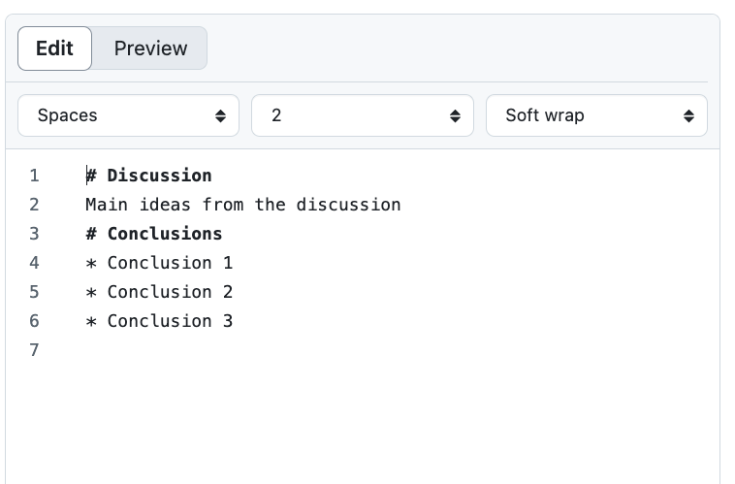

If we run our usual command, we do not know that these changes have been made.

$ git log --all --graph --decorate --oneline

* ec36ac4 (HEAD -> main, origin/main) Start discussion notes
* bf22e0b Fixed conflict, experimentsBC combined
|\
| * 5a30cfa Start description of experiment C
* | 07cadc9 Add description of experiment B
|/
* 139a948 Create structure for methods and experiment A
* adff1e4 Structure the results to include a third section
* 0a1d098 Start template for the results section
* 1bf3397 Start a template of the introduction

We saw in the previous lesson that we can use git pull to get all the information from the remote and merge into our local repository. Sometimes we may want to do this in two steps. First, fetch to see if there are more recent commits.

$ git fetch origin main
$ git log --all --graph --decorate --oneline

* a7e62f2 (origin/main) Add conclusions to the discussion
* ec36ac4 (HEAD -> main) Start discussion notes
* bf22e0b Fixed conflict, experimentsBC combined
|\
| * 5a30cfa Start description of experiment C
* | 07cadc9 Add description of experiment B
|/
* 139a948 Create structure for methods and experiment A
* adff1e4 Structure the results to include a third section
* 0a1d098 Start template for the results section
* 1bf3397 Start a template of the introduction

Here we see that the remote repository is ahead of us. However, we have not merged the changes. At this point, we may want to use git diff to see what the differences are.

$ git diff HEAD a7e62f2

Or the equivalent

$ git diff HEAD origin/main

diff --git a/discussion.md b/discussion.md
index ca08cd2..126c3f7 100644
--- a/discussion.md
+++ b/discussion.md
@@ -1,2 +1,6 @@
# Discussion
Main ideas from the discussion
+# Conclusions
+* Conclusion 1
+* Conclusion 2
+* Conclusion 3

We could use git merge to merge the changes of commit a7e62f2 into main, or we can just use git pull, which does fetch and merge at once.

$ git pull origin main
$ git log --all --graph --decorate --oneline

* a7e62f2 (HEAD -> main, origin/main) Add conclusions to the discussion
* ec36ac4 Start discussion notes
* bf22e0b (localrep/main) Fixed conflict, experimentsBC combined
|\
| * 5a30cfa (localrep/experimentC) Start description of experiment C
* | 07cadc9 Add description of experiment B
|/
* 139a948 Create structure for methods and experiment A
* adff1e4 Structure the results to include a third section
* 0a1d098 Start template for the results section
* 1bf3397 Start a template of the introduction

Ignoring things
See https://swcarpentry.github.io/git-novice/06-ignore.html

Forks and pull requests
https://osulp.github.io/git-advanced/05_forks_pull_requests/index.html

References
This lesson has been developed using these sources
- The Git novice lesson from software carpentry https://swcarpentry.github.io/git-novice/
  - Ahmadia, A., Allen, J., Appling, A., Aubin, S., Bachant, P., Banaszkiewicz, P., Barmby, P., Batut, B., Bekolay, T., Blischak, J., Bonsma, M., Borrelli, J., Boughton, A., Bouquin, D., Brauning, R., Brett, M., Brown, A., Cabunoc, A., Charlesworth, J., … Zhang, Q. (2016, juny 30). Software Carpentry: Version Control with Git. Zenodo. https://doi.org/10.5281/zenodo.57467
- Lecture 6: Version Control (git) (2020) by Anish Athalye, taught as part of an MIT Computer Science class. Find the video and notes https://missing.csail.mit.edu/2020/version-control/
- A lesson created at OSU by Ryan Wick, Clara Llebot and Steve Van Tuyl, using the software carpentry model https://github.com/osulp/git-advanced

