Industrial Internship Report on
Java Development – To-Do List Application
Prepared by
[Student Name]

Executive Summary
This report presents the work completed during Weeks 1–4 of an Industrial Internship focused on Java Development.
The project undertaken was a Java-based To-Do List Application designed as a console application for managing tasks.
During the internship period, the work progressed from understanding Java fundamentals and Object-Oriented Programming to designing the application structure and implementing core task-management features.
The application includes a Task class, task storage using ArrayList, and menu-driven operations for adding, viewing, completing, and deleting tasks. Development also involved user-input handling, testing, debugging, and improving code organization.
The internship provided practical exposure to applying programming concepts to a structured software project and strengthened problem-solving, debugging, and Java development skills.

TABLE OF CONTENTS
1 Preface 3
2 Introduction 4
2.1 About UniConverge Technologies Pvt Ltd 4
2.2 About upskill Campus 8
2.3 Objective 9
2.4 Reference 92.3 Objective
2.5 Glossary 10
3 Problem Statement 11
4 Existing and Proposed solution 12
5 Proposed Design/ Model 13
5.1 High Level Diagram (if applicable) 13
5.2 Low Level Diagram (if applicable) 13
5.3 Interfaces (if applicable) 13
6 Performance Test 14
6.1 Test Plan/ Test Cases 14
6.2 Test Procedure 14
6.3 Performance Outcome 14
7 My learnings 15
8 Future work scope 16

Preface
This report summarizes the work completed during the first four weeks of the Industrial Internship in Java Development. The internship provided an opportunity to move from learning Java fundamentals to applying those concepts in a practical To-Do List Application.
The internship was relevant to career development because it combined programming practice with practical software-development activities such as application planning, object-oriented design, user-input handling, testing, debugging, and problem solving.
The project focused on developing a Java-based To-Do List Application. The application was planned as a simple console program that allows users to manage tasks through core operations such as adding, viewing, completing, and deleting tasks.
The internship opportunity was provided through upskill Campus and The IoT Academy in association with UniConverge Technologies Pvt Ltd (UCT), following the structure described in the provided internship-report template. The template emphasizes practical exposure, real-world problem solving, and implementation of a project solution.
Program plan and weekly progress
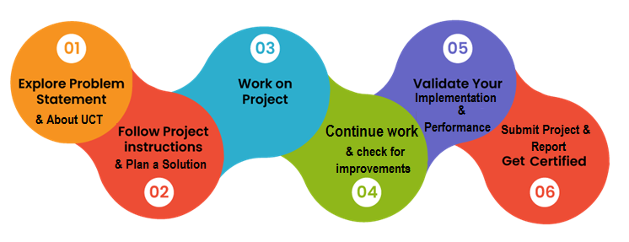
Week 1 – Java Development Foundation: Studied Java fundamentals, syntax, variables, data types, operators, conditional statements, loops, and basic Object-Oriented Programming concepts. The To-Do List problem was understood and the initial application structure and CRUD-style requirements were planned.
Week 2 – Core Application Development: Created the Task class with task ID, title/name, description, and completion status. Implemented ArrayList-based task storage, add/view/complete/delete operations, and a menu-driven console interface using Scanner, loops, and conditional statements.
Week 4 – Project Consolidation: The project work was consolidated around refining the Java application, reviewing the implemented task-management flow, testing the core operations, improving code organization and readability, and preparing the work for documentation and final presentation. This section is intentionally kept conservative because no separate Week 4 report file was available in the saved internship materials.
Week 3 – Implementation, Testing and Debugging: Strengthened Java and OOP understanding while developing and testing the To-Do List application. Multiple tasks and menu operations were tested, basic input-handling issues were identified and corrected, and debugging/problem-solving skills were improved.

Introduction

About UniConverge Technologies Pvt Ltd
A company established in 2013 and working in Digital Transformation domain and providing Industrial solutions with prime focus on sustainability and RoI.
For developing its products and solutions it is leveraging various Cutting Edge Technologies e.g. Internet of Things (IoT), Cyber Security, Cloud computing (AWS, Azure), Machine Learning, Communication Technologies (4G/5G/LoRaWAN), Java Full Stack, Python, Front end etc.

- UCT IoT Platform ()
UCT Insight is an IOT platform designed for quick deployment of IOT applications on the same time providing valuable “insight” for your process/business. It has been built in Java for backend and ReactJS for Front end. It has support for MySQL and various NoSql Databases.
- It enables device connectivity via industry standard IoT protocols - MQTT, CoAP, HTTP, Modbus TCP, OPC UA
- It supports both cloud and on-premises deployments.
It has features to
• Build Your own dashboard
• Analytics and Reporting
• Alert and Notification
• Integration with third party application(Power BI, SAP, ERP)
• Rule Engine

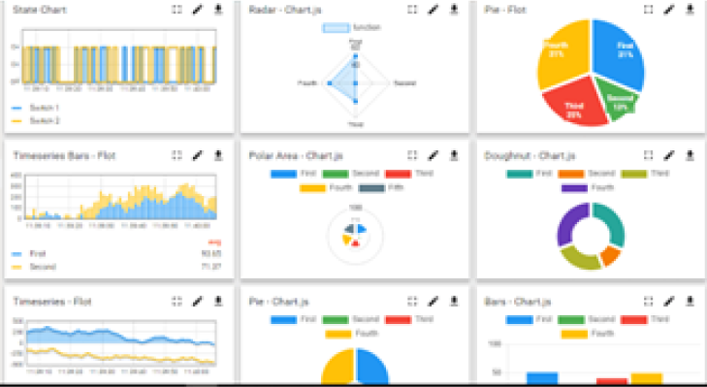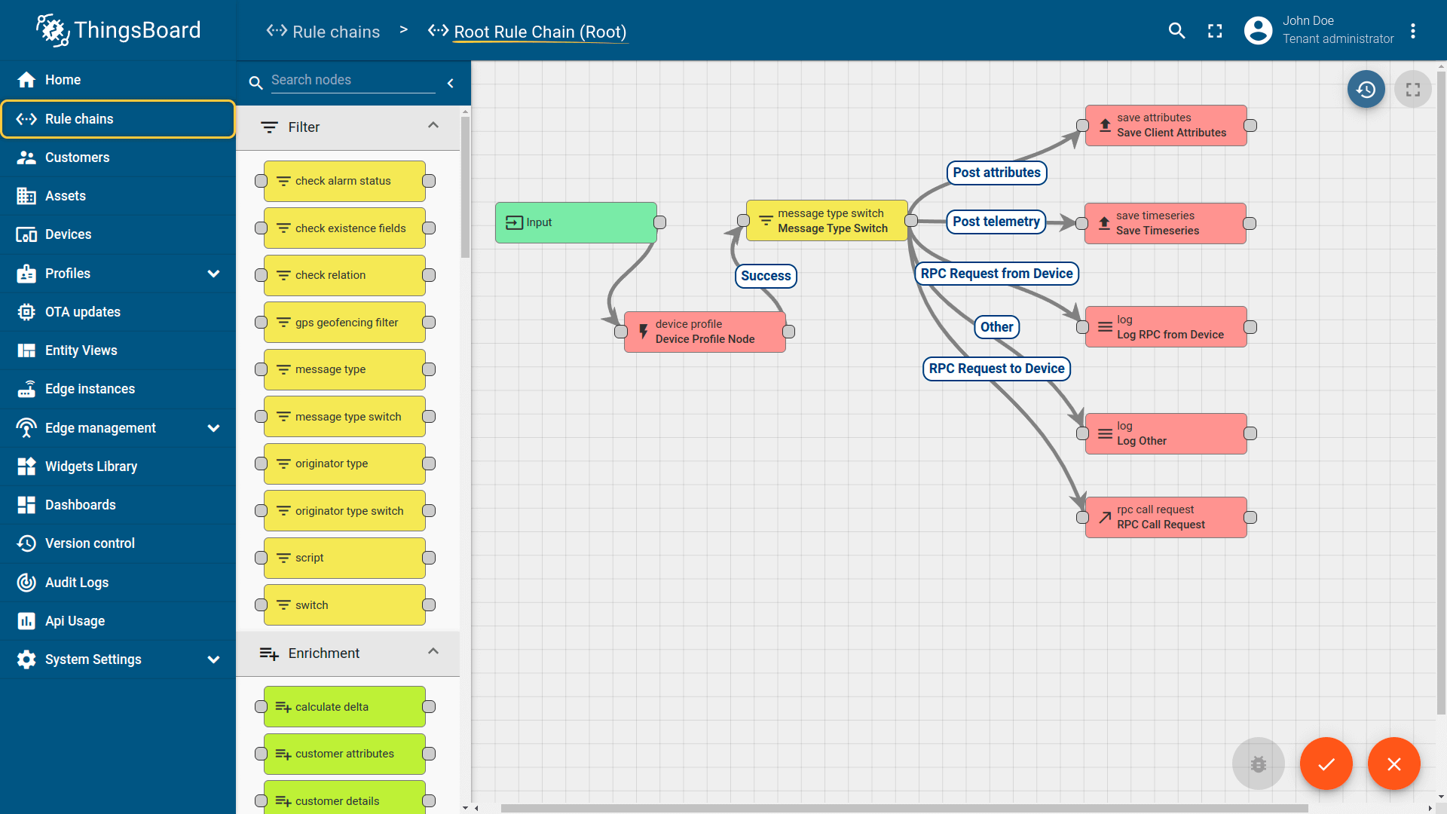

- Smart Factory Platform ()
Factory watch is a platform for smart factory needs.
It provides Users/ Factory
- with a scalable solution for their Production and asset monitoring
- OEE and predictive maintenance solution scaling up to digital twin for your assets.
- to unleased the true potential of the data that their machines are generating and helps to identify the KPIs and also improve them.
- A modular architecture that allows users to choose the service that they what to start and then can scale to more complex solutions as per their demands.
Its unique SaaS model helps users to save time, cost and money.
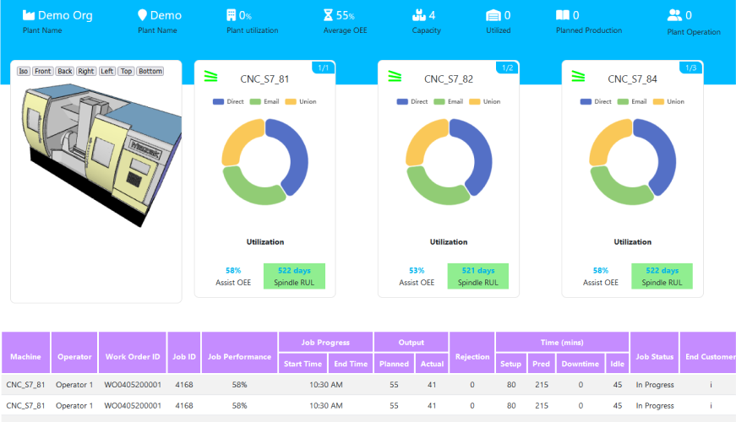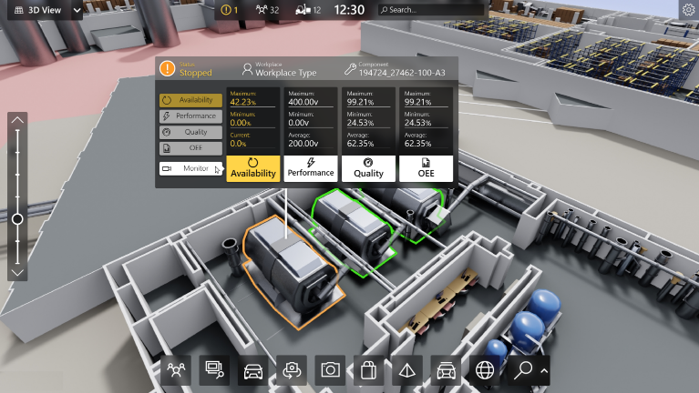

- 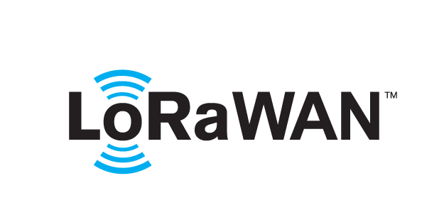 based Solution
UCT is one of the early adopters of LoRAWAN teschnology and providing solution in Agritech, Smart cities, Industrial Monitoring, Smart Street Light, Smart Water/ Gas/ Electricity metering solutions etc.
- Predictive Maintenance
UCT is providing Industrial Machine health monitoring and Predictive maintenance solution leveraging Embedded system, Industrial IoT and Machine Learning Technologies by finding Remaining useful life time of various Machines used in production process.
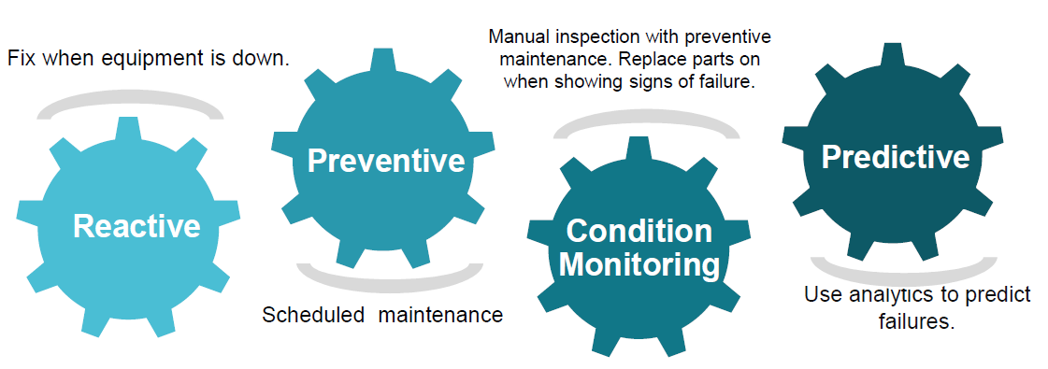

About upskill Campus (USC)
upskill Campus along with The IoT Academy and in association with Uniconverge technologies has facilitated the smooth execution of the complete internship process.
USC is a career development platform that delivers personalized executive coaching in a more affordable, scalable and measurable way.




Seeing need of upskilling in self paced manner along-with additional support services e.g. Internship, projects, interaction with Industry experts, Career growth Services
https://www.upskillcampus.com/
upSkill Campus aiming to upskill 1 million learners in next 5 year

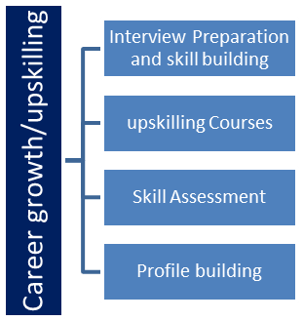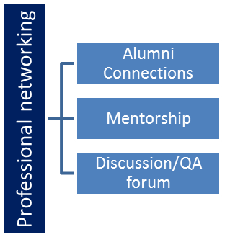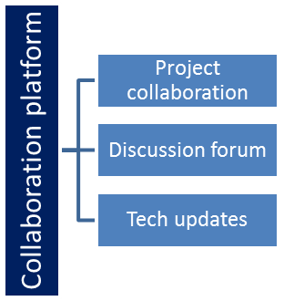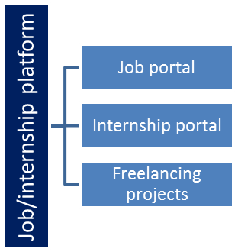

The IoT Academy
The IoT academy is EdTech Division of UCT that is running long executive certification programs in collaboration with EICT Academy, IITK, IITR and IITG in multiple domains.

Objectives of this Internship program
The objective for this internship program was to
☛ get practical experience of working in the industry.
☛ to solve real world problems.
☛ to have improved job prospects.
☛ to have Improved understanding of our field and its applications.
☛ to have Personal growth like better communication and problem solving.

Reference
[1] Oracle Java Documentation – Java Language and API documentation.
[2] Java Collections Framework – ArrayList and related collection concepts.
[3] Internship weekly progress reports for Weeks 1–4 – Java Development / To-Do List Application.

Glossary
Terms | Acronym
OOP | Object-Oriented Programming
CRUD | Create, Read, Update, Delete
JDK | Java Development Kit
IDE | Integrated Development Environment
ArrayList | Resizable Java collection used to store tasks

Problem Statement
In the assigned problem statement
The assigned project was to develop a Java-based To-Do List Application. The problem addressed is the need for a simple application through which a user can create, view, complete, and delete tasks in an organized manner. The project also required applying Java programming and Object-Oriented Programming concepts in a practical application.

Existing and Proposed solution

Existing solutions: To-Do List applications are commonly available as mobile, web, or desktop applications. For this internship project, the focus was on a lightweight console-based implementation. A console application has a simple interface and limited persistence and user-interface capabilities.
Proposed solution: Develop a Java console application with a structured Task model, collection-based task storage, and menu-driven operations. The user can add a task, view tasks, mark a task as completed, and delete a task.
Value addition: The project provides practical implementation of Java OOP, collections, methods, loops, conditional logic, input handling, testing, and debugging. The modular structure also provides a foundation for future validation, searching, filtering, persistent storage, and a graphical interface.

Code submission (Github link): [GitHub link to be added]

Report submission (Github link): [GitHub link to be added]

Proposed Design/ Model

The proposed design follows a simple flow: user starts the application, selects an operation from the menu, provides task information when required, the program performs the selected task operation, and the updated task list is displayed. The design separates task data from task-management logic using Java classes and methods.

High Level Diagram (if applicable)

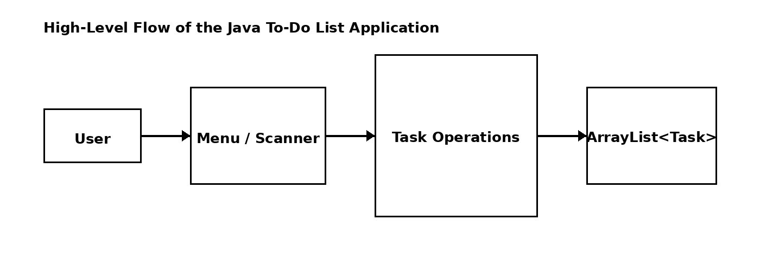
Figure 1: HIGH LEVEL DIAGRAM OF THE JAVA TO-DO LIST APPLICATION

Low Level Diagram (if applicable)

Interfaces (if applicable)
Interface and flow: Scanner is used for console input. The menu uses conditional logic to route the user's selection to task operations. ArrayList stores multiple Task objects during program execution. The main operations are Add Task, View Tasks, Complete Task, Delete Task, and Exit.

Performance Test

Testing was used to verify that the core task-management operations behaved as expected. The main constraints considered were correct user input, task selection, collection management, and reliable execution of each menu operation.
Key constraints included handling invalid menu choices, managing multiple tasks in an ArrayList, selecting the correct task for completion or deletion, and avoiding basic input-handling errors.
The design addressed these constraints by separating task data into the Task class, using collection-based storage, validating menu choices, testing operations separately, and using repeated test inputs to identify logic and input-handling issues.
The implemented core operations were tested with multiple tasks. Adding and viewing tasks worked as intended; completion and deletion were tested; and basic input-handling issues were identified and corrected during debugging.
For this console application, the most relevant practical constraints were correctness, input handling, collection management, usability of the menu, and maintainability of the code.
Further testing can be extended with larger task lists, invalid and empty inputs, repeated operations, and persistence-related scenarios when additional features are implemented.

Test Plan / Test Cases
Test cases included: (1) add a new task, (2) display all tasks, (3) mark an existing task as completed, (4) delete an existing task, (5) select different menu options, and (6) enter invalid menu choices.

Test Procedure
Procedure: Start the application, select each menu option, enter task information, observe the output, and repeat the operations with multiple tasks. Verify that the displayed task information and completion status change correctly.

Performance Outcome

Outcome: The core task-management flow was successfully exercised through repeated testing. Debugging helped identify basic input-handling and logic issues, while feature-by-feature testing made it easier to isolate and correct problems.

My learnings

The first four weeks strengthened my understanding of Java programming and gave me practical experience in applying programming concepts to a complete small application. I improved my understanding of Java syntax, variables, data types, operators, conditions, loops, methods, classes, objects, constructors, encapsulation, collections, and user-input handling.
The project work also improved my ability to break a problem into smaller components, organize code into classes and methods, test individual features, read error messages, debug syntax and logical errors, and refine a program through repeated testing. These skills will support future Java development work and larger software projects.
Key skills developed:
• Java Programming
• Object-Oriented Programming
• Classes, Objects and Methods
• ArrayList and Collections
• Console Application Development
• User Input Handling
• Testing and Debugging
• Problem Solving and Code Organization

Future work scope

The current application provides a foundation for further development. Future improvements can include stronger input validation, task searching and filtering, task updating/editing, persistent file or database storage, due dates and priorities, sorting, better exception handling, and a graphical user interface. The project could also be extended into a web or full-stack application after strengthening the Java backend concepts.

