DEPARTMENT OF COMPUTER ENGINEERING
Academic Year 2025-26


A Micro Project Report On
“Web-Based Cyber Security Awareness Model”
Submitted By

Siddharth Lokhande | 2406119
Avinash Jambhale | 2406085
Dnyaneshwar Mengal | 2306117

Guided by :
Smt.S.P.Ambavane
Lecturer, Government Polytechnic, Pune

DEPARTMENT OF COMPUTER ENGINEERING
Academic Year 2025-26

CERTIFICATE

This is to certify that the micro-project work entitled “CyberLearn – Web-Based Cyber Security Awareness Model” is a bonafide work carried out by

Siddharth Lokhande | 2406119
Avinash Jambhale | 2406085
Dnyaneshwar Mengal | 2306117

Of class Third Year in partial fulfilment of requirement for completion of course Cloud Computing (CM51207) of Diploma in Computer Engineering from Government Polytechnic, Pune. The report has been approved as it satisfies the academic requirements in respect of microproject work prescribed for the course.

Smt.S.P.Ambavane Smt.J.R.Hange Dr.R.K.Patil (Microproject Guide) (Head of Department ) (Principal)

ACKNOWLEDGEMENT

We extend our deepest gratitude to Dr. Rajendra Patil, our esteemed Principal, whose unwavering support and encouragement inspired us throughout the journey of our project, “Web-Based Cyber Security Awareness Model” His vision and guidance paved the path for its successful completion.

Special recognition is due to Mrs. J. R. Hange, our dedicated Head of Department, for her invaluable insights and constant motivation, which played a pivotal role in shaping this endeavour.

A profound thank-you to Smt. S. P. Ambavane Ma’am, our respected mentor, whose boundless patience and consistent guidance were the cornerstones of our project journey. Her valuable advice and keen insights were instrumental in overcoming challenges and achieving our objectives.

Furthermore, we acknowledge that the completion of this project was a testament to our dedication and perseverance. While we received immense support and direction from our mentors and faculty, the execution and culmination of this work were solely our own.

In closing, we express our heartfelt gratitude to all those who contributed directly or indirectly to the success of this project. This work stands as a reflection of teamwork, determination, and the pursuit of academic excellence.

The project “Web-Based Cyber Security Awareness Model” presents the design and development of CyberLearn, an interactive e-learning website that teaches users how to protect themselves from common cyber threats. The main objective of the project is to spread cyber security awareness among students and general users through simple lessons, practical tools and games.

CyberLearn provides 6 lessons (Strong Passwords, Phishing Emails, Malware & Viruses, Safe Browsing, Social Media Safety and Social Engineering), a Password Strength Checker, a “Spot the Phish” email game, an 8-question Cyber Quiz, 8 badges, levels based on points and a printable certificate of completion.

The system is developed using HTML, CSS and JavaScript and runs completely in the web browser. User progress such as points, completed lessons, best scores and badges is saved in the browser’s Local Storage, and the password typed in the checker is never saved or sent anywhere.

The project demonstrates important concepts of password security, phishing detection, malware protection, safe browsing and social engineering, and uses gamification (points, levels and badges) to make learning about cyber security simple and engaging.

Sr no | Content | Page
1. | Introduction | 1
2. | Requirement Analysis | 2-3
3. | Implementation | 4-6
4. | Code | 7-16
5. | Output | 17-19
6. | Advantages | 20
7. | Disadvantage | 21
8. | Future Scope | 22
9. | Course Level Outcomes Achieved | 23
10. | Conclusion | 24
11. | References | 25

Introduction

Cyber security has become an important part of everyday life because people use the internet for studies, banking, shopping and social media. At the same time, cyber attacks such as phishing, malware, password theft and online scams are increasing, and most of them succeed because users are not aware of the risks.

The project “CyberLearn – Web-Based Cyber Security Awareness Model” focuses on developing an interactive website that teaches cyber security awareness in a simple and practical way. Users simply open the website in a browser and start learning, without creating an account or installing any software.

CyberLearn is a single-page web application built with HTML, CSS and JavaScript. Its pages – Home, Lessons, Password, Phishing, Quiz and Badges – are shown using the address hash (for example #lessons), so the browser Back button works and every page has its own link.

The platform provides six awareness lessons, a password strength checker that estimates how long a password would take to crack, a “Spot the Phish” game based on realistic sample emails, and a cyber quiz with explanations for every answer.

To keep users motivated, the system uses gamification: users earn points, move through levels from Beginner to Cyber Expert, unlock badges and finally download a certificate of completion. All progress is stored in the browser’s Local Storage on the user’s own device.

The project provides practical exposure to how a real awareness platform can be built using basic web technologies, while keeping it free, lightweight and suitable for an academic project environment.

Requirement Analysis

2.1 Hardware Requirements & Specification
2.1.1 Development Computer/Laptop
- Processor: Intel Core i3 / AMD Ryzen 3 or higher
- RAM: Minimum 4 GB
- Storage: Minimum 1 GB free space
- Display: 1366 × 768 resolution or higher
2.1.2 User (Client) Device
- Any desktop, laptop, tablet or smartphone
- Modern web browser (Chrome, Edge, Firefox)
- Internet connection to load Google Fonts (the website itself works offline)
2.1.3 Server/Backend Environment
- No backend server or database required
- The website can be opened directly in a browser or hosted on any static web hosting service

2.2 Software Requirements & Specification:
2.2.1 Frontend
- HTML5
- CSS3 (custom theme, animations and responsive layout)
- JavaScript
- Google Fonts (Orbitron and Poppins)
2.2.2 Data Storage
- Browser Local Storage (Web Storage API)
- JSON format for saved progress
2.2.3 Development & Testing Tools
- Visual Studio Code
- Git and GitHub
- Web Browser
- Web Browser Developer Tools

2.3 SYSTEM REQUIREMENTS:
2.3.1 Home Dashboard
- Points, Lessons, Best Quiz and Badges Statistics
- Level and Progress Bar
- Cyber Tip of the Day
- Did You Know Facts
2.3.2 Learning Module
- Six Awareness Lessons
- Mark Lesson as Complete
2.3.3 Interactive Tools
- Password Strength Checker
- Spot the Phish Email Game
- Cyber Quiz with Explanations
2.3.4 Gamification Module
- Points and Levels
- Badges
- Certificate of Completion
2.3.5 Privacy Features
- No Login or Personal Data Required
- Passwords Are Never Saved or Sent
- Progress Stored Only on the User’s Device

Implementation Steps

- System Architecture:
- User (Browser) → opens index.html from any device.
- index.html → contains the structure of all six pages.
- style.css → provides the dark cyber theme and responsive layout.
- script.js → contains the data and logic of every module.
- Local Storage → saves the user’s progress in the browser.

- Step 1: Home Dashboard
1. The Home page shows the user’s points, completed lessons, best quiz score and unlocked badges.
2. A level bar shows the current level and the points needed for the next level.
3. A Cyber Tip of the Day and “Did You Know?” facts are displayed.

- Step 2: Page Navigation
1. All pages are sections of one HTML file; only the selected page is shown.
2. The page is selected from the address hash (#home, #lessons, #password, #phishing, #quiz, #badges).
3. A menu button opens the navigation on mobile screens.

- Step 3: Lessons
Six lessons are created from JavaScript data. Each lesson has an icon, a short explanation and four key safety points:
- Strong Passwords and Phishing Emails
- Malware & Viruses and Safe Browsing
- Social Media Safety and Social Engineering
Clicking “Mark as Complete” saves the lesson and gives +10 points.

- Step 4: Password Strength Checker
- Checks 6 rules: 12+ characters, uppercase, lowercase, number, symbol and not a common password
- Shows strength from Very Weak to Very Strong with a coloured bar

- Estimates the time to crack assuming 10 billion guesses per second
- Show / hide password button; nothing typed is saved or sent
Passing every check unlocks the Password Pro reward (+10 points).

- Step 5: Spot the Phish Game
- Shows 5 sample emails with sender, subject and message
- User chooses “Phishing” or “Safe” for each email
- An explanation of the warning signs is shown after every answer
- +5 points per correct answer in the best attempt

- Step 6: Cyber Quiz
- 8 multiple-choice questions on cyber safety
- Correct and wrong answers are highlighted with an explanation
- Pass mark is 6 out of 8; the best score is saved

- Step 7: Points and Levels
Points are calculated from all activities as shown below:
Activity | Points | Maximum
Lessons completed | +10 per lesson | 60
Cyber Quiz (best attempt) | +5 per correct answer | 40
Spot the Phish (best attempt) | +5 per correct answer | 25
Password Pro | +10 once | 10
Levels: Beginner (0), Learner (40), Defender (80) and Cyber Expert (120 points).

- Step 8: Badges
Eight badges are unlocked automatically:
- First Step, Bookworm and Scholar (lessons)
- Password Pro and Phish Spotter (tools)
- Quiz Taker and Perfect Score (quiz)
- Cyber Champion (all other badges)

- Step 9: Certificate of Completion
After completing all lessons and passing the quiz, the user enters a name and downloads a printable certificate showing the name, score and date of issue.

- Step 10: Saving Progress
1. Completed lessons, scores, badges and the user’s name are saved in Local Storage.
2. Progress is loaded again automatically when the website is reopened.
3. A “Reset Progress” button clears all saved data after confirmation.

Code:

Code 1: index.html – Page header, navigation and Home section
<!DOCTYPE html>
<html lang="en">
<head>
<meta charset="UTF-8">
<meta name="viewport" content="width=device-width, initial-scale=1.0">
<title>CyberLearn – Cyber Security Awareness</title>
<meta name="description" content="A web-based cyber security awareness e-learning platform with
lessons, interactive tools, quizzes and badges.">
<link rel="preconnect" href="https://fonts.googleapis.com">
<link href="https://fonts.googleapis.com/css2?family=Orbitron:wght@600;800&family=Poppins:wght@400
;500;600;700&display=swap" rel="stylesheet">
<link rel="stylesheet" href="style.css">
</head>
<body>
<header>
<a href="#home" class="logo">🛡️ <span>CyberLearn</span></a>
<button class="menu-btn" onclick="toggleMenu()" aria-label="Open menu">☰</button>
<nav id="nav">
<a href="#home" data-page="home">🏠 Home</a>
<a href="#lessons" data-page="lessons">📘 Lessons</a>
<a href="#password" data-page="password">🔐 Password</a>
<a href="#phishing" data-page="phishing">🎣 Phishing</a>
<a href="#quiz" data-page="quiz">📝 Quiz</a>
<a href="#badges" data-page="badges">🎖️ Badges</a>
</nav>
<div class="points-pill">⭐ <span id="points-top">0</span></div>
</header>

<main>
<!-- ================= HOME ================= -->
<section id="home" class="page">
<div class="hero">
<div class="hero-text">
<p class="eyebrow" id="welcome">Cyber Security Awareness Platform</p>
<h1>Become a <span class="gradient">Cyber Hero</span></h1>
<p>Learn how hackers trick people, practise spotting attacks, and earn badges as you
level up your online safety.</p>
<div class="hero-btns">
<a href="#lessons" class="btn">Start Learning →</a>
<a href="#phishing" class="btn btn-outline">Try a Challenge</a>

Code 2: index.html – Password, Phishing, Quiz and Badges sections
<!-- ================= PASSWORD ================= -->
<section id="password" class="page">
<div class="page-head">
<h1>🔐 Password Strength Checker</h1>
<p class="muted">Type a password to test it. Nothing is saved or sent anywhere. Pass every
check to earn <b>+10 points</b>.</p>
</div>
<div class="card">
<div class="pw-wrap">
<input type="password" id="pw-input" placeholder="Type a password..."
oninput="checkPassword()" autocomplete="off">
<button class="eye" onclick="togglePassword()" id="eye-btn" aria-label="Show
password">👁️</button>
</div>
<div class="bar"><div id="pw-bar"></div></div>
<div class="pw-info">
<span>Strength: <b id="pw-label">–</b></span>
<span>Time to crack: <b id="pw-time">–</b></span>
</div>
<ul id="pw-rules" class="rules"></ul>
</div>
</section>

<!-- ================= PHISHING ================= -->
<section id="phishing" class="page">
<div class="page-head">
<h1>🎣 Spot the Phish</h1>
<p class="muted">Is each email <b>Phishing</b> or <b>Safe</b>? Earn <b>+5 points</b> per
correct answer in your best attempt.</p>
</div>
<div id="phish-box"></div>
</section>

<!-- ================= QUIZ ================= -->
<section id="quiz" class="page">
<div class="page-head">
<h1>📝 Cyber Quiz</h1>
<p class="muted">Earn <b>+5 points</b> per correct answer in your best attempt. Score 6 or
more to pass.</p>
</div>
<div id="quiz-box"></div>
</section>

<!-- ================= BADGES ================= -->
<section id="badges" class="page">
<div class="page-head">

Code 3: style.css – Theme, header and page layout
/* ===================== Theme ===================== */
:root {
--bg: #070b1a;
--card: rgba(255, 255, 255, 0.05);
--border: rgba(255, 255, 255, 0.1);
--text: #e5e9f5;
--muted: #94a3b8;
--cyan: #22d3ee;
--purple: #a855f7;
--green: #22c55e;
--red: #ef4444;
--yellow: #facc15;
--glow: 0 0 25px rgba(34, 211, 238, 0.35);
}

* { box-sizing: border-box; }

body {
margin: 0;
font-family: "Poppins", "Segoe UI", Arial, sans-serif;
color: var(--text);
background:
radial-gradient(circle at 15% 10%, rgba(168, 85, 247, 0.18), transparent 40%),
radial-gradient(circle at 85% 30%, rgba(34, 211, 238, 0.15), transparent 40%),
linear-gradient(rgba(255, 255, 255, 0.025) 1px, transparent 1px) 0 0 / 40px 40px,
linear-gradient(90deg, rgba(255, 255, 255, 0.025) 1px, transparent 1px) 0 0 / 40px 40px,
var(--bg);
background-attachment: fixed;
min-height: 100vh;
display: flex;
flex-direction: column;
}

h1, h2, h3 { margin-top: 0; }
h1 { font-size: 32px; }
a { color: var(--cyan); }
.muted { color: var(--muted); }
.hidden { display: none !important; }

.gradient {
background: linear-gradient(90deg, var(--cyan), var(--purple));
-webkit-background-clip: text;
background-clip: text;
color: transparent;
}

Code 4: style.css – Quiz, phishing and badge styles
/* ===================== Quiz & Phishing ===================== */
.q-top { display: flex; justify-content: space-between; color: var(--muted); font-weight: 600;
margin-bottom: 10px; }
.q-title { font-size: 20px; margin: 18px 0 8px; }

.option {
display: block;
width: 100%;
text-align: left;
margin: 10px 0;
padding: 14px 16px;
font-size: 15px;
background: rgba(255, 255, 255, 0.04);
color: var(--text);
border: 1px solid var(--border);
border-radius: 12px;
cursor: pointer;
transition: 0.2s;
}

.option:hover:not(:disabled) { border-color: var(--cyan); background: rgba(34, 211, 238, 0.08);
transform: translateX(4px); }
.option:disabled { cursor: default; }
.correct { background: rgba(34, 197, 94, 0.2) !important; border-color: var(--green) !important; }
.wrong { background: rgba(239, 68, 68, 0.2) !important; border-color: var(--red) !important;
animation: shake 0.3s; }

@keyframes shake {
25% { transform: translateX(-6px); }
75% { transform: translateX(6px); }
}

.email {
background: #f8fafc;
color: #1e293b;
border-radius: 12px;
overflow: hidden;
margin: 14px 0 18px;
box-shadow: 0 10px 30px rgba(0, 0, 0, 0.4);
}

.email-head { background: #e2e8f0; padding: 12px 16px; font-size: 14px; }
.email-head div { margin: 3px 0; }
.email-body { padding: 16px; line-height: 1.6; }
.email-body a { color: #2563eb; }

Code 5: script.js – Lesson and quiz data
// =====================================================
// CyberLearn – Web-Based Cyber Security Awareness Model
// =====================================================

// ---------- Lesson data ----------
const lessons = [
{
icon: "🔑",
title: "Strong Passwords",
text: "Passwords are the keys to your digital life. Weak or reused passwords are the easiest
way for attackers to get in.",
points: ["Use 12+ characters with letters, numbers and symbols", "Never reuse a password on two
sites", "Use a password manager", "Turn on Two-Factor Authentication (2FA)"]
},
{
icon: "🎣",
title: "Phishing Emails",
text: "Phishing messages pretend to come from trusted companies so you'll click a link or share
private data.",
points: ["Watch for urgent threats like 'account blocked'", "Check the real sender address",
"Hover over links before clicking", "Never share OTPs or passwords"]
},
{
icon: "🦠",
title: "Malware & Viruses",
text: "Malware is harmful software such as viruses, ransomware and spyware that can steal data
or lock your files.",
points: ["Download apps only from official stores", "Keep your OS and apps updated", "Use
antivirus software", "Don't open unknown attachments (.exe, .zip)"]
},
{
icon: "🌐",
title: "Safe Browsing",
text: "Fake websites and pop-ups are made to look real. A few quick checks keep you safe while
browsing.",
points: ["Look for HTTPS and the correct website name", "Don't click pop-up ads or 'You won'
banners", "Avoid banking on public Wi-Fi", "Use a VPN on open networks"]
},
{
icon: "📱",
title: "Social Media Safety",
text: "Everything you post can be seen, saved and used by strangers, including scammers.",
points: ["Keep your accounts private", "Don't post your address, phone or live location",
"Accept requests only from people you know", "Think before you share photos"]
},
{

Code 6: script.js – Saved progress, points and page navigation
// ---------- Saved progress ----------
function load(key, fallback) {
try {
const value = localStorage.getItem(key);
return value === null ? fallback : JSON.parse(value);
} catch (e) {
return fallback;
}
}

let completed = load("completed", []);
let bestScore = load("bestScore", 0);
let quizPlayed = load("quizPlayed", false);
let phishBest = load("phishBest", 0);
let passwordPro = load("passwordPro", false);
let unlocked = load("unlocked", []);
let userName = load("userName", "");

function save() {
const data = { completed, bestScore, quizPlayed, phishBest, passwordPro, unlocked, userName };
try {
for (const key in data) localStorage.setItem(key, JSON.stringify(data[key]));
} catch (e) { /* storage blocked – progress just won't persist */ }
}

function getPoints() {
return completed.length * 10 + bestScore * 5 + phishBest * 5 + (passwordPro ? 10 : 0);
}

function maxPoints() {
return lessons.length * 10 + questions.length * 5 + emails.length * 5 + 10;
}

// ---------- Page navigation (uses #hash so Back button works) ----------
const pages = ["home", "lessons", "password", "phishing", "quiz", "badges"];

function showPage(id) {
if (!pages.includes(id)) id = "home";
document.querySelectorAll(".page").forEach(p => p.classList.toggle("active", p.id === id));
document.querySelectorAll("nav a").forEach(a => a.classList.toggle("active", a.dataset.page ===
id));
document.getElementById("nav").classList.remove("open");
if (id === "quiz") startQuiz();
if (id === "phishing") startPhish();
window.scrollTo(0, 0);
}

Code 7: script.js – Lessons and password strength checker
// ---------- Lessons ----------
function showLessons() {
document.getElementById("lesson-list").innerHTML = lessons.map((lesson, i) => {
const done = completed.includes(i);
return `
<div class="card lesson ${done ? "done" : ""}">
<div class="lesson-head">
<div class="lesson-icon">${lesson.icon}</div>
<div><small>Lesson ${i + 1}</small><h3>${lesson.title}</h3></div>
</div>
<p>${lesson.text}</p>
<ul>${lesson.points.map(p => `<li>${p}</li>`).join("")}</ul>
<button class="btn btn-small ${done ? "btn-green" : ""}" onclick="markDone(${i})" ${done ?
"disabled" : ""}>
${done ? "✔ Completed" : "Mark as Complete (+10)"}
</button>
</div>`;
}).join("");
}

function markDone(i) {
if (completed.includes(i)) return;
completed.push(i);
showToast("+10 points! ⭐");
refresh();
}

// ---------- Password checker ----------
const commonPasswords = ["password", "123456", "12345678", "qwerty", "abc123", "111111",
"iloveyou", "admin", "welcome"];

const pwRules = [
{ text: "At least 12 characters", test: p => p.length >= 12 },
{ text: "Uppercase letter (A-Z)", test: p => /[A-Z]/.test(p) },
{ text: "Lowercase letter (a-z)", test: p => /[a-z]/.test(p) },
{ text: "Number (0-9)", test: p => /[0-9]/.test(p) },
{ text: "Symbol (! @ # $ ...)", test: p => /[^A-Za-z0-9]/.test(p) },
{ text: "Not a common password", test: p => p.length > 0 && !commonPasswords.some(c =>
p.toLowerCase().includes(c)) }
];

const pwLevels = [
{ label: "–", color: "transparent" },
{ label: "Very Weak 😟", color: "#ef4444" },
{ label: "Weak 😕", color: "#f97316" },
{ label: "Medium 😐", color: "#f59e0b" },

Code 8: script.js – Spot the Phish game
// ---------- Spot the Phish ----------
let phishIndex = 0;
let phishScore = 0;

function startPhish() {
phishIndex = 0;
phishScore = 0;
showEmail();
}

function showEmail() {
const e = emails[phishIndex];
document.getElementById("phish-box").innerHTML = `
<div class="card">
<div class="q-top"><span>📧 Email ${phishIndex + 1} / ${emails.length}</span><span>Score:
${phishScore}</span></div>
<div class="bar"><div class="quiz-fill" style="width:${(phishIndex / emails.length) *
100}%"></div></div>
<div class="email">
<div class="email-head">
<div><b>From:</b> ${e.from}</div>
<div><b>Subject:</b> ${e.subject}</div>
</div>
<div class="email-body">${e.body}</div>
</div>
<div class="choices" id="choices">
<button class="btn btn-danger" onclick="answerPhish(true)">🎣 Phishing</button>
<button class="btn btn-green" onclick="answerPhish(false)">✅ Safe</button>
</div>
<div id="explain"></div>
</div>`;
}

function answerPhish(saidPhish) {
const e = emails[phishIndex];
const right = saidPhish === e.phish;
if (right) phishScore++;

document.getElementById("choices").innerHTML = `
<button class="btn" onclick="nextEmail()">${phishIndex + 1 < emails.length ? "Next Email →" :
"See Result"}</button>`;
document.getElementById("explain").innerHTML = `
<div class="explain ${right ? "right" : "no"}">
<b>${right ? "✅ Correct!" : "❌ Not quite."}</b> This email is <b>${e.phish ? "PHISHING" :
"SAFE"}</b>.<br>${e.why}
</div>`;

Code 9: script.js – Cyber Quiz module
// ---------- Quiz ----------
let current = 0;
let score = 0;

function startQuiz() {
current = 0;
score = 0;
showQuestion();
}

function showQuestion() {
const item = questions[current];
document.getElementById("quiz-box").innerHTML = `
<div class="card">
<div class="q-top"><span>Question ${current + 1} / ${questions.length}</span><span>Score:
${score}</span></div>
<div class="bar"><div class="quiz-fill" style="width:${(current / questions.length) *
100}%"></div></div>
<h3 class="q-title">${item.q}</h3>
${item.options.map((opt, i) => `<button class="option" onclick="checkAnswer(this,
${i})">${opt}</button>`).join("")}
<div id="q-explain"></div>
</div>`;
}

function checkAnswer(btn, i) {
const item = questions[current];
const buttons = document.querySelectorAll(".option");
buttons.forEach(b => (b.disabled = true));

const right = i === item.answer;
if (right) score++;
btn.classList.add(right ? "correct" : "wrong");
buttons[item.answer].classList.add("correct");

document.getElementById("q-explain").innerHTML = `
<div class="explain ${right ? "right" : "no"}"><b>${right ? "✅ Correct!" : "❌ Wrong."}</b>
${item.why}</div>
<button class="btn" style="margin-top:14px" onclick="nextQuestion()">
${current + 1 < questions.length ? "Next Question →" : "See Result"}
</button>`;
}

function nextQuestion() {
current++;
if (current < questions.length) showQuestion();

Code 10: script.js – Badges, certificate and home stats
// ---------- Badges ----------
function checkBadges() {
badges.forEach(b => {
if (!unlocked.includes(b.id) && b.check()) {
unlocked.push(b.id);
showToast(`🎖️ Badge unlocked: ${b.icon} ${b.name}`);
confetti();
}
});
}

function showBadges() {
document.getElementById("badge-list").innerHTML = badges.map(b => `
<div class="badge ${unlocked.includes(b.id) ? "" : "locked"}">
<div class="icon">${b.icon}</div>
<h4>${b.name}</h4>
<p>${b.desc}</p>
</div>`).join("");

const certReady = completed.length === lessons.length && bestScore >= PASS_MARK;
document.getElementById("cert-locked").classList.toggle("hidden", certReady);
document.getElementById("cert-unlocked").classList.toggle("hidden", !certReady);
}

// ---------- Certificate ----------
function printCertificate() {
const name = document.getElementById("cert-name").value.trim();
if (!name) {
showToast("Please enter your name first ✍️");
return;
}
userName = name;
save();
showWelcome();
document.getElementById("cert-print-name").textContent = name;
document.getElementById("cert-print-score").textContent = getPoints() + " / " + maxPoints();
document.getElementById("cert-print-date").textContent = "Issued on " + new
Date().toLocaleDateString();
window.print();
}

function showWelcome() {
if (userName) document.getElementById("welcome").textContent = `Welcome back, ${userName} 👋`;
document.getElementById("cert-name").value = userName;
}

Output:

Home Page
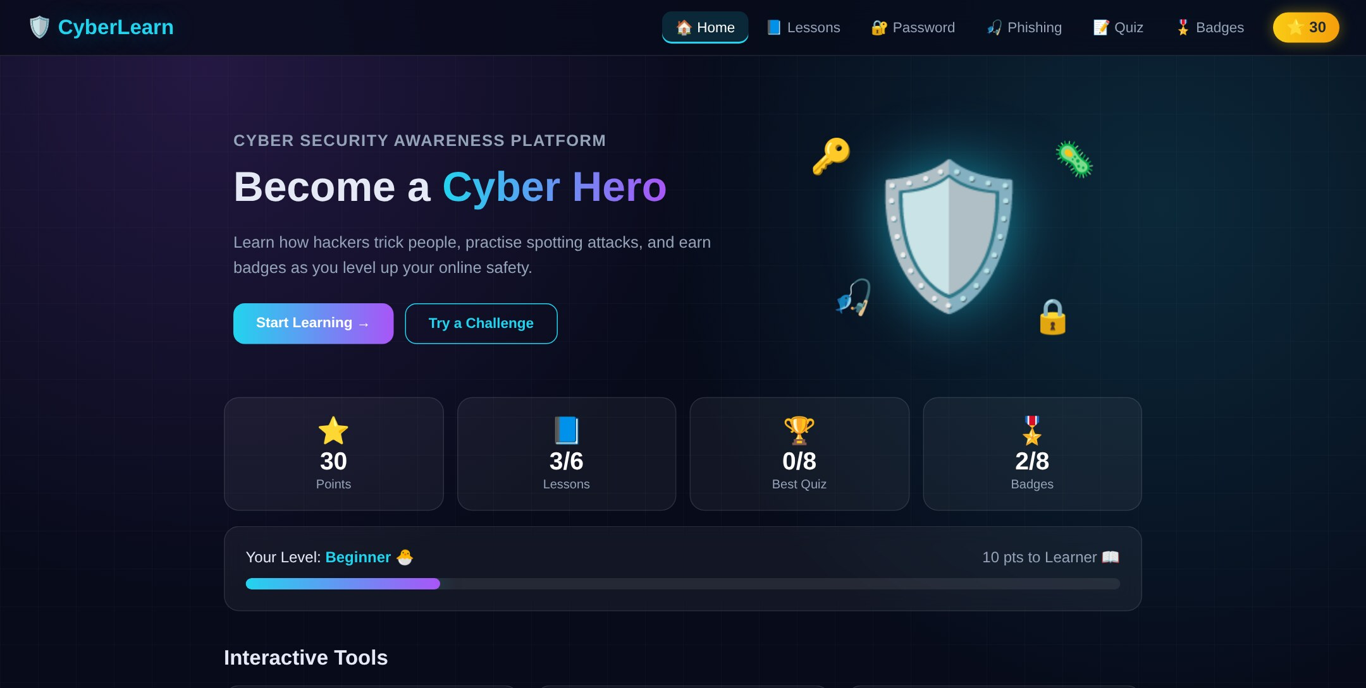
Lessons Page
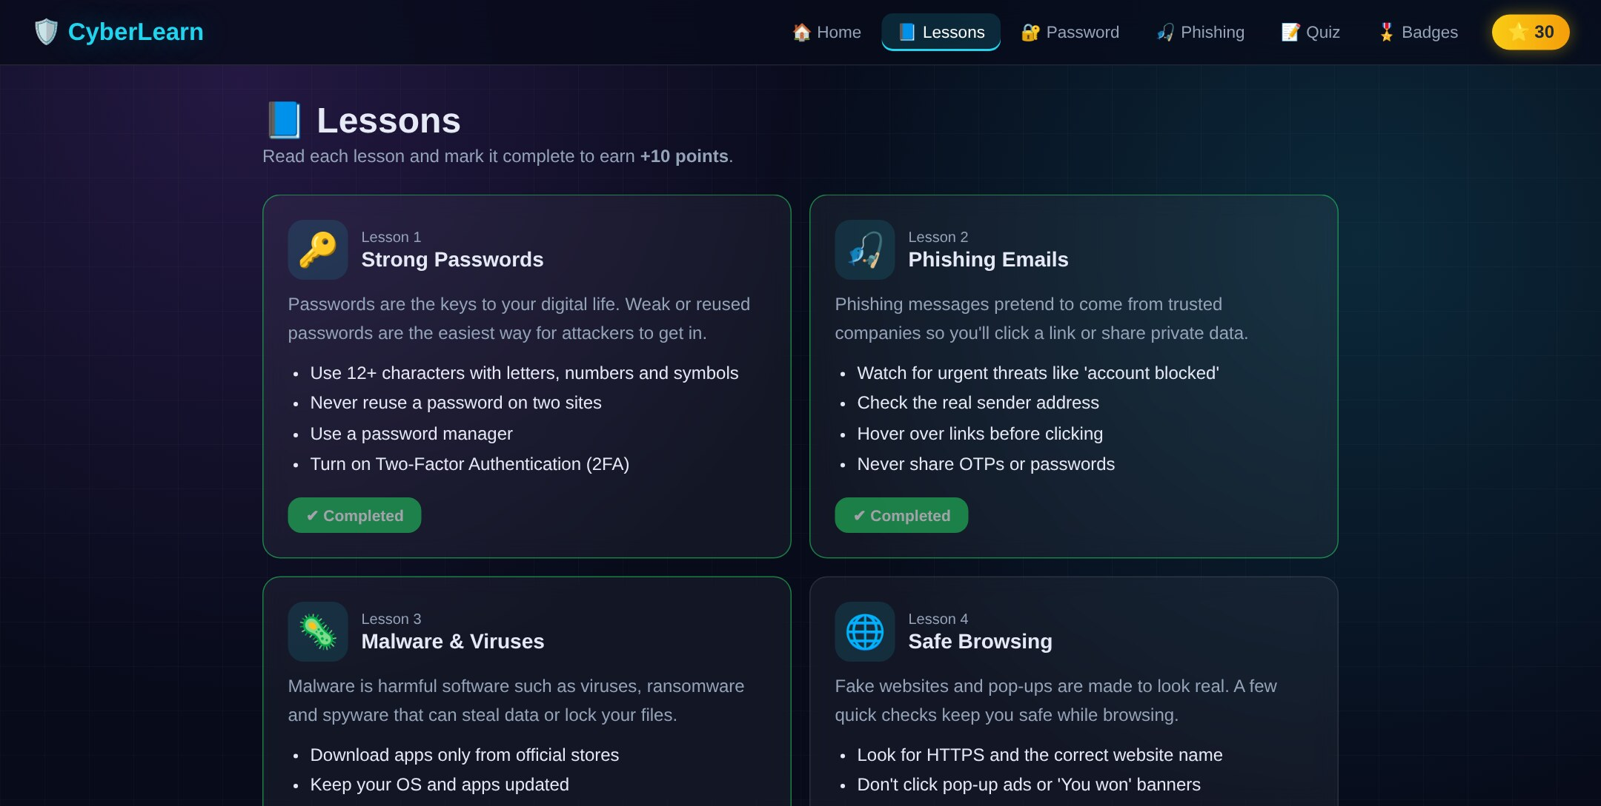

Password Strength Checker
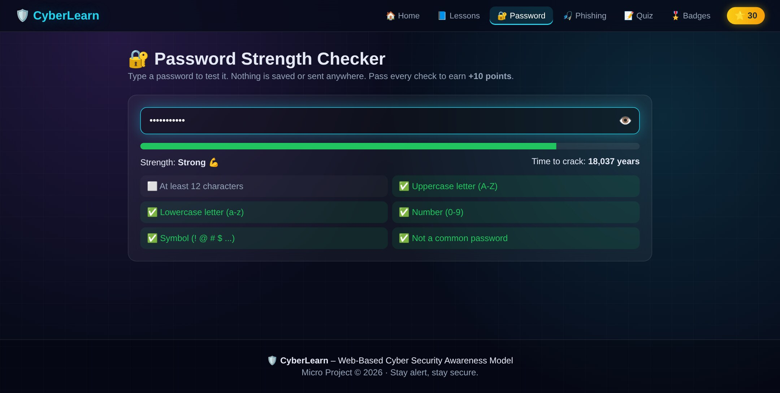
Spot the Phish Game
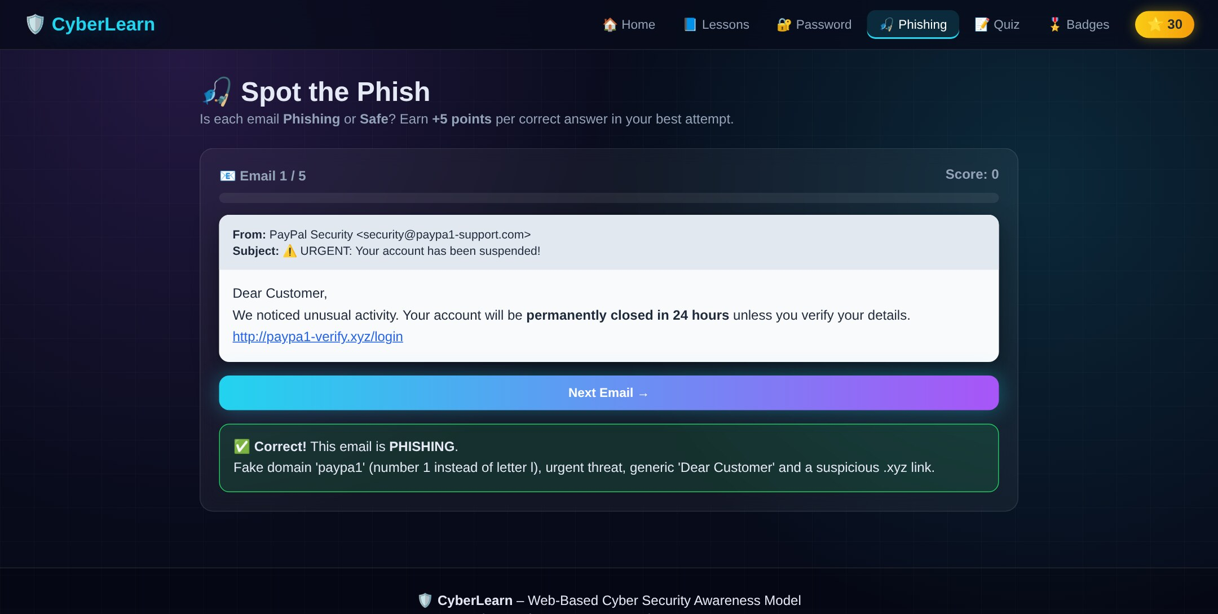

Cyber Quiz
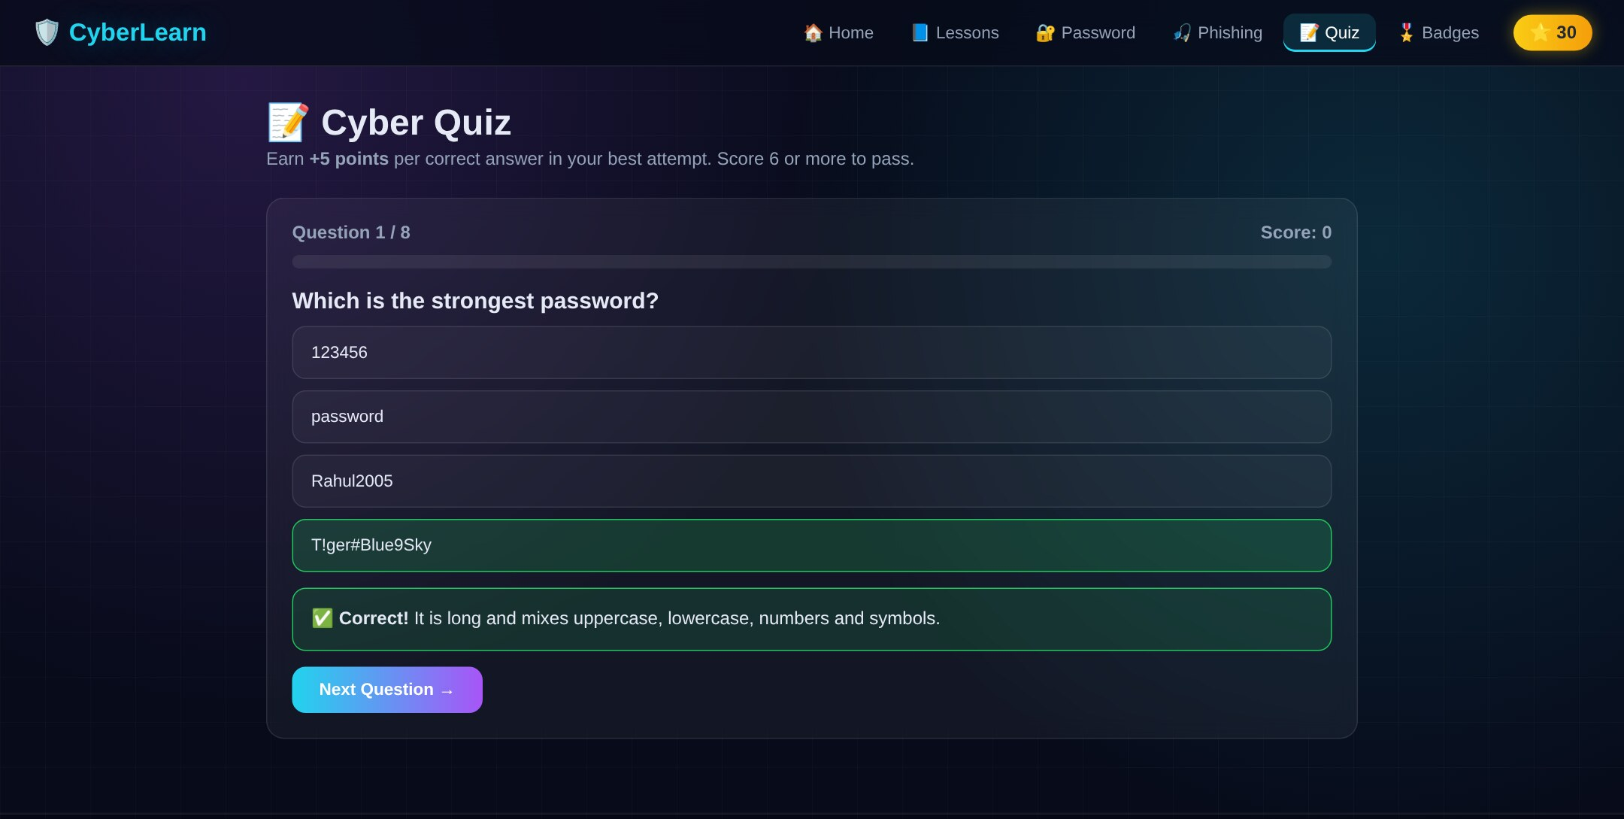
Badges & Certificate Page
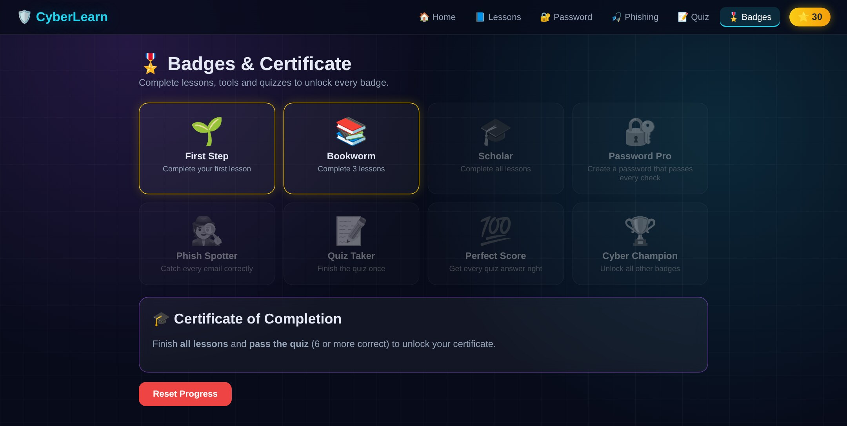

Advantages

Easy to Use:
Simple lessons and a clean interface make cyber security easy to understand.

Interactive Learning:
Password checker, phishing game and quiz give practical experience.

Gamification:
Points, levels, badges and a certificate keep users motivated.

No Login Required:
Users can start learning immediately without creating an account.

Privacy Friendly:
Passwords are never saved or sent, and progress stays on the user’s device.

Lightweight:
Built only with HTML, CSS and JavaScript, so it loads quickly and needs no server.

Works on All Devices:
Responsive design works on desktops, tablets and mobile phones.

Instant Feedback:
Every quiz and phishing answer is explained immediately.

Zero Cost:
The website can be run and hosted free of cost.

Educational Value:
Spreads awareness about real threats such as phishing, malware and scams.

Disadvantages

  - Local Progress Only:
Progress is saved in one browser and does not sync across devices.

  - Limited Content:
The current version has 6 lessons, 8 quiz questions and 5 sample emails.

  - No User Accounts:
There is no login, so progress cannot be tracked by teachers.

  - Data Loss:
Clearing browser data removes all saved progress.

  - Static Content:
New lessons or questions require changes in the source code.

  - English Only:
The platform is currently available only in English.

Future Scope

More Content:
Add more lessons, quiz questions and phishing examples.

User Accounts:
Add login so progress can be saved online.

Cloud Database:
Store progress in a cloud database to sync across devices.

Admin Panel:
Allow teachers to add lessons and questions from the website.

Multi-language Support:
Provide lessons in Hindi, Marathi and other languages.

Leaderboard:
Compare points with classmates to encourage learning.

Video Lessons:
Add short videos and animations for each topic.

Mobile Application:
Develop an Android app version of CyberLearn.

Course Level Outcomes Achieved:

CO1: Describe the basic concepts of cloud computing
CO2: Classify various Cloud Service Models
CO3: Implement Cloud Service and Resource Management Mechanisms
CO4: Maintain Storage system in the cloud
CO5: Apply Cloud Security Measures
CO6: Develop applications using Open Source and Commercial Clouds

Skills Developed
Through this project, we gained valuable technical skills, including:
Cyber Security Awareness
- Understanding of phishing, malware, social engineering and password attacks.
- Learning safe browsing and social media practices.
Frontend Development
- Developed a responsive website using HTML, CSS and JavaScript.
- Created dynamic pages from JavaScript data.
Data Storage
- Saved and loaded user progress using browser Local Storage.
- Stored data in JSON format.
Testing and Debugging
- Tested the password checker, quiz, phishing game and badges.
- Checked the layout on desktop and mobile screens.

Conclusion:

The development of Web-Based Cyber Security Awareness Model successfully demonstrates how cyber security awareness can be taught through an interactive website. The project brings together lessons, practical tools, a quiz and gamification in a single platform.

The platform allows users to learn about strong passwords, phishing, malware, safe browsing, social media safety and social engineering, test their passwords, identify phishing emails, take a quiz, earn badges and download a certificate of completion.

The combination of HTML, CSS, JavaScript and browser Local Storage provided practical experience in developing a complete, lightweight web application that works without any server and keeps user data private.

Future versions can extend the platform with more content, user accounts, a cloud database, an admin panel, multiple languages and a mobile application.

Overall, the project provided valuable practical experience in cyber security awareness, web development, data storage and testing.

References:

- MDN Web Docs – Documentation for HTML, CSS and JavaScript.

- MDN Web Storage API – Documentation for saving data using Local Storage.

- NIST SP 800-63B – Digital Identity Guidelines covering password security recommendations.

- CERT-In – Indian Computer Emergency Response Team cyber security awareness guidelines.

- Anti-Phishing Working Group (APWG) – Resources on phishing attacks and how to recognise them.

- Google Fonts – Orbitron and Poppins fonts used in the website design.

- Cyber Security Concepts – Academic references covering phishing, malware, social engineering and safe browsing.

- Project source code and development documentation of the CyberLearn platform.

