DEPARTMENT OF COMPUTER ENGINEERING
Academic Year 2025-26


A Micro Project Report On
“Cloud-Based E-Learning Platform”
Submitted By

Avinash Jambhale | 2406085
Siddharth Lokhande | 2406119
Dnyaneshwar Mengal | 2306117

Guided by :
Smt.R.J.Chavhan
Lecturer, Government Polytechnic, Pune

DEPARTMENT OF COMPUTER ENGINEERING
Academic Year 2025-26

CERTIFICATE

This is to certify that the micro-project work entitled “CloudLearn – A Cloud-Based E-Learning Platform” is a bonafide work carried out by

Avinash Jambhale | 2406085
Siddharth Lokhande | 2406119
Dnyaneshwar Mengal | 2306117

Of class Third Year in partial fulfilment of requirement for completion of course Cloud Computing (CM51207) of Diploma in Computer Engineering from Government Polytechnic, Pune. The report has been approved as it satisfies the academic requirements in respect of microproject work prescribed for the course.

Smt.R.J.Chavhan Smt.J.R.Hange Dr.R.K.Patil (Microproject Guide) (Head of Department ) (Principal)

ACKNOWLEDGEMENT

We extend our deepest gratitude to Dr. Rajendra Patil, our esteemed Principal, whose unwavering support and encouragement inspired us throughout the journey of our project, “Cloud-Based E-Learning Platform” His vision and guidance paved the path for its successful completion.

Special recognition is due to Mrs. J. R. Hange, our dedicated Head of Department, for her invaluable insights and constant motivation, which played a pivotal role in shaping this endeavour.

A profound thank-you to Smt. R. J. Chavhan Ma’am, our respected mentor, whose boundless patience and consistent guidance were the cornerstones of our project journey. Her valuable advice and keen insights were instrumental in overcoming challenges and achieving our objectives.

Furthermore, we acknowledge that the completion of this project was a testament to our dedication and perseverance. While we received immense support and direction from our mentors and faculty, the execution and culmination of this work were solely our own.

In closing, we express our heartfelt gratitude to all those who contributed directly or indirectly to the success of this project. This work stands as a reflection of teamwork, determination, and the pursuit of academic excellence.

The project “Cloud-Based E-Learning Platform” presents the design and development of a free e-learning website that runs entirely on the cloud. The main objective of the project is to demonstrate modern cloud computing concepts through a practical application, where the frontend is hosted on a cloud host and the backend (login and database) is provided by Supabase, a Backend as a Service (BaaS) platform.

CloudLearn allows students to browse a catalog of 22 courses across 6 categories (Cloud, Programming, Web, Database, DevOps, and IT & Security), sign up with a username and password, enroll in courses and learn through video lessons. A lesson is marked complete only after at least 90% of it has been watched. Progress is stored in the cloud database, so it syncs across devices, and a certificate of completion is shown when a course is finished.

The system is developed using HTML, CSS and JavaScript on the frontend, Supabase Auth for authentication, and Supabase PostgreSQL as the database. Row Level Security (RLS) policies ensure that each student can read and change only their own data. Video lessons are streamed through YouTube embeds, and the website is deployed free of cost on GitHub Pages / Netlify.

The project demonstrates important cloud computing concepts such as SaaS, BaaS, serverless architecture, scalability, cloud security and zero-cost deployment. No physical server or virtual machine is managed by the team; the cloud providers run the complete infrastructure.

Sr no | Content | Page
1. | Introduction | 1
2. | Requirement Analysis | 2-3
3. | Implementation | 4-6
4. | Output | 7-9
5. | Advantages | 10
6. | Disadvantage | 11
7. | Future Scope | 12
8. | Course Level Outcomes Achieved | 13
9. | Conclusion | 14
10. | References | 15

Introduction

Cloud computing has become an important part of modern information technology by providing computing resources and software services over the internet. Education has gained greatly from this shift: e-learning platforms let students learn anytime, from any device, without installing any software or maintaining their own infrastructure.

The project “CloudLearn – A Cloud-Based E-Learning Platform” focuses on developing a working e-learning website that demonstrates these cloud computing concepts. Students simply open the website in a browser, create an account and start learning, while all their data is stored in the cloud rather than on their device.

CloudLearn follows a serverless architecture. The static frontend, built with HTML, CSS and JavaScript, is served from a free cloud host such as GitHub Pages or Netlify. Authentication and the database are provided by Supabase, which offers a managed PostgreSQL database and a login service, so the team does not need to run or maintain any server.

The platform provides a course catalog with search, category and level filters, course detail pages, video lessons with lesson-by-lesson navigation, progress tracking, a “My Learning” dashboard and certificates of completion. It also supports dark mode and is designed to work on mobile screens.

The system is designed with security and separation of user data in mind. Supabase Auth verifies each student, and Row Level Security policies in the database make sure that a student can view and update only their own enrollments and progress.

The project provides practical exposure to how real cloud applications are built and deployed, while keeping the implementation free to run and suitable for an academic project environment.

Requirement Analysis

2.1 Hardware Requirements & Specification
2.1.1 Development Computer/Laptop
- Processor: Intel Core i3 / AMD Ryzen 3 or higher
- RAM: Minimum 4 GB
- Recommended RAM: 8 GB
- Storage: Minimum 5 GB free space
- Display: 1366 × 768 resolution or higher
- Network: Wi-Fi or Ethernet connection
2.1.2 Student (Client) Device
- Any desktop, laptop, tablet or smartphone
- Modern web browser (Chrome, Edge, Firefox)
- Internet connection for video streaming
2.1.3 Server/Backend Environment
- No physical server required
- Hosting: GitHub Pages / Netlify (free cloud hosting)
- Backend: Supabase free tier (managed cloud service)

2.2 Software Requirements & Specification:
2.2.1 Frontend
- HTML5
- CSS3
- JavaScript
- YouTube IFrame Player API
2.2.2 Backend (BaaS)
- Supabase
- Supabase Auth
- Supabase JavaScript Client Library
2.2.3 Database
- Supabase PostgreSQL
- Row Level Security (RLS) Policies

2.2.4 Deployment & Testing Tools
- Visual Studio Code
- Live Server Extension
- Git and GitHub
- GitHub Pages / Netlify
- Web Browser Developer Tools

2.3 SYSTEM REQUIREMENTS:
2.3.1 Authentication System
- Student Registration
- Student Login and Logout
- Username and Strong Password Validation
- Session Management
2.3.2 Course Catalog Module
- Course Listing
- Course Search
- Category and Level Filter
- Course Details
2.3.3 Learning Module
- Course Enrollment
- Video Lessons
- Lesson Jumping
- Resume Video
2.3.4 Progress Module
- Lesson Completion by Watching
- Cloud Progress Sync
- My Learning Dashboard
2.3.5 Security Features
- Supabase Authentication
- Row Level Security
- User Data Isolation

Implementation Steps

- System Architecture:
- Student (Browser) → opens the website from any device.
- Frontend (GitHub Pages) → serves HTML, CSS and JavaScript files.
- Supabase Auth → handles sign up, login and sessions.
- Supabase PostgreSQL → stores courses and enrollments.

- Step 1: Accessing the Platform
1. Student opens the CloudLearn website in a web browser.
2. The Home page displays featured courses and platform highlights.
3. Each page has its own link: Home, Courses, Course, My Learning and About.

- Step 2: User Authentication
1. Student registers or logs into the platform using a username and password.
2. Username is validated (3–20 characters; letters, numbers, _ . -).
3. Password must have at least 8 characters, an uppercase letter, a lowercase letter, a number and a symbol.
4. Supabase Auth validates the credentials and the student receives access to their account.

- Step 3: Course Catalog
The Courses page loads all courses from the Supabase courses table. The student can:
- Search Courses by Name
- Filter by Category (Cloud, Programming, Web, Database, DevOps, IT & Security)
- Filter by Level (Beginner / Intermediate)
- View Course Details, Outcomes, Duration and Lessons
New courses added from the Supabase Table Editor appear on the website immediately, without changing any code.

- Step 4: Course Enrollment
- Enroll in Course

- Unenroll from Course
- Enrollment Saved in Cloud Database
Each enrollment stores the student ID, course ID, completed lessons and enrollment time.

- Step 5: Video Lessons
- Watch Video Lessons (YouTube Embed)
- Jump to Any Lesson
- Highlight Current Lesson
- Resume Video from Last Position

- Step 6: Progress Tracking
- Lesson Completed Only After Watching 90% of It
- Completed Lessons Saved in the Cloud
- Progress Synced Across Devices

- Step 7: My Learning Dashboard
The dashboard provides an overview of:
- Enrolled Courses
- Course Progress Bars
- Completed Courses
- Average Progress

- Step 8: Course Completion Certificate
When all lessons of a course are completed (100%), the student can open a certificate of completion showing their name and the course title.

- Step 9: Database and Security
The Supabase PostgreSQL database contains the following tables:
Table | Main Columns | Purpose
courses | id, title, category, level, icon, duration, description, video_url, lessons[] | Course catalog (anyone can read)
enrollments | user_id, course_id, completed_lessons[], enrolled_at | Student enrollments and progress
Row Level Security (RLS) policies applied:
- Courses are public: anyone can read the course list.

- Read own enrollments: a student can see only their own enrollments.
- Enroll self: a student can enroll only themselves.
- Update own progress: a student can update only their own progress.

- Step 10: Cloud Deployment
1. The project code is pushed to GitHub.
2. GitHub Pages / Netlify hosts the website free of cost.
3. Supabase Project URL and public anon key are added in config.js.
4. The website is live 24/7 at a public URL with zero running cost.
The website also includes a demo mode: if Supabase is not configured, data is saved in the browser so the application can still be demonstrated.

Output:

Home Page
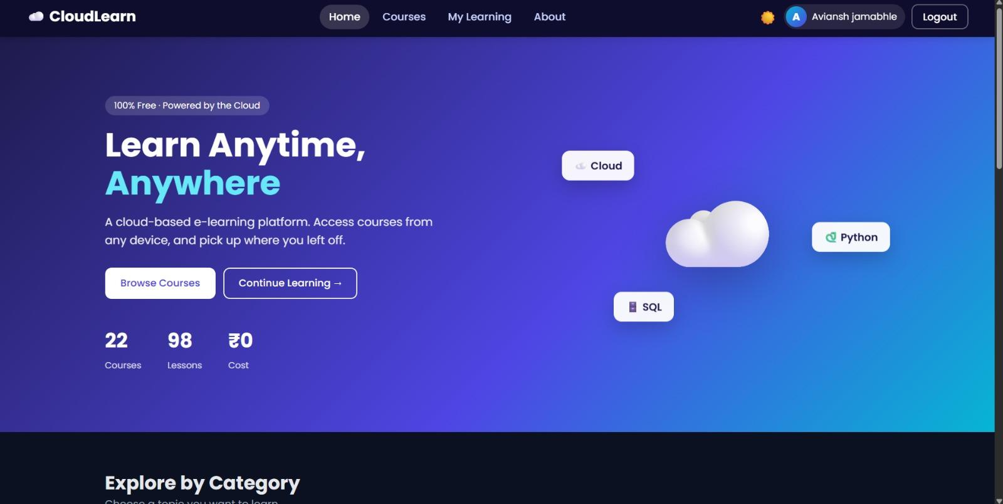
Sign Up / Login Page
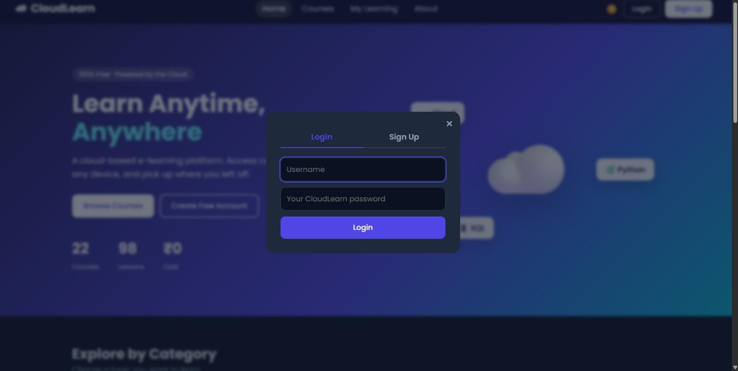

Courses Page
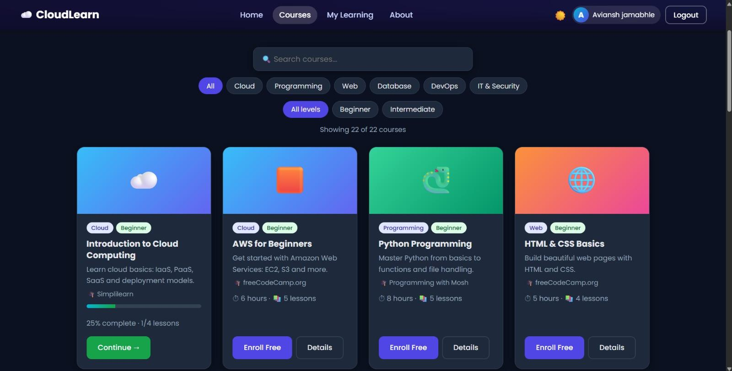
Course Details Page
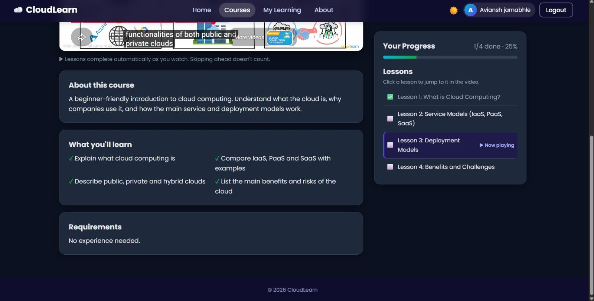

Video Lesson Page
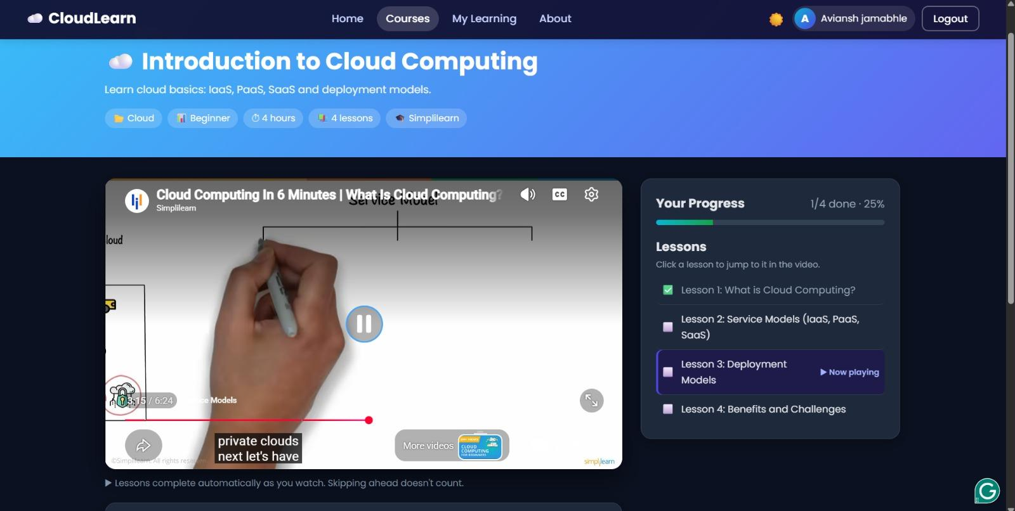
My Learning Dashboard
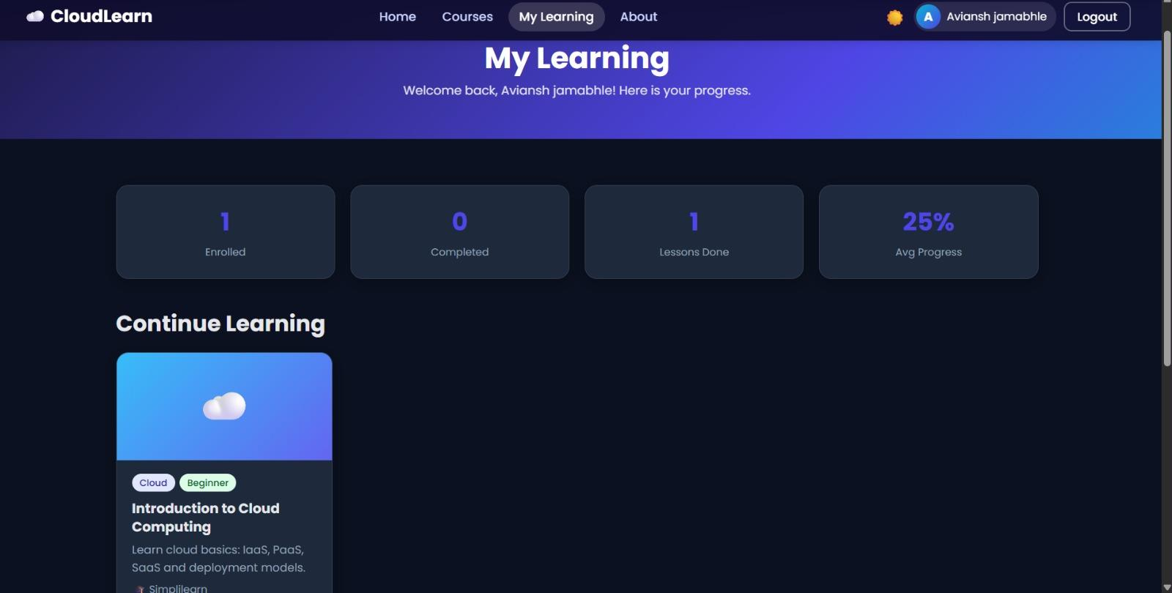

Advantages

Fully Cloud-Based:
The frontend, authentication and database all run on the cloud.

Zero Cost:
Supabase free tier and GitHub Pages / Netlify make the platform free to run.

No Server Management:
Supabase (BaaS) provides the backend, so no server or virtual machine has to be maintained.

Access Anywhere:
Students can learn from any device with a browser, 24/7.

Progress Sync:
Learning progress is stored in the cloud and syncs across devices.

Secure Data:
Supabase Auth and Row Level Security protect each student’s data.

Genuine Progress:
Lessons are completed only when 90% of the video is watched.

Easy Course Management:
New courses can be added from the Supabase Table Editor without changing code.

Scalability:
The cloud host and Supabase handle more users automatically.

User-Friendly Design:
Search, filters, dark mode, mobile layout and certificates improve the learning experience.

Educational Value:
The platform demonstrates practical cloud computing concepts in an academic environment.

Disadvantages

  - Internet Dependency:
Video lessons and cloud sync require an active internet connection.

  - Third-Party Dependency:
The platform depends on Supabase, YouTube and the hosting service being available.

  - Free Tier Limits:
Supabase free plans limit storage, bandwidth and project activity.

  - No Admin Panel:
Courses are added through the Supabase dashboard, not from the website.

  - External Videos:
Videos are hosted on YouTube, so their availability is not fully controlled.

  - No Assessments:
The current version does not include quizzes or tests.

Future Scope

Own Video Hosting:
Upload course videos to Supabase Storage.

Quizzes and Assessments:
Add tests at the end of each course.

Downloadable Certificates:
Generate certificates as PDF files.

Admin Panel:
Allow teachers to add and edit courses from the website.

Social Login:
Login with Google using Supabase OAuth.

Discussion Forum:
Allow students to ask questions and discuss lessons.

Learning Analytics:
Provide progress reports for teachers.

Mobile Application:
Develop an Android app using the same Supabase backend.

Course Level Outcomes Achieved:

CO1: Describe the basic concepts of cloud computing
CO2: Classify various Cloud Service Models
CO3: Implement Cloud Service and Resource Management Mechanisms
CO4: Maintain Storage system in the cloud
CO5: Apply Cloud Security Measures
CO6: Develop applications using Open Source and Commercial Clouds

Skills Developed
Through this project, we gained valuable technical skills, including:
Cloud Computing
- Understanding of SaaS, BaaS and serverless architecture.
- Deploying a website on cloud hosting.
Frontend Development
- Developed a responsive website using HTML, CSS and JavaScript.
- Integrated the YouTube IFrame Player API.
Database Management
- Worked with Supabase PostgreSQL.
- Designed database tables and wrote SQL scripts.
- Applied Row Level Security policies.
Testing and Debugging
- Tested authentication and progress tracking.
- Debugged integration issues between frontend and backend.

Conclusion:

The development of Cloud-Based E-Learning Platform successfully demonstrates the practical implementation of major cloud computing concepts through a working website. The project brings together cloud hosting, Backend as a Service, cloud authentication and a cloud database in a single platform.

The platform allows students to browse courses, enroll, watch video lessons, track their progress and receive certificates of completion. The project also incorporates important software engineering concepts including authentication, input validation, Row Level Security, user data isolation, database design and cloud deployment.

The combination of HTML, CSS, JavaScript, Supabase Auth, Supabase PostgreSQL and GitHub Pages / Netlify provided practical experience in developing and deploying a complete cloud-based web application at zero cost, without managing any server.

Future versions can extend the platform with its own video hosting, quizzes, downloadable certificates, an admin panel, Google login and a mobile application.

Overall, the project provided valuable practical experience in cloud computing, web development, database management, cloud security and deployment.

References:

- Supabase Documentation – Documentation for Supabase Auth, PostgreSQL and Row Level Security.

- PostgreSQL Documentation – Documentation for PostgreSQL relational database management.

- MDN Web Docs – Documentation for HTML, CSS and JavaScript.

- YouTube IFrame Player API – Documentation for embedding and controlling YouTube videos.

- GitHub Pages Documentation – Documentation for hosting static websites on GitHub.

- Netlify Documentation – Documentation for cloud deployment of web applications.

- Cloud Computing Concepts – Academic references covering SaaS, PaaS, IaaS, BaaS, serverless computing and cloud security.

- Project source code and development documentation of the CloudLearn platform.

