1.
- Without self-end
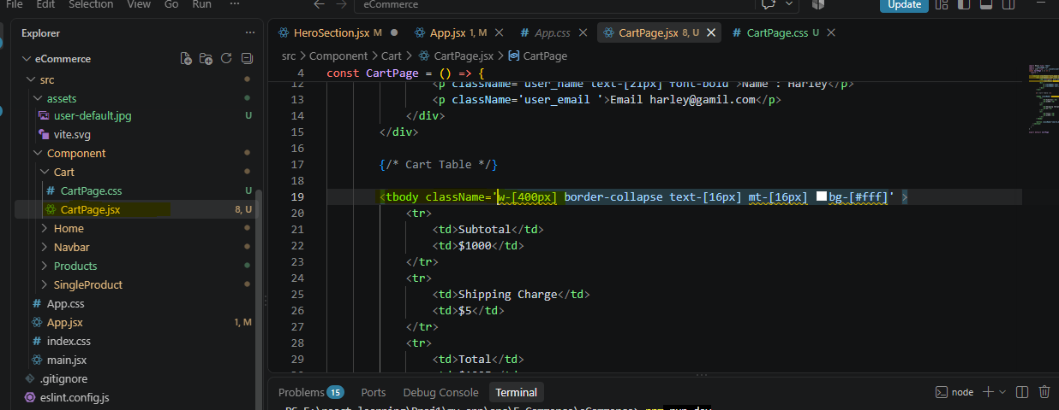

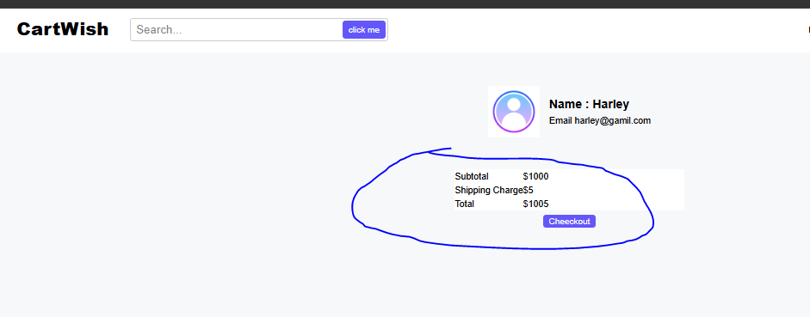

- With self-end

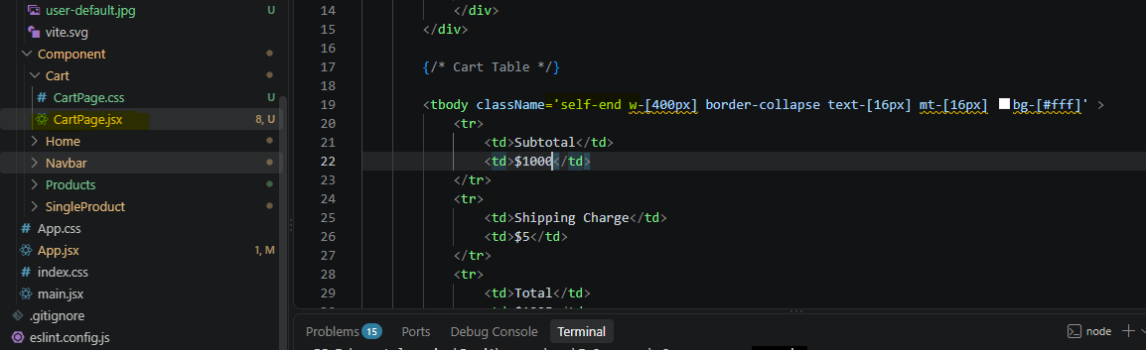

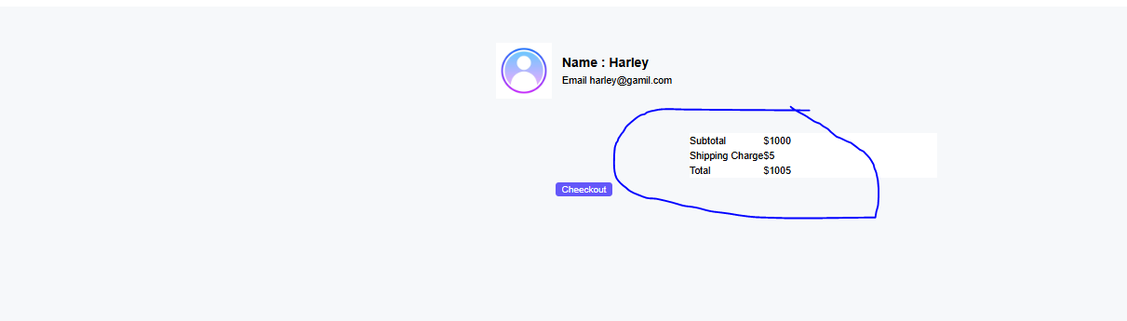

2. htmlfor attribute: In regular HTML, the for attribute is used within a <label> element to associate the label with a corresponding form element, such as an <input>. This relationship helps improve accessibility because it links the label to the input element, making it easier for screen readers to interpret the form correctly.
<label htmlFor='' >Name</label>
<input type='text'
id='name' className='form_text_input' placeholder='Enter_Your_Name'/>

Without htmlfor 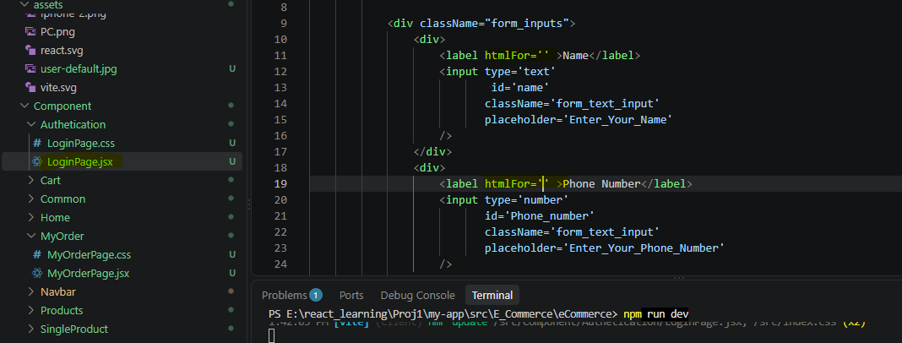
When the user clicks the label, the corresponding input field will not automatically receive focus as. See bellow
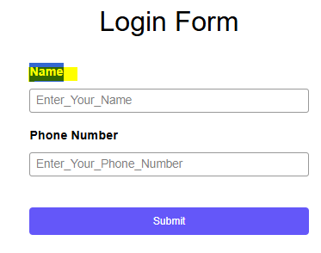

With htmlfor:
In the example above, the htmlfor="name" attribute links the label to the input field with the matching id=" name ". When the user clicks the label, the corresponding input field will automatically receive focus, enhancing the usability of the form.
<label htmlFor='name' >Name</label>
<input type='text' id='name'
id='name'
className='form_text_input'
placeholder='Enter_Your_Name'/>

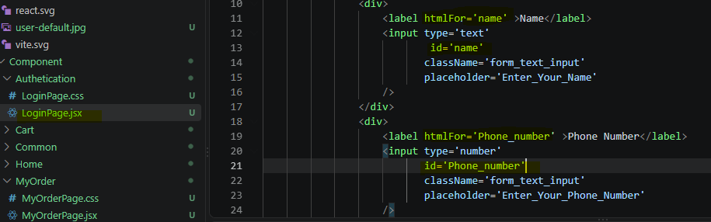
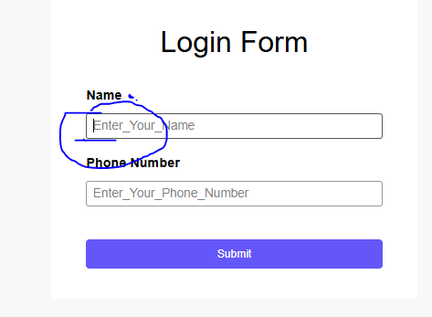

3. React-hook-form: We can use it when we are dealing to build with quick forms and have more complex structure .
See (E:\react_learning\Proj1\my-app\src\E_Commerce\eCommerce\src\Component\Authetication\LoginPage.jsx)

import {useForm} from 'react-hook-form'

const {register,handleSubmit}= useForm();--- here Useform is a object containing many method (register,handleSubmit)
- useForm hook from react-hook-form library is used to manage form state and validation.
- It provides methods like register and handleSubmit to handle form inputs and submission.
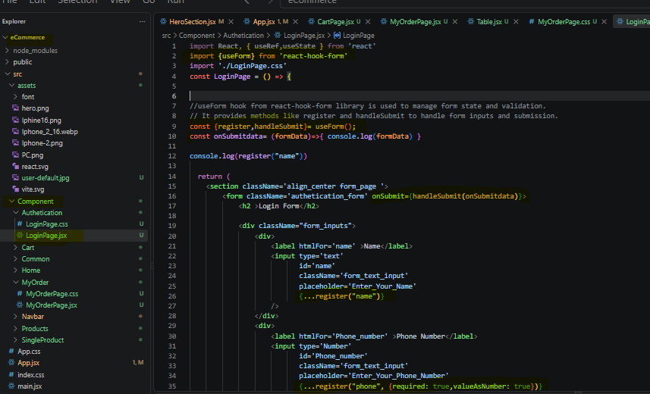

4. What is Zod? (E:\react_learning\Proj1\my-app\src\E_Commerce\eCommerce\src\Component\Authetication\LoginPage.jsx)

Zod is a TypeScript/JavaScript library used to define and validate the structure and type of data.
In a form, Zod allows us to define validation rules in one place using a schema.

IMPORT
import {z} from zod;
Syntax:
const schema = z.object({ email: z.string().email(), password: z.string().min(6), });
Important Zod concepts
A. z.object()
Defines an object/schema containing multiple fields.
const schema = z.object({
email: z.string(),
password: z.string(),
});
B. z.string()
Specifies that the value must be a string.
email: z.string()
C. .email()
Validates that a string follows an email format.
email: z.string().email()
You can provide a custom error message:
email: z.string().email({
message: "Please enter a valid email address"
})
4. .min()
Defines a minimum length for strings.
password: z.string().min(6)
With a custom message:
password: z.string().min(6, {
message: "Password must be at least 6 characters long"
})

What is zodResolver? (E:\react_learning\Proj1\my-app\src\E_Commerce\eCommerce\src\Component\Authetication\LoginPage.jsx)

zodResolver is the bridge between React Hook Form and Zod.
React Hook Form itself doesn't automatically know how to use your Zod schema.
So we connect them:
useForm({
resolver: zodResolver(schema)
});
Think of it like this:
Zod
│
Validation Rules
│
↓
zodResolver
│
↓
React Hook Form
│
↓
errors / submit
Easy way to remember
Zod = What rules should my data follow?
zodResolver = Connect those rules to React Hook Form.
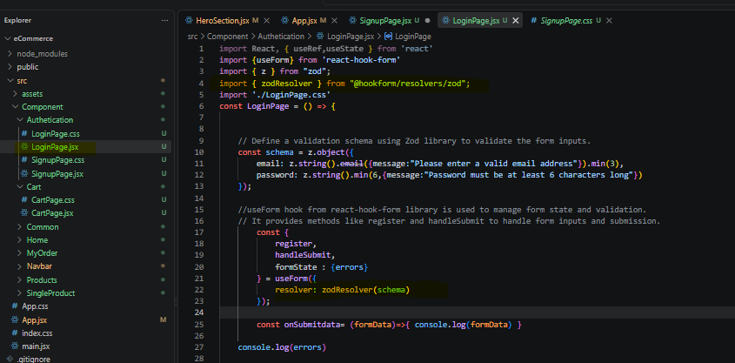

5. What is URL.createObjectURL()?
URL.createObjectURL() is a browser Web API used to create a temporary URL for a File or Blob object.
It is commonly used when we want to display a file selected by the user before uploading it to a server.
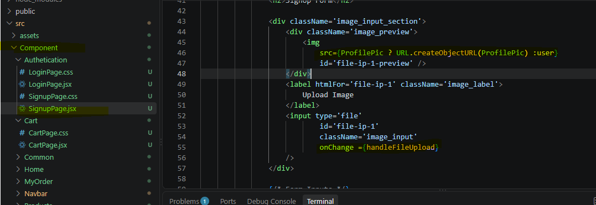

Good for:
- Image previews
- Video previews
- PDF previews
- Temporary local file references
Examle:
<div className='image_input_section'>
<div className='image_preview'>
<img
src={ProfilePic ? URL.createObjectURL(ProfilePic) :user}
id='file-ip-1-preview' />
</div>
<label htmlFor='file-ip-1' className='image_label'>
Upload Image
</label>
<input type='file'
id='file-ip-1'
className='image_input'
onChange ={handleFileUpload}
/>
</div>

