**Hospital Management**

**Software Requirements Document**

**V 1.0**

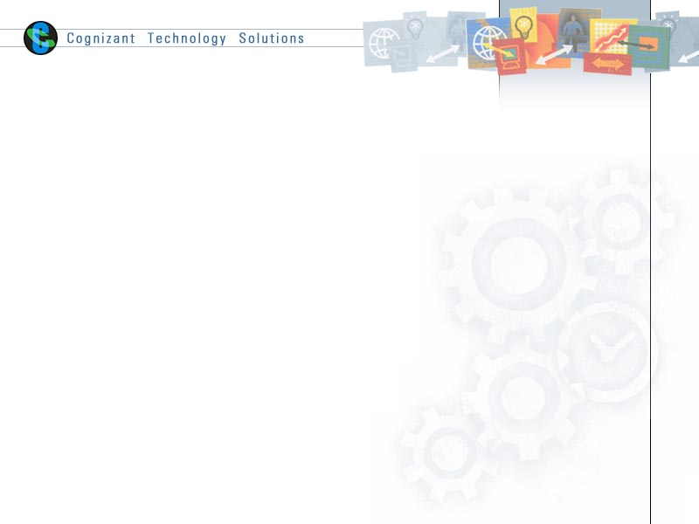

|  |  |  |  |
| --- | --- | --- | --- |
|  | **Prepared By** | **Reviewed by** | **Approved By** |
| **Name** |  |  |  |
| **Role** | Team member | Project Leader/ Team Leader/ Team Member | Project Manager/ Team Leader |
| **Signature** |  |  |  |
| **Date** |  |  |  |

Table of Contents

Contents

1 Introduction 3

1.1 About this document 3

1.1.1 Purpose & Scope of the document 3

1.1.2 Intended Audience 3

1.2 About the Software System 3

1.2.1 Scope of the system 3

1.2.2 Exclusions 4

1.2.3 System Perspective 4

1.2.4 System Environment 4

1.2.5 Architecture diagram 5

1.2.5 Impact of the System 6

1.2.6 Assumptions, Risks / Constraints 6

1.2.7 Key Technical Requirements: 6

2 System Requirements 7

2.1 Functional Requirements –excel mapping 7

2.1.1 Patient Module 7

2.1.2 Physician Module 7

2.1.3 Appointment Module 8

2.1.4 Insurance Module 8

2.1.5 Billing Module 9

3 Annexure 9

4 Terms & Conditions 9

5 Change Log 10

# Introduction

## About this document

### Purpose & Scope of the document

The purpose of the software requirements document is to systematically capture requirements for the project and the system “Enterprise Data Warehouse for Hospital Management” to be developed. Functional requirements of this system are captured in this document. It also serves as the input for the project scoping.

### Intended Audience

Project Team

## About the Software System

The following section will cover aspects related to Enterprise Data Warehouse for Hospital Management application.

ABC Hospital is a leading multispecialty hospital headquartered in Chennai. It offers comprehensive medical care in more than 40 specialties. It has vast pool of talented and experienced team of doctors who are further supported by team of highly qualified, experienced and dedicated support staff and cutting edge technology.

The following are the modules in this proposed system

1. Patient Module
2. Physician Module
3. Appointment Module
4. Insurance Module
5. Billing Module

### Scope of the system

The scope of the system is explained through its modules as follows

* **Patient Module** – This Module stores the details on patient ID, name, Date of birth, gender, address, city, country, phone, and insurance id.
* **Physician Module** -- This Module stores the details on Physician ID, Name, Date of joining, specialty, designation and experience.
* **Appointment Module**-- This Module maintains the details on Appointment ID, patient ID, physician ID, start date time and examination room.
* **Insurance Module -**- This module stores the details on Insurance ID, Insurance Name and Maximum coverage Amount
* **Billing Module –** This module stores the details on Payment ID, Patient ID, Physician ID, Amount to be paid, payment date and Insurance ID.

### Exclusions

The system will operate only on the modules discussed above and will not include any additional functionality.

### System Perspective

The Enterprise Data Warehouse for Hospital Management is an independent software system developed to store the history on all activities happening in five departments of the hospital – Patient details, physician, Patient booking appointment, Billing and health insurance. The data stored could be subsequently used for reporting.

### System Environment

* The primary focus should be technical aspect of EIM, i.e. data warehousing concepts. Business functions and calculations are secondary.
* Use lexicons for table/column names for consistency.
* Common dimensions like customer should be same for all business areas. One of the teams should take care of developing/refreshing common dimensions.
* DW Data model should be a physical one, i.e. should identify table/column names along with size, primary keys (surrogate keys), business keys and foreign keys.
* Data model is not required for staging tables. However these tables don’t need to have surrogate/foreign keys.
* Date dimension should be a common one across all business areas.
* All dimensions and facts should be prefixed with DIM and FCT respectively.
* Suffix surrogate keys, business keys and foreign keys with SK, BK and FK respectively.
* Insert and Update Timestamps apart from the start and end dates for dimensions
* Lexicon for ETL's

### 1.2.5 Architecture diagram

#### Physical Architecture:

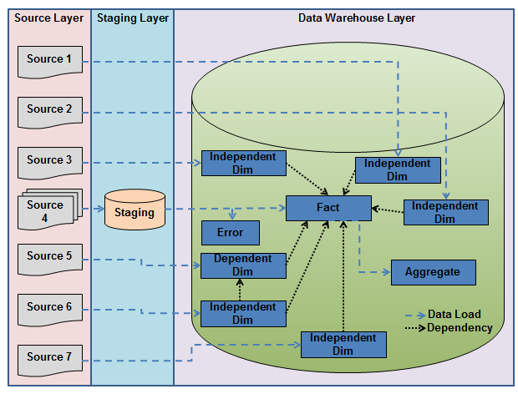

#### Logical Architecture:

The Logical Architecture defines the Processes (the activities and functions) that are required to provide the required [User Services](http://www.iteris.com/itsarch/html/user/userserv.htm). Many different [Processes](http://www.iteris.com/itsarch/html/pspec/pspecs.htm) must work together and share information to provide a User Service. The Processes can be implemented via software, hardware, or firmware. The Logical Architecture is independent of technologies and implementations.

|  |  |  |
| --- | --- | --- |
| **SOURCE LAYER DATA WAREHOUSE LAYER**   |  |  | | --- | --- | | |  | | --- | | Patient Dim  Physician Dim  Appointment Dim  Fact    Insurance  Billing |   Patient  Physician  Appointment  Insurance  Billing | |

### Impact of the System

The data warehousing system is being developed to enhance the decision support and generating customized reports for Hospital Management.

### Assumptions, Risks / Constraints

NA-

### Key Technical Requirements:

* Oracle is the source for dimensions
* Use CSV or excel sources for facts
* Star Schema with SCD type 2 will be used for DW
* DW tables to be in Oracle



# System Requirements

## Functional Requirements –excel mapping

### Patient Module

|  |  |
| --- | --- |
| Enterprise Data Warehouse for ABC Hospital | Patient |
| Functional Requirements | 1. Produce report on patient details who are not from India, not covered by any insurance 2. Produce report on patient details above age 50 3. Dimension Patient is used to get the Patient Details of the ABC Hospital including insurance details. |

### Physician Module

|  |  |
| --- | --- |
| Enterprise Data Warehouse for ABC Hospital | Physician |
| **Functional Requirements** | 1. Report of physician details who are surgeon who joined hospital between 2000 to 2010 (year) 2. To display physician details based on 3. Name 4. Experience 5. To verify whether the physicians are head of the department 6. Dimension credit is used to get the Physician information. |

### Appointment Module

|  |  |  |
| --- | --- | --- |
| Enterprise Data Warehouse for ABC Hospital | | Appointment |
| **Functional Requirements** | 1. To store patient info who have appointment today 2. To fetch Patient details based on physician and examination room. 3. To display patient who have appointment booked in future and covered by insurance. 4. Dimension Appointment is used to get the Appointment details. | |

### Insurance Module

|  |  |  |
| --- | --- | --- |
| Enterprise Data Warehouse for ABC Hospital | | Insurance |
| **Functional Requirements** | 1. To store patient info who have insurance amount greater than 2,00,000 2. To store and fetch count of patients covered by each insurance. 3. Dimension Insurance is used to get the Patient Insurance details. | |

### Billing Module

|  |  |
| --- | --- |
| Enterprise Data Warehouse for ABC Hospital | Billing |
| **Functional Requirements** | 1. To store the patient details who don’t have insurance coverage and need to pay the complete amount. 2. To fetch the patient and the actual amount to be paid (Amount to be paid – Covered by insurance). 3. To fetch physician who had maximum amount to be paid. 4. To fetch the list of patient who needs to pay this month 5. Dimension Billing is to report the Billing details of the patients. |

# Annexure

NA

# Terms & Conditions

GenCs shall be solely responsible for all its acts and omissions under this program. GenCs will comply at all times with all applicable laws. GenCs shall not use Cognizant’s name, logo and trademark in any promotional materials or other communications with third parties without the prior written consent of Cognizant. Any materials used by GenCs in relation to program will not infringe the copyrights, trademarks, patents, trade secrets or other intellectual property rights, privacy or similar rights of any person or entity. GenCs agrees not to post, draw, make, display any content that is threatening, libelous, obscene, defamatory, abusive, pornographic, or advocates/encourages any conduct that could constitute a criminal offence or give rise to any civil liability. Cognizant its associates’ personal details including but not limited to name, address, contact number shall not be shared or forwarded to any third party, without prior written consent of Cognizant, its associates. All intellectual property provided by Cognizant as part of program shall be owned exclusively by Cognizant. Intern shall indemnify, defend and indemnify Cognizant its associates, officers, directors from and against any claims, demands, loss, damage, liability, causes of action, judgments, or costs and expenses of every nature (including attorney’s fees and expenses) incurred by Cognizant based on any claim that any breach of terms and conditions of this program.

# Change Log

Please note that this table needs to be maintained even if a Configuration Management tool is used.

|  |  |  |  |  |
| --- | --- | --- | --- | --- |
| Version Number | Changes made | | | |
| V1.0 |  | | | |
| V1.1 | *<If the change details are not explicitly documented in the table below, reference should be provided here>* | | | |
| Page no | Changed by | Effective date | Changes effected |
|  |  |  |  |
|  |  |  |  |
|  |  |  |  |
|  |  |  |  |
| V1.2 | *<If the change details are not explicitly documented in the table below, reference should be provided here>* | | | |
| Page no | Changed by | Effective date | Changes effected |
|  |  |  |  |
|  |  |  |  |
|  |  |  |  |