**Network Inventory:**

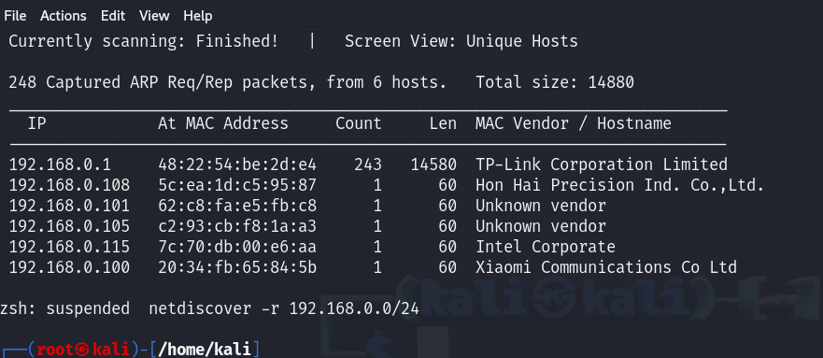

This is my home network, Including my device total 5 devices are connected to the router. In these five devices three are Laptops and two are smart phones.

**Vulnerability Assessment:**

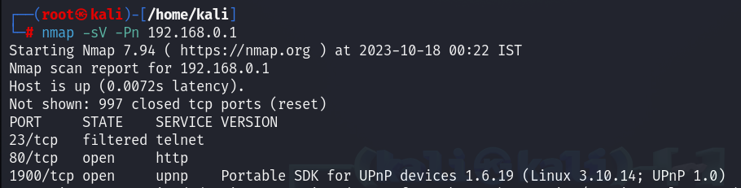

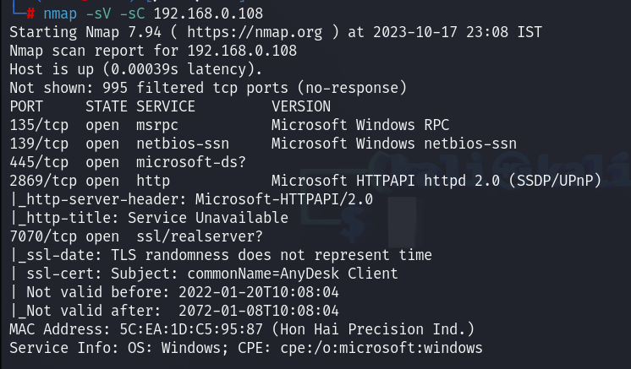

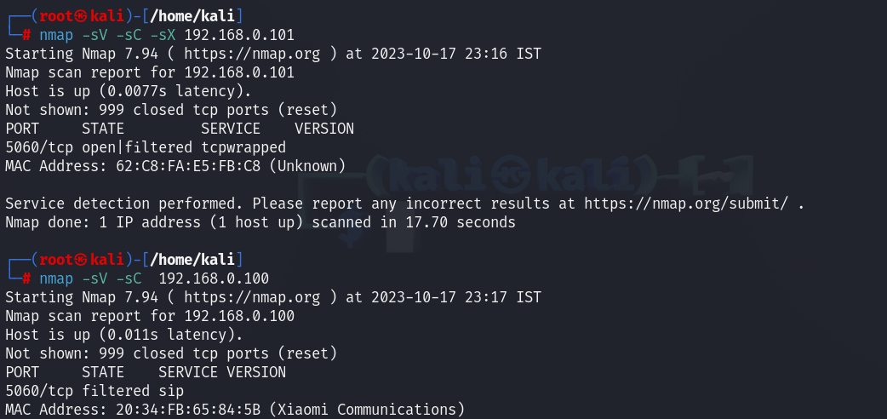

I checked all my device which are connected to my home router. I didn’t find any vulnerabilities, all port which are open using updated version of services which cannot be hacked till day.

**Password Audit:**

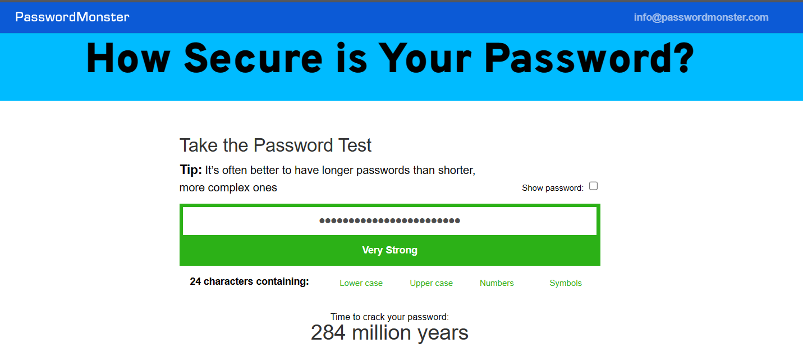

This is my password strength, it might be hacked but it will take 284 million years.

**Router Security:**

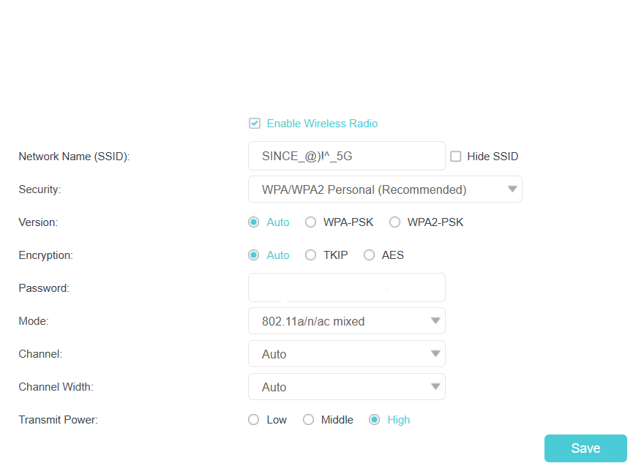

In my home router not have WPA3, till its use WPA2 and for encryption its use TKIP and AES both, so I’m using Auto. Password is hidden for privacy purpose.

**Firewall Configuration:**

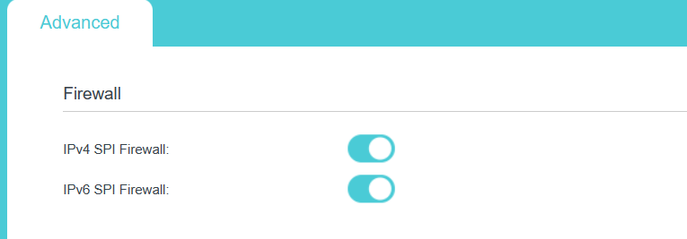

All firewalls are active mode to check the traffic and prevent the malicious attack.

**Guest Network:**

In our Router guest network option are not available, so I can’t set any isolated guest network separated from main network.

**Device Patching:**

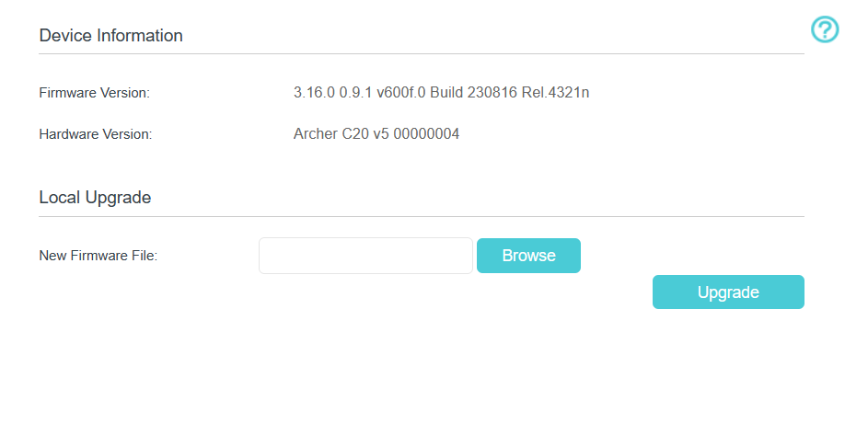

This is the latest updated version of firmware, No updates came after this version.

**Network Monitoring:**

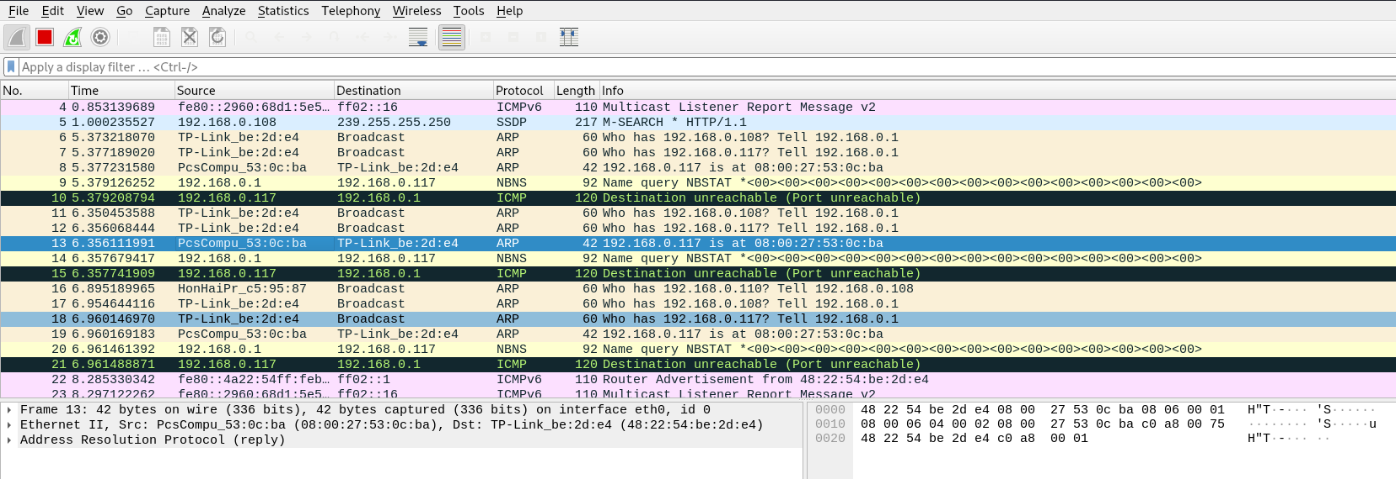

I monitored my home network using Wireshark, but not at all finding any malicious activity in my network, there are only connectivity round router and device and also some request from my device which are not malicious request or any malicious response.

**Network Diagram:**

