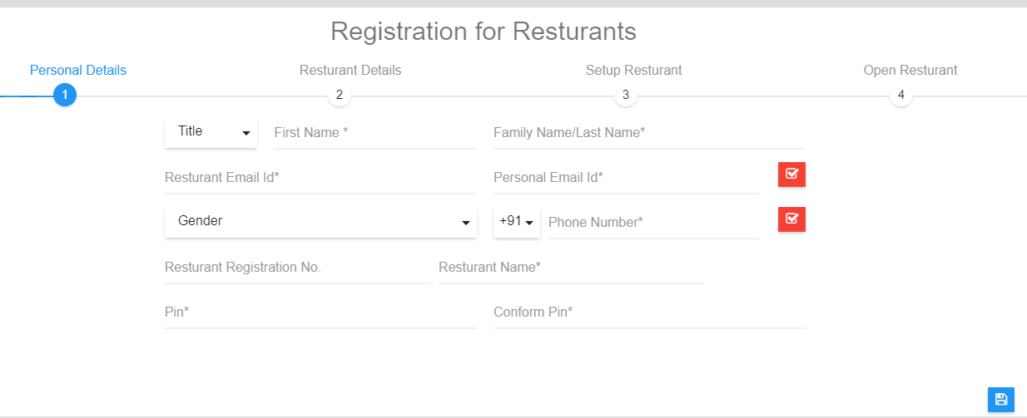

Step : 2

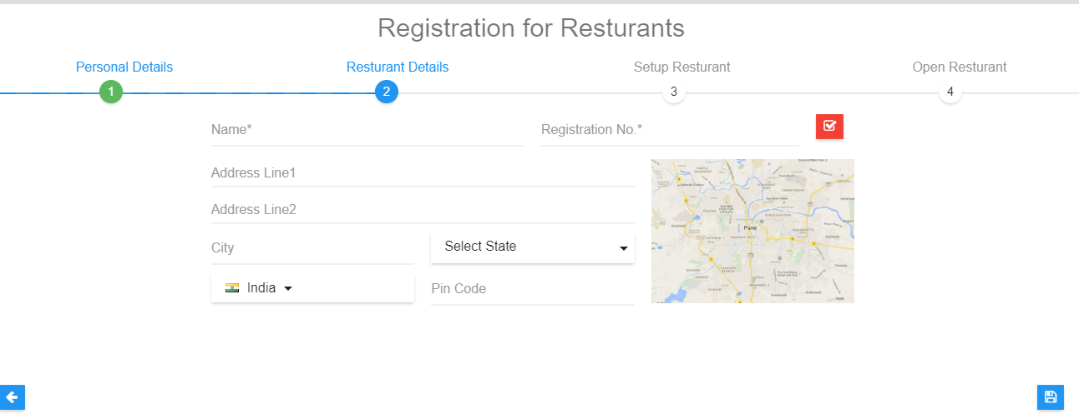

Step : 3

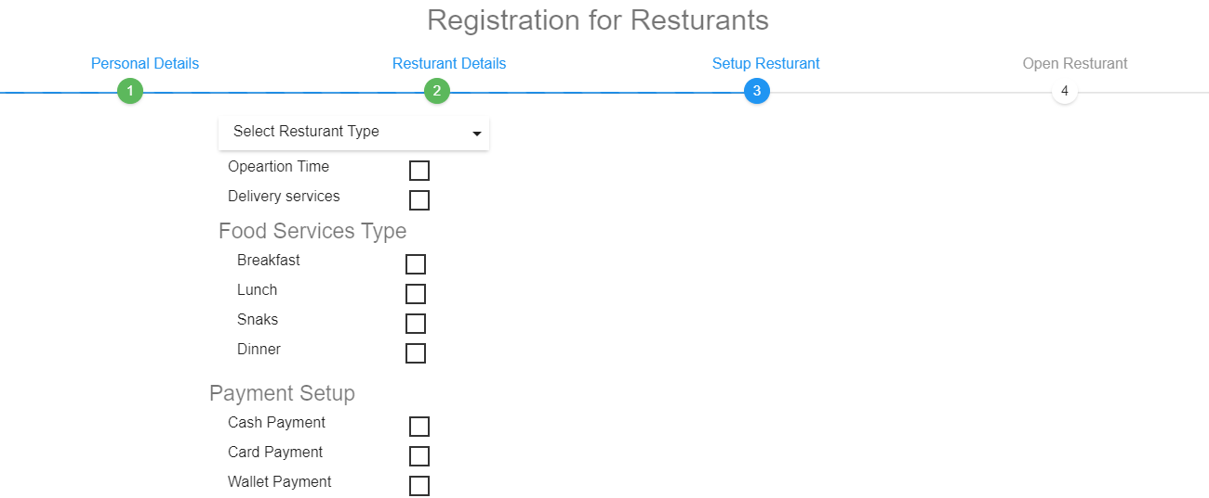

Setp :4

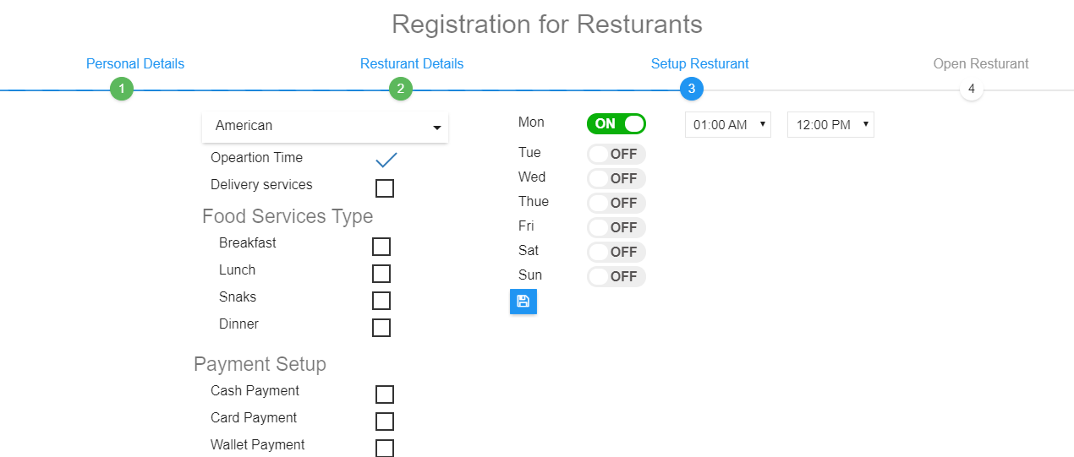

Steup : 5 In menu he can add available menus .According to categories.

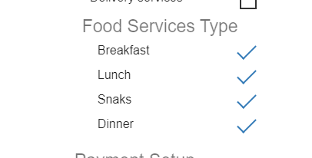

Than Last steup Restrunat Setup :

Where he can see that summery of what he fill. Like required documents and Meesage will send to admin for approval of restaurant verification.

Login Menu :

1. For user
2. For Restaurant owner
3. For Delivery partner

