STEP 1 : Go to File -> Open Project ....
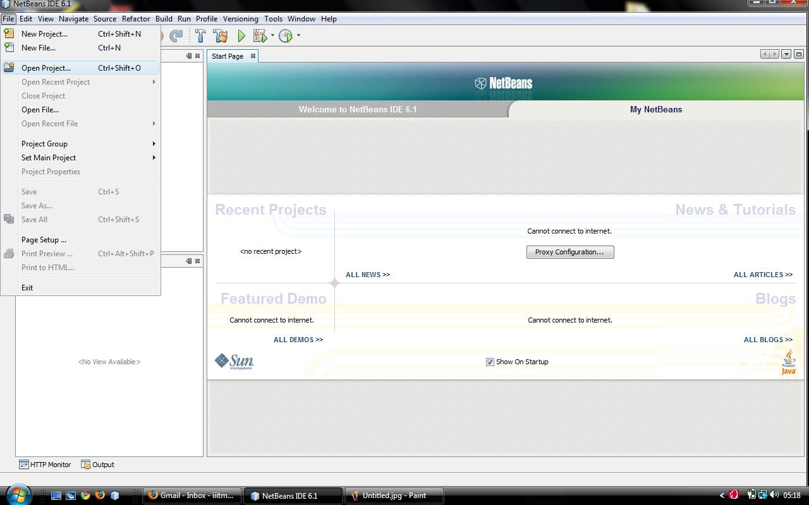
STEP 2 : Browse to the main project folder as shown below.
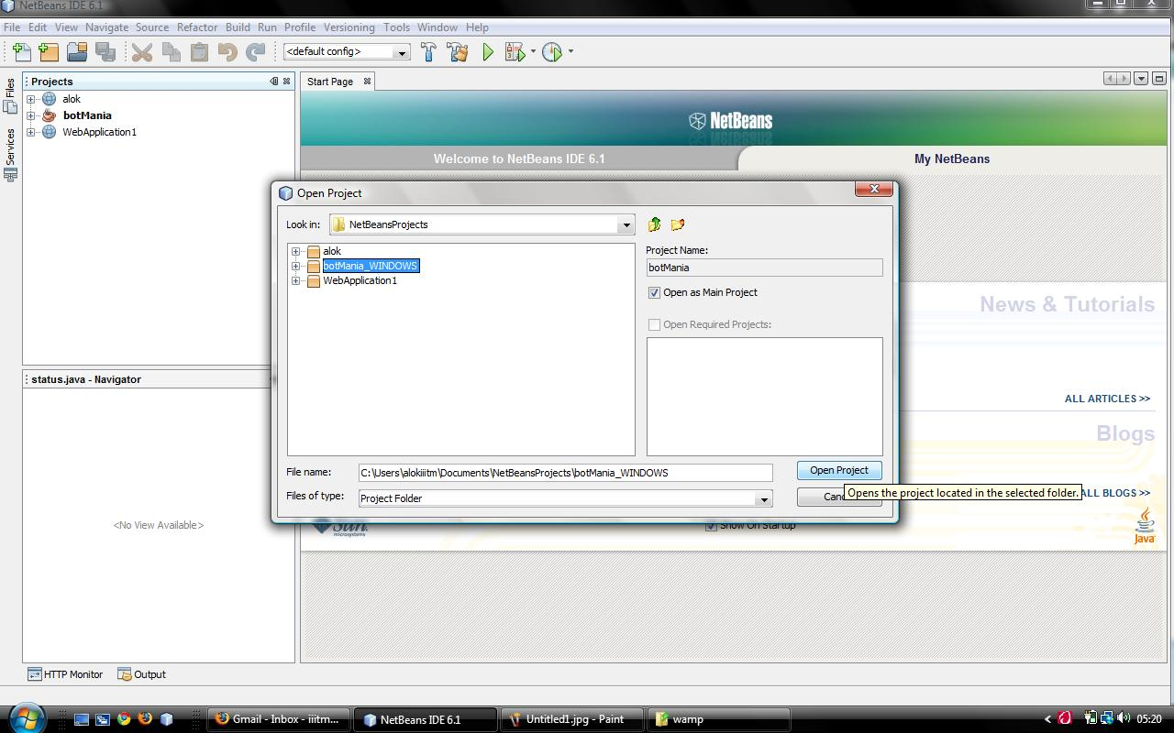
And click on Open Project button. The project for the required platform (Windows/Linux) can be selected as available in the “source” folder provided in the uploaded folder.

STEP 3 : Set the project as main project by right clicking on the project folder in Projects window (press ctrl + 1 if the Projects window is not open) and selecting Set as Main Project option from menu as shown below :
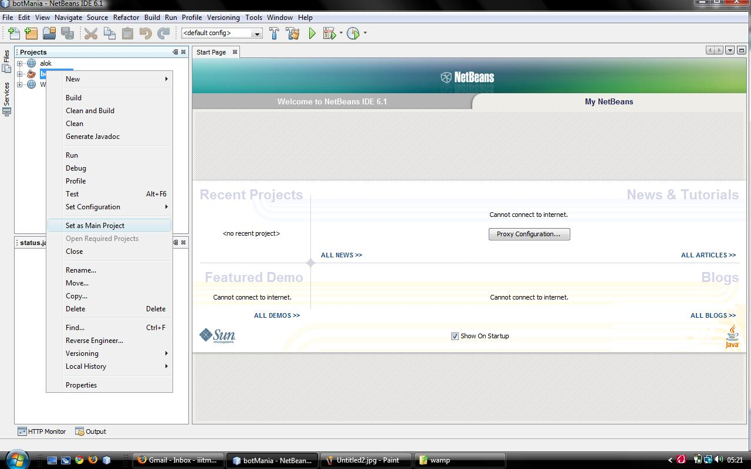

STEP 4 : Go to Build->Build Main Project or press F11 for building the project.
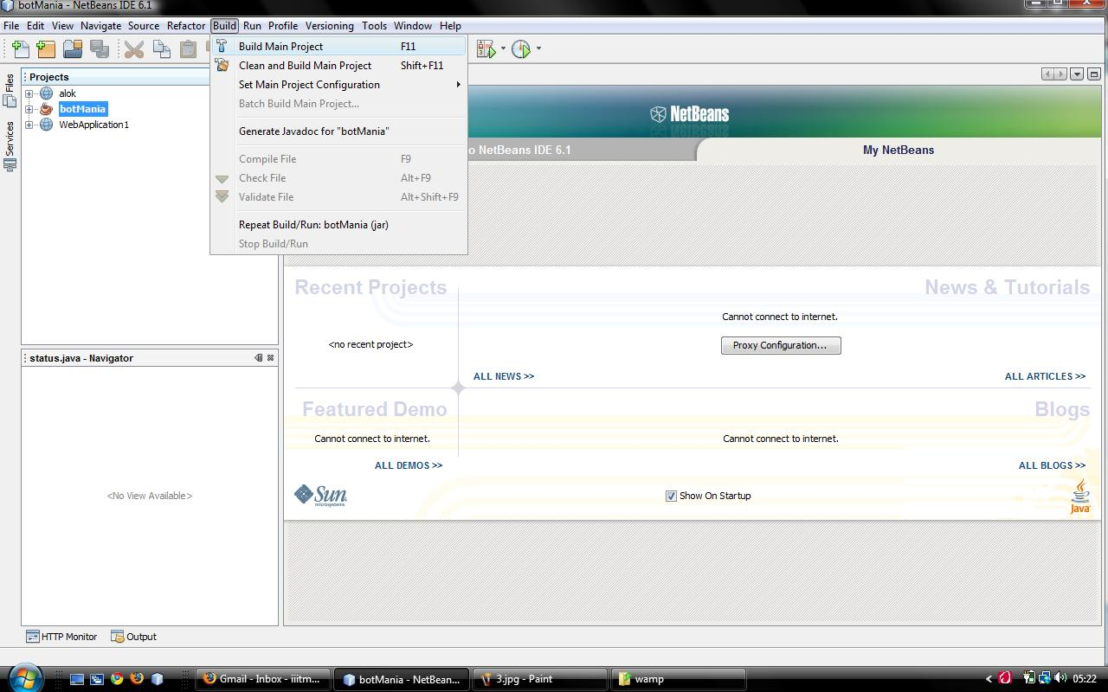
STEP 5 : After building the project , run the project by pressing F6 directly or go to Run->Run Main Project.

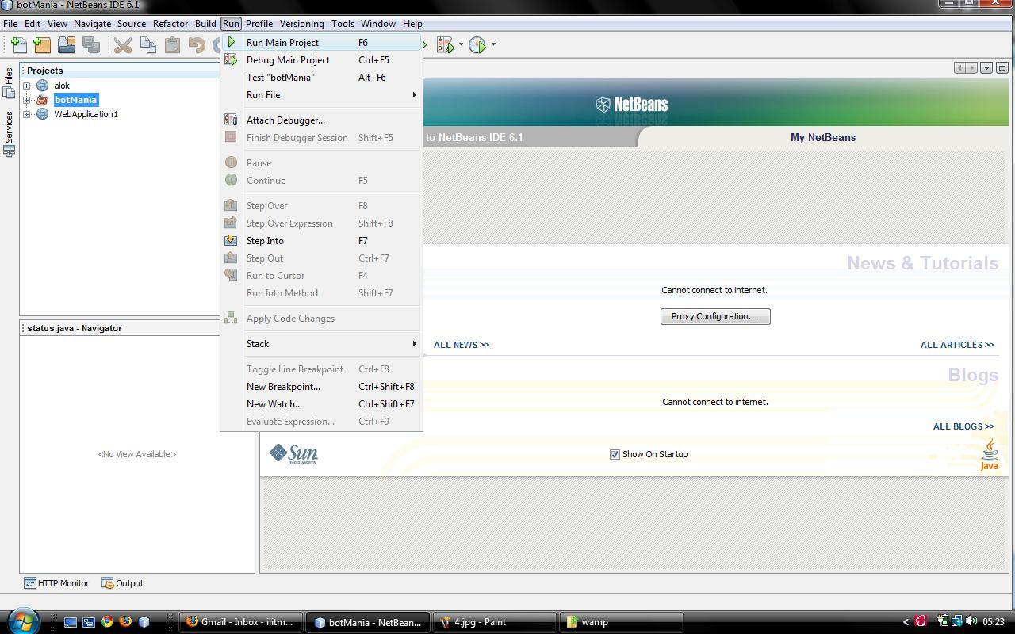
If everything goes well , the project will run and you will see the project running as shown below.
