PHISHING URL DETECTOR
An Automated Risk Scoring & Incident Reporting System for Suspicious URLs
College Major Project Report

Abstract
Phishing remains one of the most common and cost-effective attack vectors used to steal credentials, financial information, and personal data. This project presents a Flask-based web application that accepts a URL from a user, examines it across multiple independent signals — lexical URL structure, DNS resolution, WHOIS registration data, and SSL certificate validity — and combines these signals into a single, interpretable phishing risk score. The system classifies the URL as Safe, Suspicious, or Phishing, generates a plain-language explanation of the verdict, and produces a downloadable PDF incident report for record-keeping. The application is built entirely on open-source Python libraries and stores scan history in a local database for future reference.

1. Introduction
Phishing attacks rely on URLs that are deceptively close to legitimate destinations, often surviving only long enough to trick a single user before being taken down. Attackers frequently rotate domains, register throwaway hostnames, use URL shorteners and typosquatting, and present forged or short-lived SSL certificates to slip past casual inspection and outdated blocklists. Most end users have no fast, evidence-based way to judge whether a link is safe, and security teams cannot manually inspect WHOIS, DNS, and certificate data for every reported link at scale. This project addresses that gap with an automated tool that performs this inspection in seconds and documents its findings in a shareable report.

1.1 Problem Statement
There is no lightweight, explainable, and self-hosted tool that lets a user submit a URL and immediately receive a transparent risk assessment backed by concrete technical evidence (domain age, DNS validity, certificate status, and lexical red flags), along with a permanent record of that assessment for future reference or escalation.

1.2 Objectives
- Accept a URL from the user through a simple web interface and validate/sanitize it before processing.
- Extract lexical, DNS, WHOIS, and SSL-level features for the submitted URL.
- Aggregate the extracted features into a single, weighted phishing risk score.
- Classify the URL (Safe / Suspicious / Phishing) and generate a plain-language explanation of the verdict.
- Automatically generate a downloadable PDF incident report summarizing the scan.
- Persist scan history in a local database for auditing and future reference.

2. System Architecture
The application follows a linear, modular pipeline. A user submits a URL through the HTML/CSS/JavaScript frontend, which sends an HTTP POST request to the Flask backend (app.py). The backend performs input validation, hands the URL to a Feature Extraction Module, and records the request in a local history database. The Feature Extraction Module independently gathers four categories of evidence — URL-level lexical features, DNS lookup results, WHOIS registration data, and SSL certificate details — before passing all of it to a Feature Aggregator. The aggregated features feed a Risk Scoring Engine, whose output drives both an Explanation Generator and a Risk Classification step. Finally, an Incident Report Generator assembles the verdict, evidence, and explanation into a result page and a downloadable PDF report. Figure 1 illustrates this end-to-end flow.
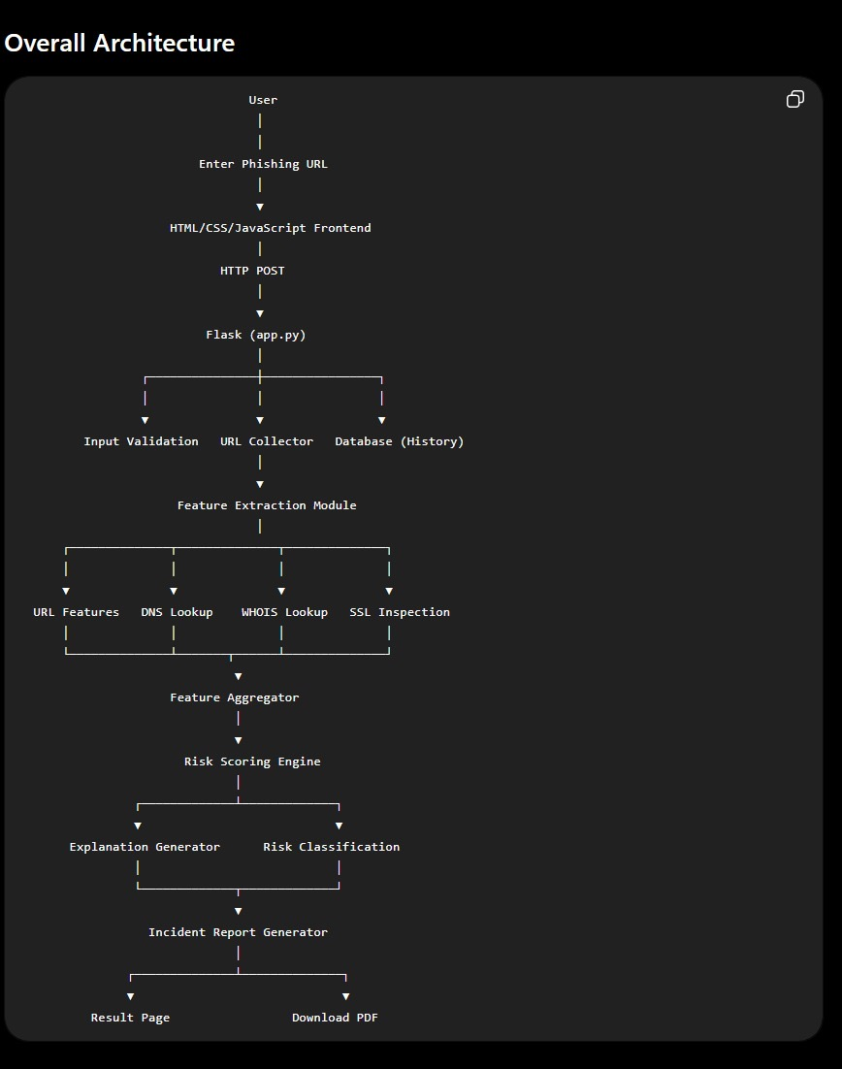
Figure 1: Overall system architecture, from URL submission to downloadable incident report.

2.1 Module Responsibilities
- collector.py — fetches and prepares the submitted URL for downstream analysis.
- analyzer.py — performs DNS, WHOIS, and SSL inspection for the target domain.
- scorer.py — assigns weighted points to each suspicious indicator and computes the aggregate risk score.
- explainer.py — converts the contributing risk factors into a human-readable explanation.
- report_generator.py — builds the downloadable PDF incident report using ReportLab and Pillow.
- validator.py — validates and sanitizes user-submitted input before it is processed.

3. Project Folder Structure
The codebase is organized as a modular Flask project, separating presentation (templates/, static/), business logic (modules/), persistence (database/), and generated artifacts (reports/) into distinct directories, as shown in Figure 2. This separation keeps the URL-analysis logic independent of the web layer, making individual modules easier to test, extend, or replace.
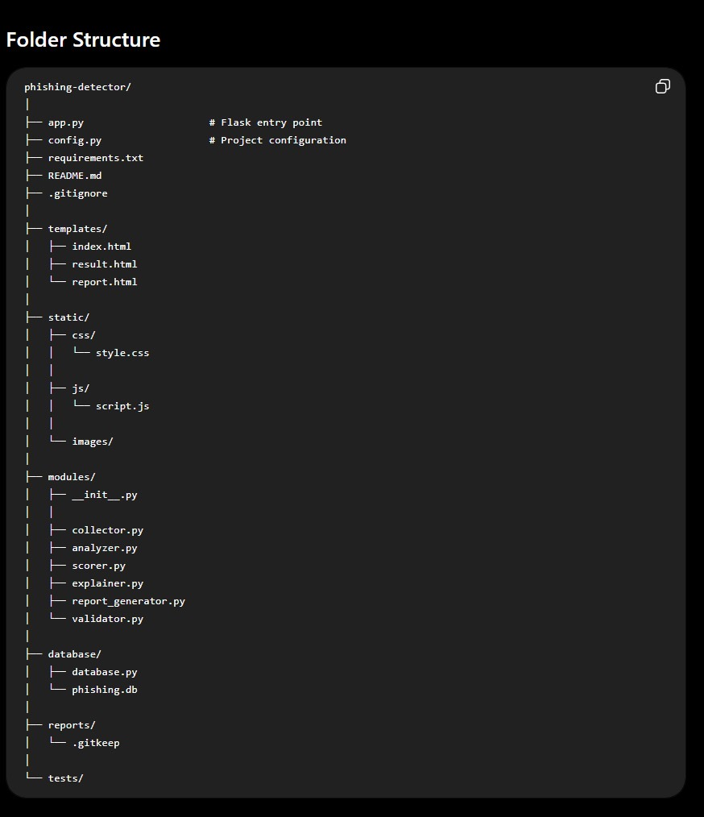
Figure 2: Project folder structure.

4. Technology Stack
The system is built entirely on established, open-source Python libraries, grouped below by role.
Category | Libraries
Web Framework | Flask, Jinja2, Werkzeug, Click, Blinker, itsdangerous, MarkupSafe
Web Scraping & Networking | Requests, requests-file, BeautifulSoup4, soupsieve, urllib3, Certifi, idna, Charset-Normalizer
Domain Intelligence | dnspython, python-whois, tldextract, validators
Report Generation | ReportLab, Pillow
Core Utilities | python-dateutil, six, FileLock, Colorama, typing_extensions

5. Conclusion & Future Scope
The Phishing URL Detector brings together lexical analysis, DNS resolution, WHOIS lookup, and SSL certificate verification into a single interpretable risk score, and closes the loop with an automatically generated, downloadable incident report. This makes phishing checks fast, explainable, and auditable, without relying on any paid or third-party API. Planned future enhancements include replacing the rule-based scorer with a trained machine-learning classifier, shipping a browser extension for real-time link checking, integrating live threat-intelligence feeds and public blocklists, adding user accounts with team-level report dashboards, and supporting batch scanning of multiple URLs in a single request.

