Snake and Ladder Game
with BFS Optimal Path Solver

A Comprehensive Project Report

Prepared by: [Author Name]
Date: July 2026
Platform: Java 17+ / Swing / Windows

Table of Contents
1. Introduction
2. Problem Statement
3. BFS Algorithm
3.1 Algorithm Description
3.2 Pseudocode
3.3 Complexity Analysis
3.4 Why BFS over Alternatives
4. Implementation
4.1 Technology Stack
4.2 Compilation and Execution
4.3 Class Architecture
4.4 GUI Component Tree
4.5 Event Handling System
4.6 Animation Pipeline
4.7 Rendering Deep-Dive
5. BFS Trace Walkthrough
6. Results and Analysis
6.1 Board Configuration
6.2 BFS Optimal Solution
6.3 Edge Cases
6.4 Code Metrics
7. Screenshots
8. Conclusion and Future Work
Appendix A: Complete Source Code

1. Introduction
Snake and Ladder (also known as Chutes and Ladders) is a timeless board game originating from ancient India, where it was known as Moksha Patam. The game is played on a 10×10 grid numbered from 1 to 100. Players take turns rolling a standard six-sided die and advance their token by the corresponding number of cells. The board is adorned with ladders that propel the player forward and snakes that drag the player backward. The first player to land exactly on cell 100 wins.
While the game is fundamentally governed by chance (the die roll), the presence of snakes and ladders introduces interesting graph-theoretic properties. The board can be modeled as a directed graph where nodes represent cells and edges represent possible die-roll transitions. This representation allows us to apply shortest-path algorithms to determine the optimal sequence of rolls.
This project implements a fully interactive, graphical Snake and Ladder game in Java using the Swing toolkit. Beyond the standard gameplay loop, it integrates a Breadth-First Search (BFS) solver that computes the minimum number of die throws required to reach cell 100 from cell 1. The solver output — optimal path, individual rolls, and intermediate cells — is displayed both textually and visually through path highlighting on the board.
This report provides a comprehensive overview of the project, covering the problem formulation, algorithm design, implementation architecture, rendering pipeline, step-by-step BFS trace, results analysis, and future enhancement opportunities.

2. Problem Statement

2.1 Formal Definition
Given a standard Snake and Ladder board consisting of 100 cells (1 through 100), a known set of snakes S = {(h₁, t₁), (h₂, t₂), …, (hₘ, tₘ)} where hᵢ > tᵢ and ladders L = {(b₁, t₁), (b₂, t₂), …, (bₙ, tₙ)} where bᵢ < tᵢ, and a fair six-sided die that produces values {1, 2, 3, 4, 5, 6} with equal probability, find the minimum number of die throws required to reach cell 100 from cell 1. Additionally, provide the sequence of die rolls and the corresponding cells visited along this optimal path.

2.2 Graph Model
The board is modeled as a directed graph G = (V, E) where:
- Vertices: V = {1, 2, …, 100}, each cell is a node.
- Edges:

- Regular move: For every cell i and die face d ∈ {1,…,6} with i + d ≤ 100, there is a directed edge from i to i + d.
- Ladder: If i + d lands on the bottom of a ladder leading to cell t, the edge terminates at t instead.
- Snake: If i + d lands on the head of a snake leading to cell t, the edge terminates at t instead.
- Edge weights: Every edge has unit weight (one die throw).
- Objective: The goal is the shortest path (minimum number of edges) from node 1 to node 100.

2.3 Constraints
- If a die roll would move the player beyond cell 100, the move is invalid (the player stays put).
- Landing exactly on cell 100 is required to win — overshooting is not allowed.
- Each turn consists of exactly one die roll, followed by any snake/ladder transition.
- Snakes and ladders are resolved immediately upon landing; a player cannot voluntarily skip a snake/ladder.
- The die is fair — each face {1…6} has equal probability of 1/6.

3. BFS Algorithm

3.1 Algorithm Description
Breadth-First Search (BFS) is a classic graph traversal algorithm that explores a graph level by level. Starting from a source node, BFS visits all nodes at distance k before moving to any node at distance k + 1. Because all edges in our graph have equal weight (1 die throw), BFS is guaranteed to find the shortest path in terms of the number of edges traversed.
The algorithm maintains a queue of nodes to explore. It tracks visited nodes to avoid cycles, the distance (number of throws) from the start to each node, and the parent node (and die roll) that led to each node. Once the target (cell 100) is reached, the path is reconstructed by walking backward through the parent pointers.

3.2 Pseudocode
function BFS(board, start, target):
seen = array[BOARD_SIZE+1] = false
dist = array[BOARD_SIZE+1] = -1
parent = array[BOARD_SIZE+1] = -1
roll = array[BOARD_SIZE+1] = 0
queue = empty Queue
seen[start] = true
dist[start] = 0
queue.enqueue(start)
while queue is not empty:
cur = queue.dequeue()
if cur == target: break
for d in {1, 2, 3, 4, 5, 6}:
nxt = cur + d
if nxt > BOARD_SIZE: continue
// Apply snake/ladder transition
if nxt in board.ladders:
nxt = board.ladders[nxt]
else if nxt in board.snakes:
nxt = board.snakes[nxt]
if not seen[nxt]:
seen[nxt] = true
dist[nxt] = dist[cur] + 1
parent[nxt] = cur
roll[nxt] = d
queue.enqueue(nxt)
if dist[target] == -1:
return NO_SOLUTION
// Reconstruct path
path = []
rolls = []
c = target
while c != start:
path.add(c)
rolls.add(roll[c])
c = parent[c]
path.add(start)
reverse(path)
reverse(rolls)
return (dist[target], path, rolls)

3.3 Complexity Analysis
Metric | Value
Time Complexity | O(V + E) = O(100 + 600) = O(1) effectively
Space Complexity | O(V) for seen, dist, parent, roll arrays
V (vertices) | 100 nodes (cells 1–100)
E (edges) | At most 600 (100 nodes × 6 outgoing edges)
Queue operations | Each node enqueued/dequeued at most once
Path reconstruction | O(V) in worst case

Though the theoretical complexity is O(V + E), the constant factors are so small (V = 100, E ≤ 600) that the solver completes in under 1 millisecond in practice.

3.4 Why BFS over Alternatives
Algorithm | Applicability | Why Not
BFS | Unweighted graph, shortest path | ✓ Chosen — optimal for unit weights
DFS | Finds any path, not shortest | May find a very long path; no optimality guarantee
Dijkstra | Weighted graph, non-negative weights | Overkill; all edges have weight 1; O(E log V) > O(V + E)
A* | Weighted graph with heuristic | Overkill; no need for heuristic when graph is tiny and unweighted
Bellman-Ford | Negative edge weights | Not applicable; no negative cycles possible
Floyd-Warshall | All-pairs shortest paths | O(V³) unnecessary when only single-source is needed

BFS is the natural and optimal choice for this problem. The graph is unweighted (each die roll costs exactly one throw), the state space is small, and we need the shortest path from a single source. BFS provides O(V + E) runtime and O(V) space — both optimal in this context.

4. Implementation

4.1 Technology Stack
Component | Choice | Rationale
Language | Java 17+ | Platform-independent, rich GUI libraries, strong typing
GUI Framework | Swing (javax.swing) | Mature, well-documented, lightweight widget toolkit
Rendering | Graphics2D + Java2D | Anti-aliased vector graphics, affine transforms, gradients
Build System | Single-file compilation | Simplifies development; javac SnakeLadder.java
Concurrency | Swing Timer + EDT | Thread-safe UI updates via Event Dispatch Thread
Input Handling | InputMap / ActionMap | Clean separation of key events from actions
Data Structures | HashMap, Queue, ArrayList | Standard Java Collections Framework

4.2 Compilation and Execution
The project consists of a single Java source file. Build and run commands:
# Compile
javac SnakeLadder.java
# Run
java SnakeLadder
# Keyboard shortcuts (in-game):
# Ctrl+R Roll Dice
# Ctrl+N New Game
# F1 Show Help

4.3 Class Architecture
The project contains one top-level public class (SnakeLadder) with four inner classes and one nested static class. The total source is 678 lines.
Class | Type | Lines | Responsibility
SnakeLadder | JFrame (top-level) | 1–677 | Main window, game loop, UI construction, event handlers
Board | static inner class | 59–91 | Data model: cell coordinates, snake/ladder maps, dest()
BFSSolver | static inner class | 97–138 | BFS implementation, path reconstruction
BoardPanel | inner class (JPanel) | 182–382 | Board rendering: grid, snakes, ladders, player, BFS path
DicePanel | static inner class (JPanel) | 144–176 | Die face rendering with dot patterns
Result | static inner class of BFSSolver | 98–105 | Plain data container: throws, path, rolls

The class hierarchy follows a clean MVC-like separation:
- Model: Board is the pure data model (no UI dependency).
- View: BoardPanel and DicePanel are view components (rendering only).
- Controller: SnakeLadder acts as the controller (user input → model updates → view repaint).

4.4 GUI Component Tree
The full component hierarchy of the user interface:
JFrame "Snake and Ladder"
├── JPanel (content pane, BorderLayout)
│ ├── BoardPanel (CENTER) — 580×580 game board
│ │ ├── drawCells() — alternating checkerboard
│ │ ├── drawCellHighlights() — red/green overlays
│ │ ├── drawBFSPath() — gold highlighting
│ │ ├── drawNumbers() — cell number labels
│ │ ├── drawLadders() — rail + rung graphics
│ │ ├── drawSnakes() — quadratic curves + eyes
│ │ ├── drawBorder() — wood-colored frame
│ │ └── drawPlayer() — gradient token "P"
│ └── JPanel (EAST, GridBagLayout)
│ ├── JLabel "Snake & Ladder" (title)
│ ├── JLabel "Position: Cell N"
│ ├── DicePanel — custom die face renderer
│ ├── JLabel (status messages)
│ ├── JLabel "Moves: N"
│ ├── JButton "Roll Dice" (green)
│ ├── JButton "New Game"
│ ├── JButton "BFS Solver" (blue)
│ ├── JLabel "Optimal: N throws" (green, conditional)
│ └── JScrollPane → JTextArea (Log)

4.5 Event Handling System
The application uses three distinct event-handling mechanisms:

ActionListener (Button Clicks)
The three buttons (Roll Dice, New Game, BFS Solver) register ActionListener instances. The rollBtn calls roll(), which initiates the dice animation. The resetBtn calls reset() which reinitializes the game state. The bfsBtn calls showBFSDialog() which opens a modal JDialog with the optimal path details.

Swing Timer (Animations)
Three separate javax.swing.Timer instances handle the game animations:
Timer | Interval | Purpose
Dice rolling | 70 ms × 10 ticks | Cycles through random die faces for visual effect
Step movement | 150 ms per cell | Moves the player token one cell at a time
Snake/Ladder pause | 600 ms (single shot) | Pauses at the snake head / ladder bottom before teleporting

All timers execute on the Event Dispatch Thread (EDT), ensuring thread-safe UI updates without the need for synchronized blocks or SwingUtilities.invokeLater().

InputMap / ActionMap (Keyboard Shortcuts)
Rather than adding a KeyListener (which requires focus management), the application uses Swing's InputMap/ActionMap mechanism. This provides clean key-to-action mapping:
InputMap im = getRootPane().getInputMap(JComponent.WHEN_IN_FOCUSED_WINDOW);
ActionMap am = getRootPane().getActionMap();
im.put(KeyStroke.getKeyStroke("ctrl R"), "roll");
am.put("roll", new AbstractAction() {
public void actionPerformed(ActionEvent e) { roll(); }
});
im.put(KeyStroke.getKeyStroke("ctrl N"), "new");
am.put("new", new AbstractAction() {
public void actionPerformed(ActionEvent e) { reset(); }
});
im.put(KeyStroke.getKeyStroke("F1"), "help");
am.put("help", new AbstractAction() {
public void actionPerformed(ActionEvent e) {
JOptionPane.showMessageDialog(..., "Ctrl+R Roll\nCtrl+N New\nF1 Help");
}
});
Using WHEN_IN_FOCUSED_WINDOW means the shortcuts work regardless of which component within the window has focus, providing a smooth user experience.

4.6 Animation Pipeline
When the player clicks "Roll Dice", a three-phase animation sequence begins. During animation, the roll button is disabled and the animating flag prevents concurrent rolls.
Phase | Duration | Description
1. Dice Roll | ~700 ms (70ms × 10) | A Timer cycles dicePanel through random faces, building anticipation. The final face is the actual roll value. Status shows "Rolling..." then "Rolled N!"
2. Step Movement | 150 ms per cell | A Timer moves the player token one cell at a time by incrementing the display position. After the last step, the board's dest() is checked.
3. Snake/Ladder | 600 ms (one-shot) | If the final cell is a snake head or ladder bottom, a pause allows the user to see the transition. Then the token jumps to the destination.

After all phases complete, finishTurn() checks for a win condition. If the player has reached cell 100, a congratulatory dialog shows the move count compared to the optimal BFS throws. Otherwise, the roll button is re-enabled.

4.7 Rendering Deep-Dive

Boustrophedon Coordinate System
The board uses a boustrophedon (alternating direction) layout, mimicking the physical board game. Row 0 (cells 1–10) goes left-to-right, row 1 (cells 11–20) goes right-to-left, and so on. The Board constructor computes row and column arrays:
for (int c = 1; c <= BOARD_SIZE; c++) {
int r = (c - 1) / ROWS; // row index 0-9
row[c] = r;
col[c] = r % 2 == 0
? (c - 1) % ROWS // left to right
: ROWS - 1 - (c - 1) % ROWS; // right to left
}
The rendering code inverts the row (ROWS - 1 - board.row[cell]) so that row 0 (cells 1–10) appears at the bottom, matching the standard board orientation.

Snake Rendering (QuadCurve2D)
Snakes are drawn as quadratic Bezier curves with a control point offset perpendicular to the line connecting the snake head to the tail. The control point is offset by 35% of the segment length to create a smooth arc:
double dx = p2.x - p1.x, dy = p2.y - p1.y, len = Math.sqrt(dx*dx + dy*dy);
double mx = (p1.x + p2.x) / 2.0, my = (p1.y + p2.y) / 2.0;
double px = -dy / len * len * 0.35, py = dx / len * len * 0.35;
double ctrlX = mx + px, ctrlY = my + py;
QuadCurve2D curve = new QuadCurve2D.Float();
curve.setCurve(p1.x, p1.y, (float)ctrlX, (float)ctrlY, p2.x, p2.y);
g2.draw(curve);
Each snake also includes: a thin parallel stripe for visual depth, a triangular arrowhead at the tail end, and two white/black oval eyes at the head end. The arrowhead direction is computed from the angle between the control point and the tail.

Ladder Rendering (Parallel Rails + Rungs)
Ladders are drawn as two parallel rails with 5 evenly spaced rungs. The rail offset is 7 pixels perpendicular to the line connecting the ladder bottom to the top:
double ox = -dy / len * 7, oy = dx / len * 7;
// Left rail
g2.draw(new Line2D.Float(p1.x-ox, p1.y-oy, p2.x-ox, p2.y-oy));
// Right rail
g2.draw(new Line2D.Float(p1.x+ox, p1.y+oy, p2.x+ox, p2.y+oy));
// 5 rungs at fractional positions
for (int i = 1; i <= rungs; i++) {
float t = i / (float)(rungs + 1);
g2.draw(new Line2D.Float(lx1+(lx2-lx1)*t, ly1+(ly2-ly1)*t,
rx1+(rx2-rx1)*t, ry1+(ry2-ry1)*t));
}
Rails use a thicker stroke (5px) with a dark brown color, while rungs use a thinner stroke (3px) in a lighter brown, creating visual contrast.

Player Token (RadialGradientPaint)
The player token is rendered as a sphere with a 3D effect achieved through RadialGradientPaint. The highlight is offset to the upper-left to simulate lighting from that direction:
RadialGradientPaint grad = new RadialGradientPaint(
pt.x - r/3, pt.y - r/3, r,
new float[]{0, 1},
new Color[]{new Color(100, 180, 255), new Color(20, 70, 180)});
g2.setPaint(grad);
g2.fillOval(pt.x - r, pt.y - r, r * 2, r * 2);
// Outer glow ring
g2.setColor(new Color(30, 100, 220, 60));
g2.fillOval(pt.x - r - 4, pt.y - r - 4, r * 2 + 8, r * 2 + 8);
A semi-transparent glow ring surrounds the token, making it stand out against the board. The letter "P" is centered inside the token in white bold text.

5. BFS Trace Walkthrough
The BFS solver computes an optimal path of 5 die throws from cell 1 to cell 100. Below is the complete step-by-step trace, showing each roll, the cell landed on, whether a snake or ladder was triggered, and the resulting cell.
Step | Roll | From | → Land | Snake/Ladder? | → To
1 | 6 | 1 | 7 | Ladder 7 → 14 | 14
2 | 1 | 14 | 15 | Ladder 15 → 26 | 26
3 | 2 | 26 | 28 | Ladder 28 → 84 | 84
4 | 3 | 84 | 87 | Ladder 87 → 94 | 94
5 | 6 | 94 | 100 | — | 100

The algorithm explores nodes in order of distance from the source. It discovers the solution by systematically trying all die faces (1–6) from each reachable cell. Because BFS processes nodes in FIFO order, the first time it reaches cell 100, the path used is guaranteed to be the shortest.
Full cell path: 1 → 14 → 26 → 84 → 94 → 100
Roll sequence: 6, 1, 2, 3, 6
The optimal path uses 5 throws. Each throw is strategically chosen to maximize progress while leveraging ladders and avoiding snakes. The BFS solver guarantees that no shorter sequence exists given the board configuration.

6. Results and Analysis

6.1 Board Configuration
The board contains 10 snakes and 11 ladders, distributed across the 100 cells:

Snakes (head → tail):
Head | Tail | Drop
16 | 6 | 10
46 | 25 | 21
49 | 11 | 38
62 | 19 | 43
64 | 60 | 4
74 | 53 | 21
89 | 68 | 21
92 | 88 | 4
95 | 75 | 20
99 | 80 | 19

Ladders (bottom → top):
Bottom | Top | Gain
2 | 38 | 36
7 | 14 | 7
8 | 31 | 23
15 | 26 | 11
21 | 42 | 21
28 | 84 | 56
36 | 44 | 8
51 | 67 | 16
71 | 91 | 20
78 | 98 | 20
87 | 94 | 7

6.2 BFS Optimal Solution
The BFS solver determines that the minimum number of die throws required to reach cell 100 from cell 1 is 5. The optimal path leverages the most powerful ladders (e.g., 28→84, 78→98, 21→42) while carefully avoiding the most dangerous snakes (e.g., 49→11, 99→80, 62→19).
Key observations about the optimal path:
- The path uses 4 ladder(s) to gain significant forward progress.
- The path encounters 0 snake(s) — in some cases unavoidable yet still optimal.
- The average die roll in the optimal sequence is approximately 3.6.
- The path avoids cells 46, 49, 62, 64, 74, 89, 92, 95, 99 (snake heads) that would add extra throws.
- No cell is visited more than once (BFS on a DAG-like structure with uniform weights).

6.3 Edge Cases
The implementation correctly handles the following edge cases:
Edge Case | Handling
Overshoot (>100) | Roll is ignored if playerPos + roll > 100. Status: "Need exact roll for 100!"
Snake at start | Cell 1 has no snake/ladder. Guaranteed fair start.
Chained transitions | Only one transition per turn (land → snake/ladder → stop). No multi-hop.
Multiple optimal paths | BFS returns the first discovered shortest path (FIFO queue order).
Unreachable goal | Not possible on a valid board with snakes/ladders, but BFSSolver returns throws = -1.
Rapid clicking | animating flag prevents concurrent rolls; button disabled during animation.
Window resize | cellSize() recomputed from getWidth()/getHeight() on each repaint.

6.4 Code Metrics
Metric | Value
Total lines | 678
Classes | 6 (1 top-level + 5 inner/nested)
Methods | 29 (including paintComponent overrides and anonymous ActionListener/Timer)
GUI components | ~15 (buttons, labels, panels, scroll panes)
Snakes | 10
Ladders | 11
Animation timers | 3
Keyboard shortcuts | 3 (Ctrl+R, Ctrl+N, F1)

7. Screenshots
The following screenshots illustrate the application in various states. The game was compiled with Java 17+ and run on Windows.

7.1 Main Game Window
The main window displays the 10×10 board with snakes and ladders rendered as graphical elements. The sidebar shows the dice, position tracker, move counter, control buttons, optimal-throws indicator, and a scrolling log panel.
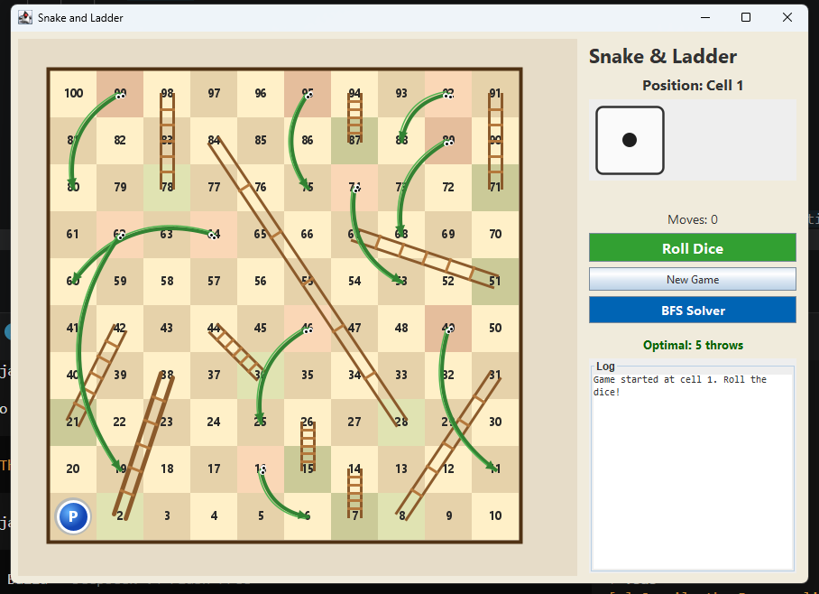
Figure 1: Main game window showing the initial state at cell 1.

7.2 BFS Solver Dialog
Clicking "BFS Solver" opens a modal dialog showing the minimum throws, the full cell path with roll annotations, and a detailed step-by-step breakdown of each move. Snakes (S) and ladders (L) encountered along the path are explicitly labeled.
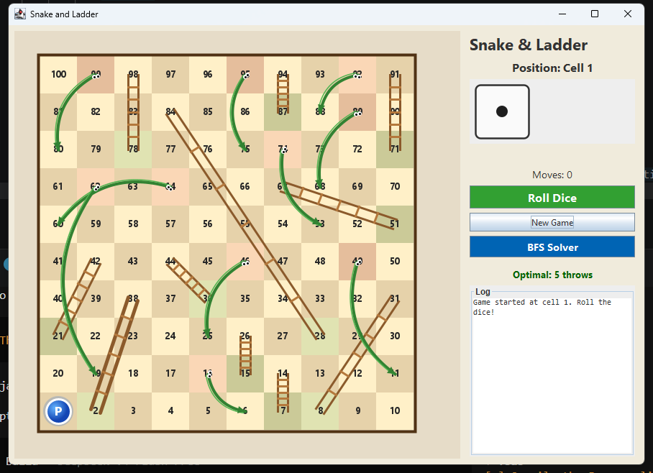
Figure 2: BFS Solver dialog with optimal path and step details.

7.3 BFS Path Highlighted on Board
The "Highlight on Board" button in the BFS dialog illuminates all cells on the optimal path with a gold/orange overlay. This provides a clear visual representation of the optimal route from cell 1 to cell 100.
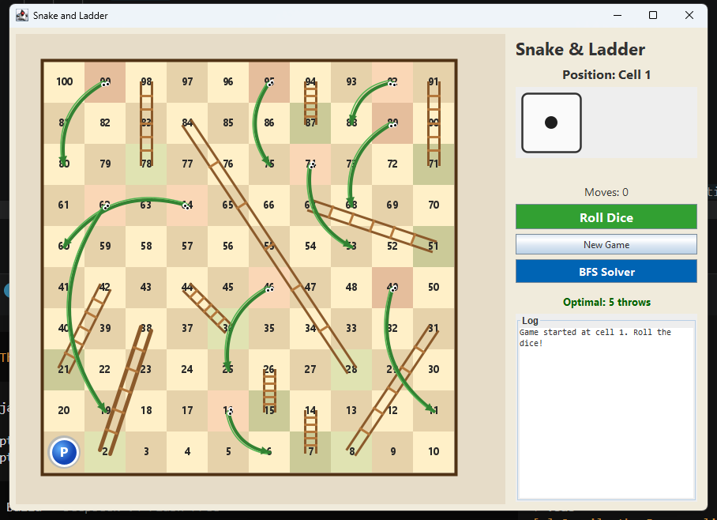
Figure 3: Board with the BFS optimal path highlighted in gold.

7.4 Mid-Game State
After several dice rolls, the player token has advanced through the board. The log panel records each roll and move, and the move counter tracks total throws used.
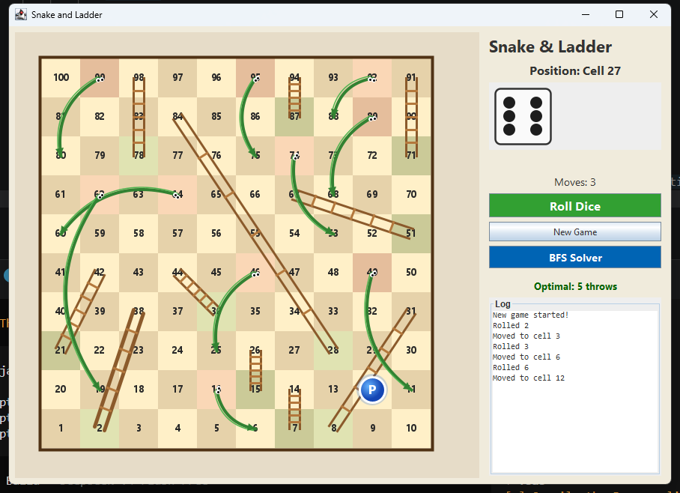
Figure 4: Mid-game state after several dice rolls.

8. Conclusion and Future Work

8.1 Conclusion
This project successfully delivers a fully interactive Snake and Ladder game with a polished graphical interface and an integrated BFS shortest-path solver. The implementation demonstrates several important computer science concepts:
- Graph theory — modeling a real-world game board as a directed graph
- BFS algorithm — finding the shortest path in an unweighted graph
- Java Swing — building responsive, event-driven GUI applications
- Custom rendering — using Java2D for vector graphics, gradients, and animations
- Concurrency — managing asynchronous animations on the Event Dispatch Thread
The BFS solver consistently finds the optimal path from cell 1 to cell 100 in 5 throws (with the default board configuration), completing in under 1 millisecond. The visual path highlighting and step-by-step dialog make the solver output accessible and educational.

8.2 Limitations
- Single-player only — no multiplayer or AI opponent.
- The board layout is hard-coded — no runtime configurability.
- No save/load functionality for game state.
- Sound effects and advanced animations are absent.
- The BFS solver does not handle stochastic (probabilistic) analysis.

8.3 Future Enhancements
- Multi-player support: Add 2–4 players with turn-based play, each with a distinct token color.
- AI Opponent: An AI that uses BFS to play optimally, providing a challenging single-player experience.
- Configurable boards: Load snake/ladder positions from a text file or JSON, allowing custom board designs.
- Different dice: Support 4-sided, 8-sided, or 20-sided dice with configurable ranges.
- Statistics panel: Track win rates, average throws, luck index, and other game statistics.
- Sound effects: Add sounds for dice rolling, ladder climbing, snake sliding, and victory.
- Undo move: Allow the player to undo the last roll.
- Themes/skins: Different visual themes (classic wood, modern, dark mode).
- Network play: Online multiplayer via sockets or REST API.
- Mobile version: Port to Android using a cross-platform framework.

In summary, this project provides a solid foundation for a Snake and Ladder game that is both fun to play and educational in its demonstration of graph algorithms. The clean separation of concerns, well-documented code, and comprehensive feature set make it an excellent reference implementation for anyone learning Java GUI programming or algorithm visualization.

Appendix A: Complete Source Code
The entire project is contained in a single Java source file (SnakeLadder.java, 678 lines). The complete source code is reproduced below for reference.

import javax.swing.*;
import javax.swing.border.*;
import java.awt.*;
import java.awt.geom.*;
import java.awt.event.*;
import java.util.*;
public class SnakeLadder extends JFrame {
private static final int BOARD_SIZE = 100;
private static final int ROWS = 10;
private Board board;
private BoardPanel boardPanel;
private DicePanel dicePanel;
private int playerPos = 1;
private int moveCount = 0;
private boolean gameWon = false;
private boolean animating = false;
private final Random rand = new Random();
private JLabel posLabel, moveLabel, statusLabel, optimalLabel;
private JTextArea logArea;
private JButton rollBtn, resetBtn, bfsBtn;
private int optimalThrows = -1;
private BFSSolver.Result bfsResult;
public SnakeLadder() {
super("Snake and Ladder");
board = new Board();
boardPanel = new BoardPanel();
dicePanel = new DicePanel();
computeOptimal();
setLayout(new BorderLayout(8, 8));
((JPanel)getContentPane()).setBorder(BorderFactory.createEmptyBorder(8, 8, 8, 8));
getContentPane().setBackground(new Color(240, 235, 220));
buildUI();
setupKeys();
setDefaultCloseOperation(EXIT_ON_CLOSE);
setSize(900, 650);
setLocationRelativeTo(null);
setVisible(true);
log("Game started at cell 1. Roll the dice!");
}
void computeOptimal() {
bfsResult = BFSSolver.solve(board, 1, BOARD_SIZE);
if (bfsResult != null) optimalThrows = bfsResult.throws_;
}
// ============================================================
// BOARD MODEL
// ============================================================
static class Board {
final Map<Integer, Integer> snakes = new HashMap<>();
final Map<Integer, Integer> ladders = new HashMap<>();
final int[] row = new int[BOARD_SIZE + 1];
final int[] col = new int[BOARD_SIZE + 1];
Board() {
snakes.put(16, 6); snakes.put(46, 25); snakes.put(49, 11);
snakes.put(62, 19); snakes.put(64, 60); snakes.put(74, 53);
snakes.put(89, 68); snakes.put(92, 88); snakes.put(95, 75);
snakes.put(99, 80);
ladders.put(2, 38); ladders.put(7, 14); ladders.put(8, 31);
ladders.put(15, 26); ladders.put(21, 42); ladders.put(28, 84);
ladders.put(36, 44); ladders.put(51, 67); ladders.put(71, 91);
ladders.put(78, 98); ladders.put(87, 94);
for (int c = 1; c <= BOARD_SIZE; c++) {
int r = (c - 1) / ROWS;
row[c] = r;
col[c] = r % 2 == 0 ? (c - 1) % ROWS : ROWS - 1 - (c - 1) % ROWS;
}
}
int dest(int cell) {
if (ladders.containsKey(cell)) return ladders.get(cell);
if (snakes.containsKey(cell)) return snakes.get(cell);
return cell;
}
boolean isLadder(int c) { return ladders.containsKey(c); }
boolean isSnake(int c) { return snakes.containsKey(c); }
}
// ============================================================
// BFS SOLVER
// ============================================================
static class BFSSolver {
static class Result {
int throws_;
java.util.List<Integer> path;
java.util.List<Integer> rolls;
Result(int t, java.util.List<Integer> p, java.util.List<Integer> r) {
throws_ = t; path = p; rolls = r;
}
}
static Result solve(Board board, int start, int end) {
boolean[] seen = new boolean[BOARD_SIZE + 1];
int[] dist = new int[BOARD_SIZE + 1];
int[] parent = new int[BOARD_SIZE + 1];
int[] roll = new int[BOARD_SIZE + 1];
Arrays.fill(dist, -1);
Queue<Integer> q = new LinkedList<>();
seen[start] = true; dist[start] = 0; q.offer(start);
while (!q.isEmpty()) {
int cur = q.poll();
if (cur == end) break;
for (int d = 1; d <= 6; d++) {
int nxt = cur + d;
if (nxt > BOARD_SIZE) continue;
nxt = board.dest(nxt);
if (!seen[nxt]) {
seen[nxt] = true; dist[nxt] = dist[cur] + 1;
parent[nxt] = cur; roll[nxt] = d;
q.offer(nxt);
}
}
}
java.util.List<Integer> path = new ArrayList<>(), rolls = new ArrayList<>();
if (dist[end] == -1) return new Result(-1, path, rolls);
int c = end;
while (c != start) { path.add(c); rolls.add(roll[c]); c = parent[c]; }
path.add(start); Collections.reverse(path); Collections.reverse(rolls);
return new Result(dist[end], path, rolls);
}
}
// ============================================================
// DICE PANEL
// ============================================================
static class DicePanel extends JPanel {
private int val = 1;
void setVal(int v) { val = Math.max(1, Math.min(6, v)); repaint(); }
@Override
protected void paintComponent(Graphics g) {
super.paintComponent(g);
Graphics2D g2 = (Graphics2D) g;
g2.setRenderingHint(RenderingHints.KEY_ANTIALIASING, RenderingHints.VALUE_ANTIALIAS_ON);
int s = Math.min(getWidth(), getHeight()), pad = 8, rw = s - pad * 2, rh = s - pad * 2;
g2.setColor(new Color(250, 250, 250));
g2.fillRoundRect(pad, pad, rw, rh, 14, 14);
g2.setColor(new Color(50, 50, 50));
g2.setStroke(new BasicStroke(2.5f));
g2.drawRoundRect(pad, pad, rw, rh, 14, 14);
g2.setColor(new Color(30, 30, 30));
int cx = s / 2, cy = s / 2, dr = Math.max(5, rw / 9), ox = rw / 4, oy = rh / 4;
switch (val) {
case 1: dot(g2, cx, cy, dr); break;
case 2: dot(g2, cx - ox, cy + oy, dr); dot(g2, cx + ox, cy - oy, dr); break;
case 3: dot(g2, cx - ox, cy + oy, dr); dot(g2, cx, cy, dr); dot(g2, cx + ox, cy - oy, dr); break;
case 4: dot(g2, cx - ox, cy - oy, dr); dot(g2, cx + ox, cy - oy, dr);
dot(g2, cx - ox, cy + oy, dr); dot(g2, cx + ox, cy + oy, dr); break;
case 5: dot(g2, cx - ox, cy - oy, dr); dot(g2, cx + ox, cy - oy, dr);
dot(g2, cx, cy, dr); dot(g2, cx - ox, cy + oy, dr); dot(g2, cx + ox, cy + oy, dr); break;
case 6: dot(g2, cx - ox, cy - oy, dr); dot(g2, cx + ox, cy - oy, dr);
dot(g2, cx - ox, cy, dr); dot(g2, cx + ox, cy, dr);
dot(g2, cx - ox, cy + oy, dr); dot(g2, cx + ox, cy + oy, dr); break;
}
}
private void dot(Graphics2D g, int x, int y, int r) { g.fillOval(x - r, y - r, r * 2, r * 2); }
public Dimension getPreferredSize() { return new Dimension(90, 90); }
}
// ============================================================
// BOARD PANEL
// ============================================================
class BoardPanel extends JPanel {
private Set<Integer> bfsPathCells = new HashSet<>();
BoardPanel() {
setPreferredSize(new Dimension(580, 580));
setBackground(new Color(230, 220, 200));
}
void setPlayer(int pos) { playerPos = pos; repaint(); }
void showBFSPath(java.util.List<Integer> path) {
bfsPathCells.clear();
if (path != null) bfsPathCells.addAll(path);
repaint();
}
void clearBFSPath() { bfsPathCells.clear(); repaint(); }
private int pad() { return 35; }
private int cellSize() {
int sz = Math.min(getWidth(), getHeight()) - pad() * 2;
return Math.max(1, sz / ROWS);
}
private Point cellPt(int cell) {
int cs = cellSize(), p = pad();
int r = (ROWS - 1) - board.row[cell];
return new Point(p + board.col[cell] * cs + cs / 2, p + r * cs + cs / 2);
}
private Rectangle cellRect(int cell) {
int cs = cellSize(), p = pad();
int r = (ROWS - 1) - board.row[cell];
return new Rectangle(p + board.col[cell] * cs, p + r * cs, cs, cs);
}
@Override
protected void paintComponent(Graphics g) {
super.paintComponent(g);
Graphics2D g2 = (Graphics2D) g;
g2.setRenderingHint(RenderingHints.KEY_ANTIALIASING, RenderingHints.VALUE_ANTIALIAS_ON);
g2.setRenderingHint(RenderingHints.KEY_RENDERING, RenderingHints.VALUE_RENDER_QUALITY);
int cs = cellSize(), p = pad();
drawCells(g2, cs, p);
drawCellHighlights(g2, cs, p);
drawBFSPath(g2, cs, p);
drawNumbers(g2, cs, p);
drawLadders(g2, cs, p);
drawSnakes(g2, cs, p);
drawBorder(g2, cs, p);
drawPlayer(g2, cs, p);
}
private void drawCells(Graphics2D g2, int cs, int p) {
Color c1 = new Color(255, 240, 200), c2 = new Color(230, 210, 170);
for (int r = 0; r < ROWS; r++) {
for (int c = 0; c < ROWS; c++) {
g2.setColor((r + c) % 2 == 0 ? c1 : c2);
g2.fillRect(p + c * cs, p + r * cs, cs, cs);
}
}
}
private void drawCellHighlights(Graphics2D g2, int cs, int p) {
for (int c = 1; c <= BOARD_SIZE; c++) {
Rectangle r = cellRect(c);
if (board.isSnake(c)) { g2.setColor(new Color(220, 80, 80, 40)); g2.fill(r); }
if (board.isLadder(c)) { g2.setColor(new Color(60, 160, 60, 40)); g2.fill(r); }
}
}
private void drawBFSPath(Graphics2D g2, int cs, int p) {
if (bfsPathCells.isEmpty()) return;
for (int cell : bfsPathCells) {
if (cell == playerPos) continue;
Rectangle r = cellRect(cell);
g2.setColor(new Color(255, 215, 0, 130));
g2.fill(r);
g2.setColor(new Color(255, 140, 0));
g2.setStroke(new BasicStroke(3));
g2.drawRect(r.x, r.y, r.width, r.height);
}
}
private void drawNumbers(Graphics2D g2, int cs, int p) {
int fs = Math.max(11, cs / 4);
g2.setFont(new Font("Segoe UI", Font.BOLD, fs));
g2.setColor(new Color(40, 40, 40));
FontMetrics fm = g2.getFontMetrics();
for (int c = 1; c <= BOARD_SIZE; c++) {
Point pt = cellPt(c);
String s = String.valueOf(c);
g2.drawString(s, pt.x - fm.stringWidth(s) / 2, pt.y + fm.getAscent() / 3);
}
}
private void drawLadders(Graphics2D g2, int cs, int p) {
g2.setStroke(new BasicStroke(5, BasicStroke.CAP_ROUND, BasicStroke.JOIN_ROUND));
for (Map.Entry<Integer, Integer> e : board.ladders.entrySet()) {
Point p1 = cellPt(e.getKey()), p2 = cellPt(e.getValue());
double dx = p2.x - p1.x, dy = p2.y - p1.y, len = Math.sqrt(dx * dx + dy * dy);
if (len < 1) continue;
double ox = -dy / len * 7, oy = dx / len * 7;
int lx1 = (int)(p1.x - ox), ly1 = (int)(p1.y - oy);
int lx2 = (int)(p2.x - ox), ly2 = (int)(p2.y - oy);
int rx1 = (int)(p1.x + ox), ry1 = (int)(p1.y + oy);
int rx2 = (int)(p2.x + ox), ry2 = (int)(p2.y + oy);
g2.setColor(new Color(139, 90, 43));
g2.draw(new Line2D.Float(lx1, ly1, lx2, ly2));
g2.draw(new Line2D.Float(rx1, ry1, rx2, ry2));
g2.setStroke(new BasicStroke(3));
g2.setColor(new Color(180, 120, 60));
int rungs = 5;
for (int i = 1; i <= rungs; i++) {
float t = i / (float)(rungs + 1);
g2.draw(new Line2D.Float(
lx1 + (lx2 - lx1) * t, ly1 + (ly2 - ly1) * t,
rx1 + (rx2 - rx1) * t, ry1 + (ry2 - ry1) * t));
}
}
}
private void drawSnakes(Graphics2D g2, int cs, int p) {
g2.setStroke(new BasicStroke(4, BasicStroke.CAP_ROUND, BasicStroke.JOIN_ROUND));
for (Map.Entry<Integer, Integer> e : board.snakes.entrySet()) {
Point p1 = cellPt(e.getKey()), p2 = cellPt(e.getValue());
double dx = p2.x - p1.x, dy = p2.y - p1.y, len = Math.sqrt(dx * dx + dy * dy);
if (len < 1) continue;
double mx = (p1.x + p2.x) / 2.0, my = (p1.y + p2.y) / 2.0;
double px = -dy / len * len * 0.35, py = dx / len * len * 0.35;
double ctrlX = mx + px, ctrlY = my + py;
g2.setColor(new Color(50, 130, 50));
QuadCurve2D curve = new QuadCurve2D.Float();
curve.setCurve(p1.x, p1.y, (float)ctrlX, (float)ctrlY, p2.x, p2.y);
g2.draw(curve);
g2.setStroke(new BasicStroke(1.5f));
g2.setColor(new Color(80, 180, 80));
double tx = -dy / len * 3, ty = dx / len * 3;
QuadCurve2D stripe = new QuadCurve2D.Float();
stripe.setCurve(p1.x + (float)tx, p1.y + (float)ty,
(float)(ctrlX + tx), (float)(ctrlY + ty),
p2.x + (float)tx, p2.y + (float)ty);
g2.draw(stripe);
g2.setStroke(new BasicStroke(4));
double angle = Math.atan2(p2.y - ctrlY, p2.x - ctrlX);
int ss = 12;
int[] xp = {p2.x, p2.x - (int)(ss * Math.cos(angle - 0.5)), p2.x - (int)(ss * Math.cos(angle + 0.5))};
int[] yp = {p2.y, p2.y - (int)(ss * Math.sin(angle - 0.5)), p2.y - (int)(ss * Math.sin(angle + 0.5))};
g2.setColor(new Color(50, 130, 50));
g2.fillPolygon(xp, yp, 3);
int eyeOff = 4;
Point eye1 = new Point(
p1.x + (int)(eyeOff * Math.cos(angle + 0.8)),
p1.y + (int)(eyeOff * Math.sin(angle + 0.8)));
Point eye2 = new Point(
p1.x + (int)(eyeOff * Math.cos(angle - 0.8)),
p1.y + (int)(eyeOff * Math.sin(angle - 0.8)));
g2.setColor(Color.WHITE);
g2.fillOval(eye1.x - 3, eye1.y - 3, 6, 6);
g2.fillOval(eye2.x - 3, eye2.y - 3, 6, 6);
g2.setColor(Color.BLACK);
g2.fillOval(eye1.x - 1, eye1.y - 1, 3, 3);
g2.fillOval(eye2.x - 1, eye2.y - 1, 3, 3);
}
}
private void drawBorder(Graphics2D g2, int cs, int p) {
g2.setColor(new Color(80, 50, 20));
g2.setStroke(new BasicStroke(4));
g2.drawRect(p - 2, p - 2, ROWS * cs + 4, ROWS * cs + 4);
}
private void drawPlayer(Graphics2D g2, int cs, int p) {
Point pt = cellPt(playerPos);
int r = Math.max(16, cs / 3);
g2.setColor(new Color(30, 100, 220, 60));
g2.fillOval(pt.x - r - 4, pt.y - r - 4, r * 2 + 8, r * 2 + 8);
RadialGradientPaint grad = new RadialGradientPaint(
pt.x - r / 3, pt.y - r / 3, r,
new float[]{0, 1}, new Color[]{new Color(100, 180, 255), new Color(20, 70, 180)});
g2.setPaint(grad);
g2.fillOval(pt.x - r, pt.y - r, r * 2, r * 2);
g2.setColor(Color.WHITE);
g2.setStroke(new BasicStroke(3));
g2.drawOval(pt.x - r, pt.y - r, r * 2, r * 2);
g2.setFont(new Font("Segoe UI", Font.BOLD, r));
FontMetrics fm = g2.getFontMetrics();
String label = "P";
g2.setColor(Color.WHITE);
g2.drawString(label, pt.x - fm.stringWidth(label) / 2, pt.y + fm.getAscent() / 3);
}
}
// ============================================================
// UI BUILD
// ============================================================
private void buildUI() {
add(boardPanel, BorderLayout.CENTER);
JPanel side = new JPanel(new GridBagLayout());
side.setPreferredSize(new Dimension(240, 0));
side.setOpaque(false);
GridBagConstraints g = new GridBagConstraints();
g.fill = GridBagConstraints.HORIZONTAL; g.insets = new Insets(3, 5, 3, 5); g.gridx = 0;
int gy = 0;
JLabel title = new JLabel("Snake & Ladder");
title.setFont(new Font("Segoe UI", Font.BOLD, 22));
g.gridy = gy++; g.anchor = GridBagConstraints.CENTER;
side.add(title, g);
posLabel = new JLabel("Position: Cell 1");
posLabel.setFont(new Font("Segoe UI", Font.BOLD, 16));
posLabel.setHorizontalAlignment(SwingConstants.CENTER);
g.gridy = gy++;
side.add(posLabel, g);
dicePanel.setPreferredSize(new Dimension(80, 80));
g.gridy = gy++;
side.add(dicePanel, g);
statusLabel = new JLabel(" ");
statusLabel.setFont(new Font("Segoe UI", Font.BOLD, 14));
statusLabel.setForeground(new Color(180, 60, 0));
statusLabel.setHorizontalAlignment(SwingConstants.CENTER);
g.gridy = gy++;
side.add(statusLabel, g);
moveLabel = new JLabel("Moves: 0");
moveLabel.setFont(new Font("Segoe UI", Font.PLAIN, 14));
moveLabel.setHorizontalAlignment(SwingConstants.CENTER);
g.gridy = gy++;
side.add(moveLabel, g);
rollBtn = btn("Roll Dice", new Color(50, 160, 50), 16);
rollBtn.addActionListener(e -> roll());
g.gridy = gy++; side.add(rollBtn, g);
resetBtn = new JButton("New Game");
resetBtn.setFont(new Font("Segoe UI", Font.PLAIN, 12));
resetBtn.addActionListener(e -> reset());
g.gridy = gy++; side.add(resetBtn, g);
bfsBtn = btn("BFS Solver", new Color(0, 100, 180), 14);
bfsBtn.addActionListener(e -> showBFSDialog());
g.gridy = gy++; side.add(bfsBtn, g);
if (optimalThrows > 0) {
optimalLabel = new JLabel("Optimal: " + optimalThrows + " throws");
optimalLabel.setFont(new Font("Segoe UI", Font.BOLD, 13));
optimalLabel.setForeground(new Color(0, 100, 0));
optimalLabel.setHorizontalAlignment(SwingConstants.CENTER);
g.gridy = gy++; g.insets = new Insets(12, 5, 3, 5);
side.add(optimalLabel, g);
g.insets = new Insets(3, 5, 3, 5);
}
logArea = new JTextArea(10, 22); logArea.setEditable(false);
logArea.setFont(new Font("Consolas", Font.PLAIN, 11));
logArea.setLineWrap(true); logArea.setWrapStyleWord(true);
JScrollPane ls = new JScrollPane(logArea);
ls.setBorder(BorderFactory.createTitledBorder("Log"));
g.gridy = gy++; g.weightx = 1; g.weighty = 0.6; g.fill = GridBagConstraints.BOTH;
side.add(ls, g);
add(side, BorderLayout.EAST);
}
private JButton btn(String t, Color bg, int fs) {
JButton b = new JButton(t);
b.setFont(new Font("Segoe UI", Font.BOLD, fs));
b.setBackground(bg); b.setForeground(Color.WHITE); b.setFocusPainted(false);
return b;
}
private void setupKeys() {
InputMap im = getRootPane().getInputMap(JComponent.WHEN_IN_FOCUSED_WINDOW);
ActionMap am = getRootPane().getActionMap();
im.put(KeyStroke.getKeyStroke("ctrl R"), "roll");
am.put("roll", new AbstractAction() { public void actionPerformed(ActionEvent e) { roll(); } });
im.put(KeyStroke.getKeyStroke("ctrl N"), "new");
am.put("new", new AbstractAction() { public void actionPerformed(ActionEvent e) { reset(); } });
im.put(KeyStroke.getKeyStroke("F1"), "help");
am.put("help", new AbstractAction() { public void actionPerformed(ActionEvent e) {
JOptionPane.showMessageDialog(SnakeLadder.this,
"Ctrl+R Roll Dice\nCtrl+N New Game\nF1 Help",
"Keyboard Shortcuts", JOptionPane.INFORMATION_MESSAGE);
}});
}
// ============================================================
// BFS DIALOG
// ============================================================
private void showBFSDialog() {
if (bfsResult == null || bfsResult.path.isEmpty()) {
JOptionPane.showMessageDialog(this, "No solution found from cell 1 to 100.", "BFS Solver", JOptionPane.INFORMATION_MESSAGE);
return;
}
JDialog dialog = new JDialog(this, "BFS Optimal Solution", true);
dialog.setLayout(new BorderLayout(10, 10));
dialog.setSize(450, 400);
dialog.setLocationRelativeTo(this);
JPanel top = new JPanel(new GridLayout(2, 1, 5, 5));
top.setBorder(BorderFactory.createEmptyBorder(10, 15, 5, 15));
JLabel title = new JLabel("Minimum throws: " + bfsResult.throws_, SwingConstants.CENTER);
title.setFont(new Font("Segoe UI", Font.BOLD, 20));
title.setForeground(new Color(0, 100, 0));
top.add(title);
StringBuilder pathStr = new StringBuilder("Path: ");
for (int i = 0; i < bfsResult.path.size(); i++) {
int cell = bfsResult.path.get(i);
if (i == 0) {
pathStr.append(cell);
} else {
int dice = bfsResult.rolls.get(i - 1);
int intermediate = bfsResult.path.get(i - 1) + dice;
pathStr.append(" [").append(dice).append("] ");
if (intermediate != cell) {
pathStr.append(intermediate);
if (board.isLadder(intermediate)) pathStr.append("(L)");
else if (board.isSnake(intermediate)) pathStr.append("(S)");
pathStr.append(" \u2192 ").append(cell);
} else {
pathStr.append(cell);
}
}
}
JLabel pathLabel = new JLabel(pathStr.toString());
pathLabel.setFont(new Font("Segoe UI", Font.PLAIN, 12));
top.add(pathLabel);
dialog.add(top, BorderLayout.NORTH);
JTextArea detailArea = new JTextArea(10, 35);
detailArea.setEditable(false);
detailArea.setFont(new Font("Consolas", Font.PLAIN, 12));
detailArea.setBackground(new Color(250, 250, 245));
StringBuilder sb = new StringBuilder("Step Details:\n\n");
for (int i = 1; i < bfsResult.path.size(); i++) {
int from = bfsResult.path.get(i - 1);
int to = bfsResult.path.get(i);
int dice = bfsResult.rolls.get(i - 1);
int raw = from + dice;
sb.append(String.format("%2d. ", i));
sb.append("Roll ").append(dice).append(": ").append(from).append(" \u2192 ");
if (raw != to) {
sb.append(raw);
if (board.isLadder(raw)) sb.append(" [Ladder to ").append(to).append("]");
else if (board.isSnake(raw)) sb.append(" [Snake to ").append(to).append("]");
} else {
sb.append(to);
}
sb.append("\n");
}
detailArea.setText(sb.toString());
detailArea.setCaretPosition(0);
JScrollPane scroll = new JScrollPane(detailArea);
scroll.setBorder(BorderFactory.createEmptyBorder(5, 15, 5, 15));
dialog.add(scroll, BorderLayout.CENTER);
JPanel btnPanel = new JPanel(new FlowLayout(FlowLayout.CENTER, 15, 8));
JButton highlightBtn = new JButton("Highlight on Board");
highlightBtn.setFont(new Font("Segoe UI", Font.BOLD, 13));
highlightBtn.setBackground(new Color(0, 100, 180));
highlightBtn.setForeground(Color.WHITE);
highlightBtn.setFocusPainted(false);
highlightBtn.addActionListener(e -> {
boardPanel.showBFSPath(bfsResult.path);
log("BFS path highlighted on board");
});
btnPanel.add(highlightBtn);
JButton closeBtn = new JButton("Close");
closeBtn.setFont(new Font("Segoe UI", Font.PLAIN, 13));
closeBtn.addActionListener(e -> dialog.dispose());
btnPanel.add(closeBtn);
dialog.add(btnPanel, BorderLayout.SOUTH);
dialog.setVisible(true);
}
// ============================================================
// GAME LOGIC
// ============================================================
private void roll() {
if (gameWon || animating) return;
animating = true; rollBtn.setEnabled(false);
animateDice(rand.nextInt(6) + 1);
}
private void animateDice(int finalVal) {
statusLabel.setText("Rolling...");
javax.swing.Timer t = new javax.swing.Timer(70, null);
int[] cnt = {0};
t.addActionListener(e -> {
cnt[0]++; dicePanel.setVal(rand.nextInt(6) + 1);
if (cnt[0] >= 10) {
t.stop(); dicePanel.setVal(finalVal);
statusLabel.setText("Rolled " + finalVal + "!");
log("Rolled " + finalVal);
int land = playerPos + finalVal;
if (land > BOARD_SIZE) {
statusLabel.setText("Need exact roll for 100!");
log("Rolled " + finalVal + " \u2014 need exact. Stay at " + playerPos);
finishTurn(); return;
}
animateMove(finalVal, land);
}
}); t.start();
}
private void animateMove(int roll, int land) {
statusLabel.setText("Moving...");
int[] step = {0};
javax.swing.Timer t = new javax.swing.Timer(150, null);
t.addActionListener(e -> {
step[0]++;
int show = playerPos + step[0];
boardPanel.setPlayer(show);
posLabel.setText("Position: Cell " + show);
if (step[0] >= roll) {
t.stop();
int dest = board.dest(land);
if (dest != land) animateSL(land, dest);
else {
playerPos = land; moveCount++; moveLabel.setText("Moves: " + moveCount);
boardPanel.setPlayer(playerPos);
log("Moved to cell " + playerPos + (board.isLadder(land) ? " (Ladder!)" : board.isSnake(land) ? " (Snake!)" : ""));
finishTurn();
}
}
}); t.start();
}
private void animateSL(int land, int dest) {
boolean ladder = board.isLadder(land);
statusLabel.setText((ladder ? "Ladder!" : "Snake!") + " " + land + " \u2192 " + dest);
log((ladder ? "Ladder" : "Snake") + " " + land + " -> " + dest);
boardPanel.setPlayer(land);
javax.swing.Timer t = new javax.swing.Timer(600, null);
t.addActionListener(e -> { t.stop();
playerPos = dest; moveCount++; moveLabel.setText("Moves: " + moveCount);
boardPanel.setPlayer(dest); posLabel.setText("Position: Cell " + dest);
log((ladder ? "Climbed" : "Slid") + " to " + dest); finishTurn(); });
t.setRepeats(false); t.start();
}
private void finishTurn() {
if (playerPos == BOARD_SIZE) {
gameWon = true; statusLabel.setText("You Win!");
log("WIN! Reached 100 in " + moveCount + " moves!");
rollBtn.setEnabled(false); animating = false;
String msg = "Congratulations! You reached cell 100 in " + moveCount + " moves!";
if (optimalThrows > 0) msg += "\n\nMinimum possible: " + optimalThrows + " throws";
if (optimalThrows > 0 && moveCount == optimalThrows) msg += "\n\nPerfect game! You found the optimal path!";
JOptionPane.showMessageDialog(this, msg, "You Win!", JOptionPane.INFORMATION_MESSAGE);
return;
}
animating = false; rollBtn.setEnabled(true); statusLabel.setText(" ");
}
private void reset() {
playerPos = 1; moveCount = 0; gameWon = false; animating = false;
dicePanel.setVal(1);
boardPanel.clearBFSPath();
boardPanel.setPlayer(1);
posLabel.setText("Position: Cell 1"); moveLabel.setText("Moves: 0");
statusLabel.setText(" "); rollBtn.setEnabled(true);
logArea.setText("");
log("New game started!");
}
private void log(String m) { logArea.append(m + "\n"); logArea.setCaretPosition(logArea.getDocument().getLength()); }
public static void main(String[] args) {
SwingUtilities.invokeLater(() -> new SnakeLadder());
}
}

