Add_manually_Administrator_to_selfonboarded_CUSTOMER_failes

Production

Date :13.07.2020

Klaus Amrhein

Version 2.0.50

# Select selfonboarded Customer from the DB

## TABLE : CUSTOMER

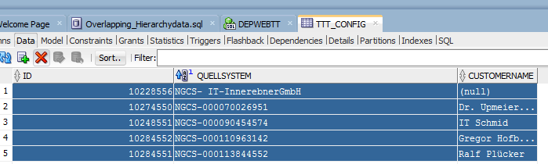

## TABLE: CUSTOMER: TTTCONFIG_ID = 10274550

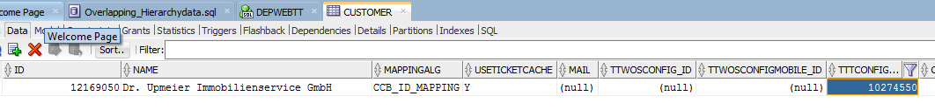

## TABLE:CUSTOMER_MASTERCCB ID = 12169050

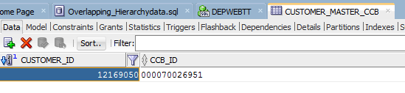

# Add additional CustomerAdmin

## Select Customer

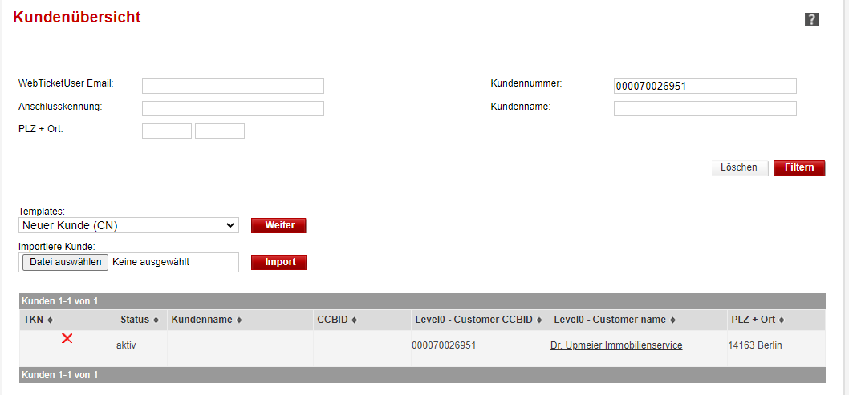

## Add Admin:

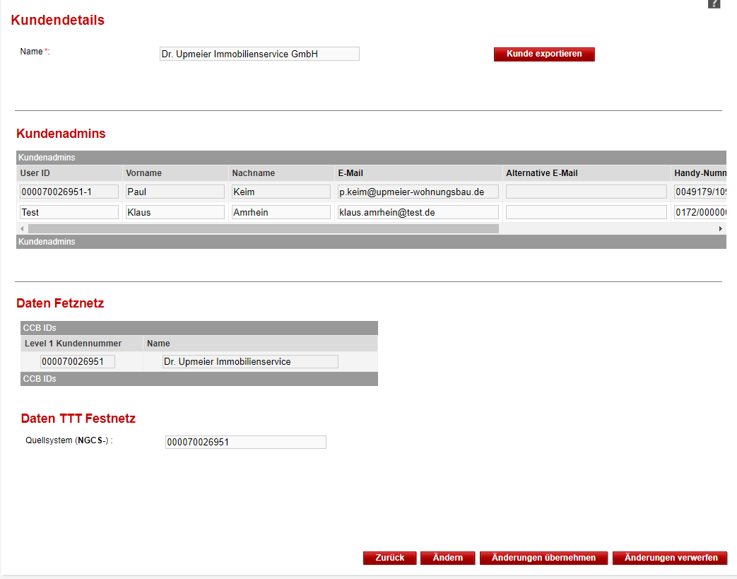

Added user:Klaus.amrhein@test.de

## Activate Changes:

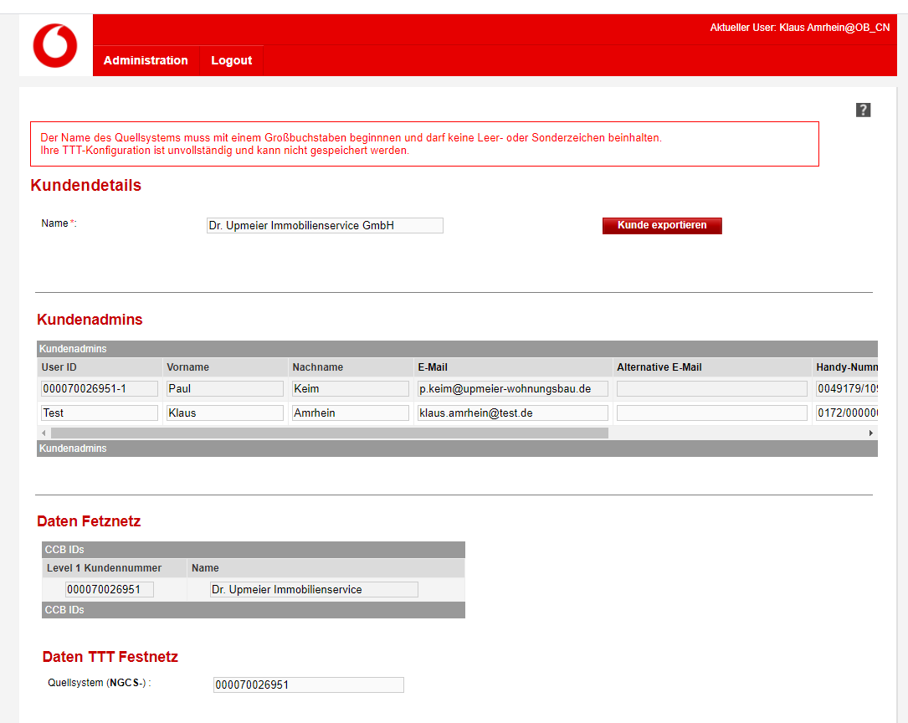

Error Message:

Der Name des Quellsystems muss mit einem Großbuchstaben beginnnen und darf keine Leer- oder Sonderzeichen beinhalten.

Ihre TTT-Konfiguration ist unvollständig und kann nicht gespeichert werden.

En:

The name of the source system must start with a capital letter and must not contain any spaces or special characters.

Your TTT configuration is incomplete and cannot be saved.

# Additional Rule validation hurted

## Space

Add : space in NGCS-_IT-InnwebenerGmbH

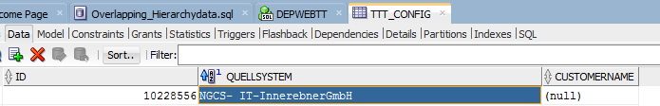

Customer got onboarded due to normal manuallay Onboarding Process via Onboarding Tool

## Digit instead of capital letter

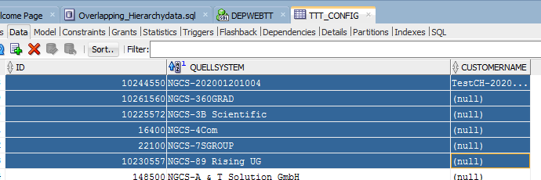

Value:

NGCS-202001201004

NGCS-360GRAD

NGCS-3B Scientific

NGCS-4Com

NGCS-7SGROUP

NGCS-89 Rising UG

NGCS-360Grad

.

.

.

Are not allowed , but are in !

# Source system NGCS-4COM

15.07.2020

Add Admin KA@4COM for Customer 4Com

CCBID = 001907647961

## Define Admin

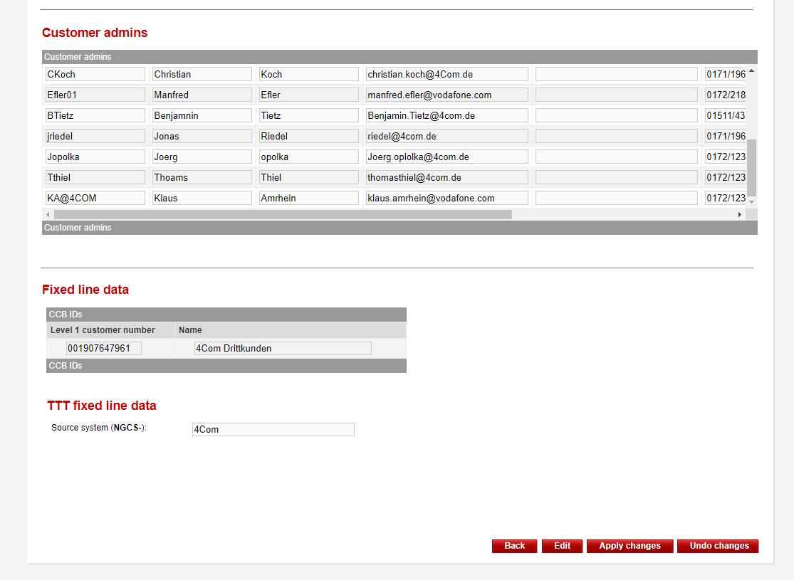

## Apply Changes

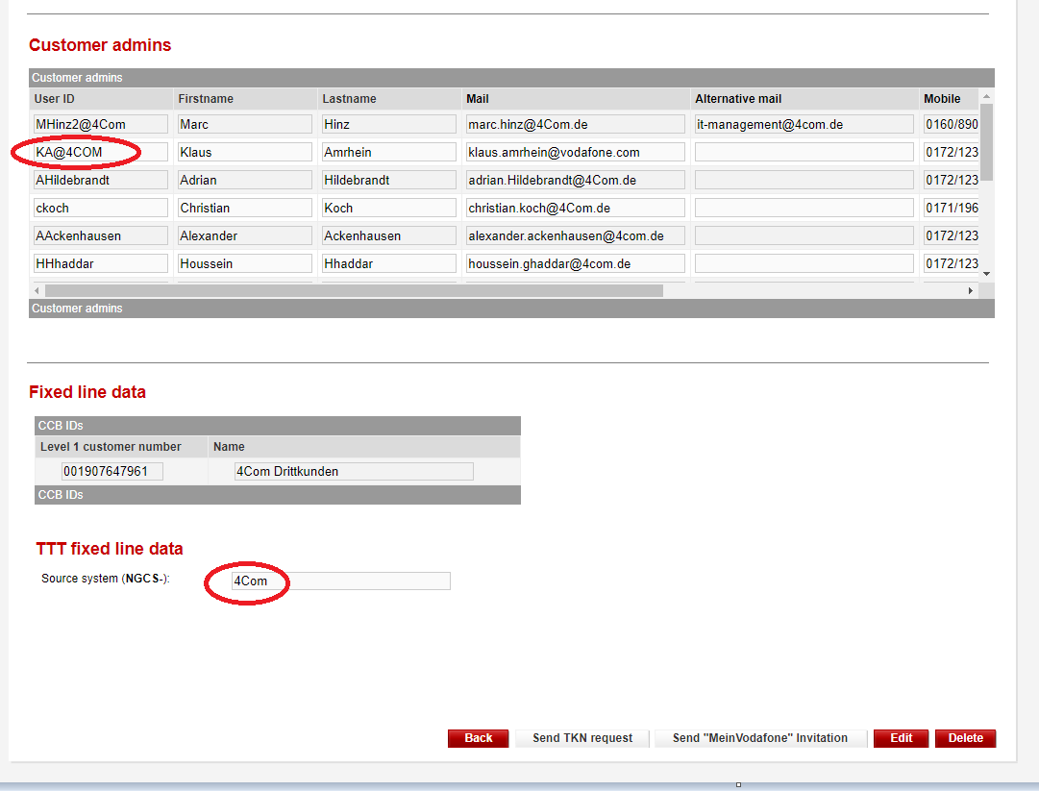

**Admin successfully onboarded**