

Reptile functional document for system test

Version: 1.0

**Document Revision History**

|  |  |  |  |
| --- | --- | --- | --- |
| **Document Version** | **Modification/Approval Date** | **Modified By** | **Section,Page(s) and Text Revised** |
| 1.0 | 15.10.2020 | Avik roy choudhury | Based on the knowledge gather while testing RMS173989 |
|  |  |  |  |
|  |  |  |  |
|  |  |  |  |
|  |  |  |  |
|  |  |  |  |

Contents

**Overview of Reptile application**

The RepTile Application counts bills for several kind of bills inside various systems. It creates a SOX Report/PDF File from this.

That creates this bill surveillance plan in the current situation. Below is a block diagram representing the links between the connected systems.

## **Short Overview used backend systems**

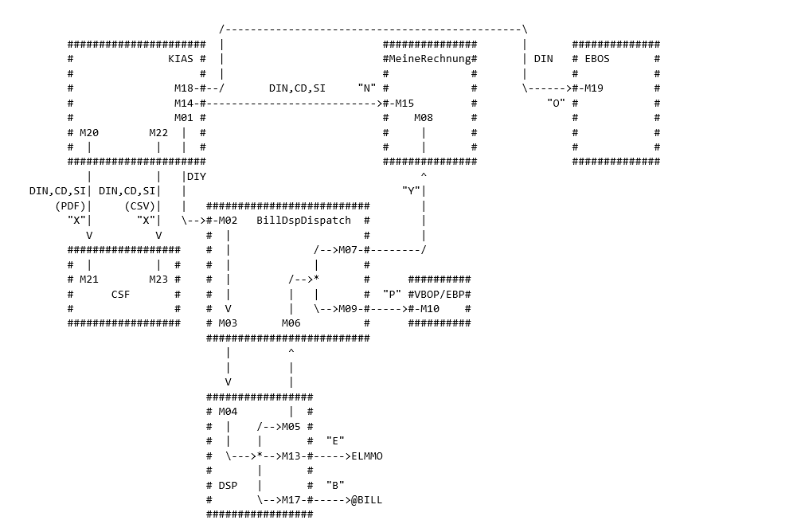

**Reptile system documents**

Please have a look into the below technical documents for further technical details.

 

**ALM path for system test cases**

ALM path for the test cases:

Test lab->Root->_RMS173989_xRechnung->RMS173989_xRechnung

**System test process for reptile test**

1. Deployment will be done by the development team.
2. Prepare the input .csv file according to the test case.
3. Share the file with development team and ask to generate the report.
4. Validate the report against the test case.