TRAFFICMANAGEMENT USING IoT

# NAME:  AVIKA M

COLLEGECODE:9530

NAN MUDHALVAN ID:  au953021106011

PHASE-5 PROJECT SUBMISSION

PROJECT TITLE:  TRAFFIC MANAGEMENT SYSTEM

# **Abstract:**

In urban environments, the burgeoning vehicular population has led to significant challenges in traffic management, resulting in increased congestion, pollution, and safety hazards. Leveraging the capabilities of the Internet of Things (IoT), this paper presents a comprehensive framework for real-time traffic management. The proposed system integrates a network of IoT devices, including sensors, cameras, and smart traffic lights, to collect and analyze real-time traffic data. By employing machine learning algorithms and predictive analytics, the system optimizes traffic flow, reduces congestion, and enhances overall road safety. The implementation of this IoT-based traffic management solution is poised to revolutionize urban transportation systems, paving the way for sustainable and efficient mobility solutions.

# **Introduction:**

Traffic congestion in Indian cities poses a significant challenge, resulting in heightened fuel consumption, air pollution, and prolonged waiting times. Factors contributing to congestion include the imbalance between vehicle volume and road capacity, as well as inadequate traffic management. Incidents like accidents and sudden braking further exacerbate the issue. Moreover, security concerns and an annual loss of Rs 65,000 cores, including fuel wastage, underscore the urgency of effective traffic control. To compound matters, slow freight vehicle speeds, amplified fuel consumption, and protracted waiting times at checkpoints persist due to a 4.01% growth in road infrastructure compared to a 10.76% increase in vehicles annually. As a result, road space is insufficient relative to the burgeoning vehicle population. With India's population rivaling China's, the rise in car ownership, attributed to advancing technology and economic growth, only intensifies traffic congestion. Consequently, adopting smart traffic management strategies, including automated signaling systems, becomes imperative to alleviate this issue.

# **Problem statement:**

The rapid increase in urbanization has resulted in a surge in vehicular traffic, leading to severe congestion, longer commute times, increased fuel consumption, and heightened air pollution levels. Additionally, the lack of efficient traffic management strategies has contributed to a rise in road accidents and safety hazards, posing a significant threat to public well-being and sustainable urban development. Thus, there is an urgent need to develop and implement comprehensive traffic management solutions that utilize advanced technologies to alleviate congestion, enhance safety measures, and promote a more sustainable and efficient urban transportation ecosystem.

# **Existing system:**

The current traffic management system, reliant on human intervention by traffic police, is plagued by a lack of smart decision-making capabilities. This limitation results in instances where roads are blocked for extended

# **Drawbacks of the existing system include:**

* Persistent traffic congestion due to inefficient management
* Inability to detect traffic congestion, leading to delayed responses
* High incidence of accidents attributable to inadequate traffic control
* Lack of remote control capabilities, restricting adaptability and responsiveness
* Heavy reliance on human resources, leading to increased manpower requirements
* Economically inefficient operations
* Suboptimal system efficiency due to manual processes and decision-making.

# **Proposed system:**

The proposed system involves deploying wireless sensor nodes with vehicle detection capabilities. These nodes relay their findings to a central microcontroller via a local server, enabling the system to analyze the data. By leveraging this data, the microcontroller makes informed decisions on route selection and lane management, accounting for traffic density and the volume of vehicles. Through this comprehensive approach, the system aims to significantly enhance traffic management, optimize route allocation, and mitigate congestion issues efficiently.

# **Advantages of the proposed system include:**

* Reduction in traffic volume, alleviating congestion
* Cost savings on fuel and time, contributing to financial benefits
* Cost-effective implementation, ensuring affordability
* Simplified implementation procedures, facilitating ease of setup
* Remote controllability, enhancing adaptability and responsiveness
* Improved efficiency, leading to optimized traffic management
* Reduced manpower requirements, streamlining operations and resource allocation.

# **Components required :**

* Arduino Mega 2560
* Traffic density sensors
* 4 X Red LEDs
* 4 X Green LEDs
* 4 X Yellow LEDs
* 12 X 220 ohm resistors
* Jumper cables
* Breadboards

# **Circuit diagram:**

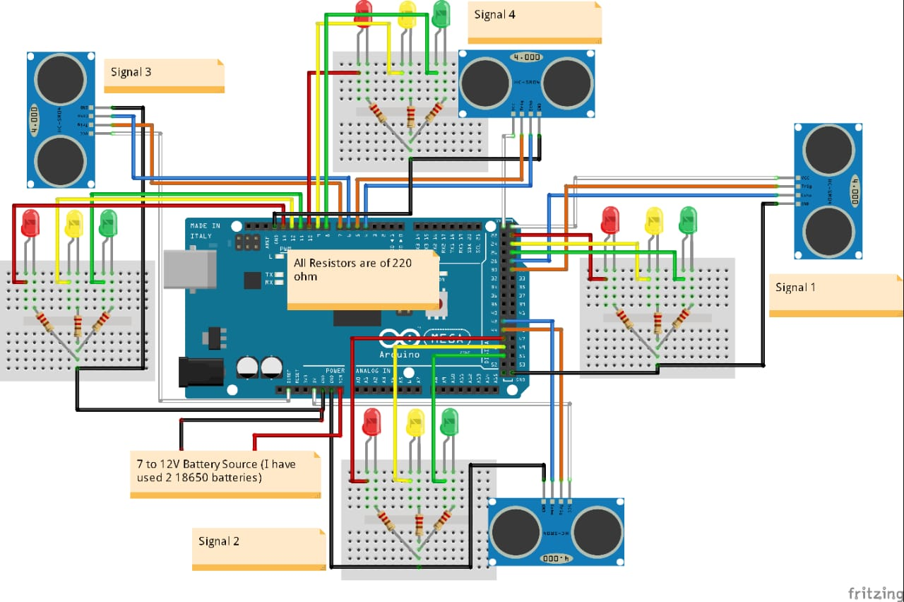

# **Upload the code to your Arduino UNO:**

* Open the ARDUINO IDE on your computer.
* connect your Arduino Mega2560 to your computer via USB.
* Select the correct board and plot under the “tools “menu.
* copy and paste the above code into the Arduino IDE.
* click the “upload” button to upload the code to your Arduino Mega2560.
* simulate the code to get the output.

# **Project description:**

The current traffic signaling system, being time-based, often leads to inefficient traffic management. Addressing the prevalent issue of traffic congestion in cities worldwide, this project aims to transition from manual or fixed timer operations to an automated system with intelligent decision-making capabilities.

Our focus is on developing a dynamic traffic signal system that adjusts signal timings automatically based on real-time traffic density at each junction. In instances where one side of the junction experiences higher traffic density, our system will allocate longer green light durations compared to the standard allotted time, ensuring smoother traffic flow.

To achieve this, we employ Proximity Infrared (PIR) sensors positioned alongside the road, which detect vehicle presence and relay the data to the Arduino microcontroller. Once the traffic density is computed, the microcontroller takes charge of assigning the appropriate green light duration, determining the timing for each lane's signal change. As a result, this system reduces traffic congestion seamlessly, eliminating the need for manual intervention.

# **Working :**

If there is traffic at all the signals, then the system will work normally by controlling the signals one by one. If there is no traffic near a signal, then the system will skip this signal and will move on to the next one. For example, if there is no vehicle at signal 2, 3 and currently the system is allowing vehicles at signal 1 to pass. Then after signal 1, the system will move on to signal 4 skipping signal 2 and 3.If there is no traffic at all the 4 signals, system will stop at the current signal and will only move on the next signal if there will be traffic at any other signal.

# **Working algorithm:**

**Case 1:**

Start

|

Check Vehicle Density

|

Vehicle density++

|

Is vehicle density < Threshold?

|

Yes ----> Normal Traffic ----> Give green signal to each Lane in a sequential manner

|

No

**Case 2:**

|

Start

|

Check Vehicle Density

|

Vehicle density++

|

Is vehicle density < Threshold?

|

No ----> Status = Congestion ----> Compare the number of density in each lane

|

Open the lane with highest density

|

Remove current Lane from Comparison

|

Go back to Check Vehicle Density

# **Source  code in python:**

import time  
import random  
  
class Vehicle:  
    def __init__(self, vehicle_id, speed):  
        self.vehicle_id = vehicle_id  
        self. speed = speed  
  
class TrafficLight:  
    def __init__(self):  
        [self. state](http://self.state) = 'red'  
  
    def switch_state(self):  
        self. state = 'green' if self. state == 'red' else 'red'  
  
class TrafficManager:  
    def __init__(self, num_vehicles, num_iterations):  
        self. Vehicles = [Vehicle(i, [random.randint](http://random.randint)(30, 70)) for i in range(num_vehicles)]  
        self.traffic_light = TrafficLight()  
        self.num_iterations = num_iterations  
  
    def run_simulation(self):  
        for iteration in range(self.num_iterations):  
            print(f"Iteration {iteration + 1}: Traffic Light is {[self.traffic_light.state](http://self.traffic_light.state)}")  
            for vehicle in [self. vehicles](http://self.vehicles):  
                if [self.traffic_light.state](http://self.traffic_light.state) == 'green':  
                    distance = [vehicle. speed](http://vehicle.speed) * 2  
                    print(f"Vehicle {vehicle.vehicle_id} moves {distance} meters.")  
                else:  
                    print(f"Vehicle {vehicle.vehicle_id} stops at the red light.")  
            self.traffic_light.switch_state()  
            [time. Sleep](http://time.sleep)(1)  
  
def main():  
    num_vehicles = 5  
    num_iterations = 5  
    traffic_manager = TrafficManager(num_vehicles, num_iterations)  
    traffic_manager.run_simulation()  
  
if __name__ == "__main__":  
    main()

# **Output:**

Iteration 1: Traffic Light is red

Vehicle 0 stops at the red light.

Vehicle 1 stops at the red light.

Vehicle 2 stops at the red light.

Vehicle 3 stops at the red light.

Vehicle 4 stops at the red light.

Iteration 2: Traffic Light is green

Vehicle 0 moves 64 meters.

Vehicle 1 moves 138 meters.

Vehicle 2 moves 128 meters.

Vehicle 3 moves 76 meters.

Vehicle 4 moves 60 meters.

Iteration 3: Traffic Light is red

Vehicle 0 stops at the red light.

Vehicle 1 stops at the red light.

Vehicle 2 stops at the red light.

Vehicle 3 stops at the red light.

Vehicle 4 stops at the red light.

Iteration 4: Traffic Light is green

Vehicle 0 moves 64 meters.

Vehicle 1 moves 138 meters.

Vehicle 2 moves 128 meters.

Vehicle 3 moves 76 meters.

Vehicle 4 moves 60 meters.

Iteration 5: Traffic Light is red

Vehicle 0 stops at the red light.

Vehicle 1 stops at the red light.

Vehicle 2 stops at the red light.

Vehicle 3 stops at the red light.

Vehicle 4 stops at the red light.

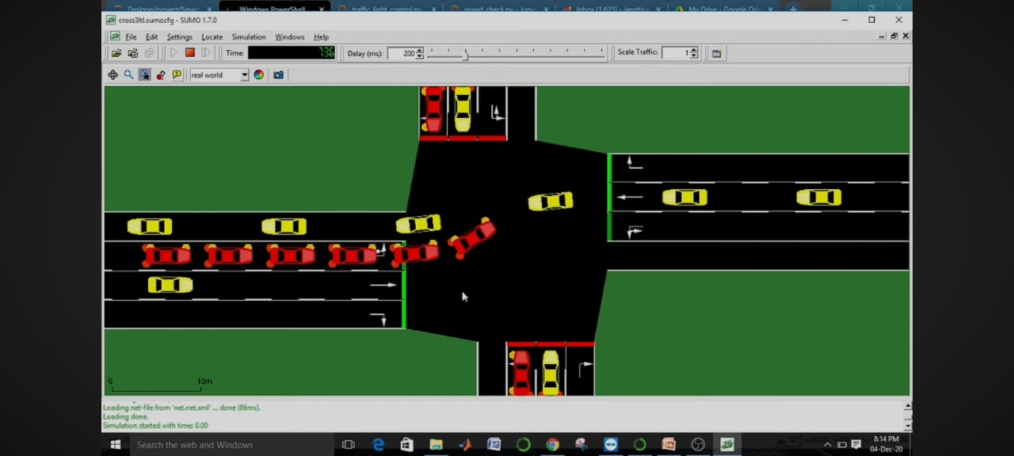

Figure:  sumo simulation

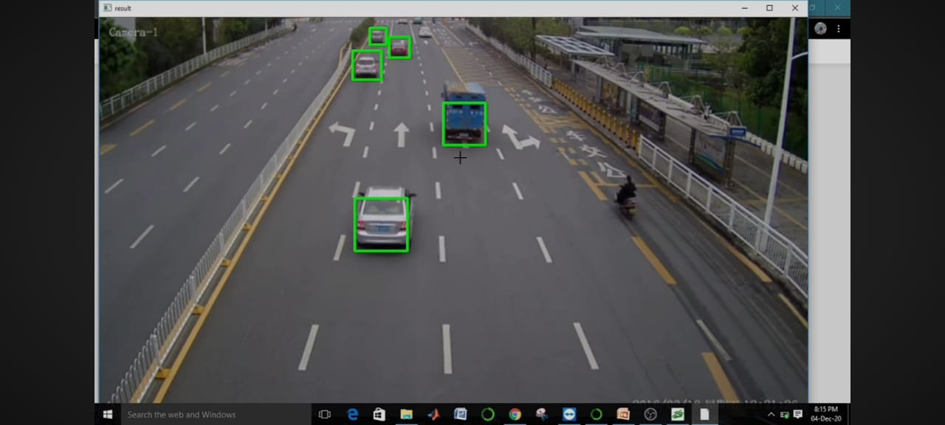

Figure:   Real time vehicle detection

# **Conclusion:**

In conclusion, the integration of IoT technology in traffic management has demonstrated its potential in optimizing traffic flow through the utilization of density-based algorithms. By leveraging real-time data on vehicle density, this system enables more efficient route planning, reduced congestion, and improved overall transportation sustainability. With its capacity for real-time adjustments and data-driven decision-making, density-based traffic management through IoT offers a promising avenue for addressing contemporary urban mobility challenges, fostering smoother commutes, and enhancing the overall quality of life for city dwellers. As we move forward, continued research and development in this field are crucial to further refine and implement intelligent traffic management solutions for the ever-evolving urban landscape.