TRAFFIC MANAGEMENT PHASE 2

*NAME: AVIKA   M*

*COLLEGE: 9530*

*NANMUDHALVAN ID: 953021106011*

PROBLEM STATEMENT:

Traffic congestion consists of incremental delay, consumption, pollution emission and stress that result from interference vehicles in traffic stream, particularly as traffic volumes approaches a road’s capacity.

DESCRIPTION:

Traffic management concerns the control, planning, and purchasing of transport services needed to physically move road vehicles.

# CIRCUIT DIAGRAM:

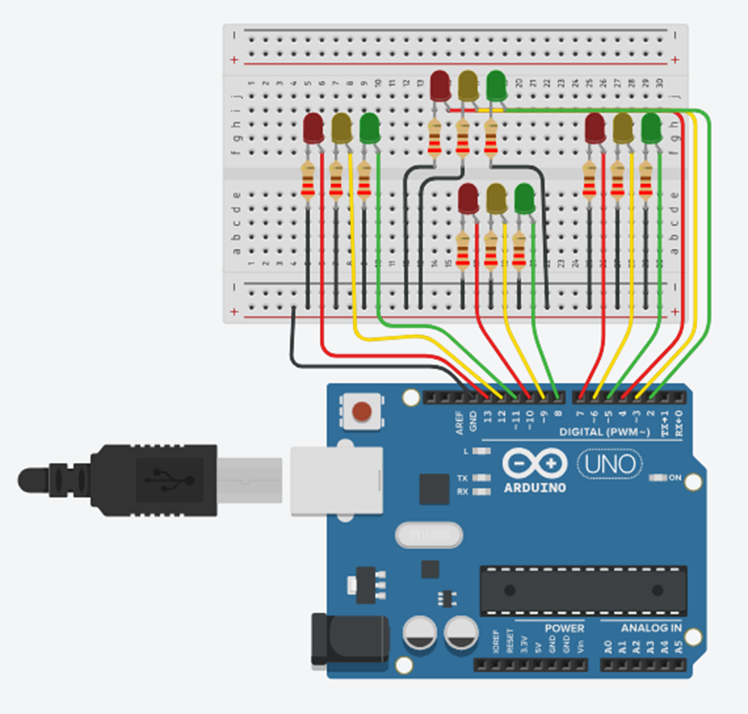

COMPONENTS REQUIRED:

* ARDUINO UNO
* TRAFFIC SENSOR
* JUMPER WIRES
* BREAD BOARD
* LED

# Microcontroller (Arduino Uno):

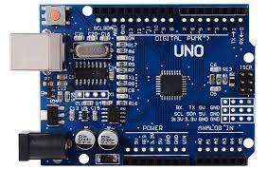 The Arduino UNO is an open-source micro- controller board based on the Microchip ATmega328Pmicrocontroller and developed by Arduino.cc. The board is equipped with sets of digital and analog input/output (I/O) pins that may be interfaced to various expansion boards (shields) and other circuits. The board has 14 Digital pins, 6 Analog pins, and programmable with the Arduino IDE (Integrated Development Environment) via a type B USB cable.

Figure 1: Arduino Uno.

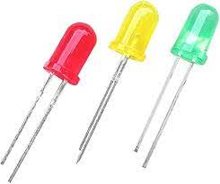2.LEDs: LEDs are used for the purpose of signaling according to the traffic condition.

Figure 2: LED for Traffic Lights.

3.Jumper Wires:It is used to connect the components to each other

Figure 3: Jumper Wires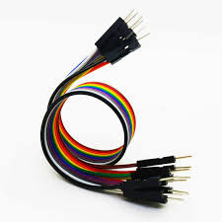

4.IR Sensor: IR Sensor is used to count the vehicles on the road.

Figure  4:IR Sensors.

### SOFTWARE REQUIRED:

* Arduino IDE:

Used to connect Arduino UNO and upload the file into them for further processing.

* TINKERCAD:

Used for creating digital circuit and to simulate that.

# TRAFFIC SYSTEM:

