Avik Bag

Prof. Balduccini

CS 380

Homework Assignment 3

Written Assignment #3

**Part 1: Written Problems (40 points)**

(This is problem 3.26 of the 3rd Edition of the textbook). Consider the unbounded version of the regular 2D grid shown in Figure 3.9. The start state is at the origin (0,0), and the goal state is at (x,y).

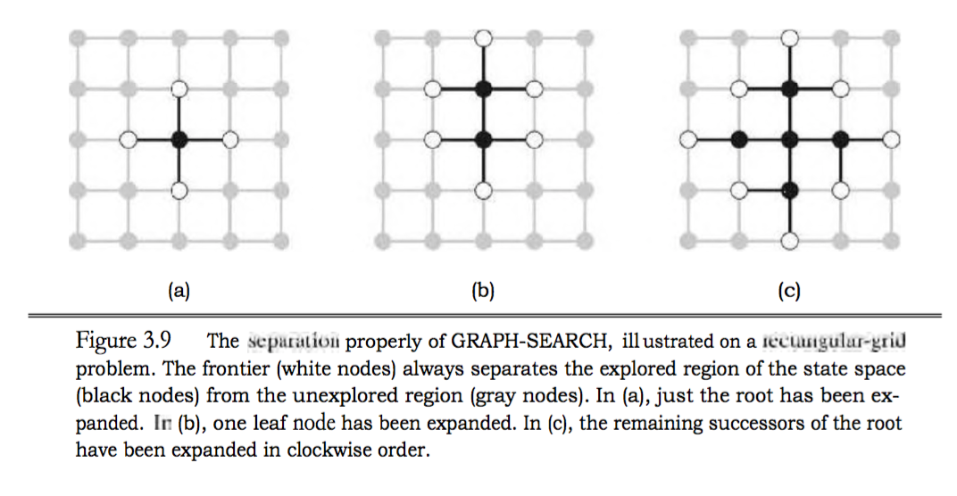

1. What is the branching factor b in this state space?

The branching factor is at 4. This because when we expand each node, there are a total of 4 possibilities. Also, this is only valid if there is no checking for repeated states.

1. How many distinct states are there at depth k (for k larger than 0)?

At depth = 1; # of nodes = 4

At depth = 2; # of nodes = 8

At depth = 3; # of nodes = 12

Therefore, the number of nodes at any given depth(k) is 4k.

1. What is the maximum number of nodes expanded by breadth-first tree search?

If there is no checking of repeated states, each node will always expand to 4 nodes.

Total number of nodes expanded is $\frac{b^{d+2}-1}{b-1}$ = $\frac{4^{d+2}-1}{3}$ as given by the summation of all the node expansion in each depth.

1. What is the maximum number of nodes expanded by breadth-first graph search?

In the bfs graph, we see that the entire space is represented by a square layout. Thus we can use this to establish the total number of nodes expanded in a bfs graph

2*(x+y)(x+y) - 1

1. Is h = |u - x| + |v - y| an admissible heuristic for a state at (u,v)? Explain.

This can work as a admissible heuristic, because this is essentially calculating the distance to the goal state from the current state, or the Manhattan distance.

1. How many nodes are expanded by A* graph search using h?

There may be as many nodes as the bfs tree node expansion, as there are so many nodes which may have the same heuristic value, thus defeating the purpose of using A*.

1. Does h remain admissible if some links are removed?

Yes, it will work if some links are removed as this will allow some of the paths to be prioritized and make use of the heuristic better.

1. Does h remain admissible if some links are added between nonadjacent states?

No. The way to optimize is it by reducing the number of paths that can access a certain node. We want to be able to find the most efficient path to the goal, and not go around in circles.