Avik Bag

Professor Peysakhov

CS 260 – Assignment #8

17th August, 2015

Written Problems

Question 1

According to Dijkstra's algorithm, when the vertex is marked closed and assumes that the shortest path to it is found. If we have a open node such that the cost to the next node is minimal, the minimality will not change. This is because adding positive numbers to a vertex will not change this value. If we have negative numbers, the basic concept of Dijkstra's algorithm is not valid, and thus won’t work.

Question 2

define delete_edge(graph, node1, node2) // using a dict representation of graphs

begin

connections1 = graph.get[node1] // list of connections to that node

connections2 = graph.get[node2] // list of connections to that node

if node1 is in connections2 && node2 is in connections1 then

delete node2 from connection1

delete node1 from connection2

else

connection doesnt exist

end

define insert_edge(graph, node1, node2)

begin

if graph.has_key(node1) == False && graph.has_key(node2) == False

return // exit function

else

connections1 = graph.get[node1] // list of connections to that node

connections2 = graph.get[node2] // list of connections to that node

connections1.append(node2)

connections2.append(node1)

end

Question 3

To make adjustments to the adjacency list, every connection list should have a corresponding node to which it is connected just once. In other words, if I have node a, and the connection list is [b,d,e] and when I want to represent node b, I do not include node a in the connection list as it would be redundant. Node with the higher order will be given priority can contain the connections to the subsequent nodes. Thus allowing us to delete any node at constant time, and also any edge at constant time.

define delete_edge_const(graph, node1) // using a dict representation of graphs

begin

connections = graph.get[node1] // list of connections to that node

delete element at index 0 of connections

end

Question 4

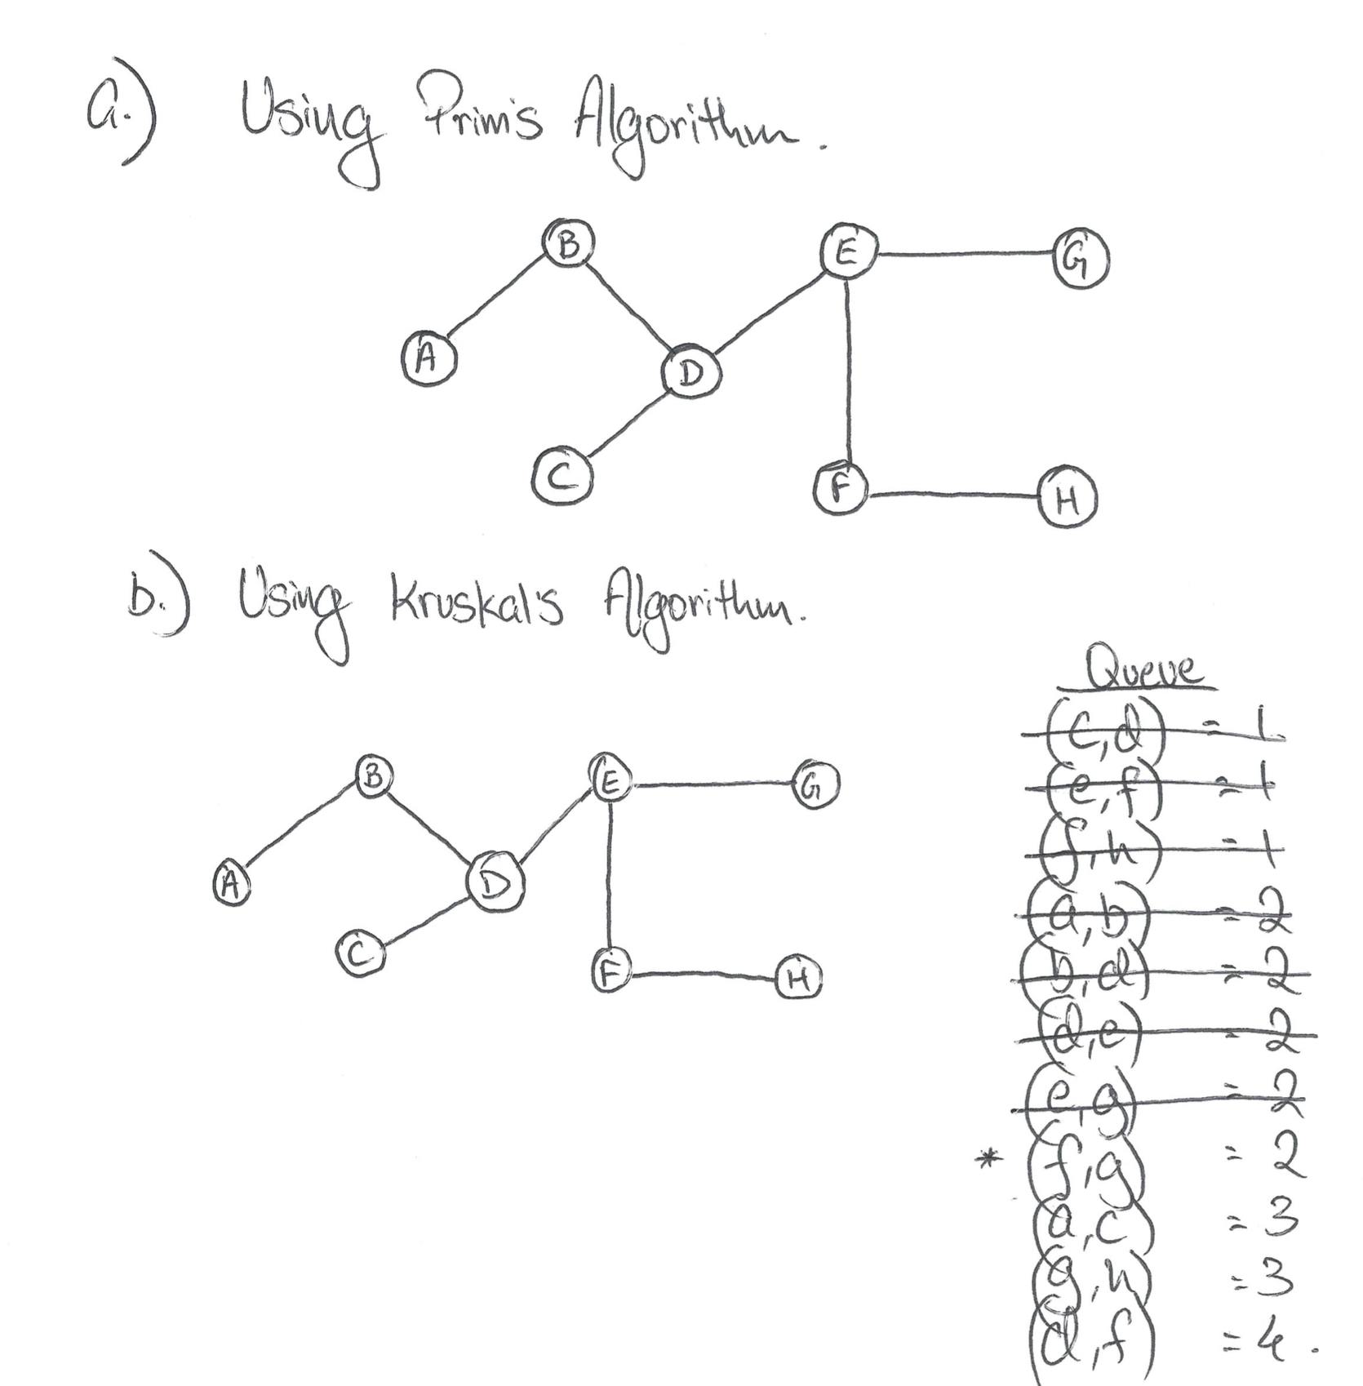

Starting at A (both DFS and BFS)

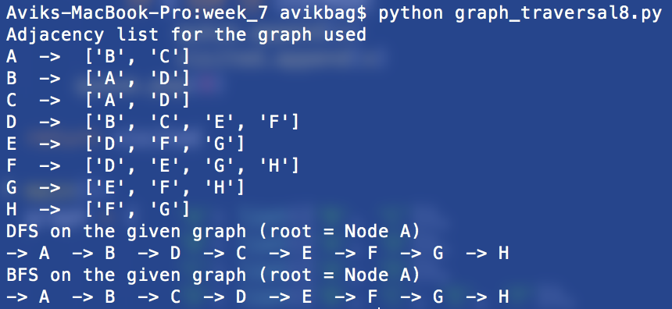

Starting at D (both DFS and BFS)

