Avik Bag

Professor Matt Burlick

CS 383 – Assignment 2

1st February 2017

# Visualization for programming part (k-means Clustering)

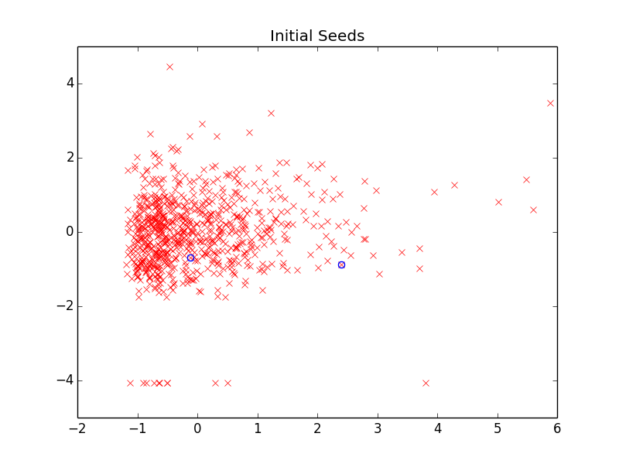

Figure : Seeds

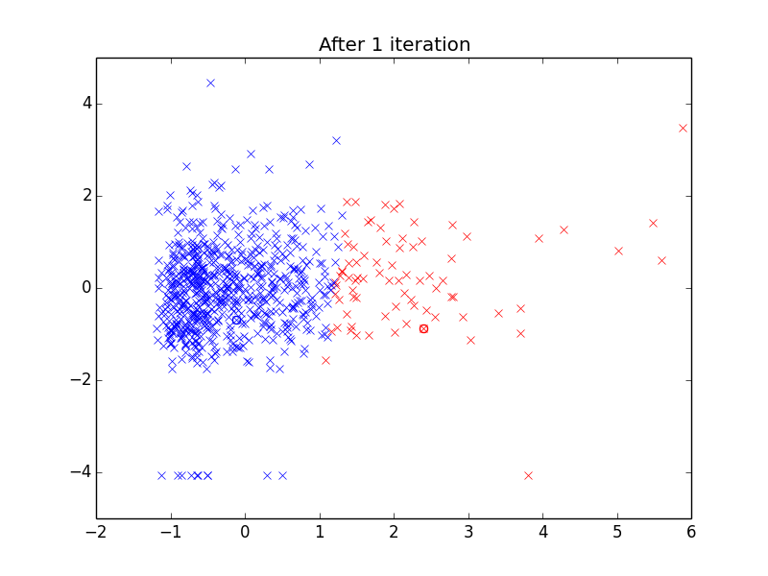

Figure : Initial Clustering

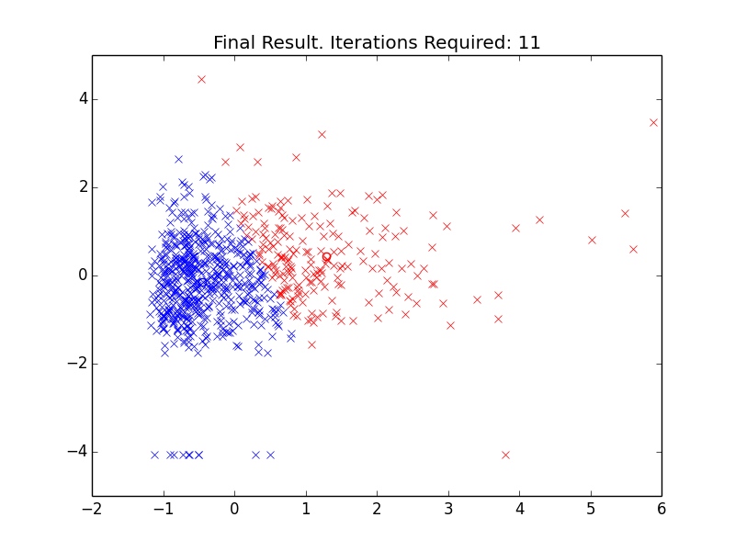

Figure : Final Clustering after meeting EM requirements

It shows that after 11 iterations, the break case for the Expectation Maximization is met. However, this is not a fixed variable. The number of iterations is highly dependent on where the initial random reference points are selected. One thing to note is that no matter how many iterations run or the randomness of the initial reference points, the end result tends to look very similar to each other after several test runs of the kmeans clustering.