Avik Bag

Professor Matt Burlick

CS 383 – Assignment 4

16th February 2017

# Visualization for Gradient Descent

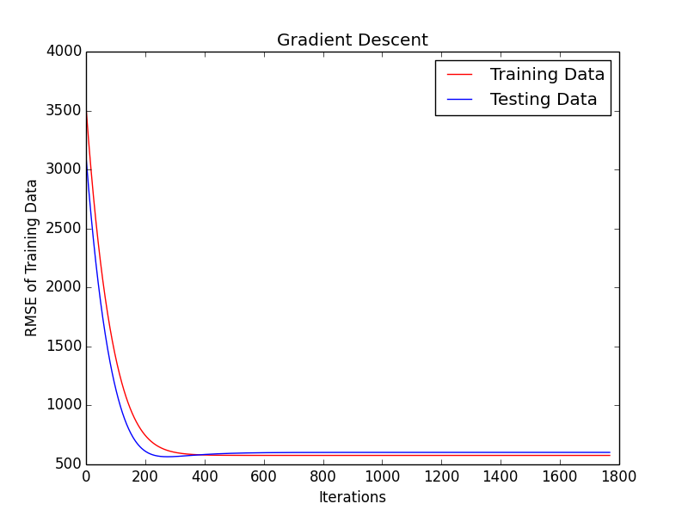

Figure : Gradient descent output

