

**Title:** Histogram Generation using OpenMP

**Names:** Avik Bag, Shannon Miles

**TA:**  Vasil Pano

**Section:** 001

**Date Performed:** 2/8/17

**Date Due:** 2/4/17

**Date Received:** 1/27/17

**Introduction:**

The object of this assignment is to take a serial implementation of the histogram generation algorithm located in the compute_gold function and develop a parallel formulation of it in the compute_using_openmp function. The parallelized code will be compared to the serial implementation and speed up will be reported when using 2, 4, 8, and 16 threads for one million, ten million, and hundred million elements. (Please see README o how to run the program.)

**Graphs and Tables:**

Table 1: Execution times along with speedups for the various elements and threads used



Table 2: Execution times along with speedups for the various elements and threads used



Figure 1: Speedup as seen on xunil

Figure 2: Speedup as seen on personal compuer

**Discussion**:

The code below is the serial version of the histogram generation algorithm:

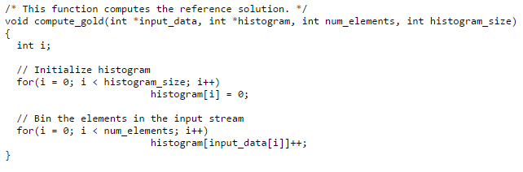

To parallelize the implementation above, the openMP library was used. First the histogram was initialized in parallel with the variable i being private and the variable histogram_size and array histogram being shared using #pragma omp parallel for default(none) private(i) shared(histogram, histogram_size)

Next, as seen in figure 3 a partial sum matrix is needed to avoid a race condition. This is done by dynamically allocating memory for this matrix and then for the index i of the matrix the thread id is stored. The second index j refers to the bins. This matrix will allow input_data to be split to the correct size based on the number of threads chosen. Once input_data is split, the partial sum is calculated for each chuck of data as seen in figure 4.

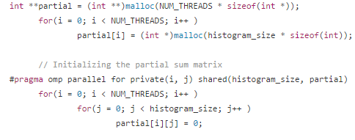  
Figure 3: partial sum setup

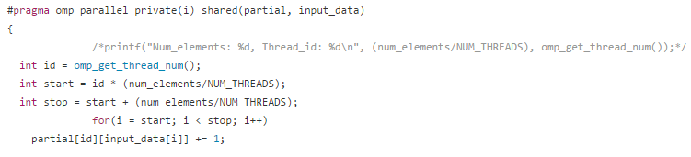  
*Figure 4: partial sum setup*

After the calculation is completed, the data is merged back into the histogram pointer as seen in figure 5, using #pragma critical to make sure threads do not interfere with each other.

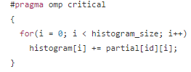  
*Figure 5: section to be critical to avoid thread collision*

On parallelizing the implementation, speed ups were seen as the number of threads increased. For 2 or 4 threads, there was no speed up; however, when using 8 or 16 threads speed up could be seen with the one million, ten million, and hundred million elements used.

We must break up the input data into the number of threads. Speed up occurs in thread four

**Conclusion:**

To conclude, parallelizing processes is beneficial only if speed up can be achieved. For our program that speed up occurred only as the number of threads increased. The size of the dataset didn’t have much impact if enough threads were used. To get adequate speedup a balance between the size of the dataset and the number of threads used.