Wealth and health inequity: Analysis of the wealth-health gradient over the life-cycle in Germany (2002-2020)

Long run, 2002-2020 (bi-yearly)

Mental and physical health scores (factor model)

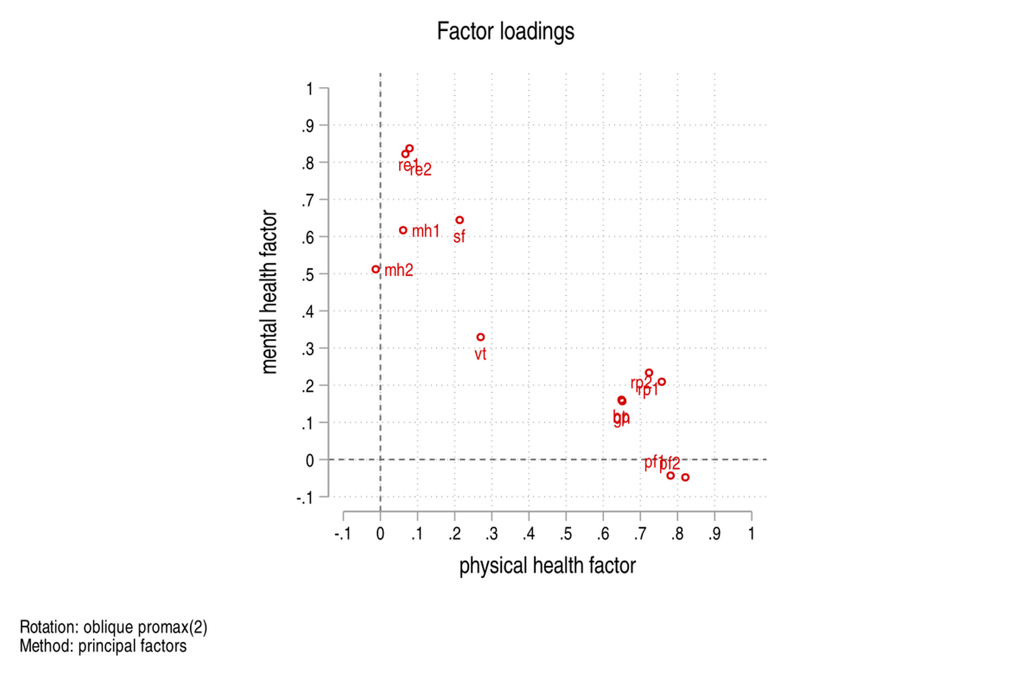Figure 1: Scatter plot of the loadings of a oblique-rotated two-actors model. Apart from Vitality (vt) the two clusters are clearly separated.
- create factor model from questions and generate two variables (physical and mental health score) from factor loading
- check for differences in wealth build up across mental and physical scores,
- check dynamic effect by looking at association of variance in health scores with wealth increase or differences in levels by wealth deciles

Group based trajectory model (GBTM) of wealth on age

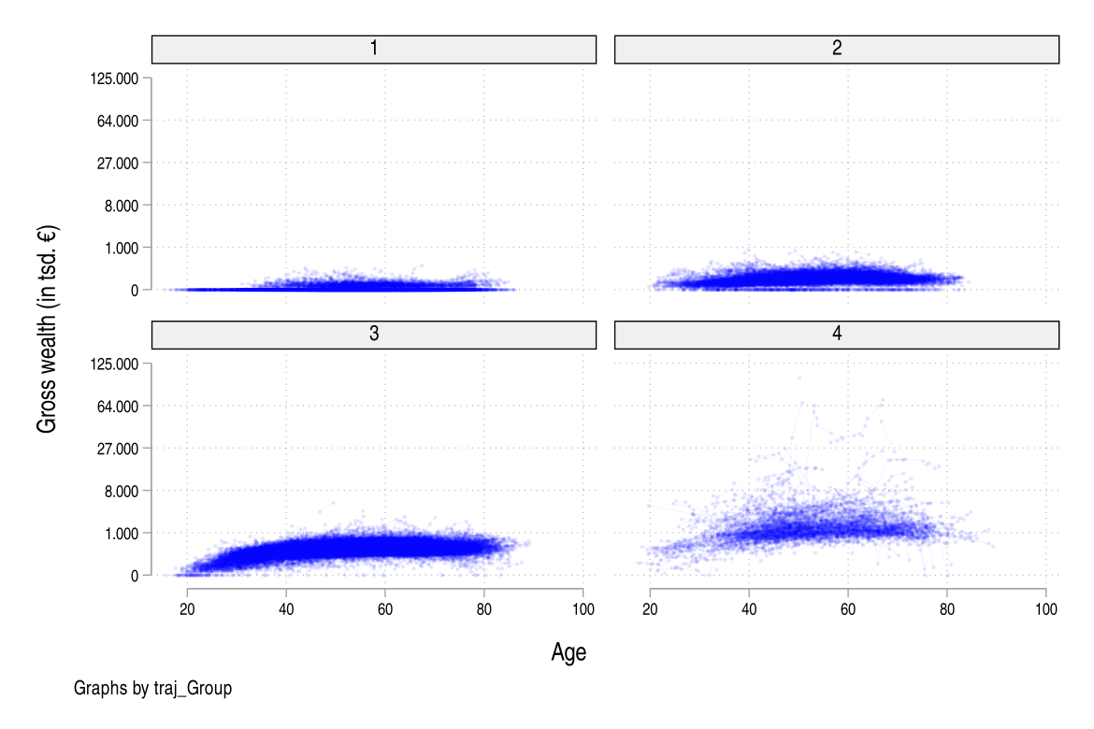  Figure 2: GBTM of gross wealth on age assuming four latent clusters. The percentages refer to each cluster size. Left: individual trajectory. Right: cluster average. | 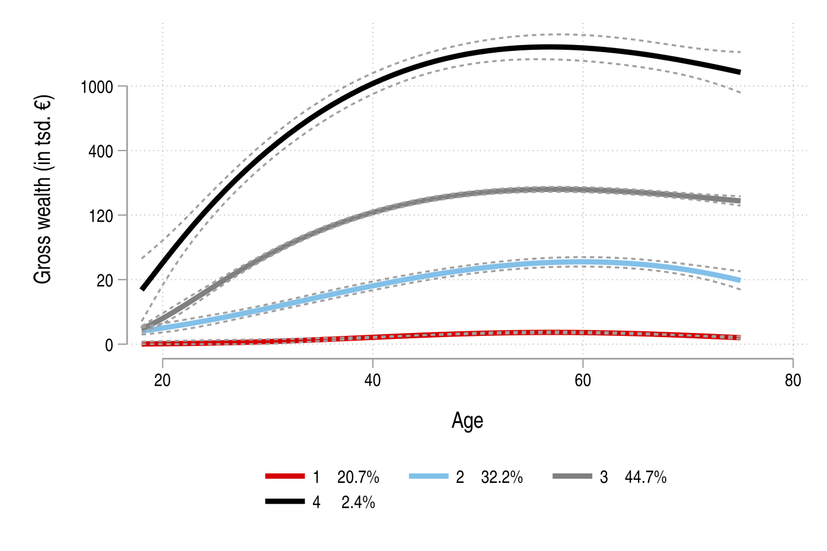
- Simple censored normal model without time-varying covariates on cubic root of gross wealth.
  - Age between 18 and 75
  - each individual is assigned a probability of belonging to K groups, (k set exogenously, here 4).
- Modeling: check for health (mental/physical) differences in each group
  - preliminary results suggest small effect of health variables on group membership, more predictive variables are schooling years and employment.
  - Might be interesting to look at young individual's parents education or social status and check group differences, specially between group 2 and 3, since they start with same wealth level.

Short run, 2011-2019 (bi-yearly)
- Where we started from :)
- graph all "concrete" health variables (diagnosed diseases)
- simple model for differences in levels, not dynamic
- check validity of SOEP against other statistics in German population

Variables of interest
- Wealth:
  - using Gross wealth due to strong distortion when focusing on lower end of distribution (rich individuals with negative wealth due to large loans.
- mcs pcs, mental and physical health score generated from factor model from health questionnaire.
  - Different to built-in variables, perform oblique rotation to allow for some correlation between mental and physical health.
    - Q: recreation of mcs/pcs more closely related to “built-in” SOEP variables, or using more variables that are currently not used in SOEPs version?
- Other health variables (short run):
  - Sleep Disturbances, Diabetes, Asthma, Cardiopathy, Cancer, Apoplectic Stroke, Migraine, High Blood Pressure, Depressive Psychosis, Dementia, Joint Disorder, Chronic Back Complaints, Other Illness, No Illness
    - Health outcome diffs on wealth groups (deciles/quartiles)
    - modeling: logit of health outcome on wealth and covariates.
      - Hard to model dynamics, since short run
  - There are also some “health/life satisfaction” variables on 1~10 Likert scale

