# Supplementary Material – Appendix S1

Diversification, Ecology and Evolution during the Quaternary in the Araucaria Forest Province (Atlantic Forest, Brazil)

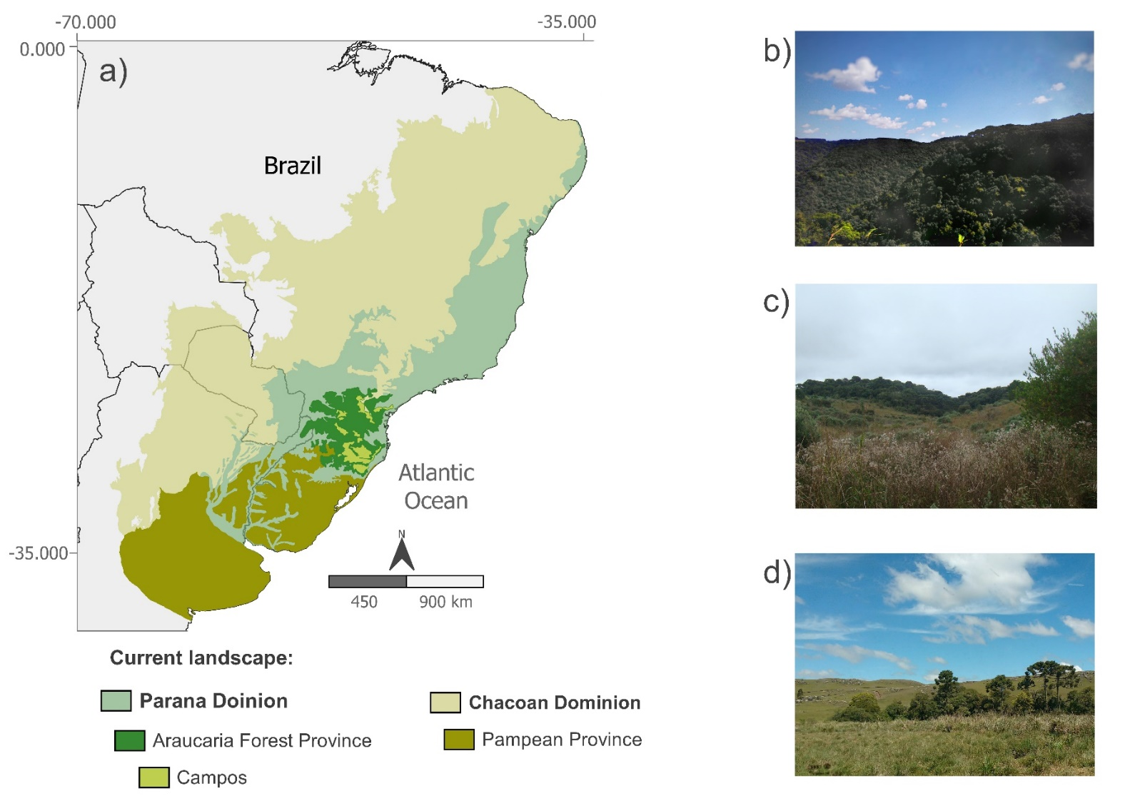

Location and characterization of the landscape of the Araucaria Forest Province. (a) Map locating the polygons of the Paraná Dominion (light green), where the Araucaria Forest Province (dark green) is located, and the Chacoan Dominion (light brown), with the location of the Pampean Province (brown) according to Morrone et al. [1]. Within our study area, the Araucaria Forest Province, the highland grassland areas (lime green), called *Campos*, are also indicated. Moreover, some records of the landscape in the study area. In the first photograph (b), Araucaria Forest, where upper stratum is dominated by *Araucaria angustifolia* conifer. In the second (c) it is possible to observe the so-called "*campo sujo*" with higher vegetation, where disturbance has been excluded for years. The last photograph (d) shows the so-called "*campo limpo*" where disturbances (fire, grazing) occur periodically. The “*campo limpo*” and “*campo sujo”* definitions were used according to Overbeck et. al [2].

# References

[1] J.J. Morrone, T. Escalante, G. Rodríguez-Tapia, A. Carmona, M. Arana, and J.D. Mercado-Gómez, “Biogeographic regionalization of the Neotropical region: New map and shapefile.,” *Anais da Academia Brasileira de Ciências*. vol. 94, no. 1, p. e20211167, 2022.

[2] G.E. Overbeck, S.C. Müller, A. Fidelis, et al., “Brazil’s neglected biome: The South Brazilian Campos,.” *Perspectives in Plant Ecology, Evolution and Systematics*. vol. 9, no. 2, pp. 101–116, 2007.