Step 1: Open the Mobile Application and you will be redirected to the login screen for Student or Teacher tab | 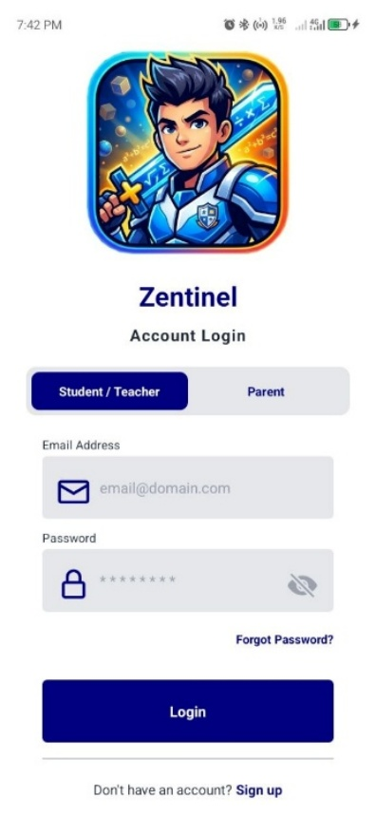
On the same screen you will also see the Parent tab screen | 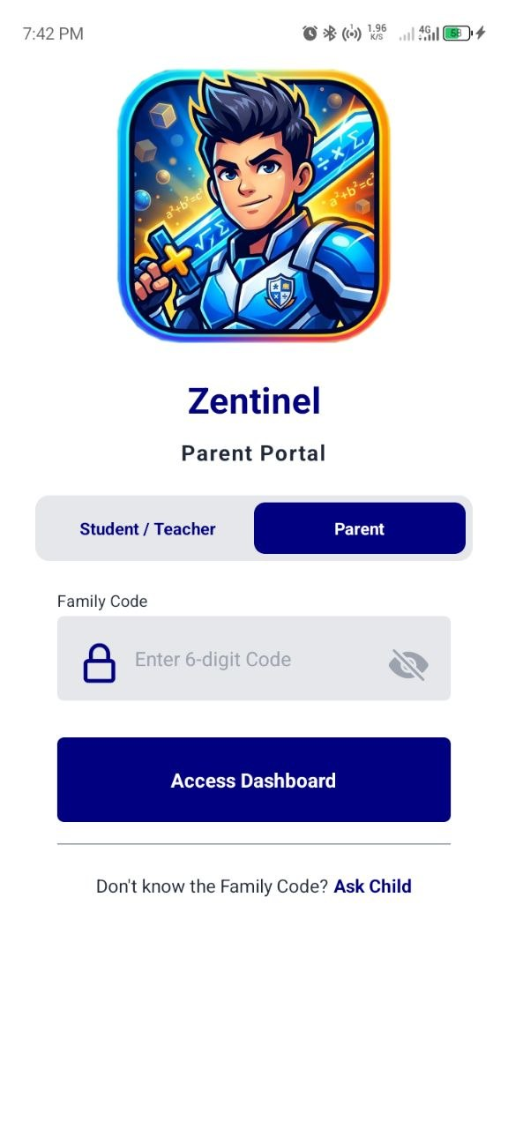
On the login screen you will see a hyperlink “Sign up” in a color blue, click this and you will be redirected to the registration screen where you can create your account if you are a new user of the mobile application, just fill out the necessary information and click “Sign up” button to save you login credentials. | 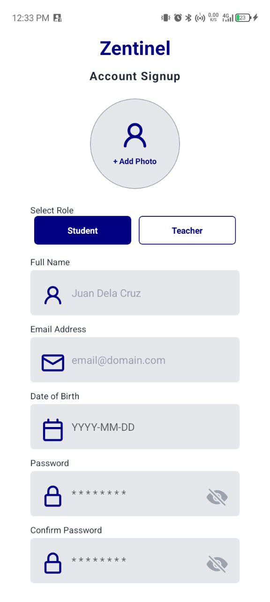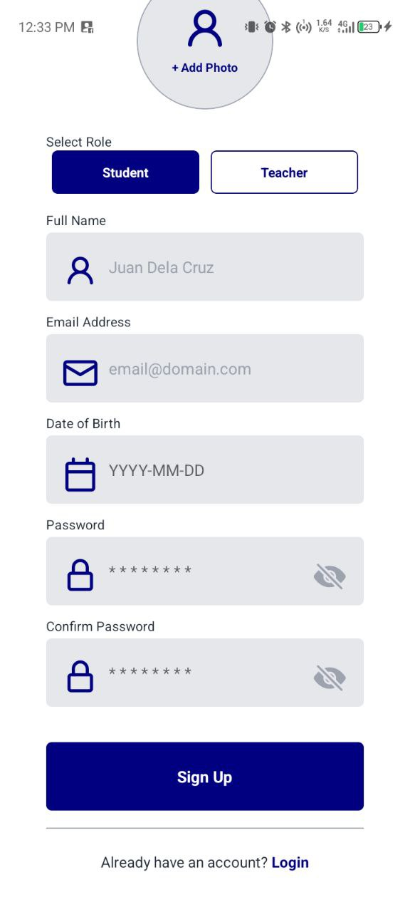
For old users, if ever you forgot your password, just click the “Forgot Password?” in color blue hyperlink that you will find at the login screen, just provide the email for the OTP code and create your new password and save it. | 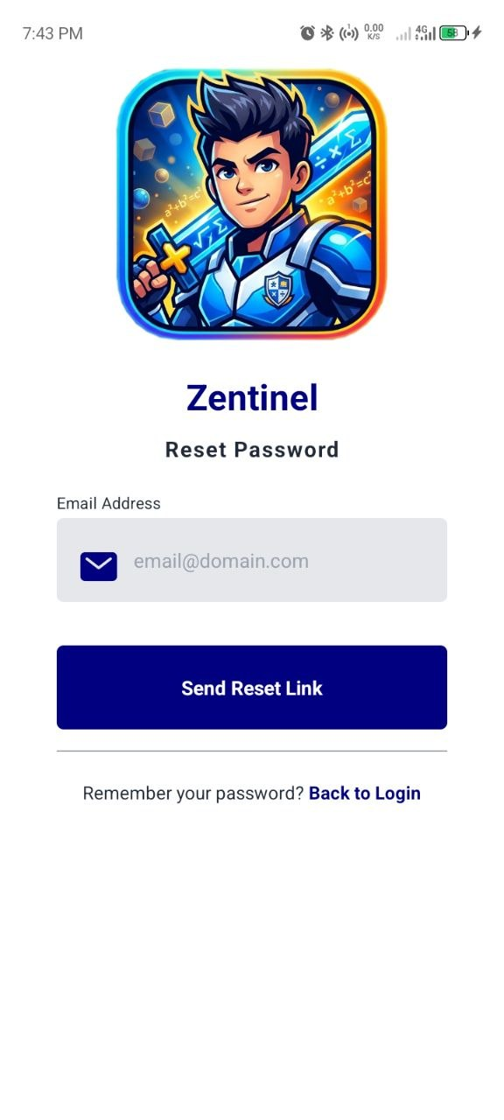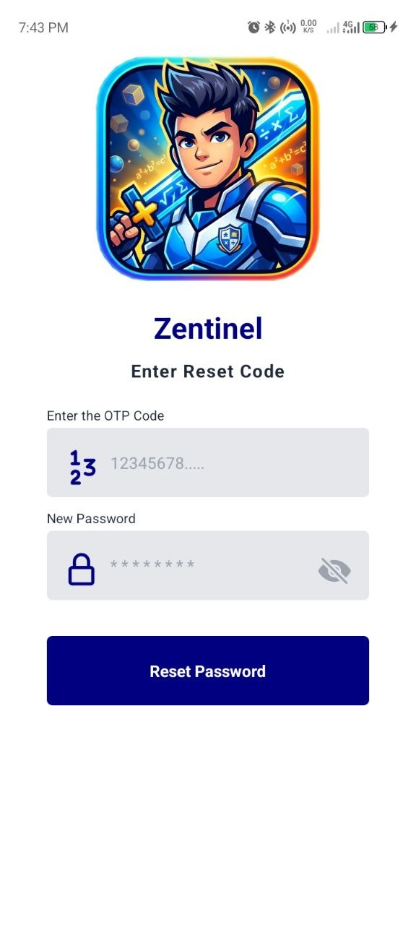
For Student, after you login, you will be redirected to the Diagnostic Phase screen, where you will take the Diagnostic Pre-Test first before you can access the full features of the mobile application, but if you failed on the pre-test you are forced to retake the pre-test. | 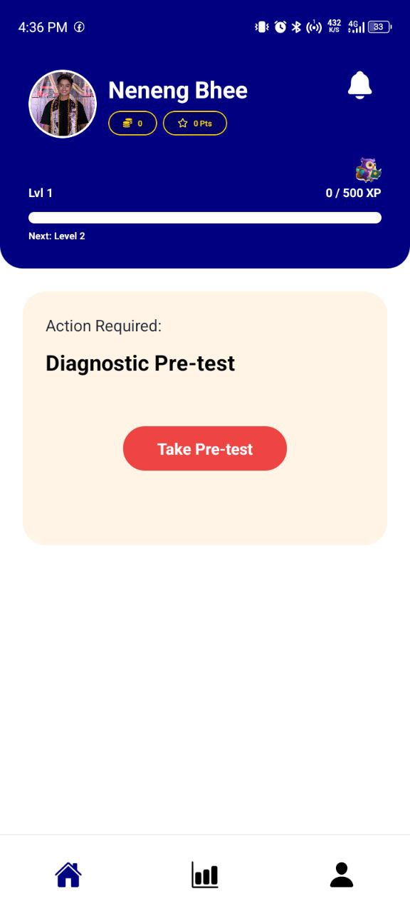
After the Diagnostic Phase, you will be redirected to the home screen where you can explore the features of the app. In this screen, you will see the Evaluation Mode just click the play button to answer the current quiz. For learning materials just click the Study Guide button where you can find preloaded study materials and also you can view a customized lesson from your teacher. And there are two other game mode that you can play also the classic quiz game for practice and the rank quiz game for more challenging game. | 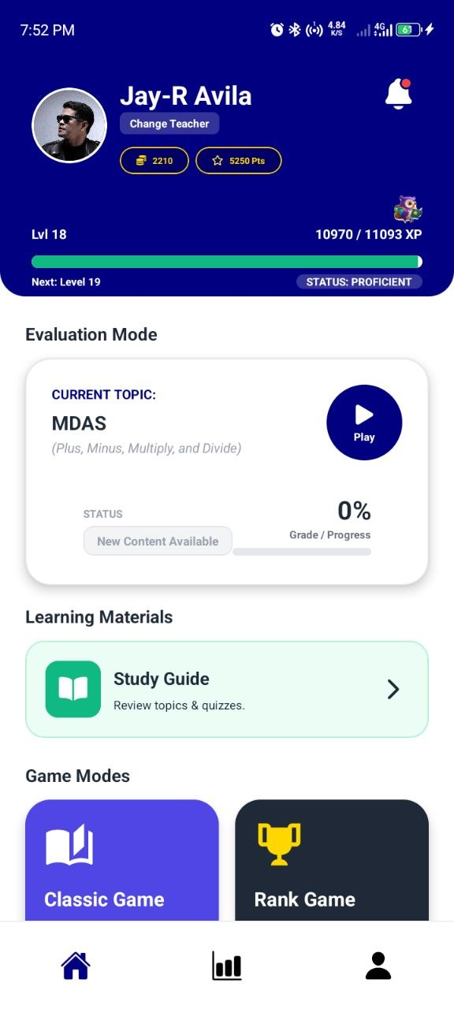
When you scroll up you will see other features like Character Shop where you can buy a hero that you will use on your game play. Another one is the Daily Missions that you need to finished for you to be able to receive a random reward from mystery treasure chest. | 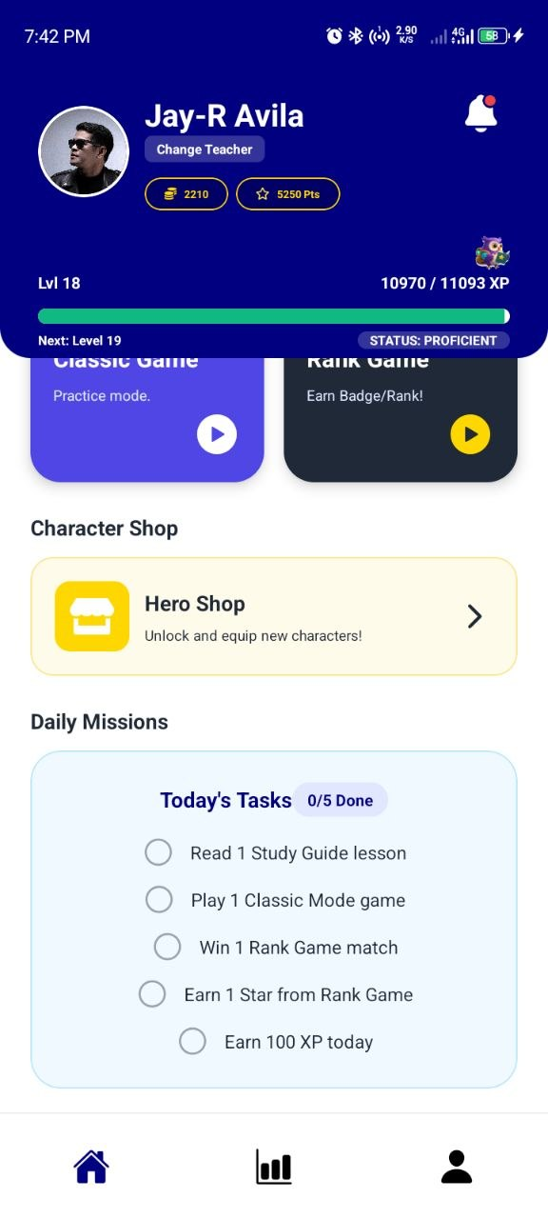
When you scroll up a bit more you will see some other features that you can find in the home screen like helper tools for you to understand math symbols, for rewards you will see your current rank and badge the mystery chest button where you can only open this if you finished you daily missions, and lastly the national leaderboard where you can see the ranking of all users of this app from across of the Philippines. | 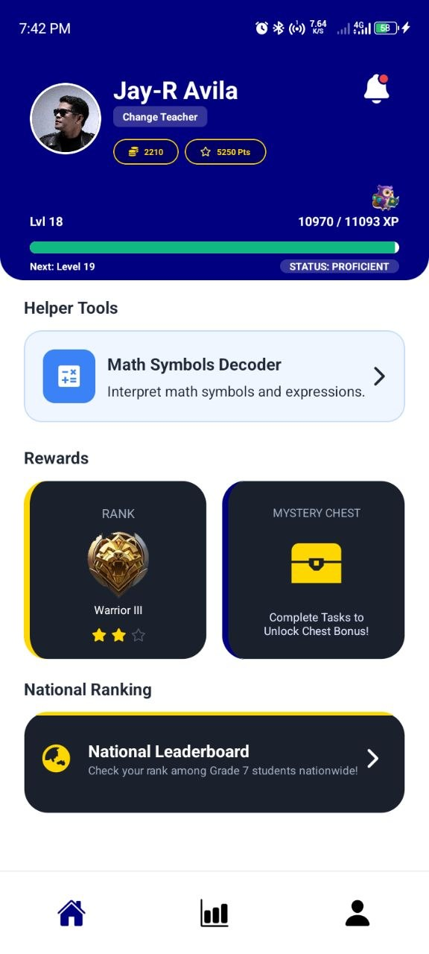
As you can see, there are three navigation buttons at the bottom of the scree and one of them is the Analytics. This is where you can see you progress from pre-test, evaluation quiz game, classic quiz game, and rank quiz game. You can also see the overview tab of all your progresses. Furthermore, the history icon button at the upper right of the screen if you click it you will be redirected to a screen where you can see and review your past quizzes for you to know where you can see which quiz items were answered incorrectly. | 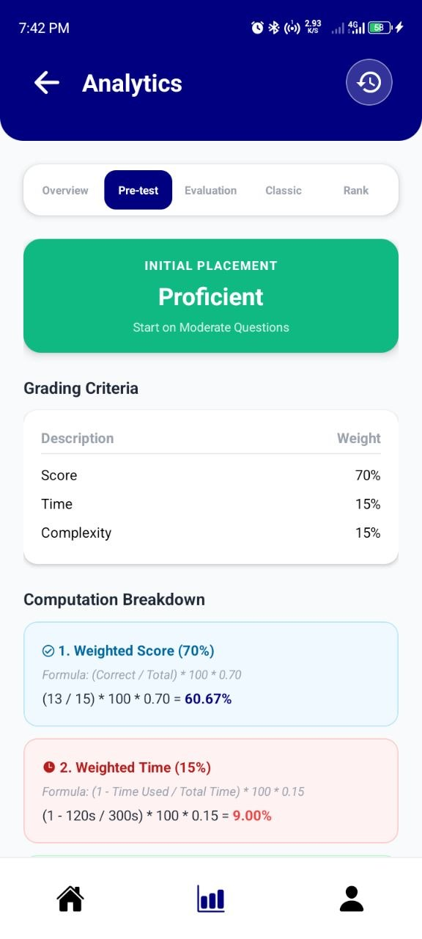
And lastly the Profile button where you can find the parent access code, you can also edit you profile information just click the edit profile button, you can also see all your rewards by clicking the achievements button and also you can setup the settings of the app depending on you just click the app settings button, and lastly just click the logout button if you want to close the app of you can just click the back button of your phone to close the app. | 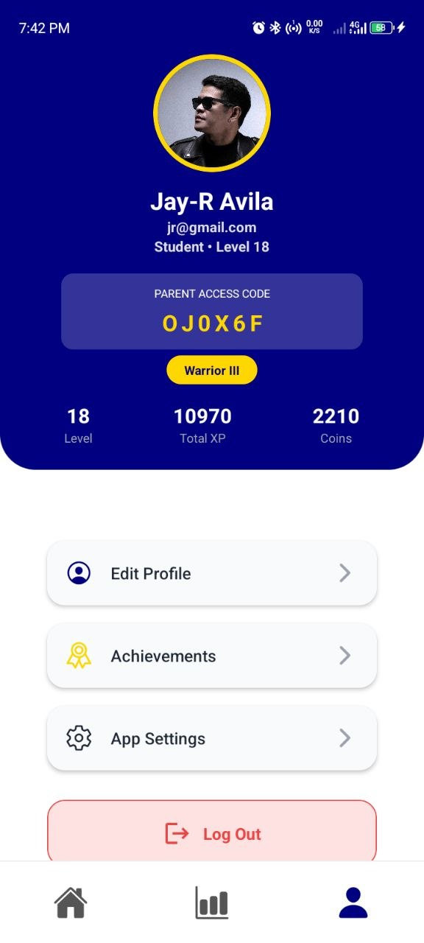
Next is for the Teachers, after you login, you will be redirected to the Teacher’s Dashboard screen where you can find the list of all the enrolled student under you and also you can click one of them to see their individual progress, also you can see on the pending tab all the list of students who are waiting for your response if they are really part of the enrolled student list from the school or not. You can also see a four (4) icons buttons at the top of your screen, where you can click one of them, such as the 1st button where you will be redirected to the class records screen, 2nd icon button you will be redirected to the lesson management screen, 3rd icon button you will be redirected to the Question Management, and lastly the 4th icon button for logout. | 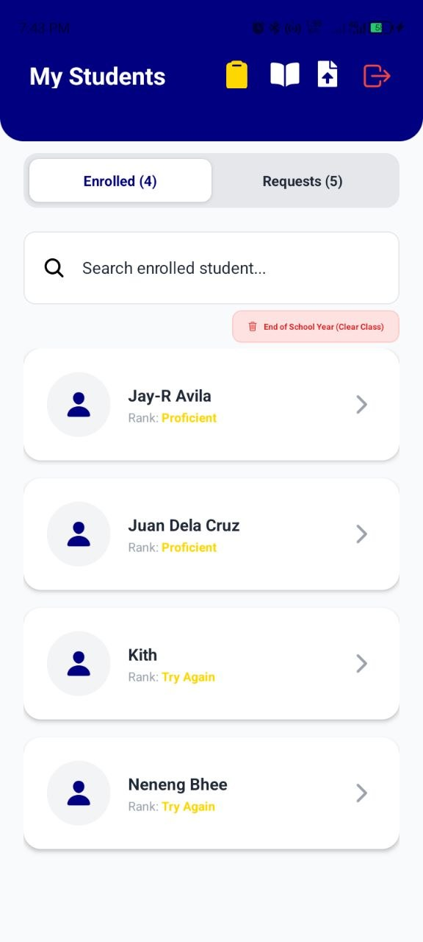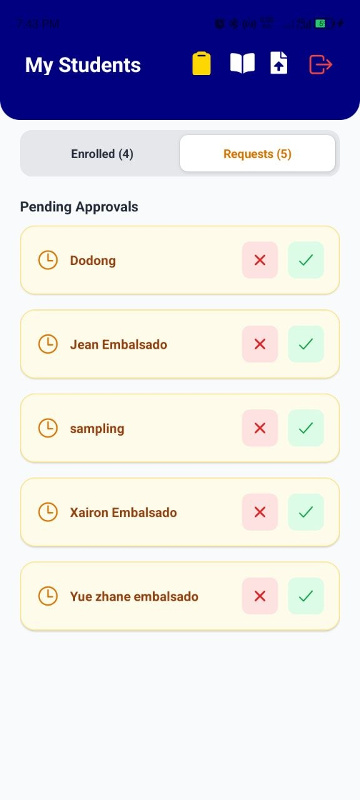
For the 1st icon button, when you click it, you will be redirected to this screen where you can see the class records, specifically the total raw scores of all your students per quizzes, one the selection field you can scroll it up and down if you already created many quizzes and select one of them to see the scores of your students. | 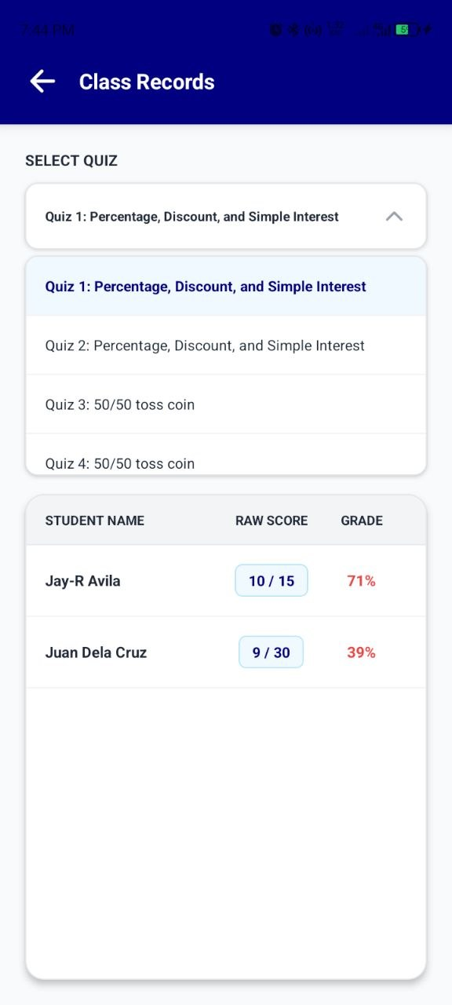
For the 2nd icon button this the screen that you will be redirected where you can upload you verified customize lessons for your students to study. Either in PDF file, Word/docx file or PowerPoint Presentation/ppt file. | 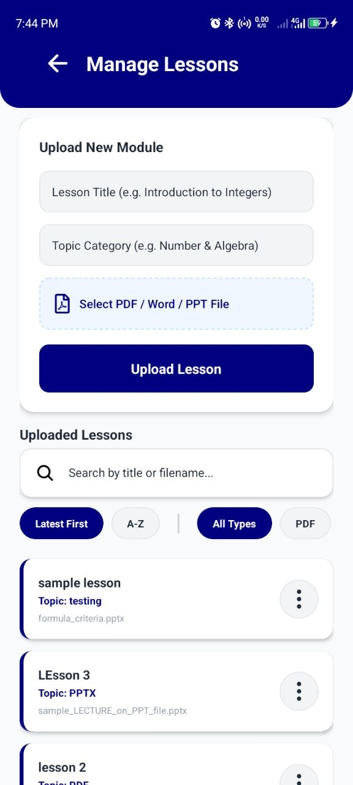
Lastly, for the 3rd icon button if you click it you will be redirected to this screen where you can upload your verified customized questions for a specific quiz event, other than that, you can also create your own quiz directly on the app just click the Create Quiz button. The three dots menu, the function of that is to view the created quiz and edit if you made some incorrect questions, also you can delete the whole quiz file. | 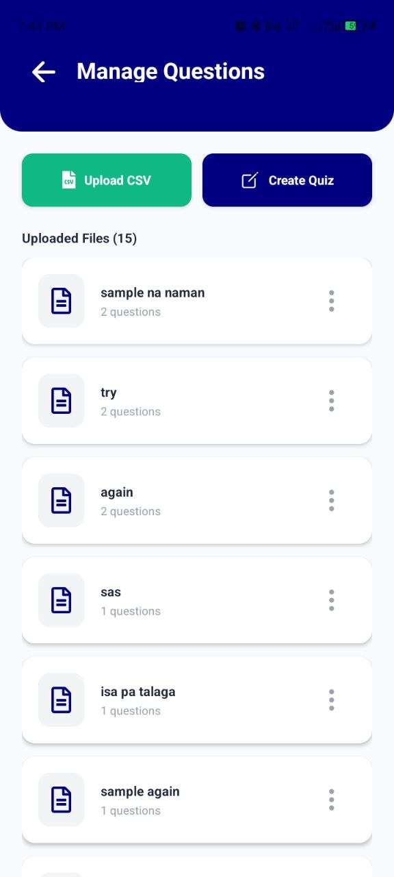
Next is for the Parent portal, to access the progress analytics of your child, ask them the family code for you to use in the login screen and after that this is the screen that you will be redirected where you can see all the progress data of your children from pre-test, evaluation quiz game, classic quiz game, rank quiz game, and in overview tab where you can find a summary of all the progress analytics of your child | 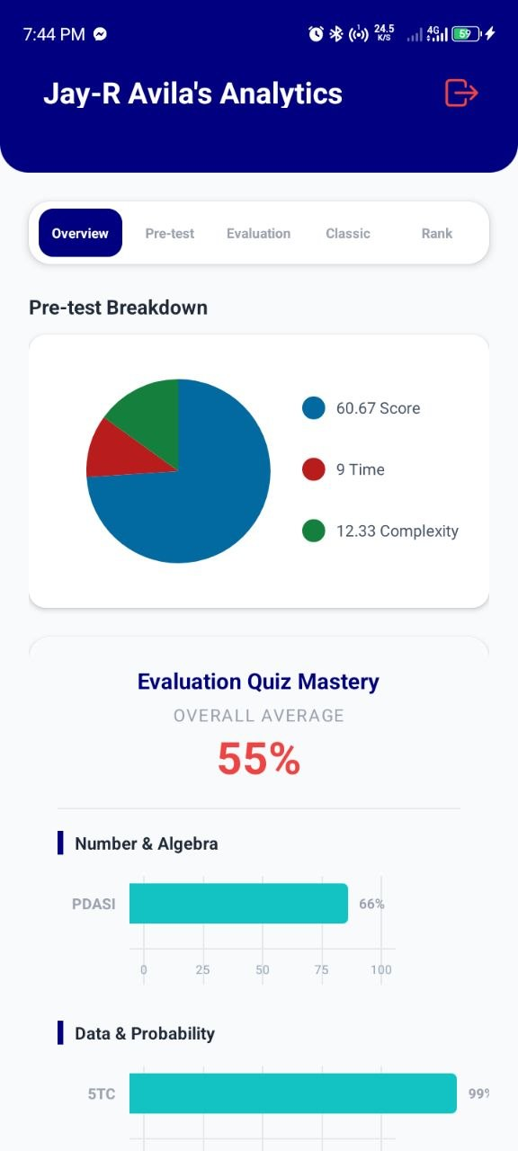

This User Manual is for the Teachers Admin Web Portal
Step 1: Open you Google Chrome or Microsoft Edge and on the Search Input Field please type the Zentinel URL Web Portal: https://zentinel-teacher-admin-portal.vercel.app/

Step 2: Login your credentials that you created using the mobile app, to access your account here in Zentinel admin web portal.

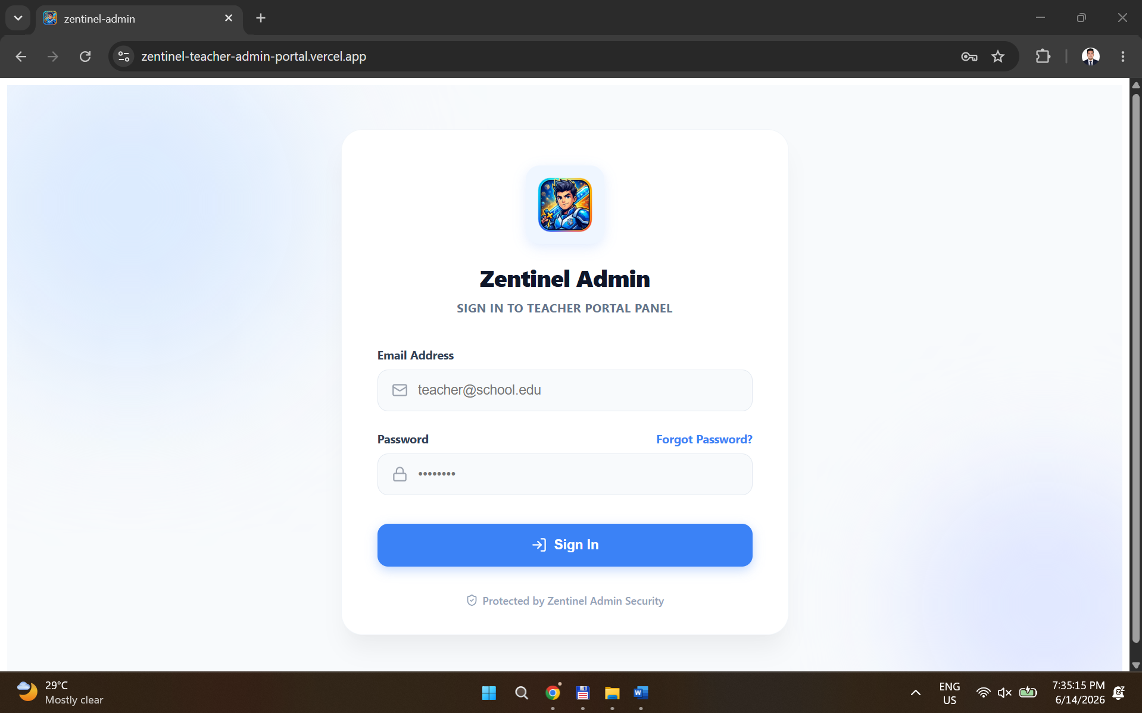

Step 3: After you login, this is the Dashboard or the Home page of the web portal.
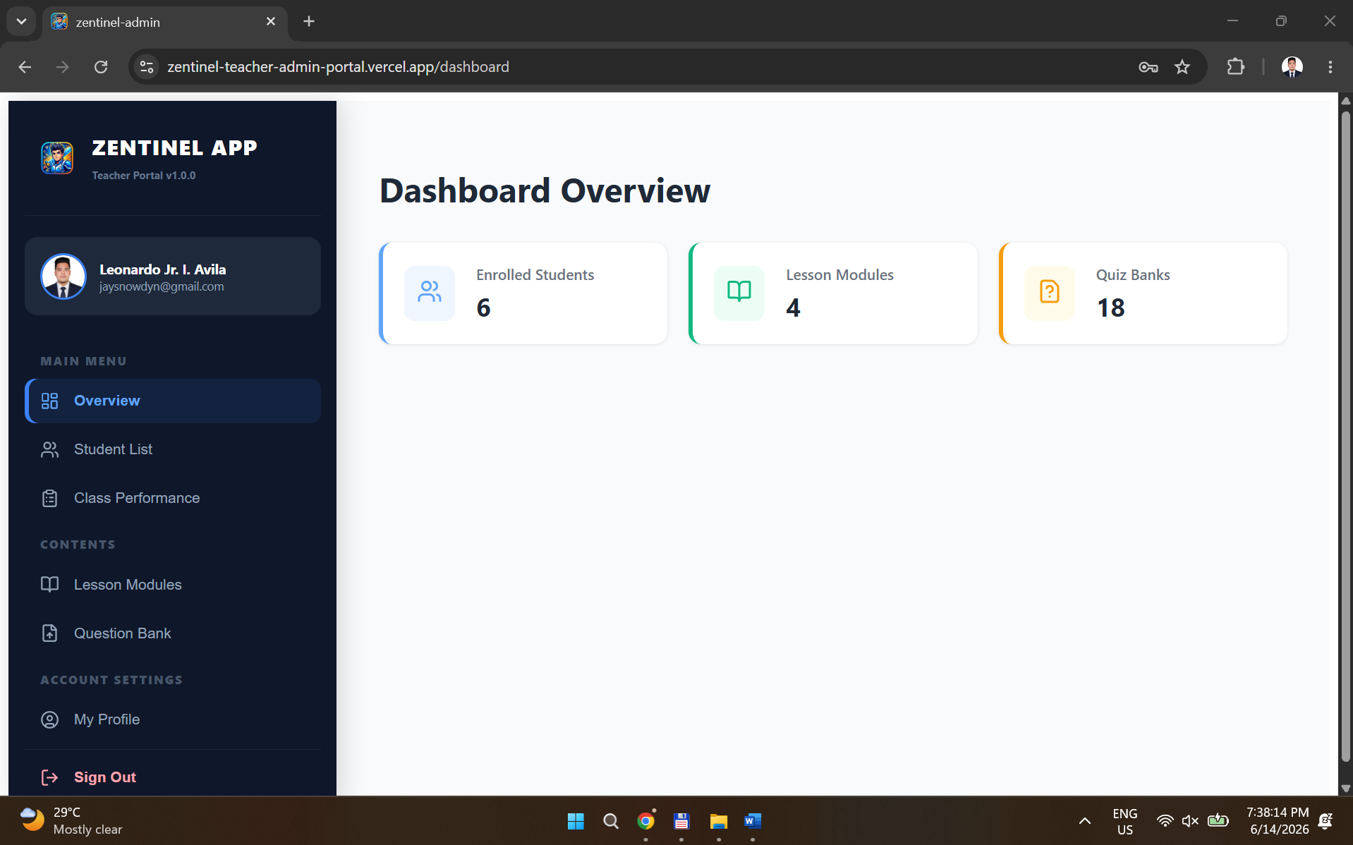
Step 4: On the left side of the screen of your laptop or PC you will see a menu buttons. Now, please navigate to “Student List” button. This is where you can find all the list of enrolled students under your math subject that you teach. As you can see under the “Enrolled Tab” you can see and search all student that you’ve approved their request to join your class. You can also export this list to excel file.

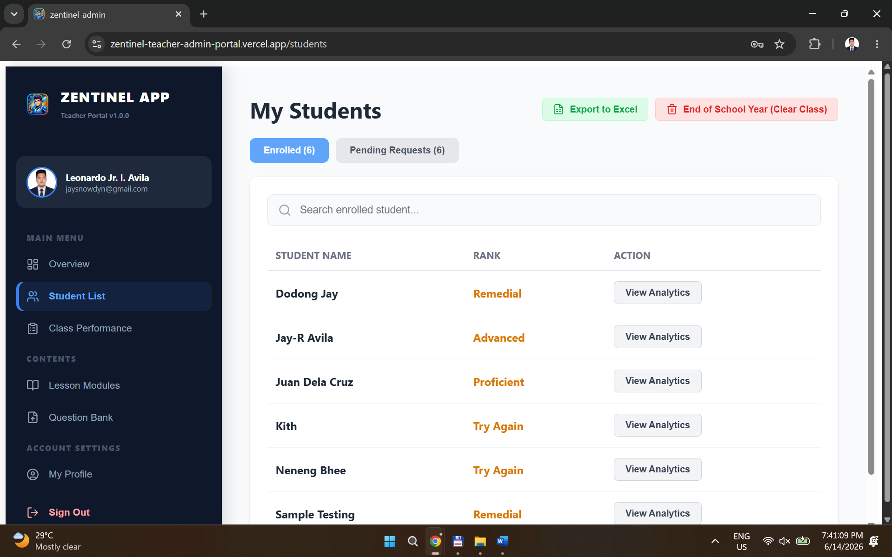

Step 5: Now, if we navigate to “Pending Requests” this is the other tab where you can find all students who requested to join your class where you can choose to reject their request or approve them.

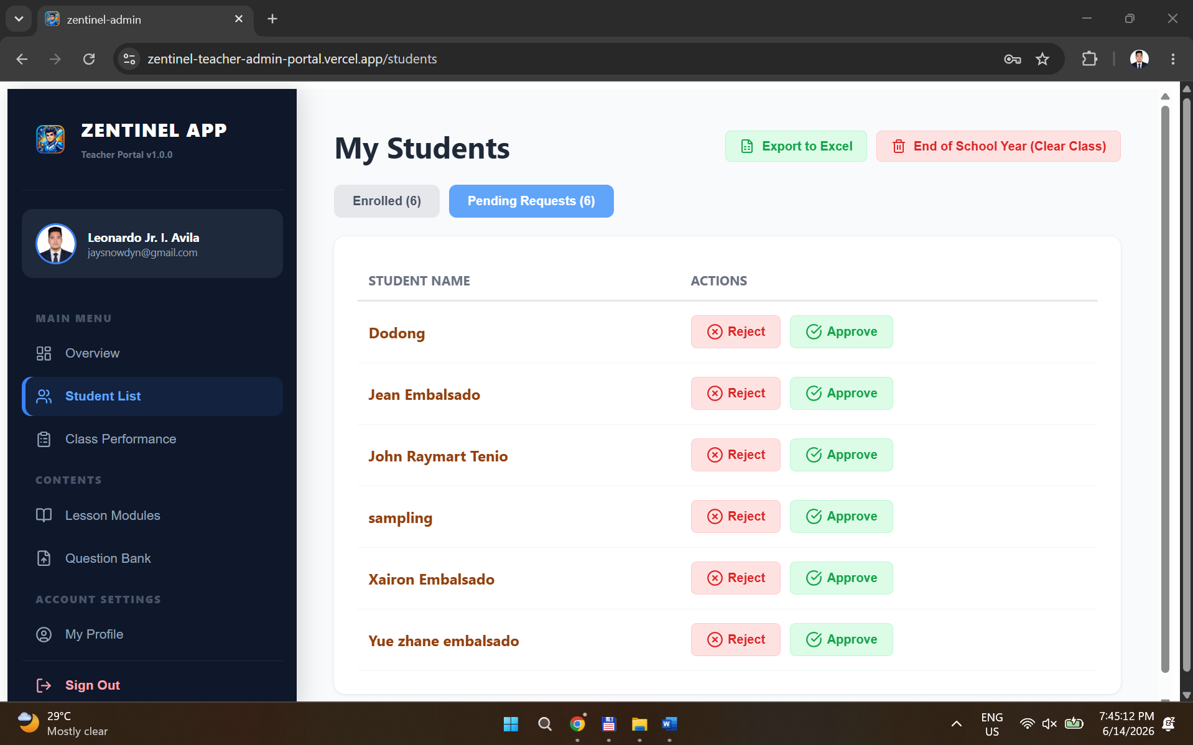
Step 6: On the left side of the screen of your laptop or PC you will see a menu buttons. Now, please navigate to “Class Performance” button. You will see here all the students who already have taken their quizzes. You can also export the class records by click the “Export Current Quiz” button.

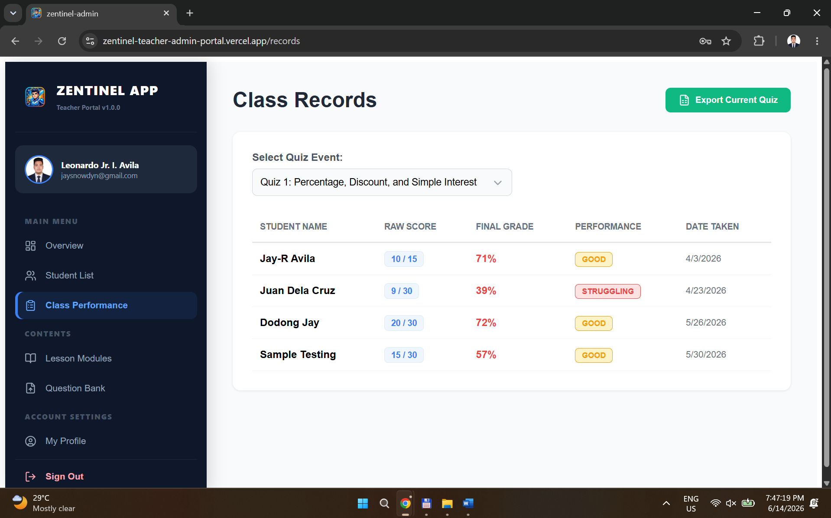

Step 7: You can also select other quizzes to see and monitor their performances.



Step 8: You can also select any from the list of students who already taken their quizzes to see the details of their performance.

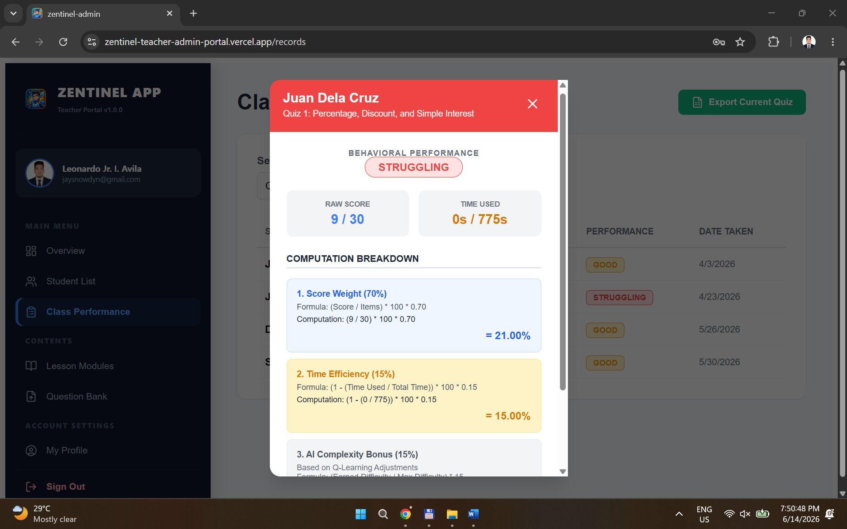

Step 9: On the left side of the screen of your laptop or PC you will see a menu buttons. Now, please navigate to “Lesson Modules” button. This is where the teacher can upload their customized and curriculum aligned lesson, so that the student can study using their mobile phone by accessing their account on the Zentinel mobile app.

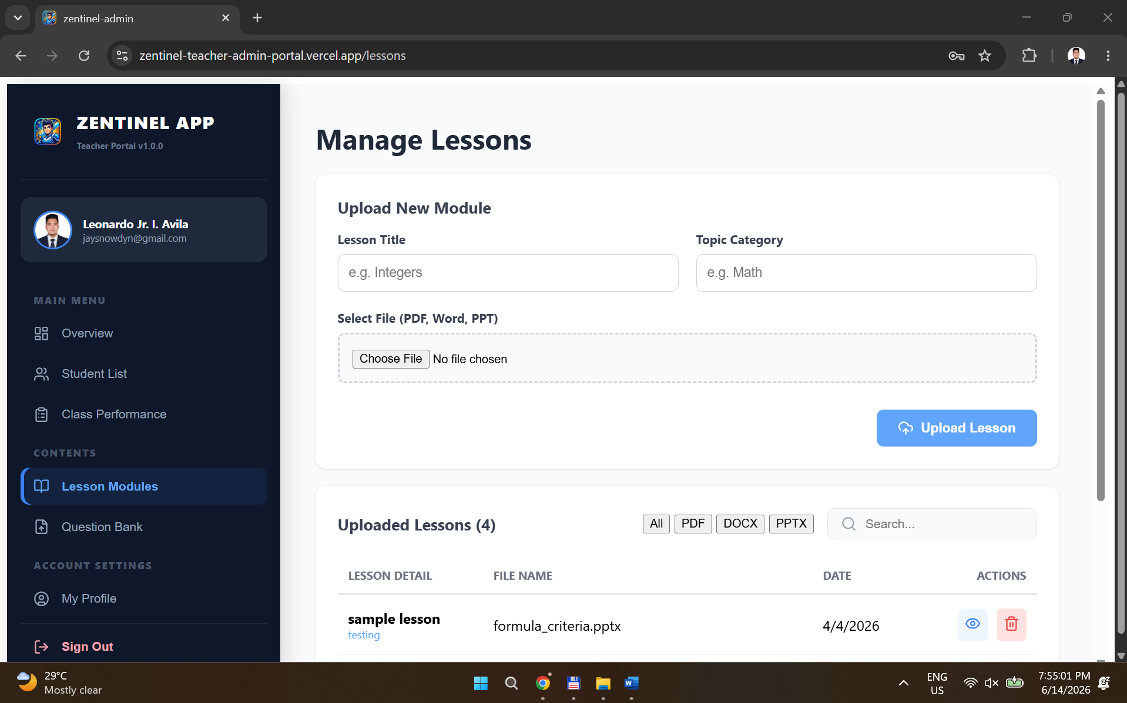
Step 10: On the left side of the screen of your laptop or PC you will see a menu buttons. Now, please navigate to “Question Bank” button. This is where the teacher can upload their customize and curriculum aligned quizzes using csv file.

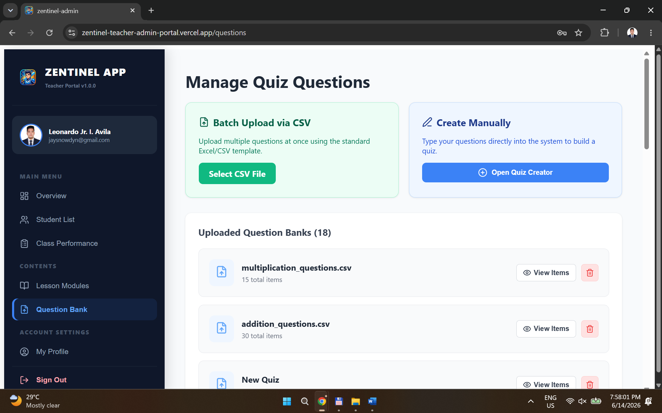

Step 11: They can also directly create the quiz inside the web portal by clicking the “Open Quiz Creator” button.

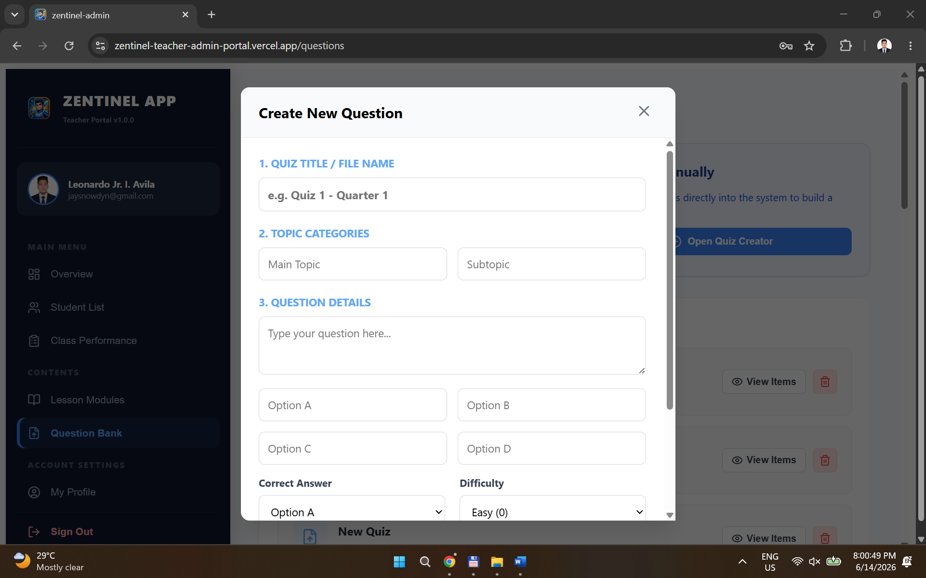

Step 12: On the left side of the screen of your laptop or PC you will see a menu buttons. Now, please navigate to “My Profile” button. This is where you can update your profile picture, name.

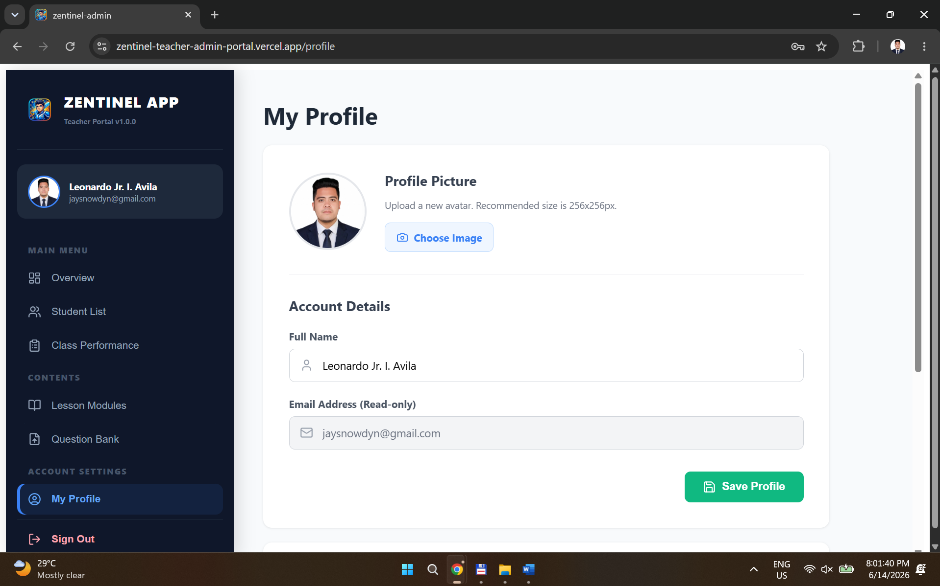

Step 13: Lastly, on the left side of the screen of your laptop or PC you will see a menu buttons. Now, if you will click the “Sign Out” button. You will automatically logout on your account.

