test

Diego Aviles

Wednesday, July 29, 2015

This is an R Markdown document. Markdown is a simple formatting syntax for authoring HTML, PDF, and MS Word documents. For more details on using R Markdown see <http://rmarkdown.rstudio.com>.

When you click the **Knit** button a document will be generated that includes both content as well as the output of any embedded R code chunks within the document. You can embed an R code chunk like this:

# Heather?

## Heather?!?!?!?

## WARNING: Rtools is required to build R packages, but is not currently installed.  
##   
## Please download and install Rtools 3.2 from http://cran.r-project.org/bin/windows/Rtools/ and then run find_rtools().  
## Loading productConfig  
##   
## Attaching package: 'gplots'  
##   
## The following object is masked from 'package:stats':  
##   
## lowess

You can also embed plots, for example:

## attr1  
## round0 2  
## round3 2

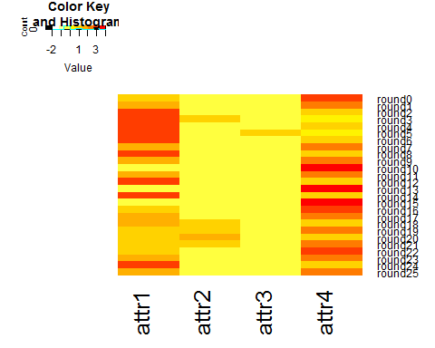

Note that the echo = FALSE parameter was added to the code chunk to prevent printing of the R code that generated the plot.