CS 499 Module One Assignment Template

Complete this template by replacing the bracketed text with the relevant information.

- Self-Introduction: Address all of the following questions to introduce yourself.

  - How long have you been in the Computer Science program?
My name is Danielle and 2026 is the 4th year of my CS program.

  - What have you learned while in the program? List three of the most important concepts or skills you have learned.
UML designs
Software Development life cycle
Unit testing and verification.

  - Discuss the specific skills you aim to demonstrate through your enhancements to reach each of the course outcomes.
I want to demonstrate my skills in creating and using APIs and SPA to enhance algorithms and data structures. This will also showcase my ability to communicate complex technological terms and instructions in a way that anyone can understand. Furthermore, it will illustrate how I can manage data effectively and efficiently.

  - How do the specific skills you will demonstrate align with your career plans related to your degree?
My degree is in Computer Science, and I have been working as a software developer. In the coming months, I will be looking for back-end developer jobs or full-stack positions, applying my experience and skills to handle data on the front end.

  - How does this contribute to the specialization you are targeting for your career?
Back-end development involves working on server-side software, ensuring the website performs correctly, and focusing on databases, back-end logic, application programming interfaces (APIs), architecture, and servers. They use code that helps browsers communicate with databases, store, understand, update, and delete data.

A back-end web developer also needs to understand the vision in order to execute it thoroughly. Strong written and conversational skills will help communicate ideas and troubleshoot with team members and stakeholders.
- ePortfolio Set Up:

  - Submit a screen capture of your ePortfolio GitHub Pages home page that clearly shows your URL.
    - You already have a repository in GitHub where you uploaded projects in previous courses. Your ePortfolio will reside in GitHub but can link to work at other sites, such as Bitbucket.

  - Use the GitHub Pages link in the Resource section for directions on:
    - How to create your GitHub website and publish code to GitHub Pages
    - Issues, such as adding links to other sites

  - Paste a screenshot of your GitHub Pages home page with your URL clearly showing in the space below.

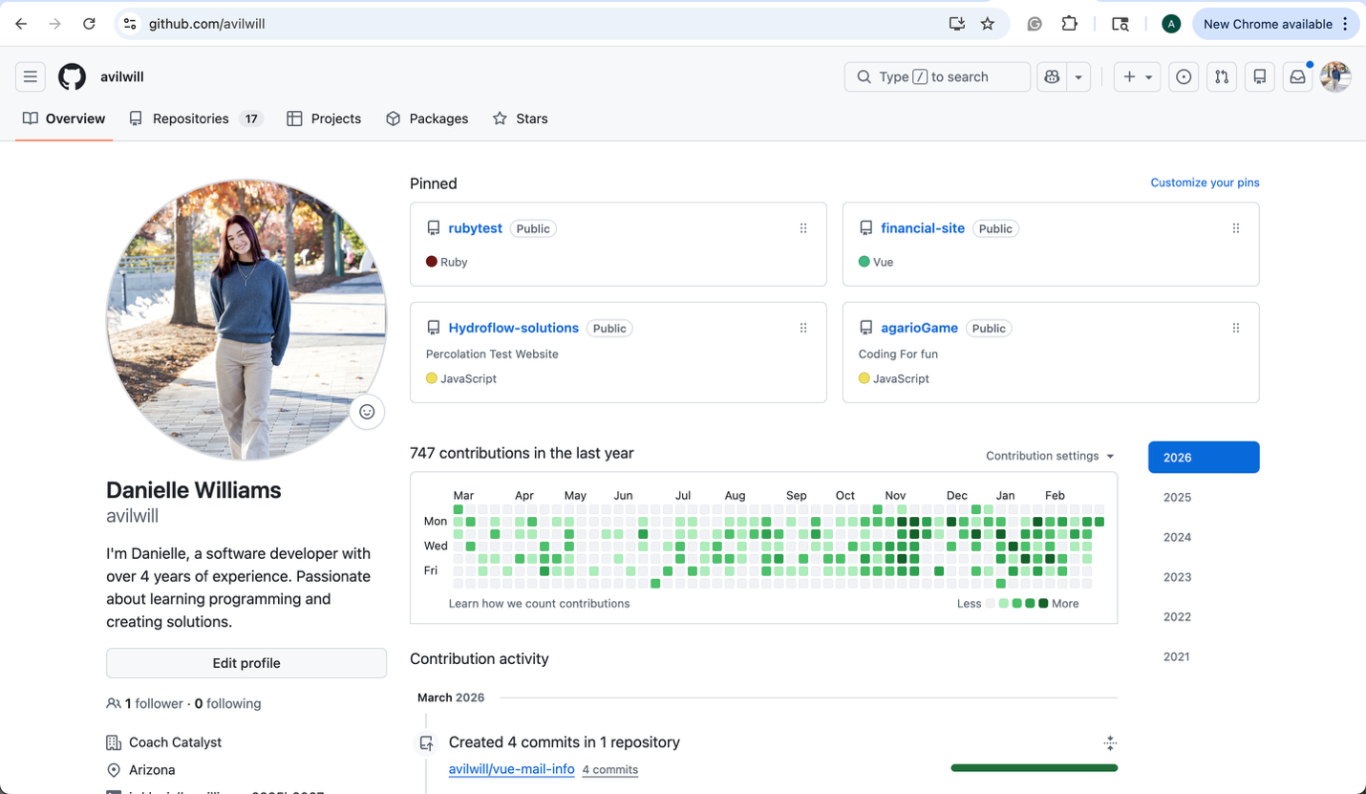

- Enhancement Plan:

Course Outcomes:

- Employ strategies for building collaborative environments that enable diverse audiences to support organizational decision-making in the field of computer science.
- Design, develop, and deliver professional-quality oral, written, and visual communications that are coherent, technically sound, and appropriately adapted to specific audiences and contexts.
- Design and evaluate computing solutions that solve a given problem using algorithmic principles and computer science practices and standards appropriate to its solution while managing the trade-offs involved in design choices.
- Demonstrate an ability to use well-founded and innovative techniques, skills, and tools in computing practices for the purpose of implementing computer solutions that deliver value and accomplish industry-specific goals.
- Develop a security mindset that anticipates adversarial exploits in software architecture and designs to expose potential vulnerabilities, mitigate design flaws, and ensure privacy and enhanced security of data and resources.

  - Category Two: Algorithms and Data Structures

- Select an artifact that is aligned with the algorithms and data structures category and explain its origin. Submit a file containing the code for the artifact you choose with your enhancement plan. You may choose work from the courses listed under Category One.

../Workspace/vue-mail-info/src/Messages.vue

- Describe a practical, well-illustrated plan for enhancement in alignment with the category, including a pseudocode or flowchart that illustrates the planned enhancement.
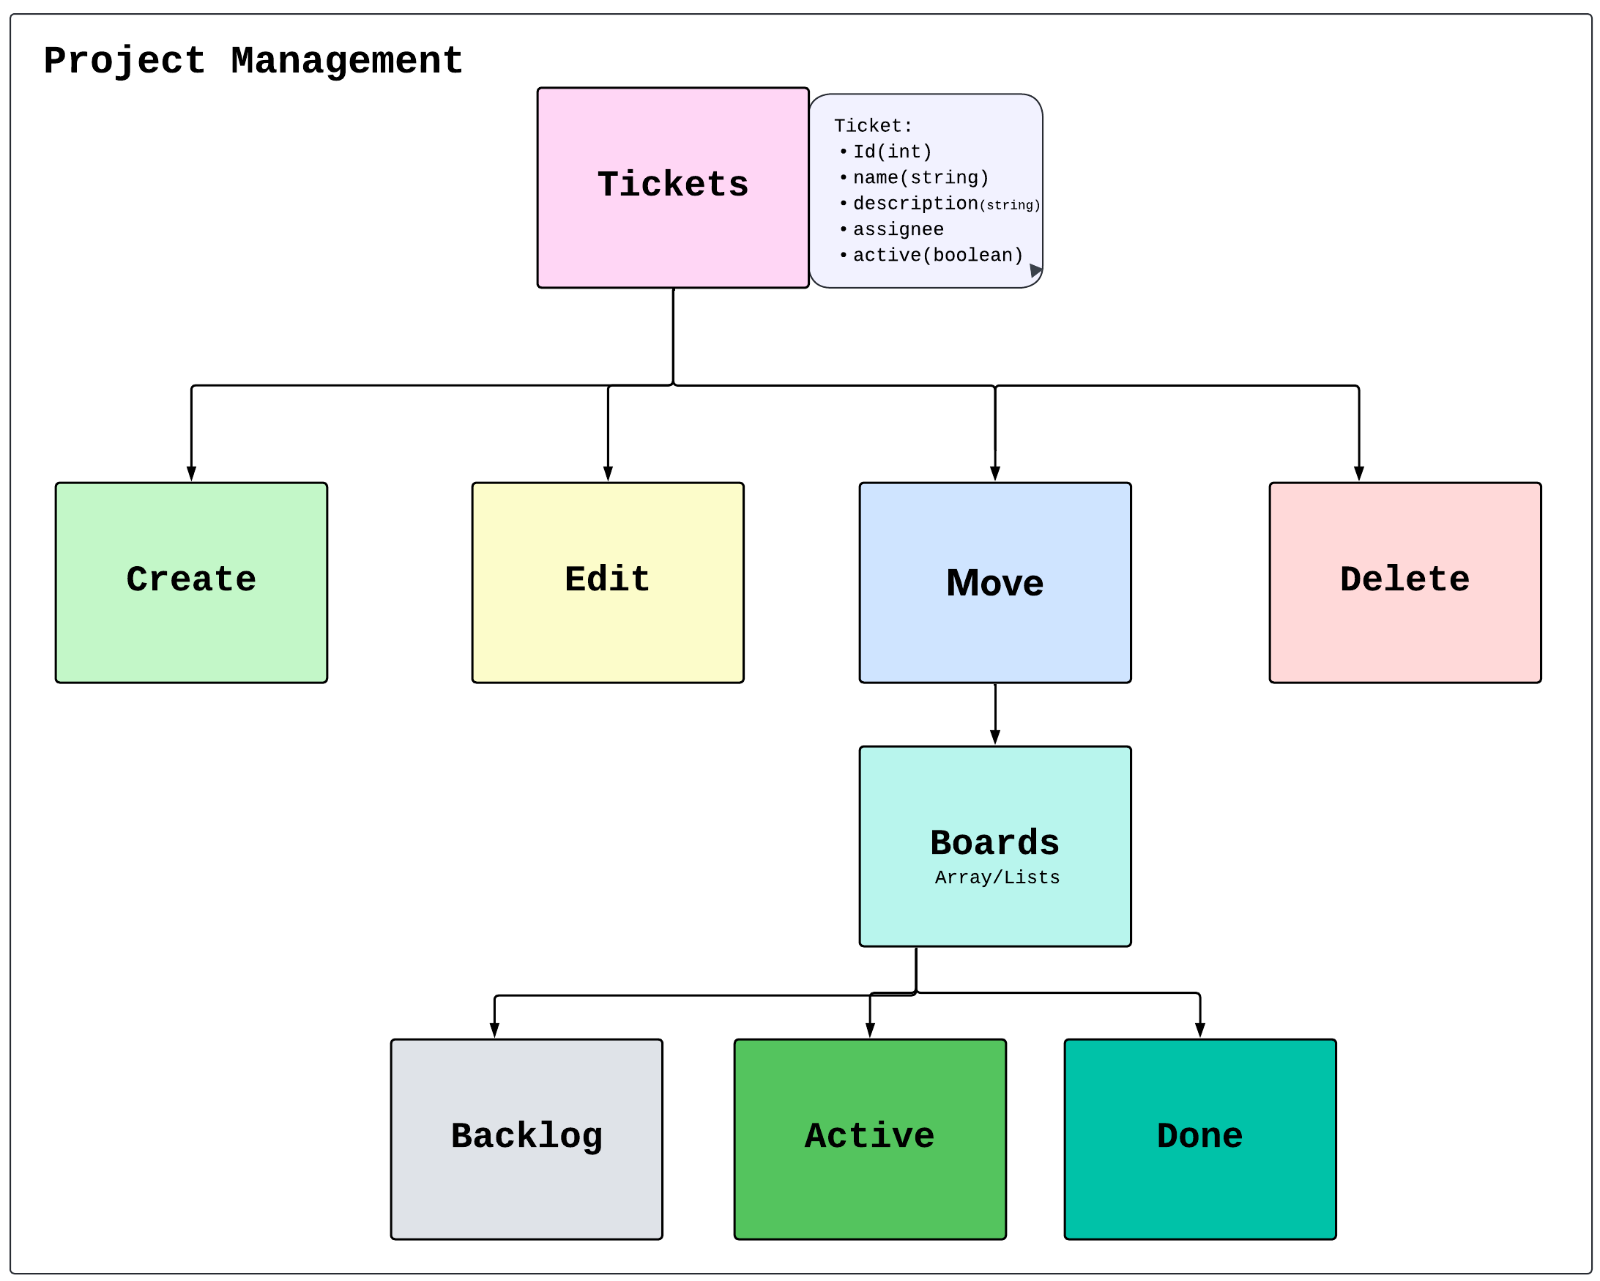
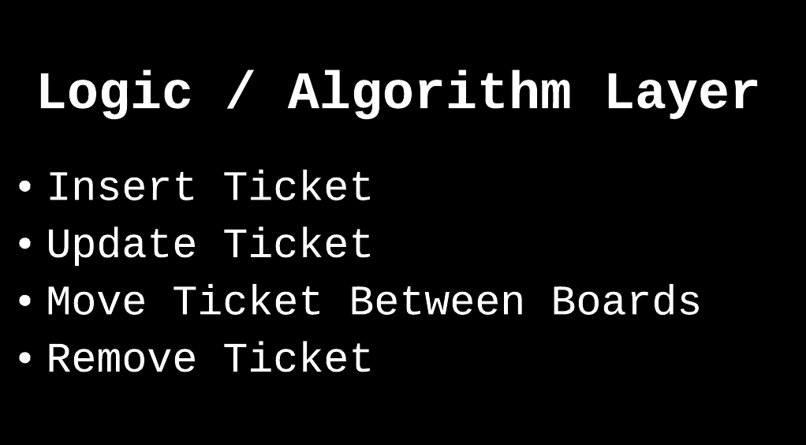
Above is the illustration I plan to implement to enhance the current state of the application.
Currently, the application functions as a mail inbox, but it has some usability issues. To improve the application and better align it with my portfolio goals, I will transform the inbox into a project management and issue-tracking application designed for software development. This enhanced version will allow users to create, update, move, and delete tickets. When users select multiple tickets, an action bar will appear and provide options for deleting or moving them. In addition, the page will update dynamically without requiring a refresh, creating a smoother and more efficient user experience.
Currently, the application allows users to click a checkbox to select multiple emails. However, clicking the checkbox also opens the email, which forces the user to go back before confirming that the item was selected. This creates frustration because the purpose of multi-select is to let users quickly manage several items at once, not require extra navigation. Another limitation is that the current “Send” email function does not perform any action. I plan to repurpose this feature by connecting it to an API that will create and add a ticket. Once created, the ticket will be added as a new item in the backlog board.

- Explain how the planned enhancement will demonstrate specific skills and align with course outcomes.

  - Identify and describe the specific skills you will demonstrate to align with the course outcome.

By refactoring the existing codebase, I will demonstrate my ability to read, analyze, and understand previously written code, as well as how the application currently manages data and user interactions. This process highlights my ability to maintain and improve an existing software system rather than building a project entirely from scratch.
I will implement API endpoints using POST, PUT, and DELETE requests to support creating, updating, and deleting tickets within the project management system. This demonstrates my ability to design and implement RESTful APIs and manage communication between the front-end interface and the backend logic. I will implement validation to ensure that data is properly checked before tickets are created, modified, or removed. This shows my understanding of data integrity and responsible data management in application development. Sicne the application is being repurposed from a mail inbox into a project management system, I will also refactor method names, variables, and application logic to ensure the code is clear, maintainable, and logically organized. This demonstrates attention to detail and the ability to follow proper naming conventions and clean coding practices.

  - Select one or more of the course outcomes listed under Category One that your enhancement will align with.

All components of my ePortfolio will work cohesively, adhering to the highest professional standards. It will showcase written and visual communications that are clear, technically sound, and appropriate to industry practices and standards. Additionally, it will highlight innovative techniques, skills, and tools in computing that are essential for implementing computer solutions that provide value, achieve industry-specific goals, and address potential vulnerabilities.

- ePortfolio Overall Skill Set

  - Accurately describe the skill set to be illustrated by the ePortfolio overall.
    - Skills and outcomes planned to be illustrated in the code review

The goal is to demonstrate skills and outcomes through quick responses to server requests within a single-page application. I want the API to showcase my expertise in components and data structures, including how to pass, store, and create entries with unique identifiers and keys. The user interface will illustrate my understanding of creating a user-friendly and efficient display of data.

    - Skills and outcomes planned to be illustrated in the narratives

I will show how I can explain complex technical ideas to different audiences. I will describe each piece of work, the problems I faced, the design choices I made, and the reasons for those choices. In this document I have shared a flow chart as well.

    - Skills and outcomes planned to be illustrated in the professional self-assessment

I will reflect on my learning during the program and how my skills have improved.I will assess how I include a security mindset when working with APIs, managing user input, and ensuring data integrity. This will highlight my readiness for back-end or full-stack roles. I will emphasize my skills in designing scalable systems, creating RESTful APIs, managing databases, and building responsive single-page applications.

