TRYHACKME NETWORKING FUNDAMENTALS
Codekrafters club – cybersecurity task

Name: M Avinaash
College: SRM Institute of Science and Technology
Branch: CSE Core
Tryhackme profile: https://tryhackme.com/p/avinaashvista

- Tryhackme room: What is networking?

What I Did?
I have completed the, what is Networking Room on TryHackMe. The room introduced the basic idea of computer networks and explained how different devices communicate with each other. I went through the sections, answered the questions, and completed all the required tasks in the room.

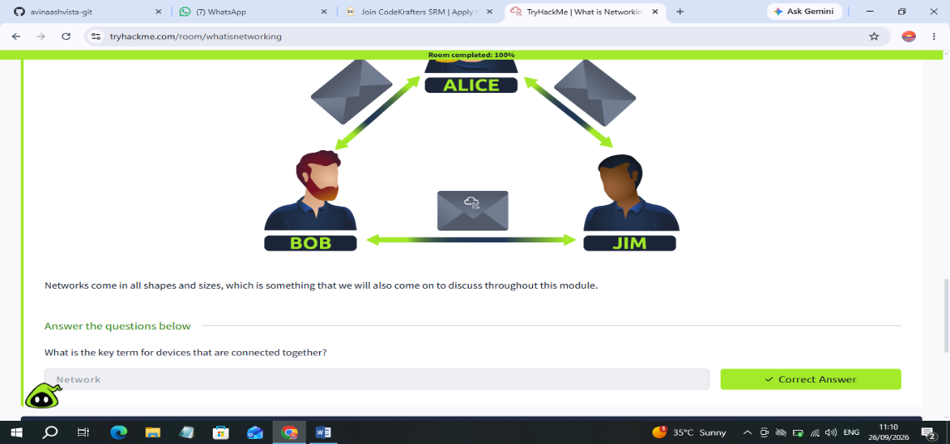
Figure 1: Introduction to the basic concept of networking.
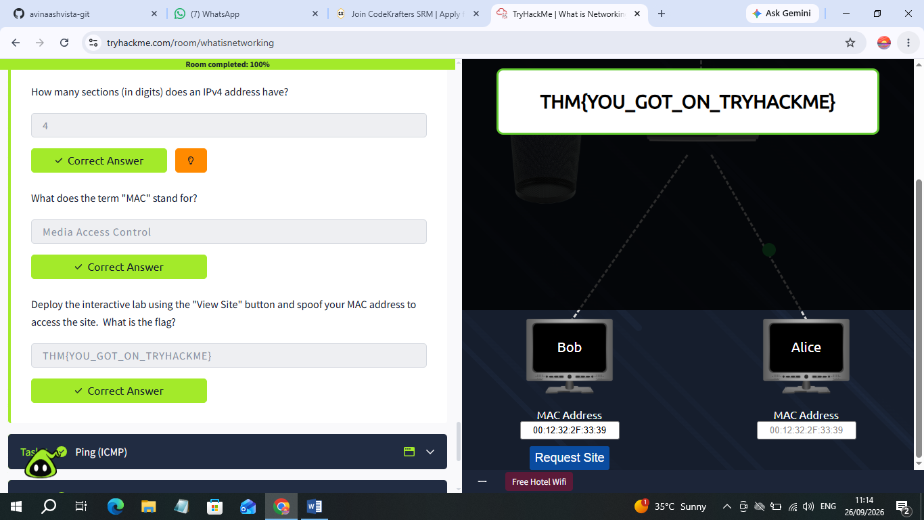

Figure 2: Identifying Devices on Network

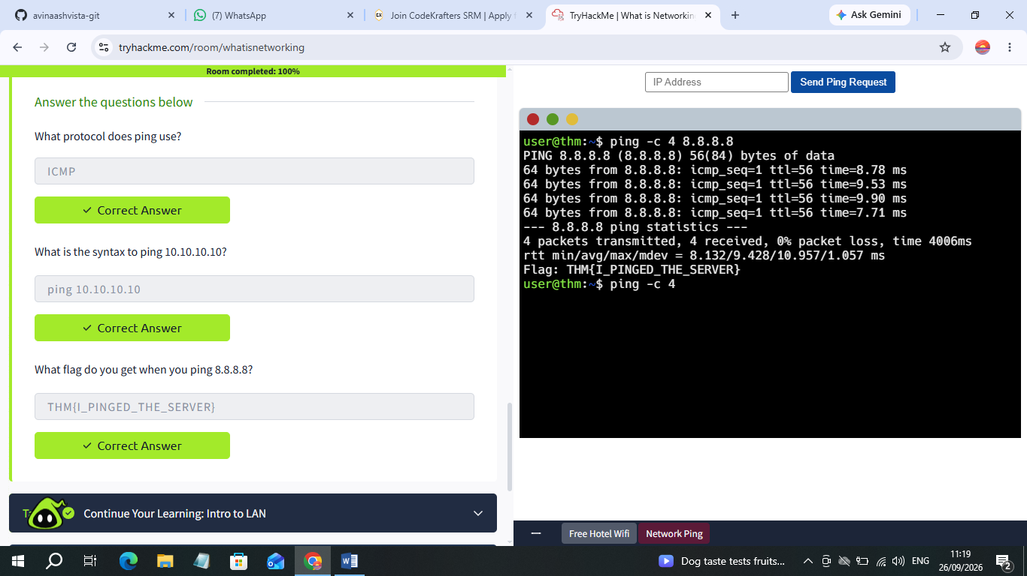

Figure 3: Ping (ICMP)

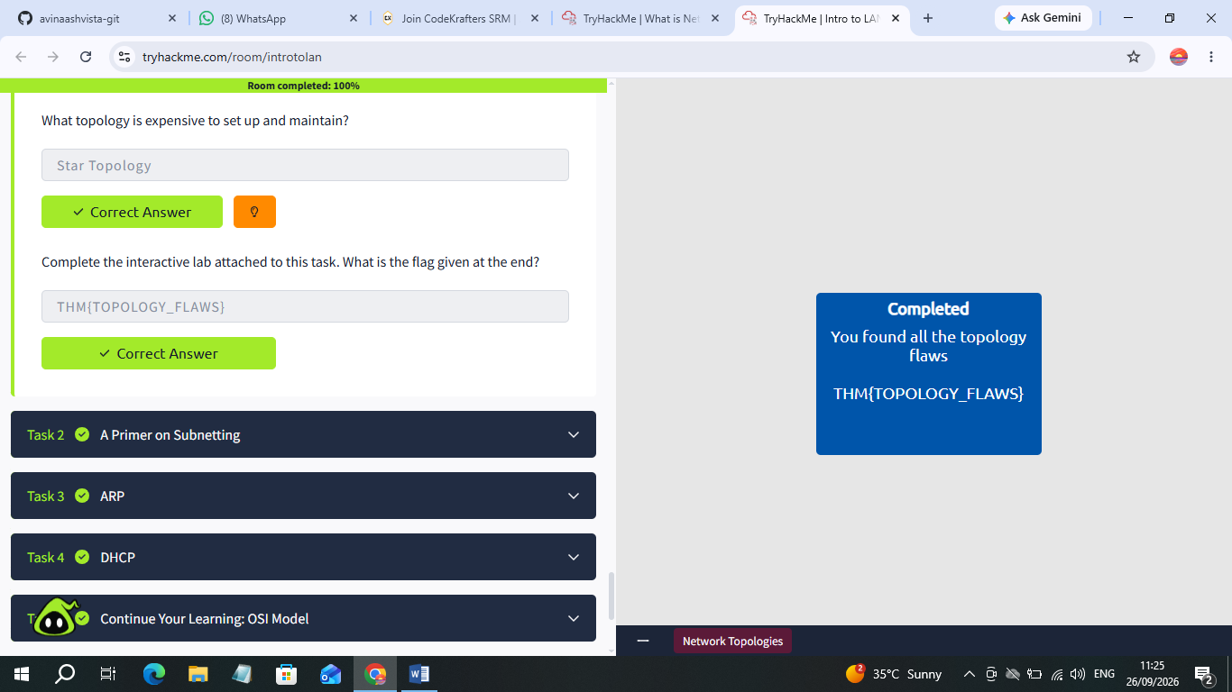

Figure 4: Introduction to LAN room and also OSI Model room

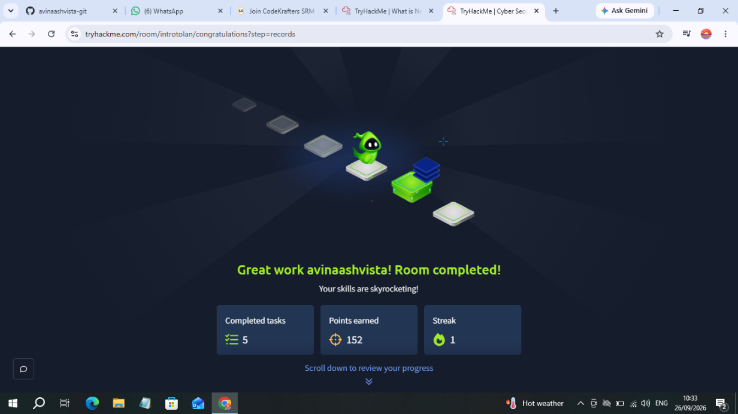

Figure 5: Final Completion Screen

What I Have Learned So far?

After completing the “What is networking?” room, I learned the basics of how devices communicate with each other through networks.
- I learned what a computer network is and how different devices can be connected.
- I understood that the Internet is a collection of interconnected networks.
- I learned about IP addresses and how they help identify devices on a network.
- I learned about LANs and common network devices such as routers and switches.
- I learned how the ping command can be used to check network connectivity and its connection with ICMP.
- Most importantly, I understood why networking is an important foundation for cybersecurity.

- Tryhackme room: Introductory Networking
(An introduction to networking theory and basic networking tools)

What I did?

I completed the Introductory Networking room on TryHackMe. I went through the different sections covering networking concepts such as the OSI model, TCP/IP, TCP and UDP, DNS, and basic networking tools. I answered the questions and also worked through the research-based questions to understand how these concepts are used in real networking situations. After completing all the sections and questions, I finished the room with 100% completion.

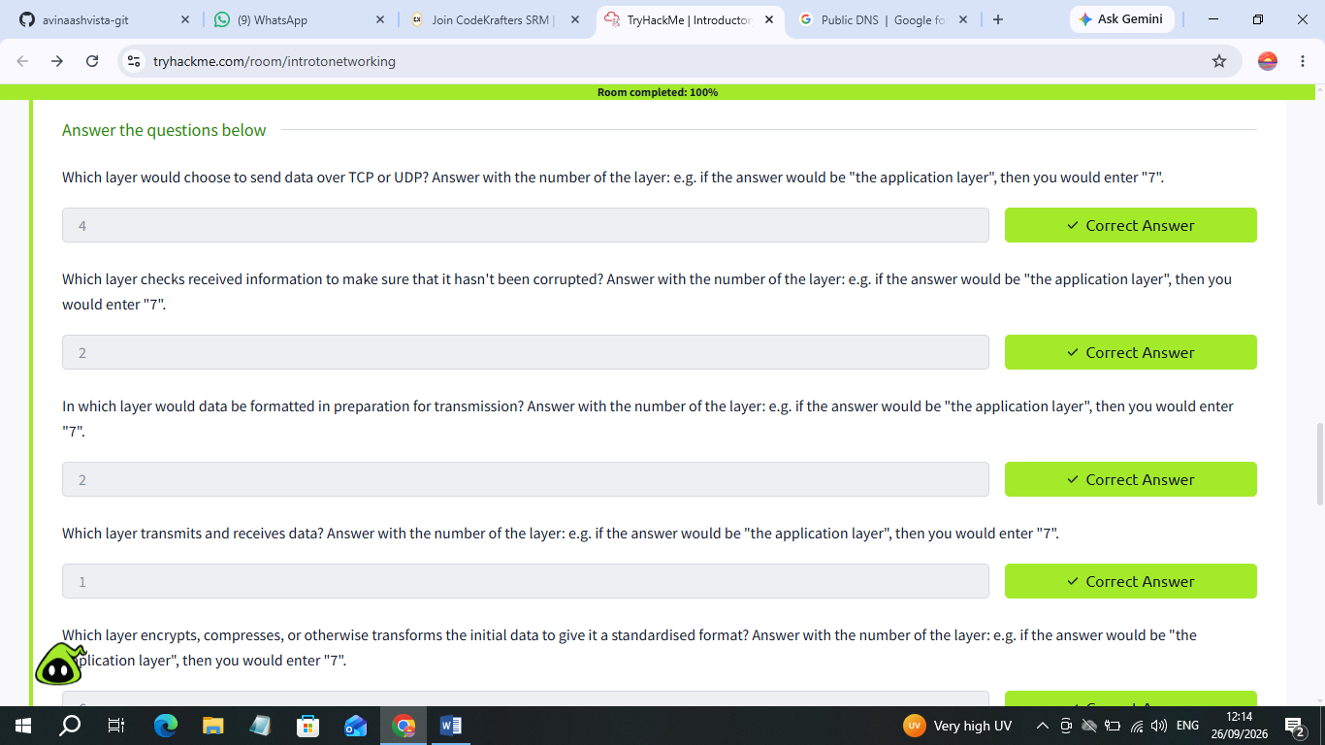

Figure 1: The OSI Model (An Overview)

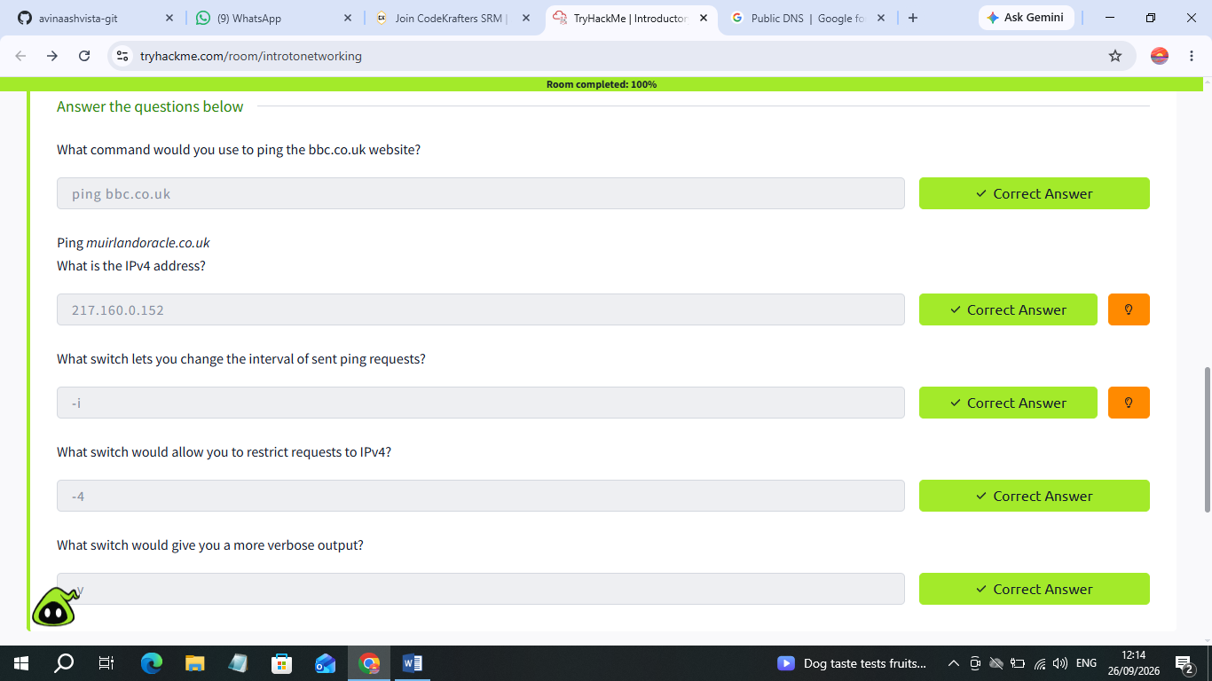
Figure 2: Networking Tools: Ping
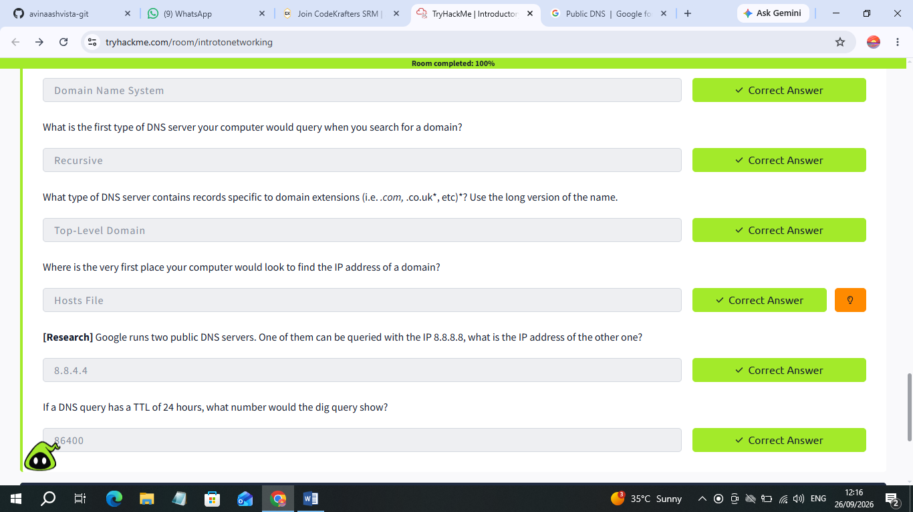

Figure 3: Networking Tools: Dig

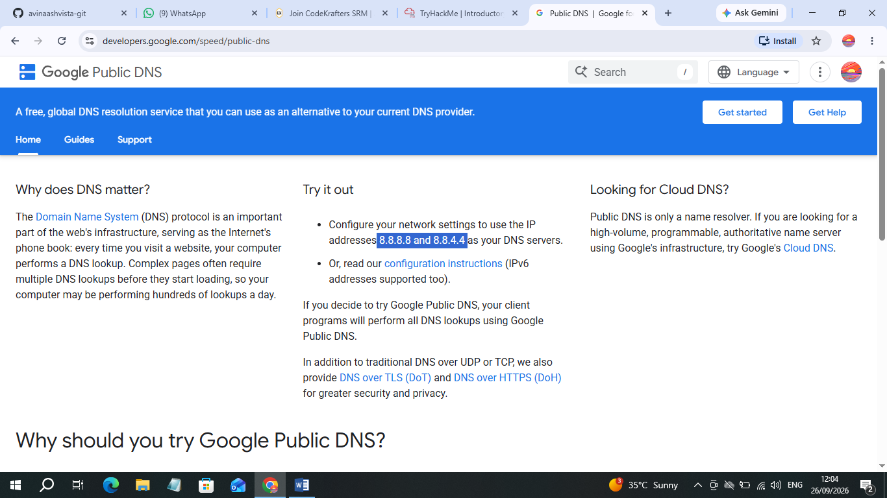

Figure 4: A Research Question

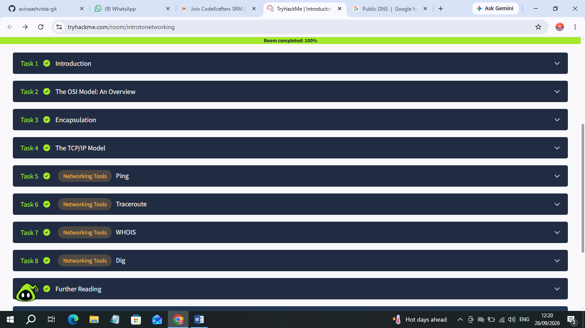

Figure 5: Final Completion Screen

What I have learned?
From the Introductory Networking room, I learned more about how network communication works and the basic tools used to understand it.
- I learned about the OSI model and how it divides network communication into different layers.
- I understood the difference between TCP and UDP and where they are commonly used.
- I learned how the TCP three-way handshake establishes a connection.
- I learned how DNS converts domain names into IP addresses.
- I explored basic networking tools such as Ping, WHOIS and DNS queries.
- I also learned how these concepts are useful for understanding and troubleshooting networks, which is important in cybersecurity.

